Ai NUERAL PART 2
ISAAC NARCISSUS CONCEPCION
LAB 1
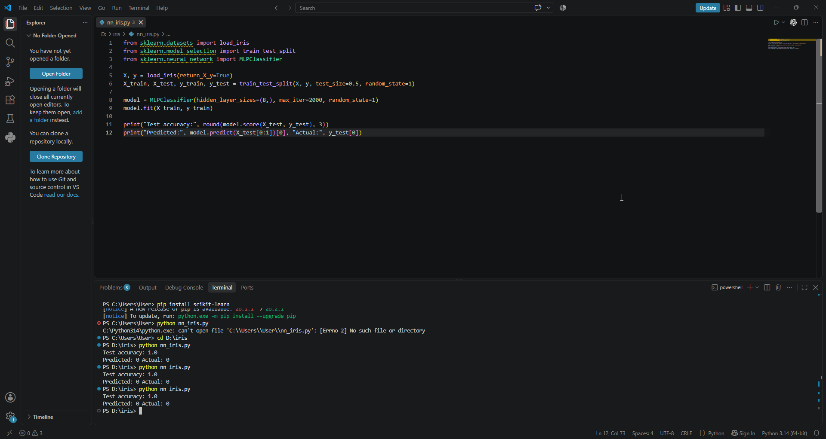
LAB 2
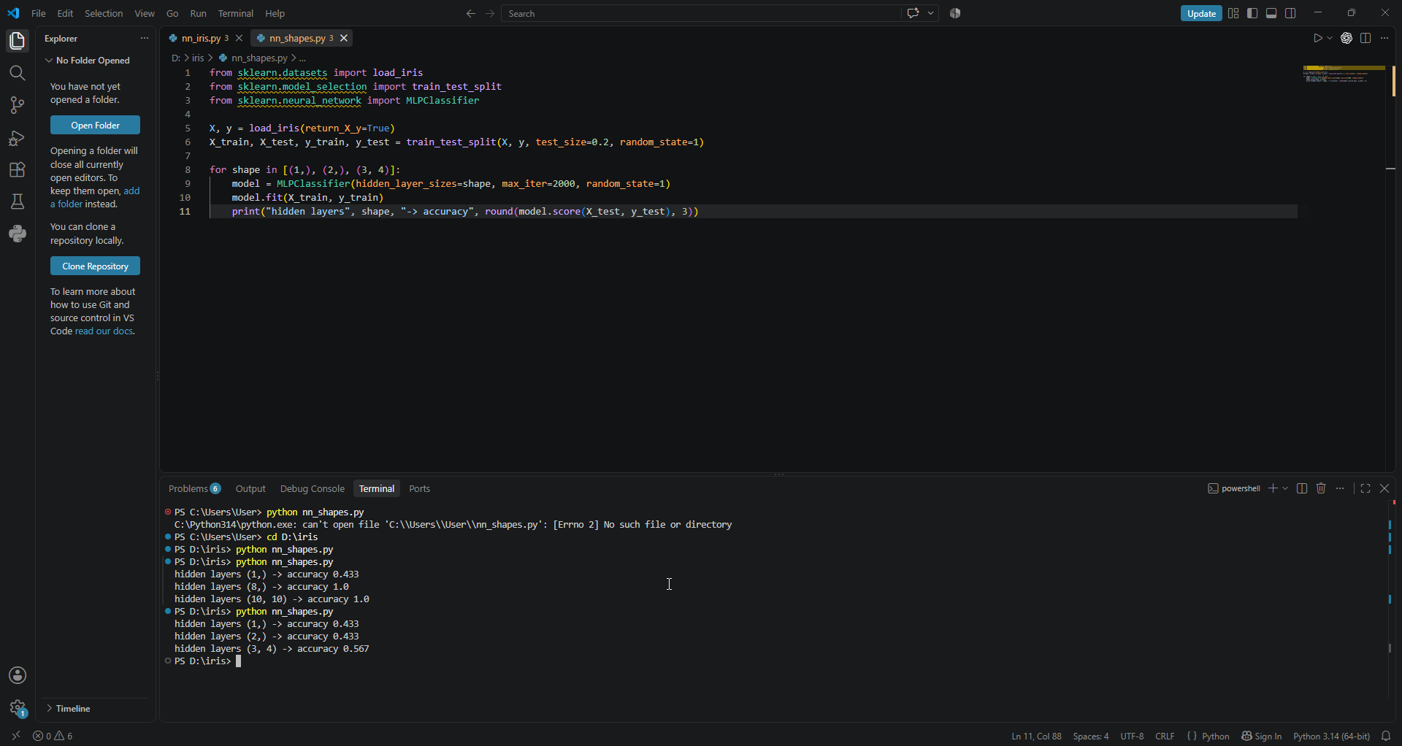

Answer : 8 neurons
LAB 3 :
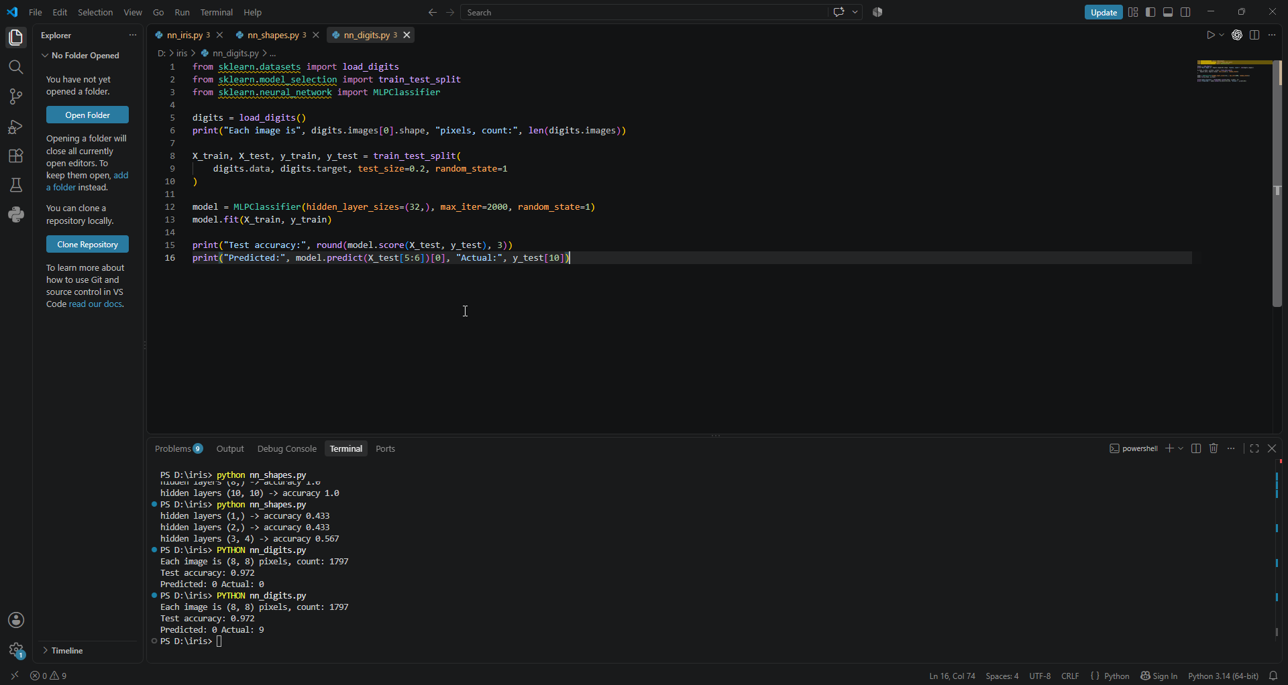

Answer : the code predicted 0 but the actual answer was 9
LAB 4:
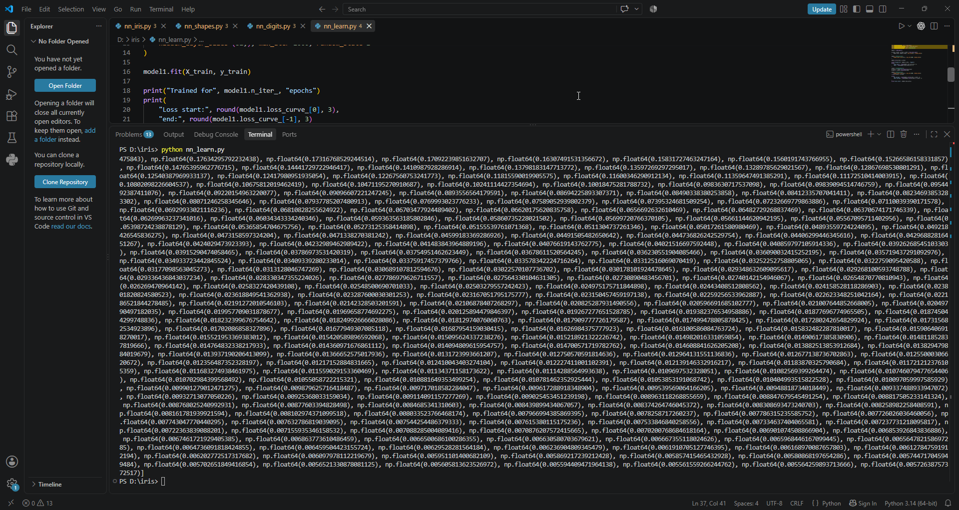

Answer: the loss decreases as the nueral network learns.

Reflect and share
- Which line of code set the number of layers and neurons?
The hidden_layer_sizes setting in MLPClassifier controls the number of hidden layers and neurons. For example, hidden_layer_sizes=(8,) means one hidden layer with 8 neurons, while (10, 10) means two hidden layers with 10 neurons each.
- How did the accuracy change when you changed the network's shape?
The accuracy changed depending on the network's size. With only 1 neuron, the accuracy was 43.3%, while 8 neurons achieved 100% accuracy. This showed that a network with too few neurons does not have enough capacity to classify the different Iris flower types properly.
3. Your digit reader hit about 97 percent. Where might that be useful in real life?
A handwritten-digit reader could be useful for reading handwritten numbers on forms, checks, postal codes, or scanned documents. It could automatically recognize numbers without requiring a person to enter them manually

