Numerical Algorithms

All implementation was done in python using numpy.

# Problem set 1

## Discretization

### 1. Trapezoidal Rule

Computation was done using numpy’s sin function and numpy’s value for $π$.

We observe that the approximation of the integral is more accurate as we reduce the step size – or equivalently, increase $n$, the number of trapezoids used.

|  |  |
| --- | --- |
| True value | 2 |
| h=0.1 | 1.99746892659 |
| h=0.01 | 1.99998206504 |

1. '''
2. @params
3. f : Unary function that takes a float input and returns a float
4. a,b: lower and upper range of integration
5. h : step size for integration
6. @returns
7. ans: integral of f from a to b
8. '''
9. **def** trapezoidal_rule(f, a, b, h):
10. # Doing it as stably as possible
11. xl = a
12. xu = xl + h
13. ans = 0
14. **while** xu<b:
15. ans += h*(f(xl) + f(xu)) # Multiply by h here to avoid overflow?
16. xl += h
17. xu += h
18. ans *= 0.5
19. **return** ans

### 2. Differential Equation

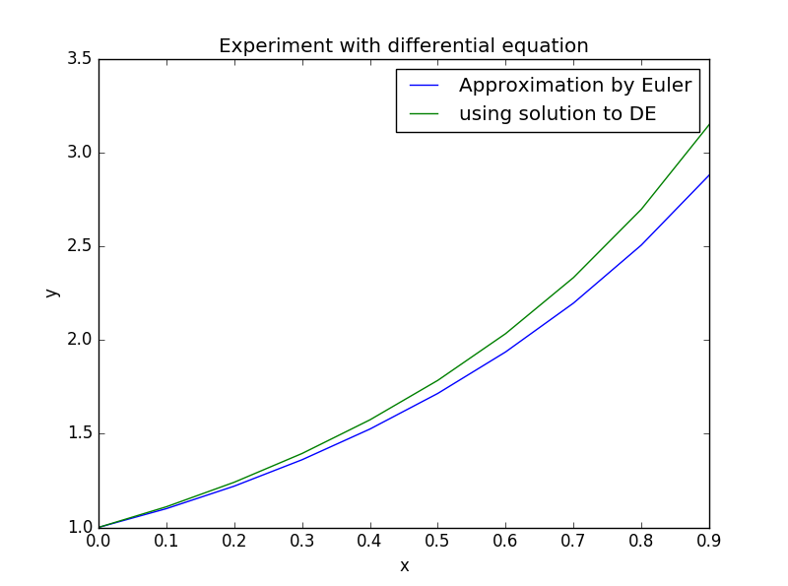

We observe that the error in our approximation grows larger as $x$ and $y'$ increase. We consistently underestimate the function because of the assumption that the gradient stays constant over the step, whereas the function actually grows.

Code used:

1. '''''
2. @params
3. f : fn: float*float -> float
4. n : number of values at step size of h
5. h : step size
6. y0: boundary condition for y at 0
7. @return
8. x,y : sequence of function values at points in the range(0:nh:h)
9. '''
10. **def** euler_method(f, n, h, y0):
11. x = []
12. y = []
13. xk = 0
14. yk = y0
15. **for** k **in** range(0,n):
16. x.append(xk)
17. y.append(yk)
18. yk += h*f(xk, yk)
19. xk += h
20. **return** x,y

Called as:

1. x,yapprox = euler_method(**lambda** xk,yk: 2*xk*yk - 2*xk*xk + 1, 10, 0.1, 1)
2. yexact = [ (np.exp(xk**2) + xk) **for** xk **in** x ]

### 3. Newton’s method

Correct value used: 1.41421356237

Value achieved: 1.41421356237

To verify the rate of convergence, we measure the number of iterations needed to achieve a certain number of digit-accuracy. We then take the exponential of the number of iterations needed.

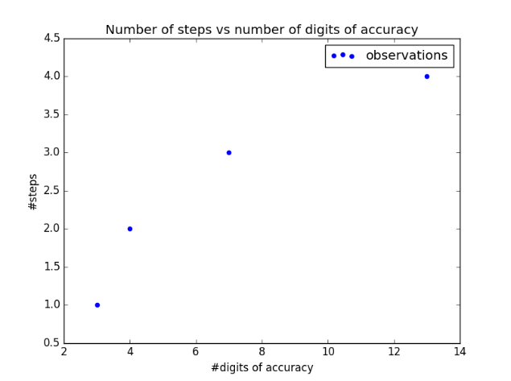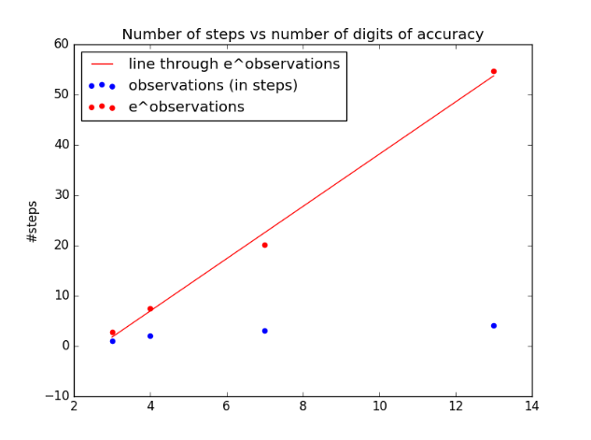

We notice that the plot of #steps vs #digits-of-accuracy looks logarithmic. At the same time, the exponential of the same fits a straight line.

## Unstable and Ill-conditioned Problems

### 1. Newton’s method

Let $π_{i}$ denote $π$ rounded to $i$ digits. Notice that $π-π_{8}>0$ while $π-π_{9}<0$.

If we used $y_{0}=π$ then the correct solution would have been $y\left(x\right)=π$.

Notice that if $π-y_{0}>0$ then the denominator of $y(x)$ is always positive and causes no major issues. It is a bad approximation for the true solution had $y_{0}=π$, but the problem is stable.

However, if $π-y_{0}<0$ then the denominator switches sign at some $x$. Hence, the denominator is 0 at some value of $x$. The problem is hence unstable if $y_{0}>π$ which is true if we use 9 digits of approximation for $π$.

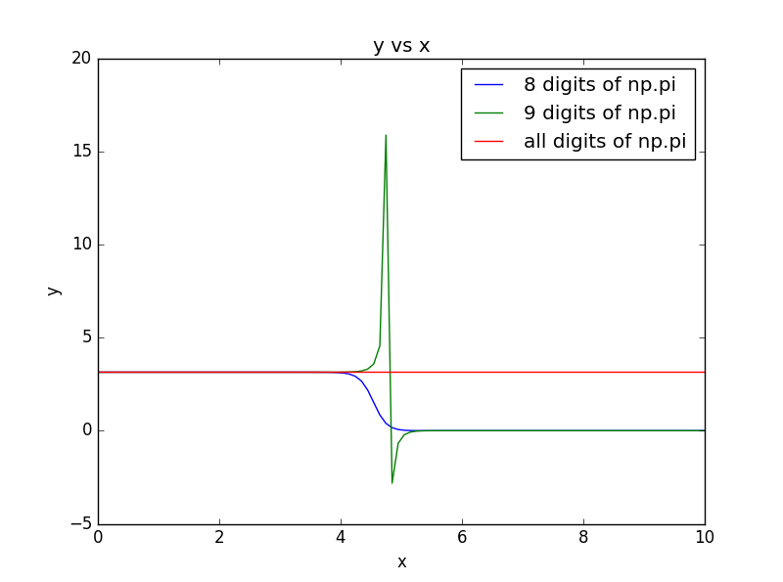

Our suspicion is confirmed by the experiment. For $x<4$, the two approximations work reasonably. However, after $x=4$, approximating $y_{0}$ by $π_{8}$ causes the denominator to explode, forcing the function to 0.

On the other hand, the approximation of $y_{0}$ by $π_{9}$ has a very large absolute gradient in $x∈[4,6]$.

1. f = **lambda** y0: **lambda** x: np.pi*y0/(y0 + (np.pi - y0)*(np.exp(x**2)))
2. xs = np.linspace(0,10,100)
3. pi8 = np.round(np.pi, 8)
4. pi9 = np.round(np.pi, 9)
5. f8 = f(pi8)
6. f9 = f(pi9)
7. y_pi8s = [f8(x) **for** x **in** xs]
8. y_pi9s = [f9(x) **for** x **in** xs]
9. y_true = [np.pi **for** x **in** xs]
10. plt.plot(xs,y_pi8s,label='8 digits of np.pi')
11. plt.plot(xs,y_pi9s,label='9 digits of np.pi')
12. plt.plot(xs,y_true,label='all digits of np.pi')
13. plt.xlabel('x')
14. plt.ylabel('y')
15. plt.title('y vs x')
16. plt.legend(loc='best')
17. plt.show()

### 2. “Qutb Minar to Gurugram”

The solutions are (1400.1, 699.8) and (1750., 874.75). The problem is not stable considering the large difference in answers caused due to a ${10}^{-3}$ change in input.

### 3. Polynomial roots

Let $P_{1}:x^{3}-102x^{2}+201x-100$ and $P_{2}:x^{3}-102x^{2}+200x-100$. Running it through a cubic equation solver we see that the roots are $\{100, 1\}$ and $\{100.01, 0.9948\}$. The value at $x=1$ changes from 0 to 1.

## Unstable methods

### 1. Quadratic Equation

We see that $\sqrt{b^{2}-4ac}=1000.0151$ approximately to 8 digits of accuracy. However, it is almost equal to $b$, which has 6 (or more?) digits of accuracy. In fact, the two values have 6 digits in common. The value of $x$ is computed using subtraction of one of these values from the other. Hence, atleast 6 digits of accuracy are lost. The maximum number of accurate digits possible is 8 because $\sqrt{b^{2}-4ac}$ is computer only to 8 digits of accuracy. That means that $x$ has 2 digits or less of accuracy.

### 2. Alternate Formula for Quadratic root

We know that errors are caused in the original formula when $\sqrt{b^{2}-4ac} ≈b$. However, in the new formula, for very large $b$, precision is lost due to dividing a small number $2c$ by a large number $O(b^{2})$

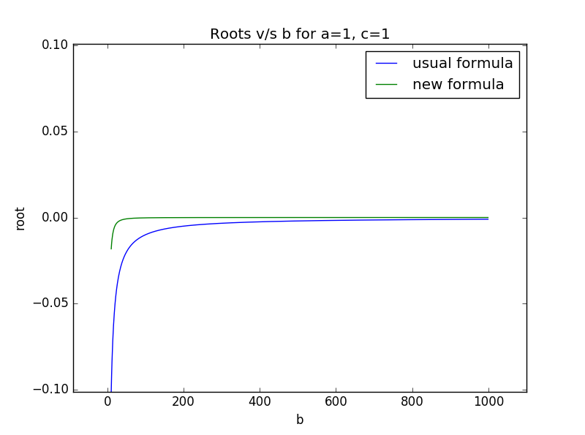

The experiment was performed for $a=c=1$ and $b∈[10,1000]$. We see that the usual formula is unstable at low $b$. However, the new formula loses precision for large values of $b$ and hence becomes 0 quickly.

### 3. Integration by parts

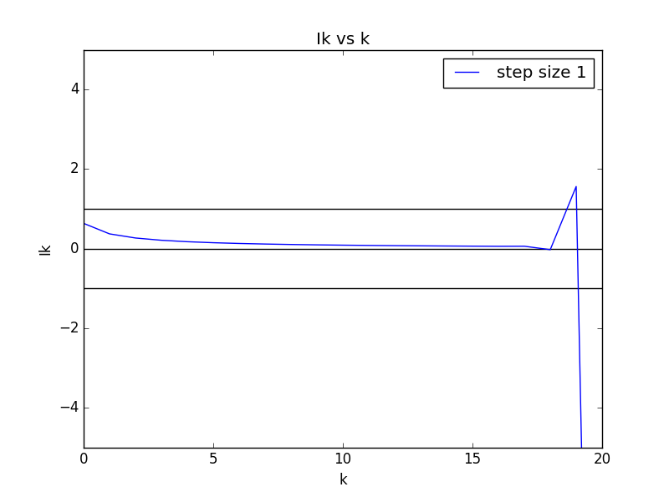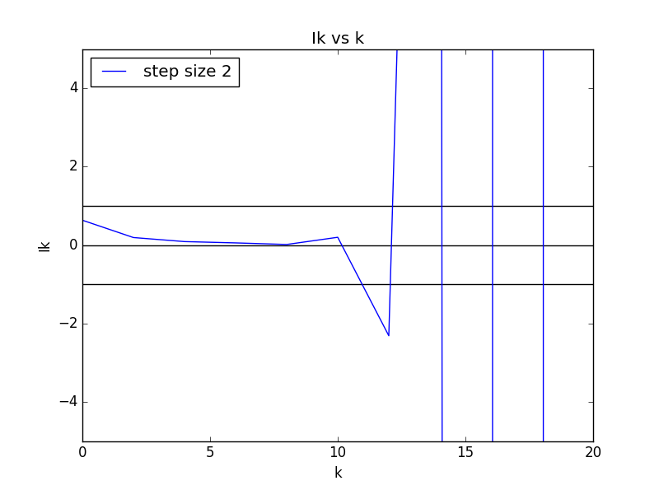

First, we look at the values of $I_{k}$ obtained using $I_{k}=1-{kI}_{k-1}$. We also plot the lines $y=0, y=1, y=-1$. We expect the values of $I_{k}$ to be less than 1 because it is integral of a term that is less than 1 over the range $(0,1)$. However, as the plot indicates, it is not. The error is because at $k=18$, $kI_{k}≈1$. Hence, on the next iteration, we lose a lot of precision. Consequently, we get incorrect values for $I_{k}$.

Using the formula $I_{k}=\frac{1}{π}-\frac{k\left(k-1\right)}{π^{2}}I_{k-2}$, we run into larger errors due to similar reasons.

### 4. Standard Deviation Formulae

(a) The second formula is instable because when all the $x_{i}$ are close together, $∀i \overline{x}≈x_{i}$. Hence, in the subtraction $x_{i}^{2}-{\overline{x}}^{2}$, we lose a lot of precision. Further, if $x_{i}^{2}-{\overline{x}}^{2}$ alternates signs, then we lose precision while adding them up too.

(b) We expect the second formula to produce a negative result when some information is lost. Specifically, notice that $x_{i}^{2}-{\overline{x}}^{2}$ is sometimes positive and sometimes negative. If we make the positive values small enough to be lost, we’re done.

For $x_{1}=1-11*{10}^{-12}$, $x_{2}=x_{3}…=x_{10}=1+{10}^{-12}$, $\overline{x}=1.0$

The first formula produces 1.2960146036e-23 while the second formula produces -1.55431223448e-16.