def binaryInsert(lis,a):  
 low = 0  
 high = len(lis) - 1  
 m = (low + high)//2  
 while low < high:  
 if lis[m] > a:  
 high = m - 1  
 elif lis[m] < a:  
 low = m + 1  
 else:  
 high = m  
 m = (low + high)//2  
 lis.insert(high+1,a)  
l = sorted([2,4,17,31,8,11,15,6,29])  
binaryInsert(l,10)  
print(l)

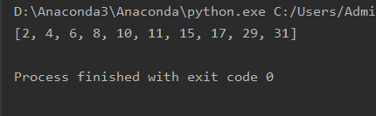

def insertSort(arr):  
 length = len(arr)  
 for i in range(1,length):  
 x = arr[i]  
 for j in range(i,-1,-1):  
 if x < arr[j-1]:  
 arr[j] = arr[j-1]  
 else:  
 break  
 arr[j] = x  
  
def printArr(arr):  
 for item in arr:  
 print(item)  
arr = [4, 7 ,8 ,2 ,3 ,5]  
insertSort(arr)  
printArr(arr)

