课程名称 算法分析与设计 学号 1807004129 学生姓名：吕昊 教师 井超
专业 | 数据科学与大数据技术 | 实验室名称 |  | 实验时间 | 2020.4
实验名称
动态规划解决单源最短路径问题
实验目的
学习动态规划
实验题目
单源最短路径
实验源代码

"""
从A到E的最短路径
"""
def creat():
filename = 'graph.txt'
graph = {}
data = []
with open(filename, 'r')as f:
for line in f:
info = line.split(',')
#print(info)
data.append(info)
for m in data[::-1]:
key = m[0]
graph[key] = []
if key != 'E':
for i in m[1:]:
node, cost = i.split()
node.strip()
cost.strip()
cost = int(cost)
graph[key].append((node, cost))
return graph
def update_distance(graph, distance):
newDistance = {}
for key in graph:
if key == 'E':
distance[key] = 0
else:
nodes = graph[key]
distance[key] = min(node[1] + distance[node[0]] for node in nodes)
return distance
def printPath(graph, distance):
list1 = []
list1.append('A')
start = 'A'
while start != 'E':
for node in graph[start]:
if distance[start] == (distance[node[0]] + node[1]):
list1.append(node[0])
start = node[0]
return list1
distance = {}
graph = creat()
#print(graph)
MAX_NUM = 999
# 距离初始化
for key in graph:
distance[key] = MAX_NUM
distance['E'] = 0
#print(update_distance(graph, distance))
distance = update_distance(graph, distance)
list1 = printPath(graph, distance)
for item in list1:
print(item, end='->')
print("\n最短路径长为：", distance["A"])
实验结果（给出题目的运行结果（插入运行结果截图））

初始条件：
A,B1 8,B2 12
B1,C1 4,C2 5,C3 7
B2,C1 6,C2 7,C3 8
C1,D1 6,D2 5
C2,D1 4,D2 3
C3,D1 7,D2 2
D1,E 3
D2,E 5
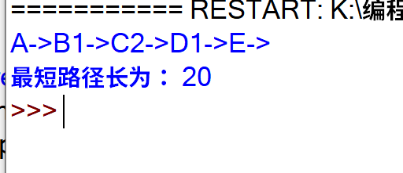

格式要求：各单元格空白行尽量少。
提交要求：电子版，文件命名中将学号和姓名具体化。

