课程名称 算法分析与设计 学号 1807004540 学生姓名 宋逸飞 教师 井超
专业 | 数据科学与大数据技术 | 实验室名称 |  | 实验时间 | 2020年3月1日
实验名称
动态规划法
实验目的
掌握动态规划法的基本思想和算法设计的基本步骤
实验题目
哈夫曼树
实验源代码
1、
class Node():
def __init__(self,item):
self.item=item
self.isin=False
self.left=None
self.right=None
class HuffmanTree():
def __init__(self,l):
self.li=[]
for x in range(0,len(l)):
self.li.append(Node(l[x]))
K=Node(float('inf'))
while len(self.li)< 2*len(l)-1:
m1=m2=K
for x in range(0,len(self.li)):
if m1.item>self.li[x].item and (self.li[x].isin is False):
m2=m1
m1=self.li[x]
elif m2.item>self.li[x].item and (self.li[x].isin is False):
m2=self.li[x]
H=Node(m1.item+m2.item)
H.right=m1
H.left=m2
self.li.append(H)
m1.isin=m2.isin=True
print ("m1=%d m2=%d m1+m2=%d" % (m1.item,m2.item,H.item))
if __name__=='__main__':
L=[9,4,1,3,7,8,2,6]
t=HuffmanTree(L)
print("success")
2、
from collections import namedtuple
from io import StringIO
import math
# define the node structure
Node = namedtuple('Node', ['data', 'left', 'right'])
# initialize the tree
tree = Node(50,
Node(21,
Node(9,None, None),
Node(12, None, None)),
Node(29,
Node(14,
Node(6, None, None),
Node(8, Node(3,None,None), Node(5,None,None))),
Node(15, None, None)))
class Queue(object):
def __init__(self):
self.queue = []
def enqueue(self, b):
self.queue.insert(0, b)
def dequeue(self):
return self.queue.pop()
def isEmpty(self):
return self.queue == []
def getheight(node):
if not node:
return 0
else:
return max(getheight(node.left), getheight(node.right)) + 1
def add_padding(str, pad_length_value):
str = str.strip()
return str.center(pad_length_value, ' ')
# sotre node , space and slashes in list first, then print out
def pretty_print(tree):
output = StringIO()
pretty_output = StringIO()
current_level = Queue()
next_level = Queue()
current_level.enqueue(tree)
depth = 0
# get the depth of current tree
# get the tree node data and store in list
if tree:
while not current_level.isEmpty():
current_node = current_level.dequeue()
output.write('%s ' % current_node.data if current_node else 'N ')
next_level.enqueue(
current_node.left if current_node else current_node)
next_level.enqueue(
current_node.right if current_node else current_node)
if current_level.isEmpty():
if sum([i is not None for i in next_level.queue]
): # if next level has node
current_level, next_level = next_level, current_level
depth = depth + 1
output.write('\n')
print('the tree print level by level is :')
print(output.getvalue())
print("current tree's depth is %i" % (depth+1))
# add space to each node
output.seek(0)
pad_length = 3
keys = []
spaces = int(math.pow(2, depth))
while spaces > 0:
skip_start = spaces * pad_length
skip_mid = (2 * spaces - 1) * pad_length
key_start_spacing = ' ' * skip_start
key_mid_spacing = ' ' * skip_mid
keys = output.readline().split(' ') # read one level to parse
padded_keys = (add_padding(key, pad_length) for key in keys)
padded_str = key_mid_spacing.join(padded_keys)
complete_str = ''.join([key_start_spacing, padded_str])
pretty_output.write(complete_str)
# add space and slashes to middle layer
slashes_depth = spaces
print('current slashes depth im_resize:')
print(spaces)
print("current levle's list is:")
print(keys)
spaces = spaces // 2
if spaces > 0:
pretty_output.write('\n') # print '\n' each level
cnt = 0
while cnt < slashes_depth:
inter_symbol_spacing = ' ' * (pad_length + 2 * cnt)
symbol = ''.join(['/', inter_symbol_spacing, '\\'])
symbol_start_spacing = ' ' * (skip_start-cnt-1)
symbol_mid_spacing = ' ' * (skip_mid-2*(cnt+1))
pretty_output.write(''.join([symbol_start_spacing, symbol]))
for i in keys[1:-1]:
pretty_output.write(''.join([symbol_mid_spacing, symbol]))
pretty_output.write('\n')
cnt = cnt + 1
print(pretty_output.getvalue())
if __name__ == '__main__':
pretty_print(tree)
实验结果（给出题目的运行结果（插入运行结果截图））
1、
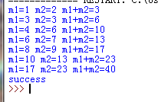
2、
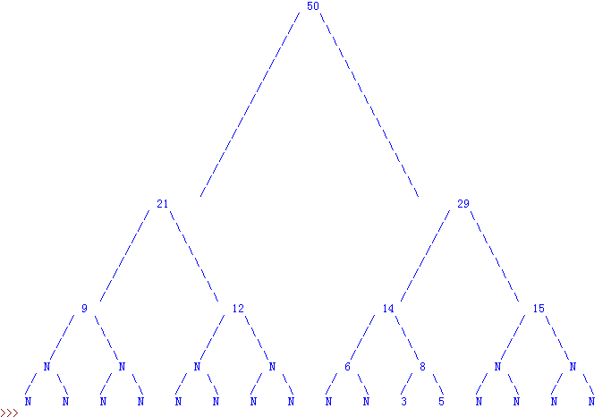
格式要求：各单元格空白行尽量少。
提交要求：电子版，文件命名中将学号和姓名具体化。

