课程名称 算法分析与设计 学号 1807004650 学生姓名 李昊 教师 井超
专业 | 数据科学与大数据技术 | 实验室名称 | 动态规划 | 实验时间 | 2020.4.9
实验名称
动态规划
实验目的
运用动态规划方法解决问题。
实验题目
运动动态规划解决迷宫问题，迷宫为m*m大小，从左上角进入，右下角出迷宫。
实验源代码
import copy,turtle
# 迷宫（1是墙，0是通路）
maze=\
[[1,1,1,1,1,1,1,1,1,1,1,1,1,1],\
[1,0,0,0,1,1,0,0,0,1,0,0,0,1],\
[1,0,1,0,0,0,0,1,0,1,0,1,0,1],\
[1,0,1,0,1,1,1,1,0,1,0,1,0,1],\
[1,0,1,0,0,0,0,0,0,1,1,1,0,1],\
[1,0,1,1,1,1,1,1,1,1,0,0,0,1],\
[1,0,1,0,0,0,0,0,0,0,0,1,0,1],\
[1,0,0,0,1,1,1,0,1,0,1,1,0,1],\
[1,0,1,0,1,0,1,0,1,0,1,0,0,1],\
[1,0,1,0,1,0,0,0,1,1,1,1,0,1],\
[1,0,1,0,0,0,1,0,0,0,0,0,0,1],\
[1,1,1,1,1,1,1,1,1,1,1,1,0,0]]
row = len(maze)
column = len(maze[0])

n = 40
x = -300
y = 200
entry = (1,0)
exit = (row-1,column-1)
path = [entry]
paths = []
# 移动的方向 上下, 左右
dirs = [(0,1),(0,-1),(1,0),(-1,0)]

def conflict(now_x,now_y):
if 0<= now_x <row and 0<= now_y<column and maze[now_x][now_y] == 0:
return False
return True

def main(now_x,now_y):
global maze,path,paths,dirs,entry,row,column
if (now_x,now_y)==exit:
paths.append(path[:])
else:
for d in dirs:# 遍历四个方向
new_x,new_y = now_x+d[0] ,now_y+d[1]
path.append((new_x,new_y))# 新坐标入栈
if not conflict(new_x,new_y):
maze[new_x][new_y] = 2
main(new_x,new_y)
maze[new_x][new_y] = 0
path.pop()

step = []
def show(path):
global maze
maze_2 = copy.deepcopy(maze)
for p in path:
maze_2[p[0]][p[1]] = 2
draw(maze_2)
turtle.done()

def draw_square(length: float, fill_color: str):
turtle.pendown()
turtle.begin_fill()
turtle.fillcolor(fill_color)
for index in range(4):
turtle.forward(length)
turtle.left(90)
turtle.end_fill()
turtle.penup()

def draw(maze_0):
for i in range(row):
for j in range(column):
turtle.goto(x + j * n, y - i * n)
if maze_0[i][j] == 1: # 墙
draw_square(n, "black")
elif maze_0[i][j] == 0: # 可通行部分
draw_square(n, "white")
else:
draw_square(n-10,"pink")

if __name__ == '__main__':
turtle.speed(200)
turtle.pensize(2)
turtle.setup(width=0.5, height=0.75, startx=30, starty=100)
turtle.penup()
(origin_x,origin_y) = entry
main(origin_x,origin_y)
print("一共有 "+str(len(paths))+" 条路径")
if len(paths)!=0:
show(paths[-1])

实验结果（给出题目的运行结果（插入运行结果截图））

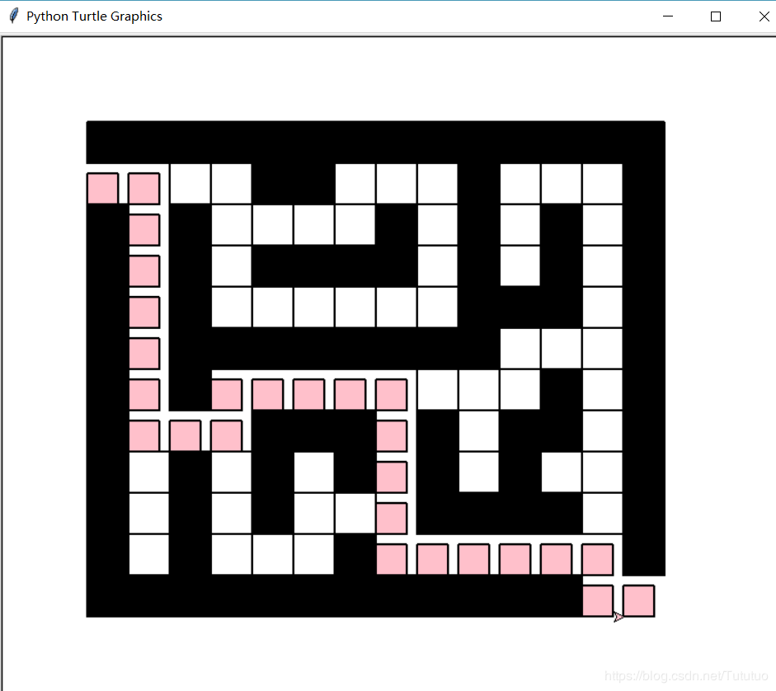

格式要求：各单元格空白行尽量少。
提交要求：电子版，文件命名中将学号和姓名具体化。

