课程名称 算法分析与设计 学号 1807004702 学生姓名 牛玉霞 教师 井超
专业 | 数据科学与大数据技术 | 实验室名称 |  | 实验时间 | 2020.04.11
实验名称
矩阵连乘问题
实验目的
动态规划的应用
实验题目
矩阵连乘问题
实验源代码

__author__ = 'ice'
class Matrix:
def __init__(self, row_num=0, col_num=0, matrix=None):
if matrix != None:
self.row_num = len(matrix)
self.col_num = len(matrix[0])
else:
self.row_num = row_num
self.col_num = col_num
self.matrix = matrix
def matrix_chain(matrixs):
matrix_num = len(matrixs)
count = [[0 for j in range(matrix_num)] for i in range(matrix_num)]
flag = [[0 for j in range(matrix_num)] for i in range(matrix_num)]
for interval in range(1, matrix_num + 1):
for i in range(matrix_num - interval):
j = i + interval
count[i][j] = count[i][i] + count[i + 1][j] + matrixs[i].row_num * matrixs[i + 1].row_num * matrixs[
j].col_num
flag[i][j] = i
for k in range(i + 1, j):
temp = count[i][k] + count[k + 1][j] + matrixs[i].row_num * matrixs[k + 1].row_num * matrixs[j].col_num
if temp < count[i][j]:
count[i][j] = temp
flag[i][j] = k
traceback(0, matrix_num - 1, flag)
return count[0][matrix_num - 1]
def traceback(i, j, flag):
if i == j:
return
if j - i > 1:
print(str(i + 1) + '~' + str(j + 1), end=': ')
print(str(i + 1) + ":" + str(flag[i][j] + 1), end=',')
print(str(flag[i][j] + 2) + ":" + str(j + 1))
traceback(i, flag[i][j], flag)
traceback(flag[i][j] + 1, j, flag)
matrixs = [Matrix(30, 35), Matrix(35, 15), Matrix(15, 5), Matrix(5, 10), Matrix(10, 20), Matrix(20, 25)]
result = matrix_chain(matrixs)
print(result)

实验结果（给出题目的运行结果（插入运行结果截图））

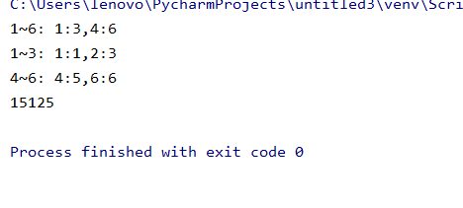
格式要求：各单元格空白行尽量少。提交要求：电子版文件命名中将学号和姓名具体化。

