课程名称 算法分析与设计 学号 1807004813 学生姓名 李欣月 教师 井超
专业 | 数据科学与大数据技术 | 实验室名称 |  | 实验时间
实验名称： 用基于变治法的堆排序算法对任意一组给定的数据进行排序
实验目的：1）深刻理解并掌握变治法的设计思想；
2）掌握堆的概念以及如何用变治法把任意给定的一组数据改变成堆；
3）提高应用变治法设计算法的技能。
实验题目：1）设计与实现堆排序算法；
2）待排序的数据可以手工输入(通常规模比较小，10个数据左右），用以检测程序的正确性；也可以计算机随机生成（通常规模比较大，1500－3000个数据左右），用以检验(用计数法)堆排序算法的时间效率。
实验源代码：package lesson5;

public class Dome5{
public static int[] getMaxA(int[] array,int a,int b ,int c){
int temp = 0;
if(array[b] >= array[c]){
if(array[a] < array[b]){
temp = array[a];
array[a] = array[b];
array[b] = temp;
}
}
else{
if(array[a] < array[c]){
temp = array[a];
array[a] = array[c];
array[c] = temp;
}
}
return array;
}
public static int[] getHeapSort(int[] array , int len){
boolean judge = true;
while(judge){
for(int i = 1;i <= len/2;i++){
if((2*i+1) < len)
array = getMaxA(array,i,(2*i),(2*i+1));
if((2*i) == len-1){
int temp = 0;
if(array[i] < array[2*i]){
temp = array[i];
array[i] = array[2*i];
array[2*i] = temp;
}
}
}

int j;
for(j = 1;j < len/2;j++){
if((2*j+1) < len){
if(array[j] < array[2*j])
break;
if(array[j] < array[2*j+1])
break;
}
if((2*j) == len-1){
if(array[j] < array[2*j])
break;
}
}

if(j == len/2)
judge = false;
}
return array;
}
public static int[] getResultSort(int[] array , int len){
array = getHeapSort(array , len);
int temp = 0;
int sortLen = len;
while(sortLen > 2){
temp = array[1];
array[1] = array[sortLen-1];
array[sortLen-1] = temp;
sortLen = sortLen - 1;
array = getHeapSort(array,sortLen);
}
return array;
}
public static int[] initArray(int n){
int[] result = new int[n];
result[0] = 0;
for(int i = 1;i < n;i++)
result[i] = (int)(Math.random()*1000);
return result;
}
public static void main(String args[]){
int[] array = {0,1,4,5,3,5,23,45,12,23,34,56,78,23,24,25};
int len = array.length;
int[] result = getResultSort(array,len);
System.out.println("排序结果为：");
for(int i = 1;i < len;i++){
System.out.print(result[i]+"\t");
}

System.out.println();
System.out.println();
int[] oneArray = initArray(1000);
int len1 = 1000;
int[] result1 = getResultSort(oneArray,len1);
System.out.println("排序结果为：");
for(int j = 1;j < len1;j++){
System.out.print(result1[j]+"\t");
if(j%15 == 0)
System.out.println();
}
}
}

实验结果：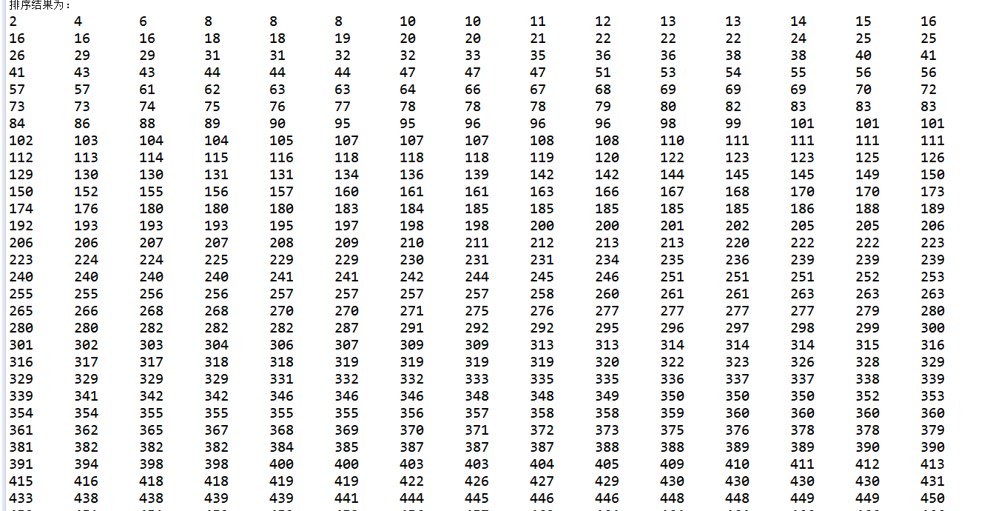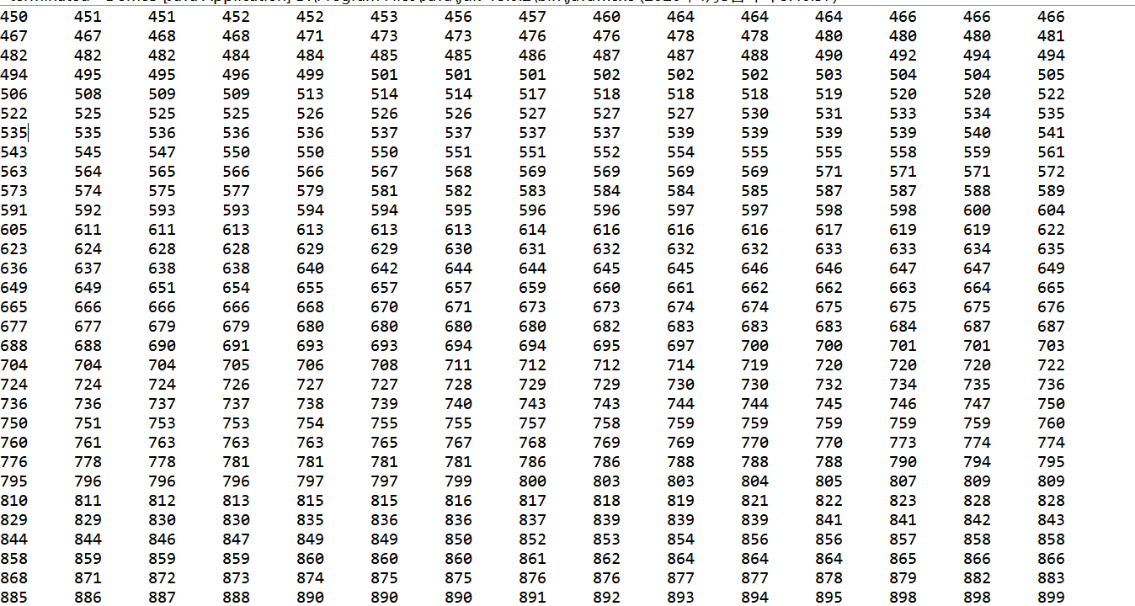

专业 | 数据科学与大数据技术 | 实验室名称 |  | 实验时间
实验名称：变治法的应用
实验目的：1掌握变治法解决问题
2 学会用变治法求解2-3树
实验题目：用分变治法对2-3树进行操作

实验源代码
package lesson3;
import java.io.*;
class DataItem{
public long dData;

public DataItem(long dd) {
dData = dd; }

public void displayItem() {
System.out.print(" "+dData); }
} //1 DataItem类

class Node{

private static final int ORDER = 4;
private int numItems;
private Node parent;
private Node childArray[] = new Node[ORDER];
private DataItem itemArray[] = new DataItem[ORDER-1];
public void connectChild(int childNum, Node child) {
childArray[childNum] = child;
if(child != null)
child.parent = this;
}
public Node disconnectChild(int childNum){
Node tempNode = childArray[childNum];
childArray[childNum] = null;
return tempNode;
}
public Node getChild(int childNum){
return childArray[childNum];
}

public Node getParent(){
return parent; }

public boolean isLeaf(){
return (childArray[0]==null) ? true : false;
}

public int getNumItems(){
return numItems;
}

public DataItem getItem(int index) {
return itemArray[index];
}

public boolean isFull(){
return (numItems==ORDER-1) ? true : false;
}

public int findItem(long key){

for(int j=0; j<ORDER-1; j++){

if(itemArray[j] == null)

break;

else if(itemArray[j].dData == key)

return j;

}

return -1;

}

public int insertItem(DataItem newItem){
numItems++;
long newKey = newItem.dData;
for(int j=ORDER-2; j>=0; j--) {
if(itemArray[j] == null)
continue;

else{

long itsKey = itemArray[j].dData;

if(newKey < itsKey)

itemArray[j+1] = itemArray[j];

else

{

itemArray[j+1] = newItem;

return j+1;

}

}

}

itemArray[0] = newItem;
return 0;

}

public DataItem removeItem()
{

DataItem temp = itemArray[numItems-1];

itemArray[numItems-1] = null;

numItems--;

return temp;

}

public void displayNode()

{

for(int j=0; j<numItems; j++)

itemArray[j].displayItem();
System.out.println(" ");

}

} //2 node类

class Tree234

{

private Node root = new Node();

public Node getNextChild(Node theNode, long theValue)

{

int j;

int numItems = theNode.getNumItems();

for(j=0; j<numItems; j++)

{

if( theValue < theNode.getItem(j).dData )

return theNode.getChild(j);

} // end for

return theNode.getChild(j);

}

public int find(long key)

{

Node curNode = root;

int childNumber;

while(true)

{

if(( childNumber=curNode.findItem(key) ) != -1)

return childNumber;

else if( curNode.isLeaf() )

return -1;

else

curNode = getNextChild(curNode, key);

}

}

public void insert(long dValue)

{

Node curNode = root;

DataItem tempItem = new DataItem(dValue);

while(true)

{

if( curNode.isFull() )

{

split(curNode);

curNode = curNode.getParent();

curNode = getNextChild(curNode, dValue);

}

else if( curNode.isLeaf() )

break;

else

curNode = getNextChild(curNode, dValue);

}

curNode.insertItem(tempItem);

}

public void split(Node thisNode)

{

DataItem itemB, itemC;

Node parent, child2, child3;

int itemIndex;

itemC = thisNode.removeItem();

itemB = thisNode.removeItem();

child2 = thisNode.disconnectChild(2);

child3 = thisNode.disconnectChild(3);

Node newRight = new Node();

if(thisNode==root)

{

root = new Node();

parent = root;

root.connectChild(0, thisNode);

}

else

parent = thisNode.getParent();

itemIndex = parent.insertItem(itemB);

int n = parent.getNumItems();

for(int j=n-1; j>itemIndex; j--)

{

Node temp = parent.disconnectChild(j);

parent.connectChild(j+1, temp);

}

parent.connectChild(itemIndex+1, newRight);

newRight.insertItem(itemC);

newRight.connectChild(0, child2);
newRight.connectChild(1, child3);

}

public void displayTree()

{

recDisplayTree(root, 0, 0);

}

private void recDisplayTree(Node thisNode, int level,int childNumber)

{

System.out.print("level="+level+" child="+childNumber+" ");

thisNode.displayNode();

int numItems = thisNode.getNumItems();

for(int j=0; j<numItems+1; j++)

{

Node nextNode = thisNode.getChild(j);

if(nextNode != null)

recDisplayTree(nextNode, level+1, j);

else

return;

}

}

}

class Tree

{

public static void main(String[] args) throws IOException

{

long value;

Tree234 theTree = new Tree234();

theTree.insert(66);

theTree.insert(35);

theTree.insert(77);

theTree.insert(24);

theTree.insert(88);

while(true)

{

System.out.print("Enter first letter of ");

System.out.print("show, insert, or find: ");

char choice = getChar();

switch(choice)

{

case 's':

theTree.displayTree();

break;

case 'i':

System.out.print("Enter value to insert: ");

value = getInt();

theTree.insert(value);

break;

case 'f':

System.out.print("Enter value to find: ");

value = getInt();

int found = theTree.find(value);

if(found != -1)

System.out.println("Found "+value);

else

System.out.println("Could not find "+value);

break;

default:

System.out.print("Invalid entry\n");

}

}

}

public static String getString() throws IOException

{

InputStreamReader isr = new InputStreamReader(System.in);

BufferedReader br = new BufferedReader(isr);

String s = br.readLine();

return s;

}

public static char getChar() throws IOException

{

String s = getString();

return s.charAt(0);

}

public static int getInt() throws IOException

{

String s = getString();

return Integer.parseInt(s);

}}

实验结果
