课程名称 算法分析与设计 学号 1807004642 学生姓名 杨志超 教师 井超
专业 | 数据科学与大数据技术 | 实验室名称 |  | 实验时间
实验名称
变治法的应用
实验目的
了解变治法，实现avl树的建立、插入和删除操作。
实验题目

实现avl树的建立、插入和删除操作。
实验源代码
#include <stdio.h>
#include <stdlib.h>
#define _AVL_TREE_H_
typedef int Type;
typedef struct AVLTreeNode{
Type key;
int height;
struct AVLTreeNode *left;
struct AVLTreeNode *right;
}Node, *AVLTree;
int avltree_height(AVLTree tree);
void preorder_avltree(AVLTree tree);
void inorder_avltree(AVLTree tree);
void postorder_avltree(AVLTree tree);
void print_avltree(AVLTree tree, Type key, int direction);
Node* avltree_search(AVLTree x, Type key);
Node* iterative_avltree_search(AVLTree x, Type key);
Node* avltree_minimum(AVLTree tree);
Node* avltree_maximum(AVLTree tree);
Node* avltree_insert(AVLTree tree, Type key);
Node* avltree_delete(AVLTree tree, Type key);
void destroy_avltree(AVLTree tree);
#define HEIGHT(p) ( (p==NULL) ? -1 : (((Node *)(p))->height) )
#define MAX(a, b) ( (a) > (b) ? (a) : (b) )
int avltree_height(AVLTree tree)
{
return HEIGHT(tree);
}
void preorder_avltree(AVLTree tree)
{
if(tree != NULL)
{
printf("%d ", tree->key);
preorder_avltree(tree->left);
preorder_avltree(tree->right);
}
}
void inorder_avltree(AVLTree tree)
{
if(tree != NULL)
{
inorder_avltree(tree->left);
printf("%d ", tree->key);
inorder_avltree(tree->right);
}
}
void postorder_avltree(AVLTree tree)
{
if(tree != NULL)
{
postorder_avltree(tree->left);
postorder_avltree(tree->right);
printf("%d ", tree->key);
}
}
Node* avltree_search(AVLTree x, Type key)
{
if (x==NULL || x->key==key)
return x;
if (key < x->key)
return avltree_search(x->left, key);
else
return avltree_search(x->right, key);
}
Node* iterative_avltree_search(AVLTree x, Type key)
{
while ((x!=NULL) && (x->key!=key))
{
if (key < x->key)
x = x->left;
else
x = x->right;
}
return x;
}
Node* avltree_minimum(AVLTree tree)
{
if (tree == NULL)
return NULL;
while(tree->left != NULL)
tree = tree->left;
return tree;
}
Node* avltree_maximum(AVLTree tree)
{
if (tree == NULL)
return NULL;
while(tree->right != NULL)
tree = tree->right;
return tree;
}
static Node* left_left_rotation(AVLTree k2)
{
AVLTree k1;
k1 = k2->left;
k2->left = k1->right;
k1->right = k2;
k2->height = MAX( HEIGHT(k2->left), HEIGHT(k2->right)) + 1;
k1->height = MAX( HEIGHT(k1->left), k2->height) + 1;
return k1;
}
static Node* right_right_rotation(AVLTree k1)
{
AVLTree k2;
k2 = k1->right;
k1->right = k2->left;
k2->left = k1;
k1->height = MAX( HEIGHT(k1->left), HEIGHT(k1->right)) + 1;
k2->height = MAX( HEIGHT(k2->right), k1->height) + 1;
return k2;
}
static Node* left_right_rotation(AVLTree k3)
{
k3->left = right_right_rotation(k3->left);
return left_left_rotation(k3);
}
static Node* right_left_rotation(AVLTree k1)
{
k1->right = left_left_rotation(k1->right);
return right_right_rotation(k1);
}
static Node* avltree_create_node(Type key, Node *left, Node* right)
{
Node* p;
if ((p = (Node *)malloc(sizeof(Node))) == NULL)
return NULL;
p->key = key;
p->height = 0;
p->left = left;
p->right = right;
return p;
}
Node* avltree_insert(AVLTree tree, Type key)
{
if (tree == NULL)
{
tree = avltree_create_node(key, NULL, NULL);
if (tree==NULL)
{
printf("ERROR: create avltree node failed!\n");
return NULL;
}
}
else if (key < tree->key)
{
tree->left = avltree_insert(tree->left, key);
if (HEIGHT(tree->left) - HEIGHT(tree->right) == 2)
{
if (key < tree->left->key)
tree = left_left_rotation(tree);
else
tree = left_right_rotation(tree);
}
}
else if (key > tree->key)
{
tree->right = avltree_insert(tree->right, key);
if (HEIGHT(tree->right) - HEIGHT(tree->left) == 2)
{
if (key > tree->right->key)
tree = right_right_rotation(tree);
else
tree = right_left_rotation(tree);
}
}
else
{
printf("添加失败：不允许添加相同的节点！\n");
}
tree->height = MAX( HEIGHT(tree->left), HEIGHT(tree->right)) + 1;
return tree;
}
static Node* delete_node(AVLTree tree, Node *z)
{
if (tree==NULL || z==NULL)
return NULL;
if (z->key < tree->key)
{
tree->left = delete_node(tree->left, z);
if (HEIGHT(tree->right) - HEIGHT(tree->left) == 2)
{
Node *r = tree->right;
if (HEIGHT(r->left) > HEIGHT(r->right))
tree = right_left_rotation(tree);
else
tree = right_right_rotation(tree);
}
}
else if (z->key > tree->key)
{
tree->right = delete_node(tree->right, z);
if (HEIGHT(tree->left) - HEIGHT(tree->right) == 2)
{
Node *l = tree->left;
if (HEIGHT(l->right) > HEIGHT(l->left))
tree = left_right_rotation(tree);
else
tree = left_left_rotation(tree);
}
}
else
{
if ((tree->left) && (tree->right))
{
if (HEIGHT(tree->left) > HEIGHT(tree->right))
{
Node *max = avltree_maximum(tree->left);
tree->key = max->key;
tree->left = delete_node(tree->left, max);
}
else
{
Node *min = avltree_maximum(tree->right);
tree->key = min->key;
tree->right = delete_node(tree->right, min);
}
}
else
{
Node *tmp = tree;
tree = tree->left ? tree->left : tree->right;
free(tmp);
}
}
return tree;
}
Node* avltree_delete(AVLTree tree, Type key)
{
Node *z;
if ((z = avltree_search(tree, key)) != NULL)
tree = delete_node(tree, z);
return tree;
}
void destroy_avltree(AVLTree tree)
{
if (tree==NULL)
return ;
if (tree->left != NULL)
destroy_avltree(tree->left);
if (tree->right != NULL)
destroy_avltree(tree->right);
free(tree);
}
void print_avltree(AVLTree tree, Type key, int direction)
{
if(tree != NULL)
{
if(direction==0)
printf("%2d is root\n", tree->key, key);
else
printf("%2d is %2d's %6s child\n", tree->key, key, direction==1?"right" : "left");
print_avltree(tree->left, tree->key, -1);
print_avltree(tree->right,tree->key, 1);
}
}
static int arr[]= {9,3,8,7,6,16,78,35,1,25};
#define TBL_SIZE(a) ( (sizeof(a)) / (sizeof(a[0])) )
void main()
{
int i,ilen;
AVLTree root=NULL;
printf("空树高度: %d\n", avltree_height(root));
printf("依次插入以下元素: ");
ilen = TBL_SIZE(arr);
for(i=0; i<ilen; i++)
{
printf("%d ", arr[i]);
root = avltree_insert(root, arr[i]);
}
printf("\n前序遍历: ");
preorder_avltree(root);
printf("\n中序遍历: ");
inorder_avltree(root);
printf("\n后序遍历: ");
postorder_avltree(root);
printf("\n");
printf("生成avl树的高度: %d\n", avltree_height(root));
printf("最小值: %d\n", avltree_minimum(root)->key);
printf("最大值: %d\n", avltree_maximum(root)->key);
printf("树的详细信息: \n");
print_avltree(root, root->key, 0);
i = 8;
printf("\n删除根节点: %d", i);
root = avltree_delete(root, i);
printf("\n高度: %d", avltree_height(root));
printf("\n中序遍历: ");
inorder_avltree(root);
printf("\n树的详细信息: \n");
print_avltree(root, root->key, 0);
destroy_avltree(root);
}
实验结果（给出题目的运行结果（插入运行结果截图））
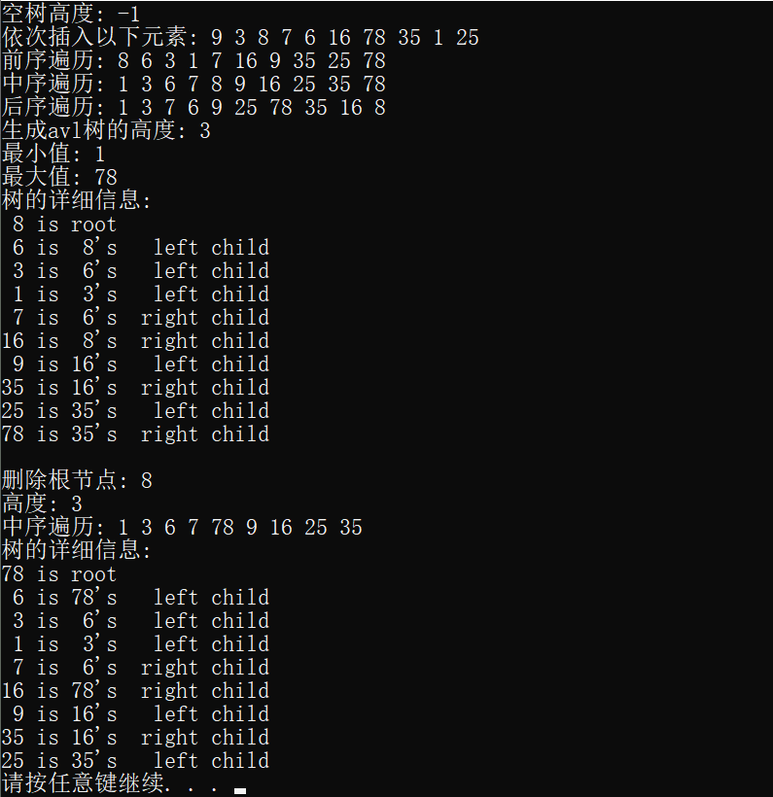
格式要求：各单元格空白行尽量少。
提交要求：电子版，文件命名中将学号和姓名具体化。

