课程名称 算法分析与设计 学号 1807004650 学生姓名 李昊 教师 井超
专业 | 数据科学与大数据技术 | 实验室名称 | 变治法 | 实验时间 | 2020.4.1
实验名称
变治法
实验目的
1）深刻理解并掌握变治法的设计思想；
2）掌握堆的概念以及如何用变治法把任意给定的一组数据改变成堆；
3）提高应用变治法设计算法的技能。
实验题目
运用变治法实现二叉查找树。
实验源代码
class Node:
def __init__(self, value):
self.value = value
self.parent = None
self.left = None
self.right = None
def add_parent(self, parent):
self.parent = parent
def add_left(self, left):
self.left = left
def add_right(self, right):
self.right = right
def __str__(self):
if self.left is not None and self.right is not None:
return str(self.value) + " l:" + str(self.left) + " r:" + str(self.right)
elif self.left is not None and self.right is None:
return str(self.value) + " l:" + str(self.left)
elif self.left is None and self.right is not None:
return str(self.value) + " r:" + str(self.right)
else:
return str(self.value)
class BST:
def __init__(self):
self.root = None
def __str__(self):
if self.root is not None:
return str(self.root)
else:
return None
def insert(self, value):
new_node = Node(value)
root_node = self.root
if root_node is None:
self.root = new_node
else:
while root_node is not None:
new_node.parent = root_node
if new_node.value < root_node.value:
root_node = root_node.left
else:
root_node = root_node.right
if new_node.value < new_node.parent.value:
new_node.parent.left = new_node
else:
new_node.parent.right = new_node
def mid_through(self, node):
if node is not None:
if node.left is not None:
self.mid_through(node.left)
print(node.value)
if node.right is not None:
self.mid_through(node.right)
def search_recurrent(self, start_node, value):
if start_node.value == value:
return start_node
elif value < start_node.value:
if start_node.left is not None:
return self.search_recurrent(start_node.left, value)
else:
return None
else:
if start_node.right is not None:
return self.search_recurrent(start_node.right, value)
else:
return None
def search_cycle(self, value):
start_node = self.root
while start_node is not None and start_node.value != value:
if value < start_node.value:
start_node = start_node.left
else:
start_node = start_node.right
return start_node
def min_node(self, node):
while node.left is not None:
node = node.left
return node
def max_node(self, node):
while node.right is not None:
node = node.right
return node
def success(self, node):
if node.right is not None:
return self.min_node(node.right)
else:
parent = node.parent
child = node
while parent is not None and child.value == parent.right.value:
child = parent
parent = parent.parent
return parent
def predecess(self, node):
if node.left is not None:
return self.max_node(node.left)
else:
parent = node.parent
child = node
while parent is not None and child.value == parent.left.value:
child = parent
parent = parent.parent
return parent
def delete(self, node):
if node.left is None and node.right is None:
if node.value == node.parent.left.value:
node.parent.left = None
elif node.value == node.parent.right.value:
node.parent.right = None
elif node.left is not None and node.right is None:
if node.value == node.parent.left.value:
node.parent.left = node.left
elif node.value == node.parent.right.value:
node.parent.right = node.left
elif node.left is None and node.right is not None:
if node.value == node.parent.left.value:
node.parent.left = node.right
elif node.value == node.parent.right.value:
node.parent.right = node.right
else:
successor = self.success(node)
if successor.value == node.right.value:
successor.left = node.left
if node.value == node.parent.left.value:
node.parent.left = successor
elif node.value == node.parent.right.value:
node.parent.right = successor
else:
if successor.value == successor.parent.left.value:
successor.parent.left = successor.right
elif successor.value == successor.parent.right.value:
successor.parent.right = successor.right
node.value = successor.value
if __name__ == "__main__":
bst = BST()
bst.insert(0)
bst.insert(4)
bst.insert(2)
bst.insert(1)
bst.insert(7)
bst.insert(5)
bst.insert(6)
bst.insert(3)
bst.insert(8)
bst.mid_through(bst.root)
print(bst.min_node(bst.root))
print(bst.max_node(bst.root))
node4 = bst.search_recurrent(bst.root, 4)
print(node4)
print(bst.success(node4))
print(bst.predecess(node4))
bst.delete(node4)
print(bst)

实验结果（给出题目的运行结果（插入运行结果截图））

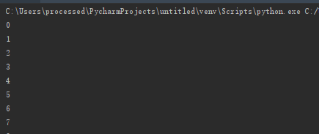
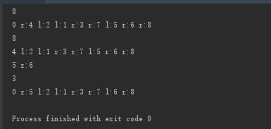

格式要求：各单元格空白行尽量少。
提交要求：电子版，文件命名中将学号和姓名具体化。

