课程名称 算法分析与设计 学号 1807004828 学生姓名 王秀峰 教师 井超
专业 | 数据科学与大数据技术 | 实验室名称 |  | 实验时间
实验名称
变治法的应用
实验目的
掌握变治法求解具体问题的一般步骤，具备运用变治法思想编程实现排AVL树、2-3树和矩阵LU分解问题的能力。
实验题目
矩阵LU分解求逆
实验源代码
import numpy as np
def LU_decomposition(A):
n = len(A[0])
L = np.zeros([n, n])
U = np.zeros([n, n])
for i in range(n):
L[i][i] = 1
if i == 0:
U[0][0] = A[0][0]
for j in range(1, n):
U[0][j] = A[0][j]
L[j][0] = A[j][0] / U[0][0]
else:
for j in range(i, n): # U
temp = 0
for k in range(0, i):
temp = temp + L[i][k] * U[k][j]
U[i][j] = A[i][j] - temp
for j in range(i + 1, n): # L
temp = 0
for k in range(0, i):
temp = temp + L[j][k] * U[k][i]
L[j][i] = (A[j][i] - temp) / U[i][i]
return L, U

def Linv(L):

m = len(L[0])
Linv = np.zeros([m, m])
for j in range(0,m):
for i in range(j,m):
if i == j:
Linv[i][j] = 1/L[i][j]
elif i < j:
Linv[i][j] = 0
else:
temp = 0
for k in range(j,i):
temp = L[i][k] * Linv[k][j] + temp
Linv[i][j] = -Linv[j][j] * temp
return Linv
def Uinv(U):
m = len(U[0])
Uinv = np.zeros([m, m])
for j in range(0,m):
for i in range(j,-1,-1):
if i == j:
Uinv[i][j] = 1/U[i][j]
elif i > j:
Uinv[i][j] = 0
else:
temp = 0
for k in range(i + 1,j + 1):
temp = U[i][k] * Uinv[k][j] + temp
Uinv[i][j] = -1/U[i][i] * temp
return Uinv

def Mult(L,U):
m = len(L[0])
ans = np.zeros([m, m])
for i in range(0,m):
for j in range(0,m):
for k in range(0,m):
ans[i][j] = ans[i][j] + U[i][k] * L[k][j]
return ans

if __name__ == '__main__':
A = [[4,2,1,5],[8,7,2,10],[4,8,3,6],[6,8,4,9]]
L, U = LU_decomposition(A)
Linv = Linv(L)
Uinv = Uinv(U)
ans = Mult(Linv,Uinv)
print("L矩阵为:",'\n',L, '\n',"U矩阵为:",'\n', U)
print()
# print(Linv, '\n', Uinv)
print()
print("矩阵求逆为：",'\n',ans)
实验结果（给出题目的运行结果（插入运行结果截图））
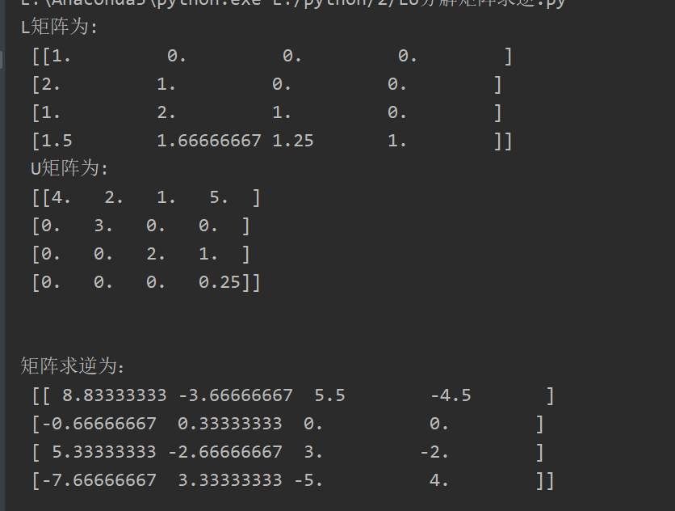

格式要求：各单元格空白行尽量少。
提交要求：电子版，文件命名中将学号和姓名具体化。

