MMA3001 Project Report
Environmental Feature Importance on Occupancy Modelling
Harper Vicic | Student ID: 34989943 | MMA3001 Numerical Methods and Machine Learning, Monash University | October 2026 | Code: github.com/HarperVicic/MMA3001-Project

1. Engineering Problem

1.1 Engineering Context
Smart buildings rely on accurate occupancy information to operate heating, ventilation and air-conditioning (HVAC) systems efficiently, manage indoor air quality and reduce energy use. Dedicated occupancy sensors, such as cameras, infrared and access-control systems, measure occupancy directly but add installation and maintenance costs, raise privacy concerns and can be unreliable. Environmental sensors that measure CO₂, temperature, humidity and air quality are already widely installed in commercial and educational buildings.
Occupants change these conditions: they exhale CO₂, release heat and moisture, and affect air quality through their activity. Environmental measurements may therefore contain enough information to estimate occupancy without dedicated sensors. This project investigates whether occupancy can be estimated from environmental data alone, and which measurement gives the strongest indication of human presence.

1.2 Problem Statement
The objective is to develop a computational model that predicts room headcount using only environmental sensor measurements: CO₂ (ppm), temperature (°C), relative humidity (%RH), formaldehyde (µg/m³), atmospheric pressure (hPa), light volatile organic compounds (VOC, ppb) and particulate matter (PM1, PM2.5, PM4 and PM10, µg/m³), all measured by one indoor sensor. Measured headcount from an occupancy sensor is the ground truth. Because the environmental sensor reports every 10 minutes and headcount is recorded every few seconds, each environmental reading is paired with the time-weighted average headcount over the preceding 10 minutes.
A global degree-2 polynomial regression is the baseline. Random Forest and Gradient Boosting models are compared with it, and the model with the lowest test error (a tuned Random Forest) is selected. Performance is measured with RMSE, MAE and R² on a held-out 30% test set. A sensitivity analysis then removes each variable in turn, retrains the final model and measures the loss in accuracy; the variable whose removal causes the largest loss is the strongest predictor. The project therefore answers two questions: can room occupancy be estimated accurately from environmental measurements alone, and which variable contributes most to the prediction?

1.3 Importance of the Problem
Ventilation is commonly run for design occupancy, so rooms receive outdoor air for their maximum number of occupants even when partly or completely empty. Every unit of outdoor air must be heated or cooled, so over-ventilation wastes HVAC energy, while under-ventilation lets CO₂ and other contaminants accumulate. Standards such as AS 1668.2 specify outdoor air rates per occupant, so demand-controlled ventilation needs a reliable headcount. Estimating it from existing air-quality sensors avoids the cost and privacy concerns of dedicated sensors, and knowing which variable carries most information shows which sensors to prioritise.

1.4 Intended Use of the Solution
The solution is a virtual occupancy sensor: every 10 minutes it estimates a room's average headcount from the environmental sensor's readings, for demand-controlled ventilation, as a back-up or cross-check for dedicated occupancy sensors, for space-utilisation data and to guide sensor selection. Estimates outside the training conditions are flagged. As it estimates an average number of people, it is not suitable for safety-critical uses such as evacuation counts, or for tracking individuals.

1.5 Project Scope and Limitations
The scope is set by the period in which the environmental and occupancy records overlap: one room (floorspace 941f0352) and one environmental sensor (6012002000869, registered in room G.38), from 29 February to 6 May 2024, giving 4,009 paired readings with 10-minute average headcounts of 0–6.7 people. The sensor does not measure light level. The main limitations are:
- Generalisation: with one room and sensor, results cannot be tested on other rooms, volumes or ventilation systems.
- Room-sensor pairing: the registry does not list occupancy rooms, so the pairing was inferred from the correlation between headcount and CO₂, not confirmed from building records.
- Time period: the occupancy export was truncated at Excel's 1,048,575-row limit, so seasonal changes in temperature, humidity and HVAC operation are not represented.
- Signal strength: CO₂ stayed between 416 and 633 ppm, close to outdoor levels, which limits the information available to the model.

2. Inputs and Outputs

2.1 Input Data: Format, Units and Domain
Three files provided for the unit are used (Monash University, 2024): an occupancy CSV (1,048,575 headcount events for five rooms, with floorspaceid, headcount in people and collecteddate; 289,206 rows for room 941f0352); an environmental CSV (179,447 records from five sensors, each storing its readings as a JSON list of variables with a measurement time in Unix seconds; 29,341 records for sensor 6012002000869); and an Excel registry of 78 environmental sensors and their locations. Table 1 gives the units and training range of each input, which define the domain in which the model is valid.
Table 1. Model inputs, units and training range.
Variable | Unit | Range | Variable | Unit | Range
CO₂ | ppm | 416–633 | Pressure | hPa | 1003–1028
Temperature | °C | 20.8–28.5 | VOC | ppb | 0–595
Humidity | %RH | 27–74 | PM1 / PM2.5 | µg/m³ | 0–26 / 0–33
Formaldehyde | µg/m³ | 17–39 | PM4 / PM10 | µg/m³ | 0–39 / 0–40

2.2 Data Preprocessing and Alignment
The JSON records for sensor 6012002000869 are flattened into one row per measurement time, removing duplicate uploads. The sensor reports every 10 minutes (20 minutes for 10% of intervals, where a reading was missed), while occupancy events are irregular (median interval 4 s, gaps up to 15.6 days). Each environmental reading is paired with the time-weighted average headcount over the preceding 10 minutes (Section 3.3), giving 4,009 paired readings over 68 days; the other 9,791 readings have no matching headcount.

2.3 Handling of Invalid, Missing and Unsupported Inputs
- Unparseable timestamps and non-numeric headcounts are removed; corrupt JSON records are skipped; missing files or columns stop the program with a descriptive error.
- Battery voltage is excluded, and sensors 227, 241 and 777 (a frozen value) and 326 (no readings in the occupancy period) are not used.
- A headcount is never carried across a gap longer than 10 minutes, and windows less than 80% covered by occupancy data are discarded.
- Readings outside the training period or the training range of any variable are flagged at prediction time (Section 5.7).

2.4 Outputs: Meaning and Intended Use
The outputs are the predicted 10-minute average headcount (people, ≥ 0) for every reading, with reliability flags, for ventilation control; RMSE, MAE (people) and R² for each model; the sensitivity results and feature ranking, to identify informative sensors; performance measurements; and the figures in Appendix A. All are saved as CSV, text and PNG files in the repository's outputs folder.

3. Computational Solution

3.1 Workflow Overview
The workflow is: (1) load and clean the occupancy and environmental data; (2) align them with the 10-minute time-weighted average; (3) split the 4,009 paired readings 70/30 into training (2,806) and test (1,203) sets; (4) train the polynomial baseline and two alternative models, and tune the Random Forest using the training set only; (5) select the model with the lowest test RMSE; (6) run the sensitivity analyses on that model; and (7) predict headcount for every reading. It is implemented in Python using pandas (McKinney, 2010), NumPy (Harris et al., 2020) and scikit-learn (Pedregosa et al., 2011) as a documented module, src/occupancy_model.py, which runs as a script or from the notebook. The inputs, outputs, units and errors of each function are documented in its docstring and in the generated HTML documentation (docs/ in the repository).

3.2 Exploratory Data Analysis
The 10-minute headcount ranges from 0 to 6.7 people (mean 1.39, median 1.14) and is right-skewed: three quarters of readings are below 2 people. Figure A1 shows headcount and each variable over time. CO₂ has by far the strongest correlation with headcount (r = 0.47), followed by formaldehyde (0.16), temperature (0.14), VOC (0.13) and humidity (−0.12); pressure (0.02) and particulate matter (|r| ≤ 0.06) show almost none (Figure A2). The four particulate-matter channels are strongly correlated with one another (r = 0.71–0.99), so they carry largely the same information. CO₂ stays between 416 and 633 ppm, only about 200 ppm above typical outdoor levels.

3.3 Time-Weighted Averaging of Headcount
Headcount is a step function: it stays constant until someone enters or leaves. The average over the window [t − Δ, t], with Δ = 10 min, is therefore calculated with the rectangle (zero-order hold) rule rather than the trapezoidal rule (Monash University, 2026), which would assume a linear change between readings:
H̄(t) = (1 / T_{valid}) Σ h_{i} Δt_{i}
where Δt_{i} is the time that reading h_{i} holds within the window and T_{valid} is the time covered by valid data. Segments longer than 10 minutes count as missing, and windows with T_{valid} < 0.8Δ are discarded. The cumulative area under the step function is computed once, so each window average is the difference between two cumulative values located by binary search, an O((n + m) log n) operation for n occupancy readings and m windows. Matching Δ to the sensor's 10-minute interval means every environmental reading is used once, without interpolation.

3.4 Polynomial Regression Model (Baseline)
The baseline is a global degree-2 polynomial fitted by ordinary least squares to the standardised inputs:
Ĥ = β₀ + Σ β_{i}x_{i} + Σ β_{ii}x_{i}² + Σ β_{ij}x_{i}x_{j}
With ten inputs this gives 65 terms (10 linear, 10 squared and 45 interactions). The model is transparent and fast, and assumes a smooth relationship that holds across the whole input space, with independent errors of constant variance (fits shown in Figure A3).

3.5 Implementation, Settings and Parameters
Table 2. Main settings (named constants in src/occupancy_model.py).
Component | Setting
Alignment | 10-minute window; maximum bridged gap 10 minutes; minimum coverage 80%
Split | 70% training / 30% test; random seed 42 (all models use the same seed)
Polynomial (baseline) | Standardised inputs; degree 2; ordinary least squares
Random Forest (default) | 100 trees; unlimited depth; all features considered at each split
Random Forest (tuned) | 300 trees; maximum depth 20; 50% of features per split; minimum leaf size 1
Gradient Boosting | 100 trees; learning rate 0.1; maximum depth 3
Software | Python 3.10, pandas, NumPy, scikit-learn, matplotlib, seaborn

3.6 Assumptions and Known Limitations
- Conditions at time t reflect the occupancy over the preceding 10 minutes; the delay in the CO₂ response is not modelled.
- Room 941f0352 and sensor 6012002000869 share the same air space (inferred, Section 1.5), and readings are treated as independent although consecutive readings are correlated.
- Tree models cannot extrapolate; the polynomial extrapolates unreliably and can predict negative headcounts (3 of 1,203 test predictions, minimum −0.10).

4. Alternative Solutions

4.1 Baseline Model: Global Polynomial Regression
The degree-2 polynomial (Section 3.4) is the baseline. As a lower reference, always predicting the training mean gives a test RMSE of 1.02 people; any useful model must improve on this.

4.2 Alternative Models: Random Forest and Gradient Boosting
A Random Forest (Breiman, 2001) averages many deep decision trees, each trained on a bootstrap sample with a random subset of features at each split. Gradient Boosting (Friedman, 2001) adds shallow trees one at a time, each fitted to the remaining errors. Both capture non-linear and interacting effects without specifying terms, and are insensitive to input scaling and largely to correlated inputs.

4.3 Comparison: Accuracy, Robustness, Run Time, Memory and Interpretability
Table 3. Test-set performance and computational cost of each model.
Model | RMSE | MAE | R² | Train (s) | Predict (ms / 1,000) | Size (MB) | Interpretability
Polynomial (baseline) | 0.869 | 0.667 | 0.272 | 0.01 | 1.9 | 0.003 | High (equation)
Gradient Boosting | 0.786 | 0.600 | 0.403 | 0.26 | 2.1 | 0.14 | Medium
Random Forest (default) | 0.720 | 0.544 | 0.500 | 0.94 | 23 | 25 | Low
Random Forest (tuned) | 0.710 | 0.538 | 0.513 | 0.98 | 62 | 73 | Low

Both tree models clearly outperform the baseline (Figure A4); robustness is assessed in Section 5.4. The polynomial is cheapest and most interpretable, but its largest coefficients belong to interactions between the near-identical particulate-matter channels, which offset one another, so they cannot be read as importance. All models train in about a second, and tree training time grows roughly as n log n with the number of readings, so the approach scales to more rooms and longer periods; the polynomial is the simplest to implement and deploy.

4.4 Model Selection Justification
The model with the lowest test RMSE is selected automatically. The tuned Random Forest is best on all three metrics, reducing RMSE by 18% relative to the baseline and by 30% relative to predicting the mean. Its cost (73 MB, 62 ms per 1,000 predictions) is negligible for a 10-minute update interval on a server-based building management system. On a memory-limited embedded controller, Gradient Boosting (0.14 MB) would be the better compromise.

5. Validation and Verification

5.1 Validation Strategy
Accuracy is validated against withheld test data: 1,203 readings (30%) are used only to evaluate the trained models, while tuning uses only the training data (out-of-bag error and 5-fold cross-validation). The measured headcount is direct ground truth for the same 10-minute windows.

5.2 Performance Metrics and Acceptance Criteria
RMSE (people) penalises large errors, MAE (people) gives the typical error and R² the fraction of variance explained. A model is accepted if it beats both the mean predictor (RMSE 1.02) and the polynomial baseline on all three metrics, with a stable R² across random splits (standard deviation below 0.03). The tuned Random Forest meets both criteria, and these results determined the model selection.

5.3 Prediction Results
On the test set the tuned Random Forest gives RMSE 0.710, MAE 0.538 and R² 0.513. Its predictions follow the daily pattern of occupancy (Figure A7), but their range (0.25–4.27 people) is narrower than the measured range (0–6.26 people): busy periods are under-predicted and empty periods over-predicted (Figure A4). The model was applied to all 13,800 readings, including the 9,791 with no measured headcount.

5.4 Robustness: Train/Test Split Sensitivity
The final model was retrained for test sizes of 10–50% with five seeds each. Mean R² fell steadily from 0.55 to 0.48 as the test share increased, and was 0.52 ± 0.012 at the 30% split, so the result does not depend on one particular split, and the model is limited by the amount of training data.

5.5 Verification of the Numerical Method
The time-weighted average matched a slow second-by-second calculation on randomly chosen windows exactly, and reproduces a hand-calculated case (2 people for 4 minutes then 5 people for 6 minutes gives 3.8), kept as an executable test; the 45 automated tests in the repository (run with pytest, with a generated test report) and 31 docstring examples all pass, and the module reproduces the notebook's results exactly. Given the step-function assumption the averaging is exact, so the main sources of error are that assumption and missing occupancy data.

5.6 Error Analysis
Table 4. Test-set error of the tuned Random Forest by measured headcount (bias = mean of predicted − measured).
Measured headcount | 0–0.5 | 0.5–1 | 1–2 | 2–3 | > 3
Readings | 249 | 250 | 441 | 173 | 90
Bias (people) | +0.56 | +0.26 | +0.09 | −0.50 | −1.19
MAE (people) | 0.57 | 0.35 | 0.43 | 0.65 | 1.25

The model over-predicts when the room is nearly empty and under-predicts when more than two people are present, pulling estimates towards the mean. This is expected when the inputs carry limited information: CO₂ lags changes in headcount and rises only slightly in this space. Errors are largest during the day (MAE 0.57 between 08:00 and 18:00, against 0.46 at night), when occupancy varies most.

5.7 Unsupported Inputs and Failure Modes
Of the 9,791 readings without a measured headcount, 5,193 fall after the training period and 5,358 have a variable outside its training range, mostly formaldehyde (4,825), which rises after May. Tree models cannot extrapolate, so these estimates are flagged as unreliable. Other failure modes are frozen sensors (as seen in three of the five sensors), sensor relocation and changes to the ventilation system.

5.8 What the Validation Cannot Establish
- Performance in other rooms: cross-room validation was not possible with one overlapping room and sensor.
- Performance on future days or seasons: the random split puts readings from the same day in both sets, which may make the score optimistic; a date-based split was not performed.
- Unbiased final performance (the test set was also used for selection), or the accuracy of the occupancy sensor itself, which is treated as exact ground truth.

6. Sensitivity Analysis

6.1 Method
A leave-one-feature-out analysis was performed on the final model. For each variable, the tuned Random Forest was retrained without it, using the same settings and the same split, and the change in test RMSE, MAE and R² was recorded. A larger loss in accuracy means the variable carried more information that the other variables could not replace.

6.2 Final Model Performance with All Variables
With all ten variables, the tuned Random Forest gives RMSE 0.710, MAE 0.538 and R² 0.513 (Table 3); these are the reference values for Table 5.

6.3 Variable Removal Experiments
Table 5. Change in test performance when each variable is removed, and the resulting importance ranking.
Variable removed | ΔRMSE | ΔMAE | ΔR² | Model importance | |r| with headcount | Overall rank
CO₂ | +0.076 | +0.046 | −0.110 | 0.348 | 0.47 | 1
Formaldehyde | +0.059 | +0.039 | −0.085 | 0.118 | 0.16 | 2
Humidity | +0.037 | +0.034 | −0.052 | 0.126 | 0.12 | 3
Temperature | +0.031 | +0.024 | −0.044 | 0.105 | 0.14 | 4
Pressure | +0.038 | +0.029 | −0.054 | 0.120 | 0.02 | 5
VOC | +0.000 | +0.000 | −0.000 | 0.038 | 0.13 | 6
PM1, PM2.5, PM4, PM10 | −0.009 to 0.000 | −0.006 to +0.001 | −0.000 to +0.012 | 0.030–0.042 | 0.03–0.06 | 7–10

Removing CO₂ causes the largest loss on all three metrics (Figure A6). Removing VOC makes no difference, and removing any particulate-matter channel slightly improves accuracy, so these variables add noise.

6.4 Feature Importance Ranking
The overall rank is the average of the ranks from the sensitivity analysis, the model's built-in importance and the correlation with headcount. The ranking is CO₂, formaldehyde, humidity, temperature, pressure, VOC, then particulate matter. CO₂ ranks first on all three measures. Light level could not be ranked because the sensor does not measure it.

6.5 Engineering Interpretation
CO₂ is the strongest predictor because occupants are its main indoor source: a seated adult exhales about 0.005 L/s of CO₂ (Persily and de Jonge, 2017), and at steady state the indoor concentration rises above outdoor by the generation rate divided by the ventilation rate. At 10 L/s per person this is about 500 ppm per occupant; the observed rise of at most about 200 ppm indicates a well-ventilated or lightly used space, which explains the moderate accuracy.
Formaldehyde, emitted by furnishings faster at higher temperatures, most likely follows the daily HVAC schedule that coincides with occupied hours. Humidity and temperature respond to occupants' moisture and heat (about 70 W of sensible heat per seated person; ASHRAE, 2021), damped by HVAC control. Pressure follows the weather; its importance suggests the model recognises particular days, a side effect of the random split.

7. Optimisation and Performance Analysis

7.1 Baseline Implementation
A global degree-2 polynomial regression (Section 3.4) was chosen as the baseline and implemented first, because it is simple, fast and transparent. It gives a test RMSE of 0.869 and R² of 0.272, trains in 0.01 s and is 0.003 MB in size (Table 3). Random Forest and Gradient Boosting were trained on the same data and split and compared with it on accuracy, cost and interpretability. The tuned Random Forest had the lowest error on all three metrics (18% lower RMSE, R² 0.27 to 0.51) and was selected as the final model. The initial draft pipeline is compared with the final solution in Section 7.5.

7.2 Run Time and Memory Measurements
Run times were measured with time.perf_counter (each pipeline stage, and the median of three runs for each model and alignment method), and the pipeline was profiled with Python's cProfile. Loading and parsing the data takes about 8 s, and tuning the Random Forest about 172 s, around 70% of the 4-minute run; model training time, prediction time and size are in Table 3. Arithmetic work was estimated from operation counts. The final alignment performs about 2.2 × 10⁶ operations (5 per occupancy reading, plus 2 log₂ n + 20 per window) on about 15 MB of data, an arithmetic intensity of about 0.15 operations per byte, so it is limited by memory access rather than processor speed. One prediction needs about 205 operations for the polynomial, 300 comparisons for Gradient Boosting and 4,200 for the tuned Random Forest (300 trees of about 14 levels). Timings vary between computers.

7.3 Optimisation Performed
Alignment algorithm. The original method applied the trapezoidal rule to each window in turn, taking 5.2 s for 8,298 windows; the cumulative-sum method (Section 3.3) computes all 13,800 windows in 0.06 s, about 150 times faster per window, and corrects the averaging. Profiling showed that about two-thirds of the original method's time was spent converting timestamps separately for each window: interpreter overhead, not arithmetic, since both methods perform a similar number of operations.
Random Forest tuning. The out-of-bag RMSE fell from 0.772 with 25 trees to 0.739 with 100, 0.731 with 300 and 0.729 with 500 (Figure A5), so 300 trees were used (within 0.5% of the best). A 5-fold grid search then selected a depth of 20, 50% of features per split and a leaf size of 1, reducing the cross-validated RMSE from 0.750 to 0.745. Restricting depth to 6 (0.823) or forcing leaves of 20 readings (0.825) increased the error, so the model is limited by the information in the inputs rather than by overfitting.

7.4 Performance Trade-Offs
Tuning improved the test RMSE by only 1.3% but made the model about three times larger (73 MB) and slower to predict, which is acceptable for a server-based system updating every 10 minutes. Where memory is limited, Gradient Boosting (0.14 MB, 10% higher RMSE) or the polynomial (an explicit equation, 22% higher RMSE) would be preferred.

7.5 Comparison of Baseline and Final Solution
Table 6. Initial draft pipeline compared with the final solution.
Aspect | Initial draft | Final solution
Timestamp used | Upload time (createdate) | Measurement time from the JSON record
Rooms and sensors | 5 rooms merged; all 5 sensors, including 3 frozen | 1 room; 1 working sensor
Averaging | 15-minute trapezoidal rule, divided by the data span | 10-minute step-function time-weighted average
Paired readings | 5,545, mostly from different times | 4,009, correctly aligned
Variables and models | 6 variables; 3 untuned models | 10 variables; tuned Random Forest selected automatically
Alignment run time | 5.2 s (8,298 windows) | 0.06 s (13,800 windows)
Code | Notebook only | Documented module with tests, and notebook

8. Discussion

8.1 Main Findings
Room occupancy can be estimated from environmental data alone with moderate accuracy: the tuned Random Forest explains about half of the variation in the 10-minute headcount (R² 0.51) with a typical error of about half a person (MAE 0.54). This is enough to distinguish an empty, lightly used or busy room, but not to give exact counts. CO₂ is the strongest predictor, followed by formaldehyde, humidity and temperature, while particulate matter adds no useful information.

8.2 Engineering Implications
CO₂ sensors should be the first priority for estimating occupancy, with temperature, humidity and formaldehyde improving the estimate; particulate-matter sensors serve air quality, not occupancy. The model must be trained for each space, because ventilation rate and room volume set how strongly CO₂ responds to occupants, and its reliability flags should trigger scheduled ventilation outside the training conditions.

8.3 Limitations
The scope (Section 1.5) and validation limits (Section 5.8) apply. The polynomial assumes one smooth relationship across the input space, is destabilised by correlated inputs and can predict negative headcounts. The Random Forest cannot extrapolate, compresses extreme values towards the mean (Table 4) and offers no explicit equation. Neither model uses past readings, so the CO₂ delay is ignored.

8.4 Future Improvements
Add lagged CO₂ values and the rate of change of CO₂ as inputs; validate with a date-based split and against an hour-of-week average; obtain the full May–December data and confirmed sensor-room mappings to test more rooms and seasons; compare with a physics-based CO₂ mass-balance model; and remove the redundant particulate-matter channels.

8.5 Lessons Learned
- Check what each data field means before using it: the upload timestamp looked correct but was months out.
- Analyse and develop a strong understanding of what each dataset represents and what it lacks before using them.
- Choose the numerical method to suit the signal: a step-function average suits headcount, the trapezoidal rule does not.
- A simple baseline and a mean predictor give the results meaning, and every reported figure should come from code.

9. Conclusion
A tuned Random Forest, trained on correctly aligned data, predicts the 10-minute average headcount from environmental data alone with an RMSE of 0.71 people and an R² of 0.51, outperforming a global polynomial baseline (RMSE 0.87, R² 0.27). Sensitivity analysis showed that CO₂ is the strongest predictor of occupancy, consistent with occupants being its main indoor source. Environmental sensors can therefore support demand-controlled ventilation as a low-cost supplement to dedicated occupancy sensors, provided the model is trained for each space and used only within the conditions it was trained on.

10. AI Use and Reflection

10.1 AI Tools Used
Three AI tools were used: Google Gemini (Gemini 3.5 Flash and 3.1 Pro, through Google Colab, July–October 2026), Microsoft Copilot (desktop app, July–October 2026) and Claude (Anthropic, through the Claude desktop app, October 2026). A log of the main sessions is given in Appendix D.

10.2 Purpose of AI Use, Reasons and Level of Contribution
- Copilot (moderate) planned the pipeline against the brief and drafted the licence, because it allowed the plan to be structured quickly before any code was written; the plan changed substantially once the data was examined.
- Gemini (high, for the draft) generated most of the draft notebook's code and text from the author's prompts, improved the pipeline and compared it with the MMA3001 criteria, because it is built into Colab.
- Claude (high, for the final code, documentation and report drafts) investigated the data, corrected and extended the pipeline, wrote the documented module, tests and repository, and drafted the report (Appendix D), because it could inspect the full datasets and run code to check its changes. All drafted text was reviewed by the author.

10.3 How AI Output Was Verified
AI output was treated as a draft to be checked. All AI-generated code was run on the full dataset; the numerical method was verified independently (Section 5.5); claims about the data, such as which sensors overlap and the lag between upload and measurement times, were confirmed by summarising the raw files; and every number in this report was taken from code output. Results suggested by AI before the analysis were discarded.

10.4 Decisions That Remained the Author's Responsibility
The author chose the topic and research questions; made the polynomial the baseline for comparison with Random Forest and other methods, with sensitivity analysis on the best model; extended the inputs to all ten measured variables; modelled a single room; kept the CO₂ lag as a limitation; and decided how the data and repository are published. Copilot's summaries also record that the author:
- required a headcount rather than an occupied/unoccupied status, changing the task from classification to regression;
- chose a restrictive academic licence suited to Monash assessment work instead of the suggested MIT licence; and
- removed unnecessary hourly averaging and resampling assumptions, corrected the variable list (light volatile organic compounds, not light level and VOC), and clarified the role of the sensitivity analysis.
In most cases the author refined AI suggestions rather than rejecting them outright.

10.5 Errors, Limitations and Unhelpful Suggestions from AI
Table 7. Errors and limitations of AI output, and how they were resolved.
Tool | Error or limitation | Resolution
Copilot | Assumed sensors could be joined to rooms via the registry; suggested 15-minute bins with mean or maximum headcount | Room identified from the data; 10-minute time-weighted average used
Copilot | Stated example results and a conclusion before any analysis; only an AI-written summary of the session exists | Discarded; all results taken from code (the actual ranking differed)
Gemini | Aligned data by upload time (median lag ~160 days); merged five rooms; included three frozen sensors | Measurement time, one room and one working sensor used
Gemini | Averaging code did not match its description; overconfident explanatory text | Step-function average verified independently; text rewritten
Claude | A mis-placed click closed editor tabs; a file-transfer step saved an older version of the report | Stopped and reported; saved file checked and re-saved
Claude | Over-estimated the number of paired readings; room-sensor pairing inferred, not confirmed | Corrected from code output; listed as a limitation

10.6 Reflection: Effect on Understanding and Workflow
Going into this project, my understanding was that my limited coding experience would be the largest barrier for me. I was unsure whether this would limit my ability to understand what the AI was writing and to conduct the analysis, or to fully optimise the chosen approach. However, through the use of Jupyter Notebooks, where the AI could provide large text cells with an explanation or analysis alongside its code, I found it increasingly easy to become immersed in the AI’s thought process.
I was also very impressed by the AI’s ability to format files correctly. When I gave it a prompt and the project brief, it could organise the code and the GitHub repository to the required standard.
The AI's errors (Table 7) also changed how I worked. Its output was well formatted and confident even when it was wrong, such as aligning the data by upload time instead of measurement time, so I learned to check its assumptions against the raw data before building on its code. In future I would do this from the start, and ask the AI to explain how each result had been verified.

References
ASHRAE. (2021). ASHRAE Handbook – Fundamentals (SI ed.), Chapter 18: Nonresidential cooling and heating load calculations. ASHRAE.
Breiman, L. (2001). Random forests. Machine Learning, 45(1), 5–32.
Friedman, J. H. (2001). Greedy function approximation: A gradient boosting machine. The Annals of Statistics, 29(5), 1189–1232.
Harris, C. R., et al. (2020). Array programming with NumPy. Nature, 585, 357–362.
McKinney, W. (2010). Data structures for statistical computing in Python. Proceedings of the 9th Python in Science Conference, 56–61.
Monash University. (2024). Occupancy sensor and environmental sensor datasets, May–December 2024 [Data set]. Provided by the MMA3001 teaching team.
Monash University. (2026). MMA3001 Numerical Methods and Machine Learning: Pre-workshop notes [Unpublished course notes]. Monash University.
Pedregosa, F., et al. (2011). Scikit-learn: Machine learning in Python. Journal of Machine Learning Research, 12, 2825–2830.
Persily, A., and de Jonge, L. (2017). Carbon dioxide generation rates for building occupants. Indoor Air, 27(5), 868–879.
Standards Australia. (2012). AS 1668.2—2012: The use of ventilation and air conditioning in buildings, Part 2: Mechanical ventilation in buildings.

Appendix A. Additional Figures
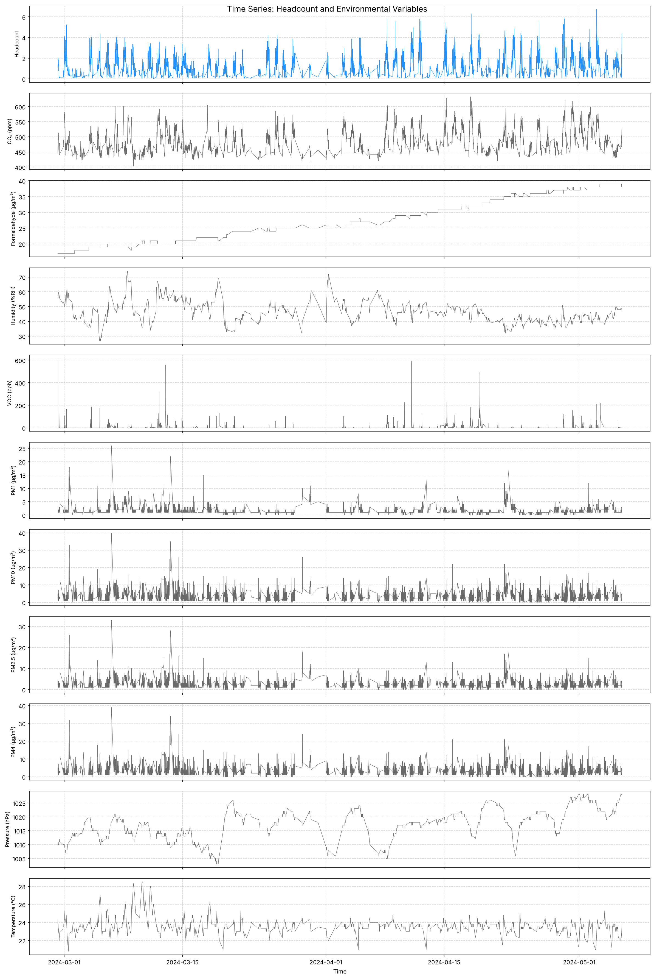
Figure A1. Headcount and environmental variables over the modelling period.
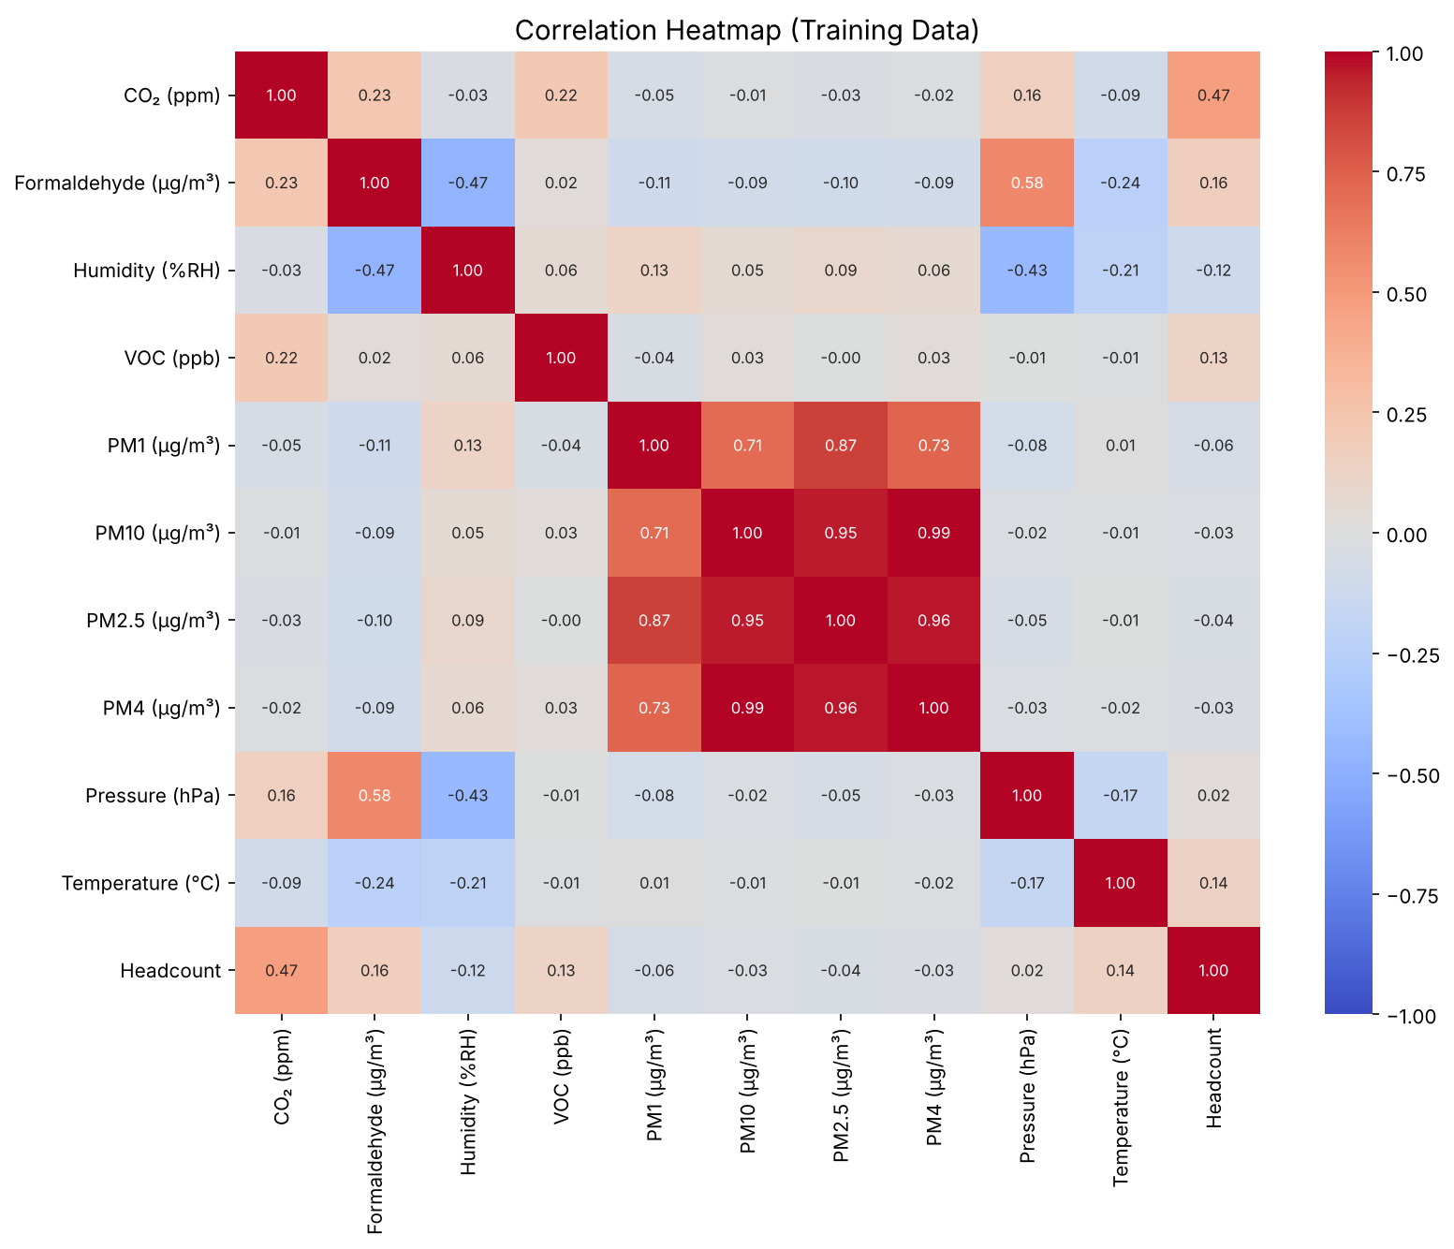
Figure A2. Correlation between the environmental variables and headcount (training data).
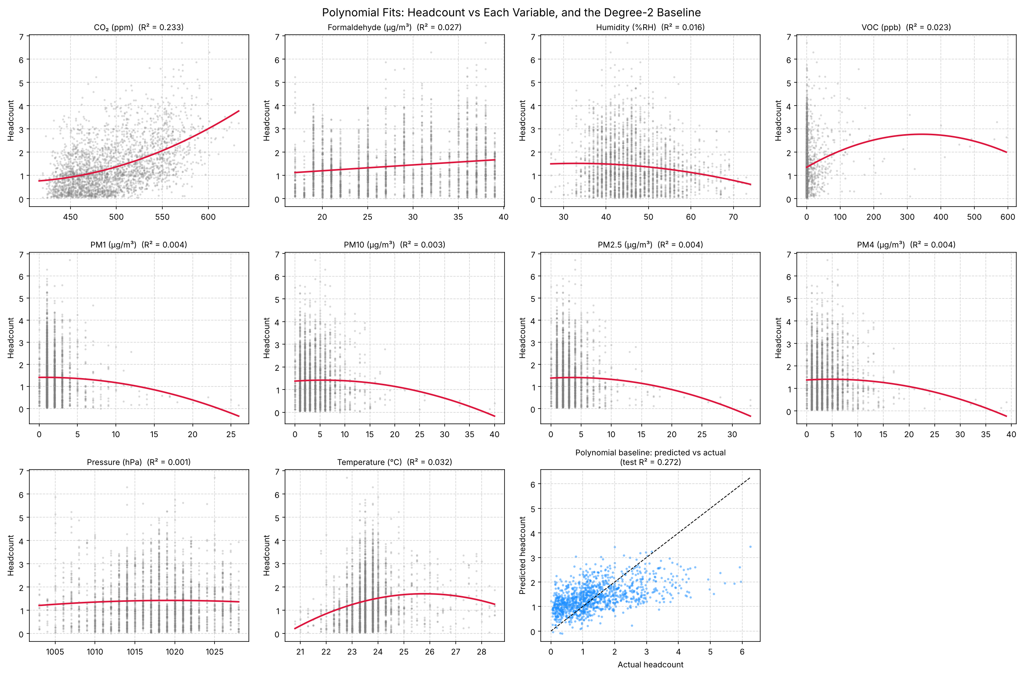
Figure A3. Quadratic fit of headcount against each variable, and the polynomial baseline's predicted versus actual headcount.
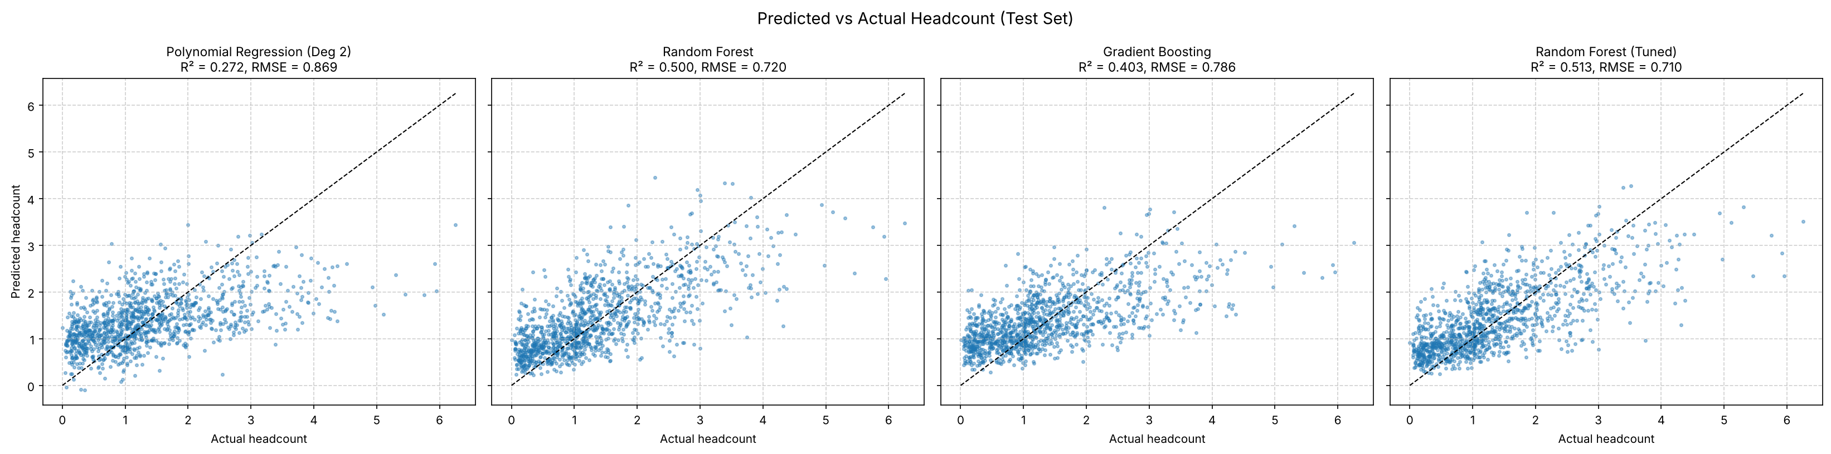
Figure A4. Predicted versus measured headcount on the test set for each model.
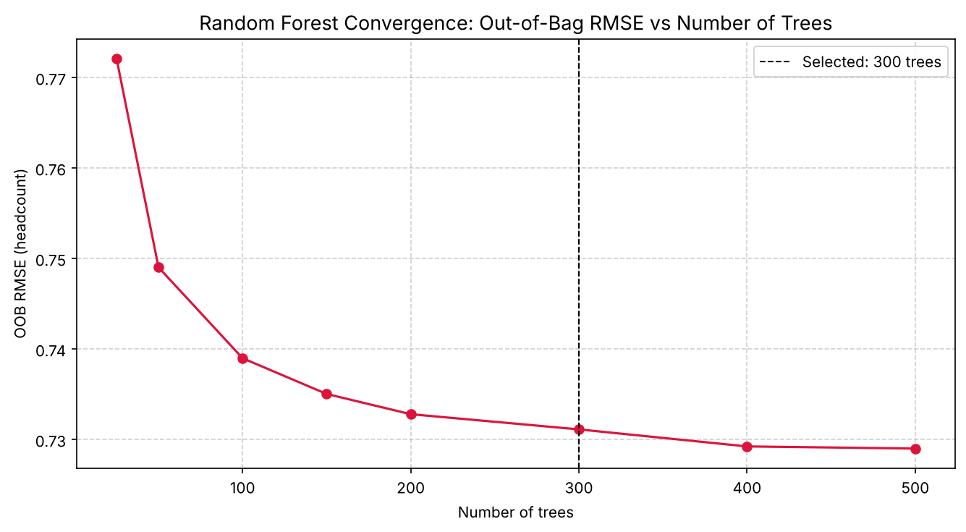
Figure A5. Out-of-bag RMSE against the number of Random Forest trees.
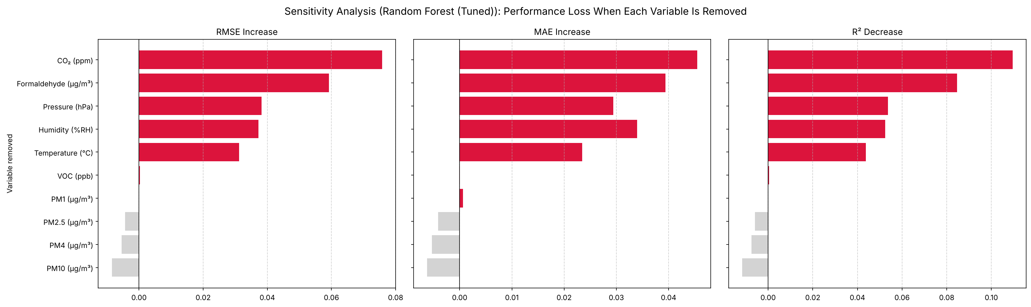
Figure A6. Loss in RMSE, MAE and R² when each variable is removed from the tuned Random Forest.
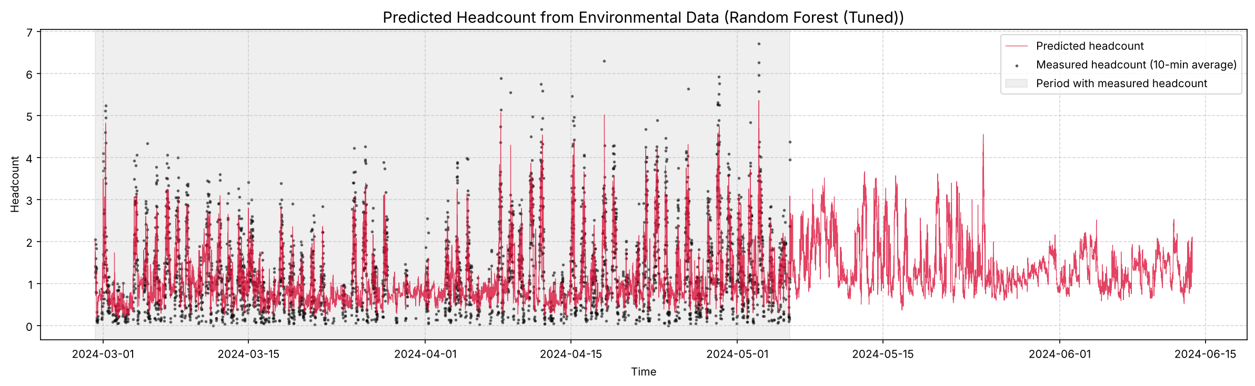
Figure A7. Predicted and measured headcount over time, including readings with no measured headcount.

Appendix B. Code Snippets
Core of the time-weighted averaging (time_weighted_headcount in src/occupancy_model.py):
seg_len = np.diff(t) # how long each reading is held
seg_valid = seg_len <= max_gap_s # don't bridge long gaps
cum_area = np.concatenate([[0.0], np.cumsum(np.where(seg_valid, h[:-1] * seg_len, 0.0))])
cum_time = np.concatenate([[0.0], np.cumsum(np.where(seg_valid, seg_len, 0.0))])

area_end, time_end = cumulative_at(end) # binary search into the cumulative sums
area_start, time_start = cumulative_at(end - window_s)
covered = time_end - time_start
enough = covered >= min_coverage * window_s
result[enough] = (area_end - area_start)[enough] / covered[enough]

Appendix C. GitHub Repository Structure
Repository: github.com/HarperVicic/MMA3001-Project
MMA3001-Project/
├── DATA/ Compressed datasets and data README
├── Jupyter Notebooks/
│ └── Occupancy_Modelling.ipynb Step-by-step analysis
├── src/occupancy_model.py Documented functions and command-line pipeline
├── docs/ HTML documentation (pdoc)
├── outputs/ Result tables (CSV) and figures (PNG)
├── report/ This report
├── tests/ pytest tests and test report
├── requirements.txt, LICENSE, README.md

Appendix D. AI Use Log
Main AI sessions, with what was asked, what was produced and how it was used.
10 October 2026 – Microsoft Copilot (desktop app). Topic: project pipeline design. Produced: a project plan covering inputs (CO₂, temperature, humidity), sensor-to-room mapping, resampling to 5 or 15 minutes, a polynomial regression model with squared and interaction terms, a 70/30 split, RMSE/MAE/R², leave-one-variable-out sensitivity analysis, the required visualisations and a conclusion template. Use: adopted as the starting structure; the variables, alignment method, room mapping and model role were later changed. Other Copilot discussions covered the model output (occupancy status or headcount) and the repository licence (MIT suggested; a restrictive academic licence written instead). Record: Copilot-generated summaries (no verbatim export).
July–October 2026 – Google Gemini 3.5 Flash and 3.1 Pro (Colab). Topic: draft notebook code, improvement and optimisation of the initial pipeline, and comparison with the MMA3001 brief and criteria. Produced: the draft notebook (data loading and JSON parsing, 15-minute trapezoidal resampling, polynomial, Random Forest and Gradient Boosting models, sensitivity analyses, plots and explanatory text). Use: basis of the analysis notebook; the timestamp handling, room selection, faulty-sensor filtering, averaging method and explanatory text were later corrected (Section 10.5).
24–25 October 2026 – Claude (Anthropic, Claude desktop app). Topic: local set-up, data investigation, pipeline correction and extension, code documentation, repository set-up and report drafting. Produced: corrected analysis notebook (Occupancy_Modelling.ipynb), the documented module src/occupancy_model.py, Random Forest tuning and outputs sections, README and DATA/README, compressed datasets, and drafts of every report section apart from the parts marked for the author to write, including this appendix. Use: adopted after review and testing (Section 10.3). Record: full conversation available in the Claude app.

