Game Design Document

Fill up the Following document

1. Write the title of your project.

Watch it!

1. What is the goal of the game?

To dodge the obstacles in way

1. Write a brief story of your game?

There’s a baby bird, it needs to save itself from approaching bigger birds by getting out of their way

1. Which are the playing characters of this game?

* Playing characters are the ones which respond to the user based on the input from the user
* Cars, monkeys, dinos, wizards etc, are the playing characters in the game.

|  |  |  |
| --- | --- | --- |
| Number | Character Name | What can this character do? |
| 1 | Baby Bird | Move up and down |
| 2 | Big Birds | Eat the baby |
| 3 |  |  |
| 4 |  |  |
| 5 |  |  |
| 6 |  |  |
| 7 |  |  |
| 8 |  |  |

1. Which are the Non Playing Characters of this game?

* Non Playing characters are the ones which don't have an action or a behaviour when the user interacts with the game.
* Hurdles, stones, bananas, coins, etc are non playing characters in the game.

|  |  |  |
| --- | --- | --- |
| Number | Character Name | What can this character do? |
| 1 | Big Birds | Eat the baby bird |
| 2 | platform | For bird’s rest |
| 3 |  |  |
| 4 |  |  |
| 5 |  |  |
| 6 |  |  |
| 7 |  |  |
| 8 |  |  |

Draw your imagination of this game. What does this game look like?

* Draw the game either on your computer or on paper,
* Add images of scenes of the game to show each of the playing and non-playing characters at least once.

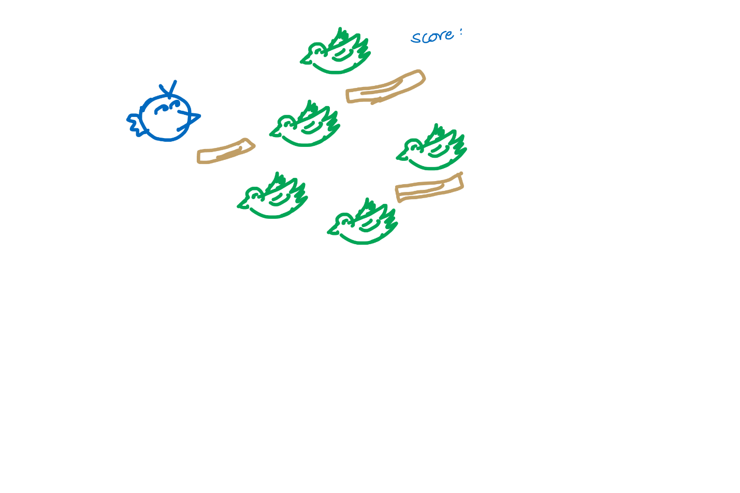

How do you plan to make your game engaging?

By allowing bird to rest on the platform and awarding points