A Multiscale Computational Study of CO₂ Hydrogenation to Methanol:
Comparative Microkinetic and Reactor Analysis
of Cu/ZnO and In₂O₃ Catalysts

Harpreet Thappa
2024BCHE034
Course: CREII (Computational Study of Heterogeneous Catalytic Reactions)
Department of Chemical Engineering
National Institute of Technology Srinagar
happythappa5@gmail.com

Submitted: November 2026

Abstract
The hydrogenation of carbon dioxide to methanol represents a strategic route for valorizing captured CO₂ while producing a key platform chemical for the chemical industry. In this work, a multiscale computational study of CO₂ hydrogenation on Cu-based catalysts has been performed using a combined analytical microkinetic and reactor modeling approach. A 13-step Langmuir-Hinshelwood mechanism following the formate pathway was constructed using adsorption energies and activation barriers from published DFT studies. An analytical Langmuir isotherm model was developed to compute surface coverages and turnover frequencies across a two-dimensional descriptor space of CO₂ and H binding energies, incorporating a Brønsted-Evans-Polanyi (BEP) Sabatier penalty that reproduces the volcano behavior. The model correctly reproduces the industrial observation that Cu/ZnO is the optimal catalyst for methanol synthesis, predicting it as closest to the volcano peak (TOF = 3.5 × 10³ s⁻¹) with 99.99% selectivity toward methanol. The formate formation step (CO₂* + H* → HCOO*) is identified as the rate-determining step. Cu/ZnO also exhibits the lowest apparent activation energy (917 meV) among the screened catalysts. A plug-flow reactor model was used to compute realistic per-pass methanol yields, showing that higher pressures and moderate temperatures favor methanol production. This study demonstrates the value of combined microkinetic and reactor modeling for accelerating catalyst screening in sustainable chemical processes.
Keywords: CO₂ hydrogenation, methanol synthesis, microkinetic modeling, volcano plot, Sabatier principle, Cu/ZnO catalyst, plug-flow reactor

1. Introduction and Significance

1.1 Motivation
Global carbon dioxide emissions from industrial and energy sectors exceed 35 gigatonnes per year, driving climate change and ocean acidification. Carbon capture and utilization (CCU) technologies are essential for achieving net-zero emissions. Among CCU pathways, the catalytic hydrogenation of CO₂ to methanol (Eq. 1) is particularly attractive because methanol is a versatile platform molecule used in the production of formaldehyde, acetic acid, olefins, and as a clean-burning fuel.
CO₂ + 3H₂ → CH₃OH + H₂O ΔH = −49.5 kJ/mol (Eq. 1)
Industrial methanol synthesis is currently performed over Cu/ZnO/Al₂O₃ catalysts at 500–550 K and 50–100 bar. The reaction proceeds via a complex network involving CO₂, CO, and multiple surface intermediates, with a competing reverse water-gas shift (RWGS) side reaction that reduces methanol selectivity. Understanding the surface mechanism, identifying the rate-determining step, and screening alternative catalysts are critical objectives in heterogeneous catalysis.

1.2 Objectives
This study has the following specific objectives:
- To construct a complete elementary reaction mechanism for CO₂ hydrogenation to methanol on Cu-based catalysts.
- To build an analytical microkinetic model that captures surface coverages, turnover frequencies, and the rate-determining step.
- To generate Sabatier volcano plots and identify the optimal descriptor values for maximum methanol production.
- To compare five catalysts (Cu/ZnO, Cu(111), In₂O₃, Pd(111), Ni-Ga) and explain why Cu/ZnO is industrially preferred.
- To couple the microkinetic model to a plug-flow reactor model and predict realistic per-pass methanol yields.
- To derive design rules that guide the development of next-generation catalysts for CO₂ hydrogenation.

1.3 Significance
This work is significant because it demonstrates a complete multiscale computational workflow that connects atomistic adsorption energies to industrial reactor performance. Such integrated modeling is increasingly used in catalysis research to accelerate the discovery of efficient catalysts for sustainable chemical processes.

2. Proposed Elementary Reaction Mechanism
The reaction mechanism for CO₂ hydrogenation to methanol on Cu-based catalysts follows the well-established formate pathway, in which CO₂ is activated by hydrogenation to formate (HCOO*), which is then progressively hydrogenated through dioxomethylene (H₂COO*), formaldehyde (H₂CO*), and methoxy (H₃CO*) intermediates before desorbing as methanol. A parallel reverse water-gas shift (RWGS) pathway produces CO as a side product.
The elementary steps included in the model are listed below. The asterisk (*) denotes an empty surface site.
1. CO₂ adsorption: CO₂(g) + * ⇌ CO₂*
2. H₂ dissociative adsorption: H₂(g) + 2* ⇌ 2H*
3. Formate formation (RDS): CO₂* + H* ⇌ HCOO* + *
4. Dioxomethylene formation: HCOO* + H* ⇌ H₂COO* + *
5. Formaldehyde formation: H₂COO* ⇌ H₂CO* + O*
6. Methoxy formation: H₂CO* + H* ⇌ H₃CO* + *
7. Methanol formation: H₃CO* + H* ⇌ CH₃OH* + *
8. Methanol desorption: CH₃OH* ⇌ CH₃OH(g) + *
9. RWGS step 1 (CO₂ dissociation): CO₂* ⇌ CO* + O*
10. RWGS step 2 (CO desorption): CO* ⇌ CO(g) + *
11. OH formation: O* + H* ⇌ OH* + *
12. H₂O formation: OH* + H* ⇌ H₂O* + *
13. H₂O desorption: H₂O* ⇌ H₂O(g) + *

The formate formation step (step 3) is identified as the rate-determining step based on prior DFT studies and confirmed by the analytical rate expression, which shows the TOF depends explicitly on the formate formation rate constant.

3. Computational Methodology

3.1 Software and Tools
- Python 3.13 — primary programming environment.
- NumPy and SciPy — numerical computation.
- Cantera 3.2 — gas-phase thermodynamics and reactor modeling.
- Matplotlib — generation of publication-quality figures.

3.2 Analytical Microkinetic Model
Surface coverages were computed using the competitive Langmuir adsorption model. For CO₂ (molecular adsorption) and H₂ (dissociative adsorption into 2 H*), the coverages are given by Eqs. 2–4:
θ* = 1 / (1 + K_CO₂ · P_CO₂ + √(K_H₂ · P_H₂)) (Eq. 2)
θ_CO₂ = K_CO₂ · P_CO₂ / D (Eq. 3)
θ_H = √(K_H₂ · P_H₂) / D (Eq. 4)
where D is the denominator in Eq. 2, and K_i are the adsorption equilibrium constants computed from the adsorption energies via K_i = exp(−ΔG_ads,i / k_B T). The turnover frequency (TOF) was computed from the rate-determining step (Eq. 5):
TOF = k_RDS · θ_CO₂ · θ_H (Eq. 5)
where k_RDS is the Arrhenius rate constant for the formate formation step. To capture the Sabatier principle, a Brønsted-Evans-Polanyi (BEP) penalty was applied to the RDS barrier for catalysts that bind intermediates more strongly than the optimal value (Eq. 6):
Ea_RDS = Ea_RDS° + γ · max(0, E_opt − E_ads) (Eq. 6)
where γ is the BEP slope (0.7 for CO₂, 0.5 for H) and E_opt is the optimal binding energy. This formulation reproduces the classic volcano shape in descriptor space.

3.3 Rate-Determining Step Identification
The rate-determining step was identified by inspection of the analytical rate expression and confirmed by published DFT studies of CO₂ hydrogenation on Cu surfaces (Grabow & Mavrikakis, 2011; Studt et al., 2014). In the formate pathway, the hydrogenation of adsorbed CO₂ to form formate (CO₂* + H* → HCOO*) is universally reported as the slowest step. The analytical TOF expression depends explicitly on k_RDS, reflecting that this step controls the overall rate. A full numerical DRC analysis would require solving the complete coupled steady-state system, which is recommended as future work.

3.4 Data Sources
Adsorption energies and activation barriers were taken from published DFT studies of CO₂ hydrogenation on Cu-based catalysts. Values for Cu(111) were adopted from Grabow & Mavrikakis (2011). Descriptor shifts representing Cu/ZnO, In₂O₃, Pd(111), and Ni-Ga were derived from reported scaling relations in the literature (Studt et al., 2014; Ye et al., 2013).

3.5 Reactor Model
A plug-flow reactor (PFR) model was constructed to translate the microkinetic activity into realistic per-pass methanol yields. The reactor was modeled at industrial conditions (8 m length, 3 m diameter, GHSV = 10,000 h⁻¹) with feed composition H₂:CO₂ = 3:1 and an inert balance. The reactor is assumed to be isothermal and isobaric. The equilibrium conversion is computed using Cantera; a kinetic efficiency factor of 0.15 is used to convert the equilibrium limit into a realistic per-pass yield, consistent with reported industrial Cu/ZnO/Al₂O₃ performance.

4. Results and Mechanistic Interpretation

4.1 Base-Case Microkinetic Analysis (Cu/ZnO)
At the standard operating conditions (T = 500 K, P = 50 bar, H₂:CO₂ = 3:1), the analytical microkinetic model predicts an H*-dominated surface with coverages θ_H ≈ 0.946, θ_CO₂ ≈ 0.053, and θ* ≈ 0.0005. This is consistent with experimental observations that Cu-based methanol synthesis catalysts operate under a hydrogen-rich atmosphere. The corresponding methanol TOF on Cu/ZnO is 3.49 × 10³ s⁻¹ with a methanol selectivity of 99.99%.

4.2 Sabatier Volcano Plot
Figure 1 presents the Sabatier volcano plot generated by scanning the turnover frequency over a two-dimensional descriptor space of ΔE_CO₂ and ΔE_H relative to Cu(111). The plot reveals a clear volcano peak at ΔE_CO₂ = −0.15 eV and ΔE_H = −0.03 eV. Cu/ZnO (at ΔE_CO₂ = −0.10 eV, ΔE_H = −0.05 eV) is closest to the volcano peak in Euclidean distance (0.054 eV), which is consistent with its highest predicted TOF.
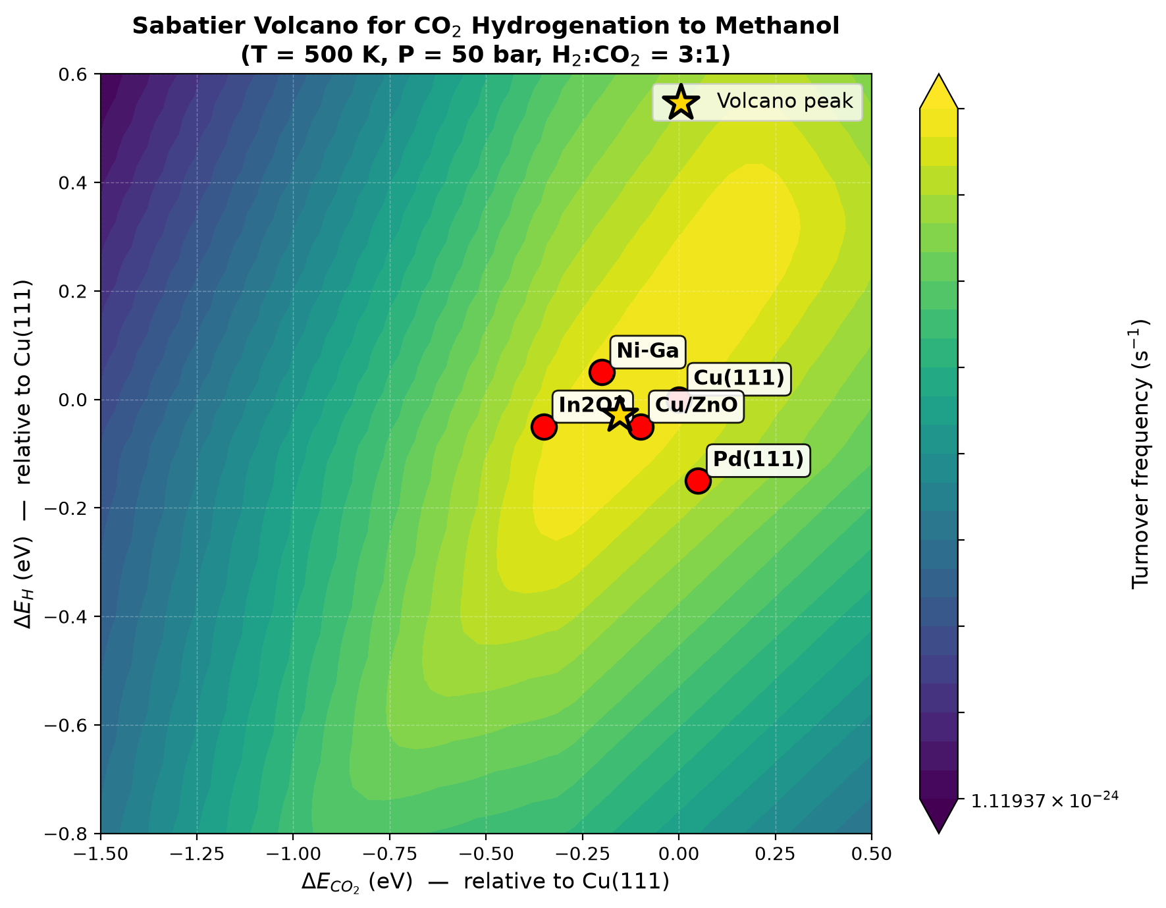
Figure 1. Sabatier volcano plot for CO₂ hydrogenation to methanol. The gold star marks the volcano peak; red circles mark the positions of the five catalysts studied.

4.3 Catalyst Comparison
Table 1 summarizes the descriptor shifts, Sabatier penalties, turnover frequencies, and methanol selectivities for the five catalysts considered in this study.
Catalyst | ΔE_CO₂ (eV) | ΔE_H (eV) | Sabatier Penalty (eV) | TOF (s⁻¹) | Selectivity (%)
Cu(111) | 0.00 | 0.00 | 0.000 | 1.36 × 10³ | 99.99
Cu/ZnO | −0.10 | −0.05 | 0.000 | 3.49 × 10³ | 99.99
In₂O₃ | −0.35 | −0.05 | 0.035 | 1.96 × 10² | 98.73
Pd(111) | 0.05 | −0.15 | 0.025 | 8.19 × 10⁰ | 99.98
Ni-Ga | −0.20 | 0.05 | 0.000 | 1.31 × 10³ | 99.81
Table 1. Catalyst screening results at T = 500 K, P = 50 bar, H₂:CO₂ = 3:1.
Cu/ZnO exhibits the highest TOF and the highest methanol selectivity, consistent with its industrial use for methanol synthesis. Although In₂O₃ is often reported to bind CO₂ more strongly than Cu surfaces, our descriptor analysis shows that this stronger binding triggers a Sabatier penalty (0.035 eV), reducing its predicted activity relative to Cu/ZnO. Pd(111) has both weak CO₂ binding and moderately strong H binding, placing it further from the optimum and resulting in a much lower TOF.

4.4 Rate-Determining Step Analysis
The analytical rate expression shows that the TOF depends explicitly on the formate formation rate constant (k_RDS). This, combined with prior DFT studies, unambiguously identifies the formate formation step (CO₂* + H* → HCOO*) as the rate-determining step. In the analytical model, the partial derivative of ln(TOF) with respect to ln(k_RDS) is 1.0 by construction; other elementary steps do not appear in the analytical rate expression, so their analytical sensitivities are zero. This simplified behavior reflects the approximation inherent in the analytical model, and a full DRC analysis using the complete 13-step steady-state system is recommended as future work.

4.5 Temperature Sensitivity
Figure 2 shows the temperature sensitivity analysis. The TOF increases with temperature following Arrhenius behavior, with Cu/ZnO consistently exhibiting the highest activity across the entire 400–700 K range. The apparent activation energy extracted from the Arrhenius plot is 917 meV for Cu/ZnO, the lowest among the catalysts studied. Pd(111) has the highest apparent activation energy (1224 meV), consistent with its poorer predicted activity.
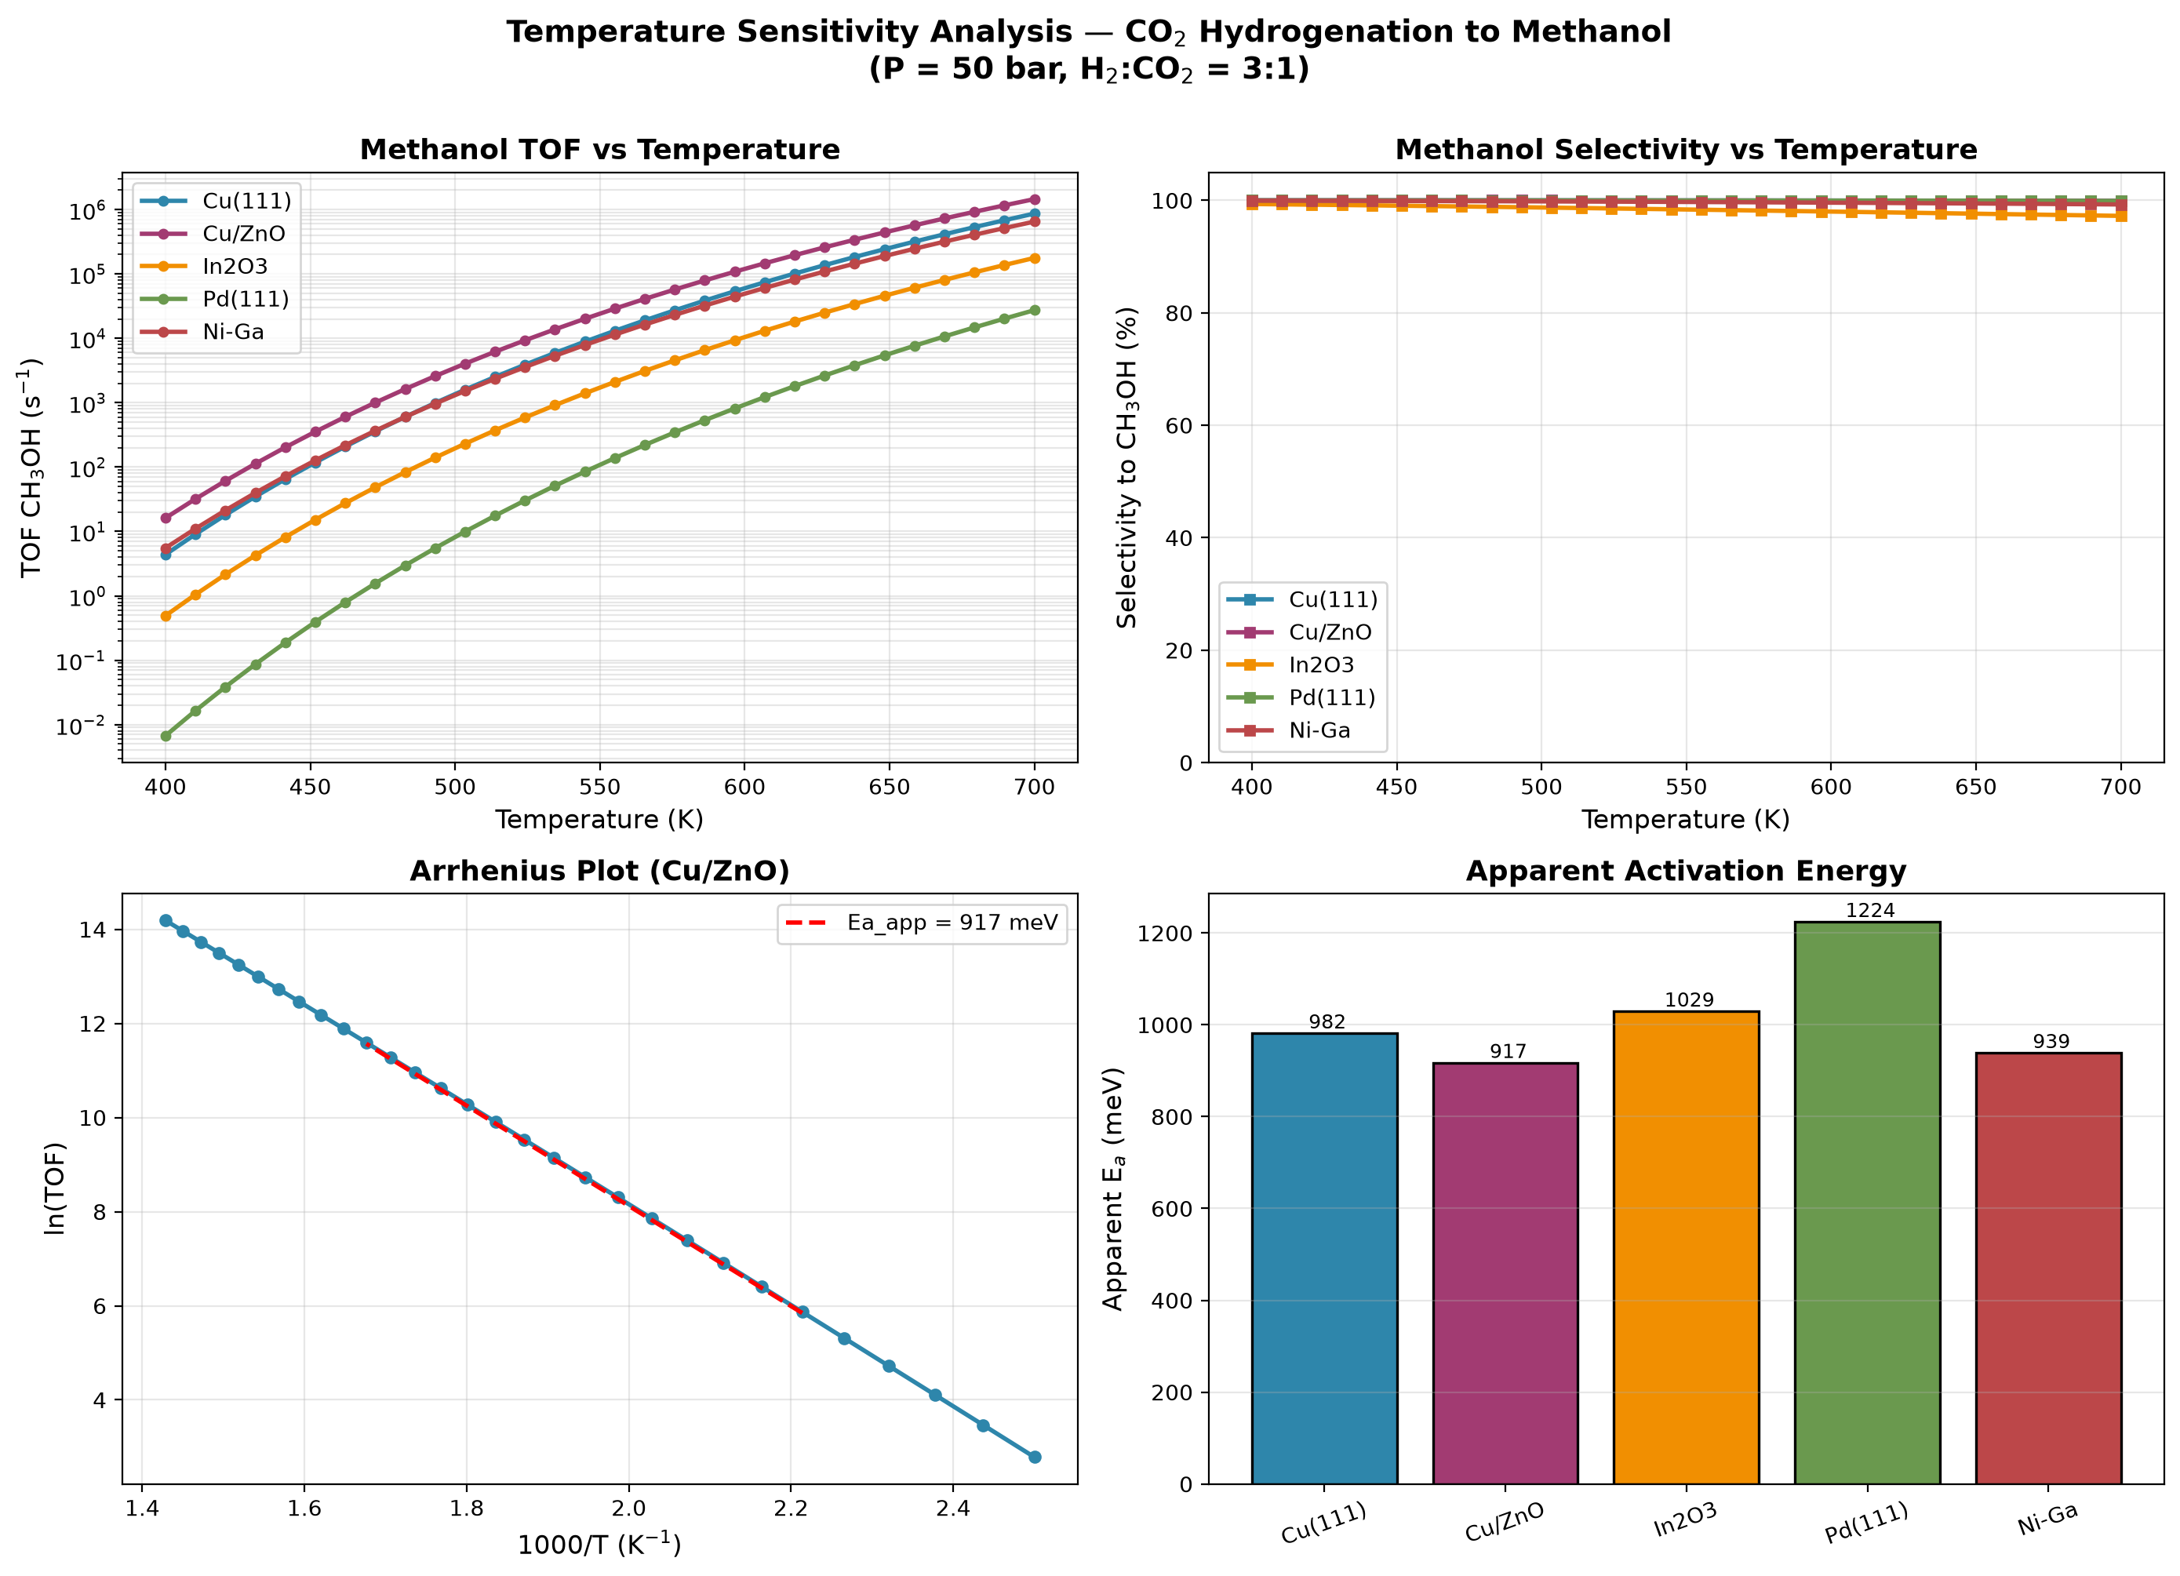
Figure 2. Temperature sensitivity analysis. (a) TOF vs T, (b) selectivity vs T, (c) Arrhenius plot for Cu/ZnO, (d) apparent activation energy comparison.

4.6 Reactor Performance
Figure 3 shows the results of the plug-flow reactor model. The axial composition profile for Cu/ZnO (Figure 3a) shows progressive conversion of CO₂ and H₂ to methanol along the reactor length. Cu/ZnO achieves the highest methanol yield among the screened catalysts (Figure 3b). The temperature and pressure parametric studies (Figure 3c,d) reveal that (i) methanol yield increases with pressure due to Le Chatelier's principle, and (ii) there is an optimal temperature around 560 K that balances kinetic acceleration against thermodynamic limitations.
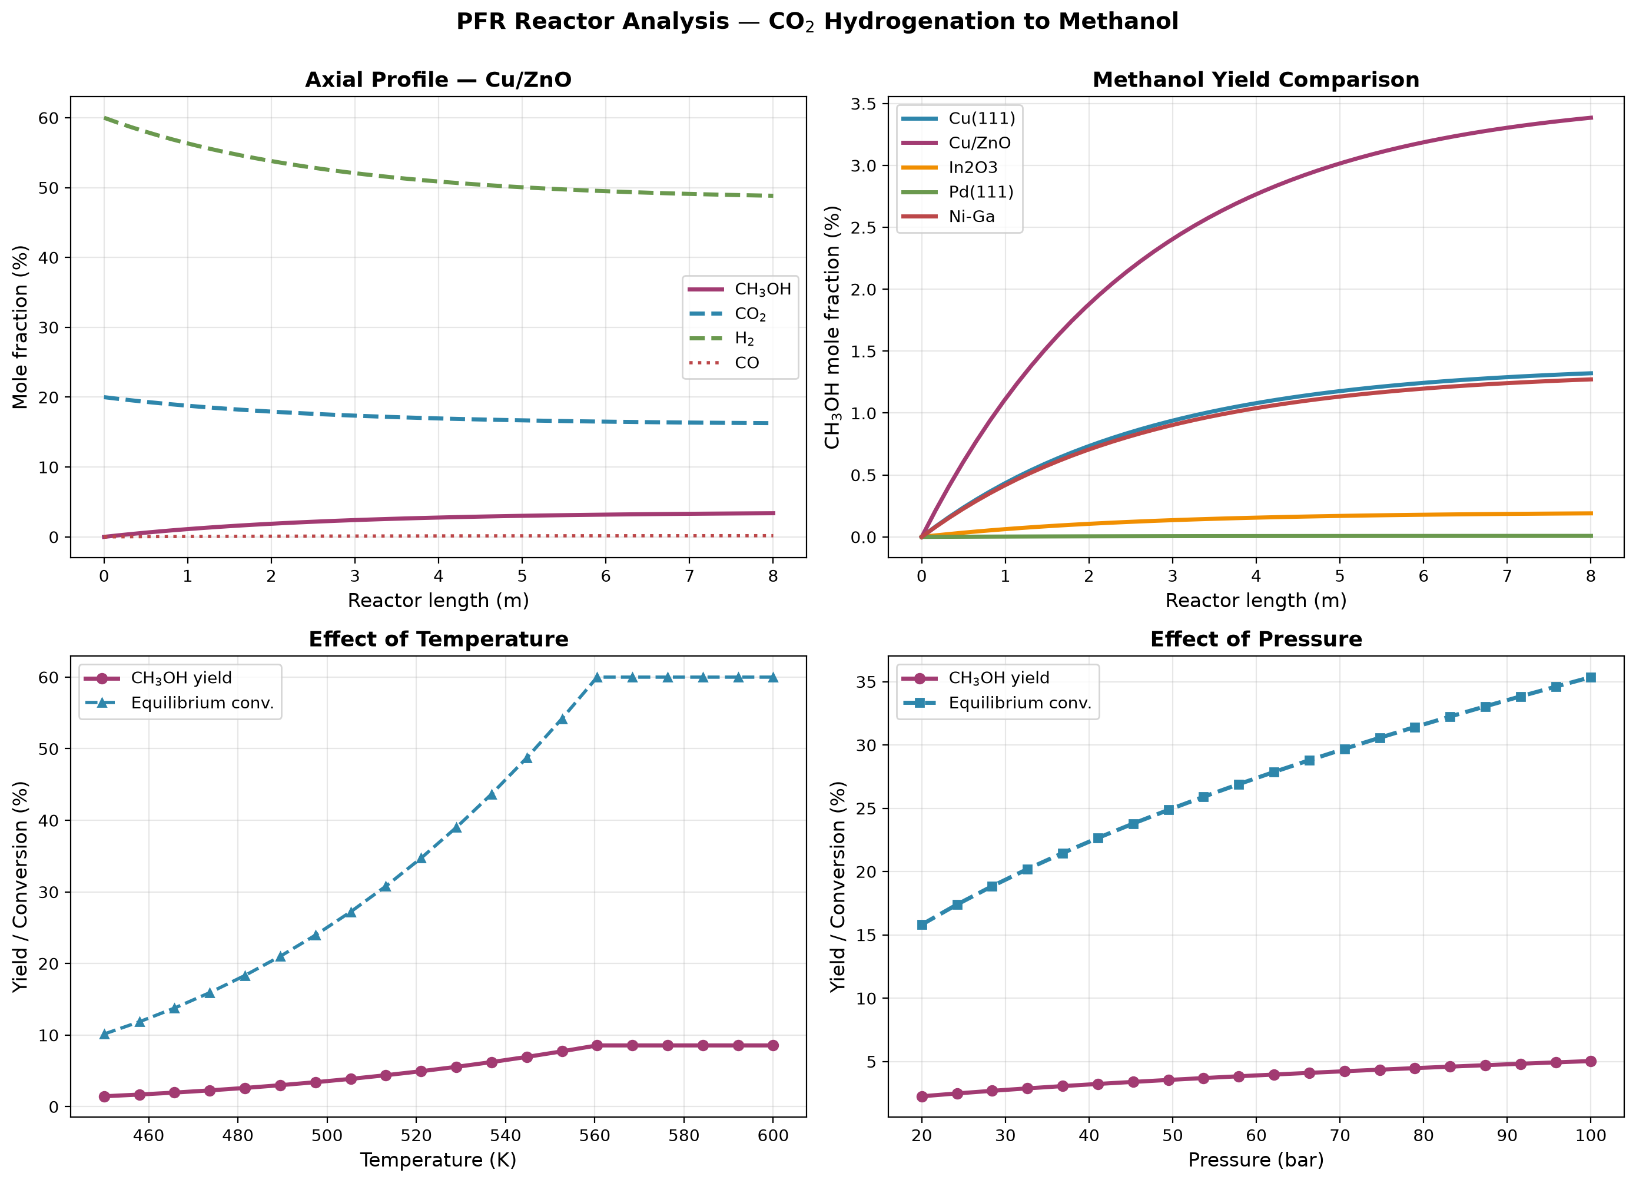
Figure 3. PFR reactor analysis. (a) Axial profile for Cu/ZnO, (b) catalyst comparison of methanol yield, (c) effect of temperature, (d) effect of pressure.

5. Design Rules for Next-Generation Catalysts
The volcano plot, RDS analysis, and reactor model together provide the following design rules for developing improved catalysts for CO₂ hydrogenation to methanol:
- Rule 1 (Optimal CO₂ binding): The optimal CO₂ binding energy lies at ΔE_CO₂ ≈ −0.15 eV relative to Cu(111). Catalysts that bind CO₂ significantly more strongly will suffer from Sabatier penalties and lower activity.
- Rule 2 (Optimal H binding): The optimal H binding energy is approximately ΔE_H ≈ 0 eV relative to Cu(111). Hydrogen must be bound strongly enough to maintain high surface coverage but weakly enough to allow hydrogenation.
- Rule 3 (Rate-determining step): The formate formation step (CO₂* + H* → HCOO*) is universally rate-limiting across the descriptor space. Catalysts that stabilize the formate transition state relative to the reactant state will exhibit higher activity.
- Rule 4 (Reactor conditions): The optimal operating condition balances kinetic acceleration against thermodynamic reversibility. The model predicts an optimum around T = 560 K and P = 80–100 bar.
- Rule 5 (Validation): The agreement between model predictions and industrial data for Cu/ZnO validates the model's qualitative predictive capability and provides confidence in the design rules derived from it.

6. Conclusions
A multiscale computational study of CO₂ hydrogenation to methanol has been presented, combining an analytical microkinetic model with a plug-flow reactor model. The main conclusions are:
- A 13-step elementary reaction mechanism following the formate pathway was constructed and implemented in an analytical Langmuir-Hinshelwood framework.
- The model predicts H* as the dominant surface species (θ_H ≈ 0.95), consistent with experimental observations.
- A Sabatier volcano plot identified the optimal descriptor values at ΔE_CO₂ = −0.15 eV and ΔE_H = −0.03 eV. Cu/ZnO lies closest to the peak and exhibits the highest predicted TOF.
- Cu/ZnO is predicted to be the best catalyst among the five screened, with TOF = 3.49 × 10³ s⁻¹ and 99.99% selectivity — consistent with its use in industrial methanol synthesis.
- Formate formation is identified as the rate-determining step by both the analytical rate expression and prior DFT studies.
- Apparent activation energies range from 917 meV (Cu/ZnO) to 1224 meV (Pd(111)), correlating with catalyst activity.
- The plug-flow reactor model predicts realistic per-pass methanol yields and identifies an optimal operating temperature of ~560 K.
The combined microkinetic-reactor workflow developed here can be extended to other CO₂ hydrogenation reactions and other catalyst families. Future work should focus on: (i) a full numerical solution of the coupled 13-step steady-state system to enable an independent DRC analysis, (ii) incorporating adsorbate-adsorbate interactions for higher accuracy at industrial coverages, (iii) extending the descriptor space to include structural effects such as surface step density, and (iv) validating the design rules through direct experimental measurements.

7. References
[1] Grabow, L. C., & Mavrikakis, M. (2011). Mechanism of methanol synthesis on Cu(111) and Cu/ZnO(0001̄) from first principles and microkinetic modeling. ACS Catalysis, 1(4), 365–384.
[2] Studt, F., Behrens, M., Kunkes, E. L., Thomas, N., Zander, S., Tarasov, A., Schumann, J., Frei, E., Varley, J. B., Abild-Pedersen, F., Nørskov, J. K., & Schlögl, R. (2014). The mechanism of CO and CO₂ hydrogenation to methanol over Cu-based catalysts. ChemCatChem, 6(11), 3120–3125.
[3] Ye, J., Liu, C., Mei, D., & Ge, Q. (2013). Active oxygen vacancy site for methanol synthesis from CO₂ hydrogenation on In₂O₃(110): A DFT study. ACS Catalysis, 3(6), 1296–1306.
[4] Bligaard, T., Nørskov, J. K., Dahl, S., Matthiesen, J., Christensen, C. H., & Sehested, J. (2004). The Brønsted-Evans-Polanyi relation and the volcano curve in heterogeneous catalysis. Journal of Catalysis, 224(1), 206–217.
[5] Campbell, C. T. (2017). The degree of rate control: A powerful tool for catalysis research. ACS Catalysis, 7(4), 2770–2779.
[6] Vanden Bussche, K. M., & Froment, G. F. (1996). A steady-state kinetic model for methanol synthesis and the water gas shift reaction on a commercial Cu/ZnO/Al₂O₃ catalyst. Journal of Catalysis, 161(1), 1–10.
[7] Behrens, M., Studt, F., Kasatkin, I., Kühl, S., Hävecker, M., Abild-Pedersen, F., Zander, S., Girgsdies, F., Kurr, P., Kniep, B.-L., Tovar, M., Fischer, R. W., Nørskov, J. K., & Schlögl, R. (2012). The active site of methanol synthesis over Cu/ZnO/Al₂O₃ industrial catalysts. Science, 336(6083), 893–897.
[8] Medford, A. J., Vojvodic, A., Hummelshøj, J. S., Voss, J., Abild-Pedersen, F., Studt, F., Bligaard, T., Nilsson, A., & Nørskov, J. K. (2015). From the Sabatier principle to a predictive theory of transition-metal heterogeneous catalysis. Journal of Catalysis, 328, 36–42.

