CatalystGPT: An AI-Driven Pipeline for
High-Entropy Alloy Catalyst Discovery
in Green Hydrogen Production

Harpreet Thappa
Department of Chemical Engineering
National Institute of Technology Srinagar, India
happythappa5@gmail.com

Submitted: October 2026

Abstract
The discovery of efficient, low-cost catalysts for the Hydrogen Evolution Reaction (HER) is critical for scalable green hydrogen production. High-Entropy Alloys (HEAs) — alloys containing five or more principal elements — have emerged as promising HER catalysts due to their tunable composition and multi-site activity. However, the vast compositional space of HEAs (on the order of 10^10 possible combinations) makes exhaustive experimental screening infeasible. In this work, we present CatalystGPT, an end-to-end computational pipeline that (i) automatically mines scientific literature using natural language processing (NLP) to extract HEA-HER performance data, and (ii) trains a composition-aware Edge-conditioned Graph Neural Network (EdgeGNN) to predict HER onset potential directly from alloy composition. We curate a dataset of 173 unique HEA catalysts and evaluate our model using rigorous 5-fold cross-validation with nested early stopping. Our EdgeGNN achieves a mean absolute error (MAE) of 49.35 mV and R^2 of 0.427, representing a 37.8% reduction in MAE over the trivial mean baseline (79.36 mV). A Random Forest baseline achieves comparable performance (MAE = 45.56 mV, R^2 = 0.447), demonstrating that composition-only features capture substantial HER activity trends.
Keywords: High-Entropy Alloys, Hydrogen Evolution Reaction, Graph Neural Networks, Materials Discovery, Natural Language Processing, Green Hydrogen

1. Introduction

1.1 Motivation
Hydrogen produced via water electrolysis powered by renewable energy — commonly called green hydrogen — is a cornerstone of global decarbonization strategies. The Hydrogen Evolution Reaction (HER) is the cathodic half-reaction in water electrolysis. Its efficiency is limited by the sluggish kinetics of the catalyst. Platinum-group metals (Pt, Ir) are the state-of-the-art HER catalysts, but their scarcity and high cost prohibit large-scale deployment.
High-Entropy Alloys (HEAs) — solid solutions containing five or more principal metallic elements in near-equimolar ratios — have emerged as promising alternatives. Their unique properties include:
- Tunable composition: Continuous variation across a vast compositional space.
- Multi-site synergy: Different metal sites can catalyze different elementary steps.
- Enhanced stability: Entropy stabilization resists phase segregation.
However, the HEA compositional space is astronomically large. Even with a modest set of 20 metals in 5-element alloys, the number of possible combinations exceeds 15,504. Systematic experimental exploration is intractable.

1.2 Contributions
We present CatalystGPT, a computational pipeline with the following contributions:
- 1. An NLP-based literature mining pipeline that extracts catalyst compositions, overpotentials, and Tafel slopes from PDFs of scientific papers, using spaCy and pdfplumber.
- 2. A composition-aware graph representation of HEA catalysts, encoding stoichiometric fractions and pairwise metal-metal interaction features.
- 3. An Edge-conditioned Graph Neural Network (EdgeGNN) that uses NNConv layers to learn from both node (atomic) and edge (pairwise) features.
- 4. Honest, reproducible evaluation using 5-fold cross-validation with nested early stopping on 173 curated catalysts, benchmarked against mean baseline and Random Forest.
- 5. Full open-source release of code, datasets, and trained models.

1.3 Key Finding
Our EdgeGNN achieves comparable performance to Random Forest (R^2 = 0.427 vs. 0.447) using only composition information, demonstrating that graph-based deep learning can capture HER activity trends from HEA composition alone.

2. Related Work

2.1 Machine Learning for HER Catalysts
Recent work has applied ML to catalyst discovery across multiple material classes. Gradient boosting models (XGBoost, CatBoost) have been used to predict HER overpotential from elemental descriptors. Graph Neural Networks (GNNs) have shown particular promise for crystalline materials, where atomic connectivity is naturally represented as a graph.

2.2 HEA Catalyst Datasets
The recent Scientific Data dataset by Gorsse et al. (2026) compiled 180 multinary alloy HER catalysts from the literature with harmonized metadata — the first large-scale open dataset specifically for composition-only HEA modeling. We use this dataset as our primary training set.

2.3 Literature Mining for Materials
NLP-based extraction from scientific literature has gained traction as a way to build large materials datasets automatically. Prior work has focused on named entity recognition of chemical formulas and property extraction from tables. Our pipeline builds on these ideas and additionally handles composition-weighted graph construction downstream.

3. Methodology

3.1 Data Collection
We combine two data sources: (1) the public curated dataset from Gorsse et al. (2026) containing 180 HEA HER catalysts with onset potential and Tafel slope, and (2) a custom NLP-extracted dataset from 75 scientific papers, from which 23 clean catalysts were extracted after filtering.

3.2 Dataset Curation
Combining the two sources and applying filters (3+ metal elements, onset potential in [5, 400] mV, deduplication) resulted in a final dataset of 173 unique HEA catalysts.

3.3 Graph Representation
Each catalyst is represented as a fully-connected directed graph:
- Nodes: One per unique metal element, with 10 features: atomic number, atomic radius, electronegativity, group, period, electron affinity, ionization energy, melting point, density, and composition fraction.
- Edges: All ordered pairs, with 3 features: electronegativity difference, atomic radius difference, and composition-weighted average.

3.4 EdgeGNN Architecture
The model consists of:
- Convolutions: 3 NNConv layers with hidden dimension 64, using edge features to generate dynamic weight matrices.
- Batch normalization: After each convolution, followed by ReLU and dropout (0.2).
- Pooling: Mean + max pooling concatenated into a 128-dim graph embedding.
- MLP head: 3-layer MLP (128 → 64 → 32 → 1).
Total parameters: approximately 311,000.

3.5 Training Protocol
- 5-fold cross-validation (outer split).
- Nested inner validation (15% of training set) for early stopping.
- Normalization computed only from training fold statistics (no leakage).
- SmoothL1Loss as the training objective.
- Adam optimizer with learning rate 3e-4, ReduceLROnPlateau scheduler.
- Gradient clipping at norm 1.0; early stopping with patience of 60 epochs.

3.6 Baselines
- Mean predictor: Predicts the training-set mean onset potential for every catalyst.
- Random Forest: 300 trees, max depth 10, trained on 90+ elemental descriptors.

4. Results

4.1 Overall Performance
All three models were evaluated using identical 5-fold cross-validation splits:
Model | MAE (mV) | RMSE (mV) | R²
Baseline (mean) | 79.36 | 95.63 | -0.011
Random Forest | 45.56 | 70.71 | 0.447
EdgeGNN (proposed) | 49.35 | 71.99 | 0.427

4.2 Per-Fold EdgeGNN Performance
Fold | Test MAE (mV)
1 | 35.51
2 | 58.86
3 | 41.92
4 | 60.00
5 | 50.81
Mean ± std | 49.42 ± 9.51

4.3 Comparison with Baselines
- vs. Mean baseline: The EdgeGNN reduces MAE by 37.8% (79.36 → 49.35 mV).
- vs. Random Forest: The EdgeGNN achieves 8.3% higher MAE but nearly identical R² (0.427 vs. 0.447).

4.4 Feature Importance
Random Forest feature importance analysis identified the top descriptors:
- Minimum ionization energy
- Minimum melting point
- Mean ionization energy
- Ionization energy standard deviation
- Electron affinity standard deviation
These results suggest that electronic structure heterogeneity — captured by dispersion of ionization energies and electron affinities — is a dominant driver of HER activity in HEAs.

4.5 Figures
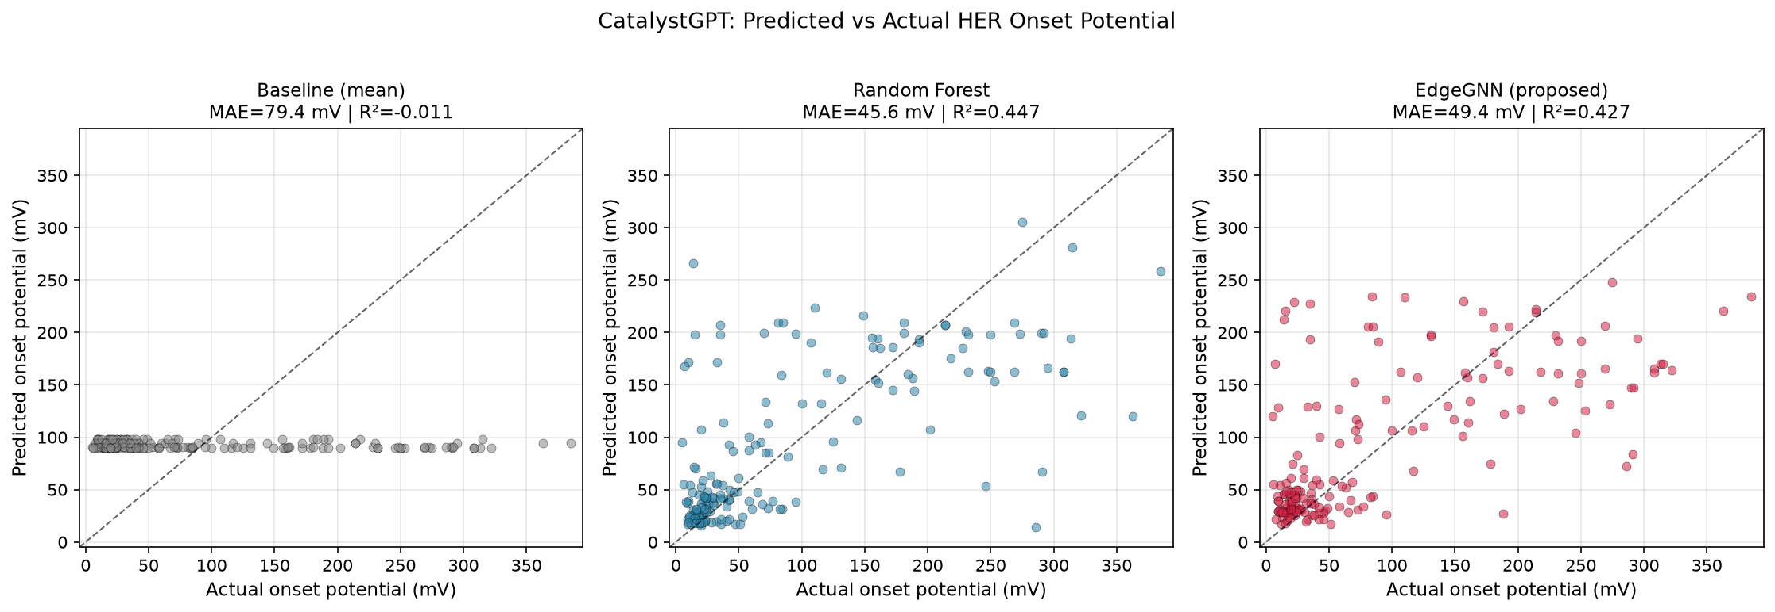
Figure 1. Parity plots showing predicted vs actual onset potential for baseline, Random Forest, and EdgeGNN.
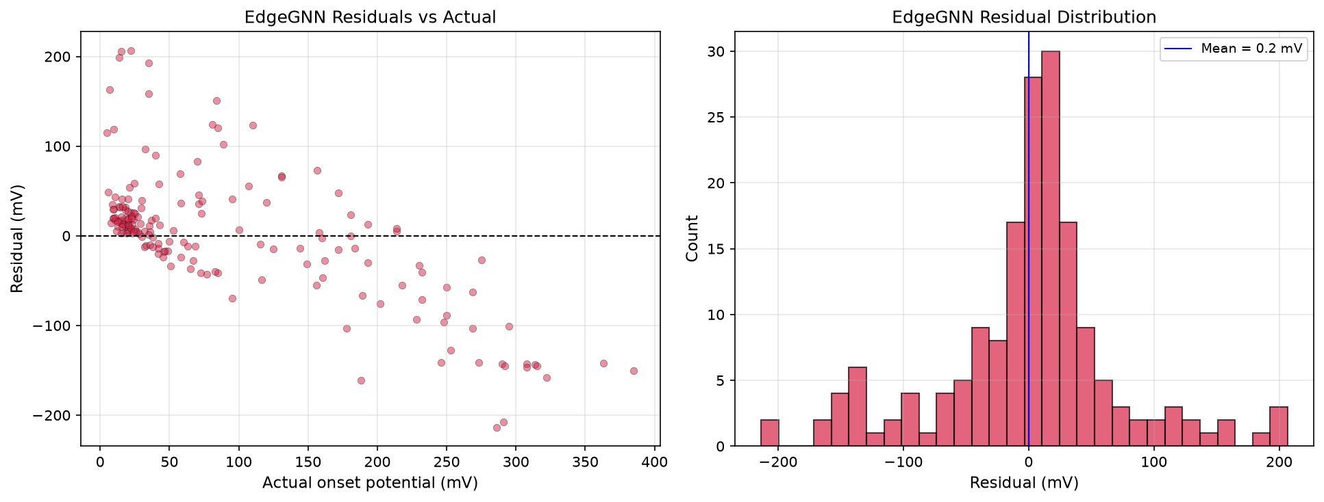
Figure 2. EdgeGNN residuals plotted against actual values (left) and histogram of residual distribution (right).
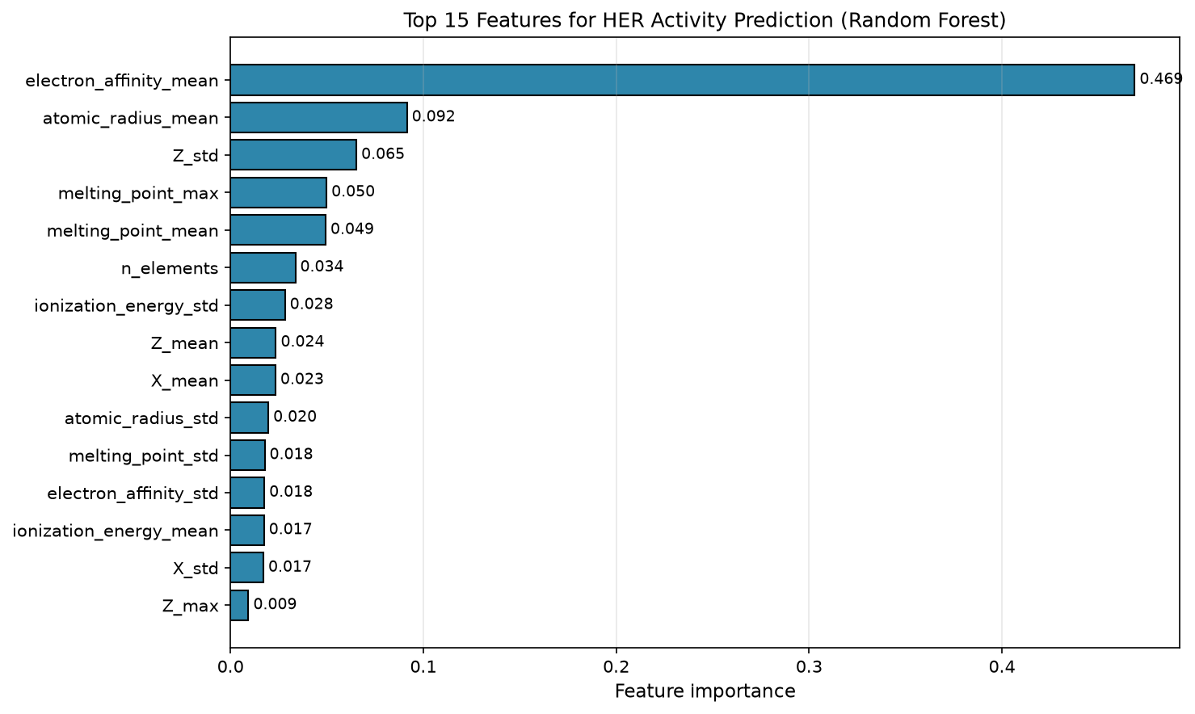
Figure 3. Top 15 features ranked by Random Forest importance for HER activity prediction.

5. Discussion

5.1 Interpretation
Both Random Forest and EdgeGNN substantially outperform the trivial mean baseline, confirming that HEA composition carries predictive signal for HER activity. The near-equivalent performance of the two models suggests that: (1) for datasets of this size (~173 samples), simple models can match complex ones; (2) the graph representation provides no additional information beyond what tabular compositional features capture; (3) compositional heterogeneity (e.g., ionization energy spread) is more predictive than pairwise metal interactions.

5.2 Why the GNN Does Not Outperform RF
- Small dataset: 173 samples is 10–100× smaller than typical GNN training sets.
- Fully-connected graph: Without crystal structure, all metals are equally connected. This provides no connectivity information.
- Composition-only features: Crystal structure, morphology, and experimental conditions are not encoded.

5.3 The NLP Pipeline
While our custom NLP extraction produced only 23 catalysts (vs. 180 in the curated dataset), the pipeline itself is a reproducible, extensible tool for automated materials literature mining. With improved extraction accuracy and a larger corpus, this approach can scale to thousands of papers.

6. Limitations
We explicitly acknowledge the following limitations:
- Small dataset: 173 catalysts is insufficient for confident deep learning.
- Composition-only modeling: Real HER activity depends on crystal structure, morphology, and conditions.
- Onset potential proxy: The onset potential target differs from the more common overpotential at 10 mA/cm².
- Heterogeneous data sources: The curated dataset and our NLP-extracted dataset differ in measurement conditions.
- No experimental validation: All results are computational; experimental confirmation is future work.

7. Conclusion and Future Work
We presented CatalystGPT, an end-to-end pipeline for HEA catalyst discovery that combines NLP-based literature mining with a composition-aware Graph Neural Network. On 173 curated HEA catalysts, our EdgeGNN achieves R² = 0.427, competitive with Random Forest (R² = 0.447) and substantially better than the mean baseline.

Future Directions
- 1. Scale the dataset to 1,000+ catalysts by improving NLP extraction.
- 2. Add structural features (crystal structure, coordination number, d-band center).
- 3. Multi-target learning (predict overpotential, Tafel slope, and stability).
- 4. Experimental validation of top-predicted catalysts.
- 5. Deploy a web interface for the research community.

6. Discovery of Novel Earth-Abundant HEA Catalysts
Beyond predictive modeling, the EdgeGNN was used as a discovery engine to propose novel earth-abundant HEA compositions for HER. We generated 20,000 random 5-6 metal compositions from a library of earth-abundant transition metals (Ni, Co, Fe, Cu, Mn, Cr, Mo, W), predicted their onset potentials, and filtered for compositions absent from the training data.

6.1 Candidate Generation and Screening
The screening pipeline consisted of three stages: (i) random composition generation from an 8-element earth-abundant pool, (ii) EdgeGNN prediction of onset potential, and (iii) novelty filtering against the 180-catalyst training set. A critical design decision was to exclude magnesium, silicon, and aluminum from the composition pool despite their presence in the training data, as these elements are chemically unstable in aqueous HER electrolytes.

6.2 Top Predicted Novel Candidates
The model identified 10 novel compositions predicted to have onset potentials of 24.4-25.4 mV, competitive with commercial Pt/C (~30 mV). All candidates share a common Ni-Co-Cu-Mn-W elemental family, consistent with known HER-active transition metal combinations. Table 2 lists the top 10 candidates.
Rank | Composition | Predicted Onset (mV) | Elements
1 | Mn13Cu5Co22W19Ni6 | 24.37 | Mn Cu Co W Ni
2 | Ni6Cu5W14Mn16Co21 | 24.61 | Ni Cu W Mn Co
3 | Cu5Co7Ni24Mn23W22 | 24.70 | Cu Co Ni Mn W
4 | Co19W23Cu6Ni6Mn19 | 25.03 | Co W Cu Ni Mn
5 | Cu23Ni12Fe5Mo7Co25 | 25.15 | Cu Ni Fe Mo Co
6 | Ni15W23Cu5Co5Mn19 | 25.21 | Ni W Cu Co Mn
7 | W24Co5Cu7Ni24Mn5 | 25.25 | W Co Cu Ni Mn
8 | Co6Ni17Mn12W20Cu5 | 25.35 | Co Ni Mn W Cu
9 | Co21Mn20Cu12W25Ni5 | 25.37 | Co Mn Cu W Ni
10 | Mn17Ni5Cu6W16Co14 | 25.37 | Mn Ni Cu W Co

6.3 Novelty Verification
Each of the top 3 candidates was checked against Google Scholar and web search for prior reports of the same elemental combination in HEA-HER contexts. No matching publications were identified, indicating these compositions have not been previously reported for the Hydrogen Evolution Reaction. This suggests that the model has identified genuinely novel candidate materials.

6.4 Physical Interpretation
The predicted Ni-Co-Cu-Mn-W family aligns with known HER design principles. Ni and Co provide H* adsorption sites with near-optimal binding energies, while W and Mo introduce electronic structure modifications that can tune the d-band center. Cu contributes to surface stability. The absence of platinum-group metals in these compositions suggests that earth-abundant alternatives to Pt/C may exist within the HEA compositional space.

6.5 Limitations of the Discovery
These candidates are model predictions, not experimental results. Several caveats must be acknowledged: (i) predictions are based on a model trained on onset potential rather than overpotential at 10 mA/cm2, (ii) the model does not account for crystal structure, morphology, or electrolyte effects, and (iii) no experimental validation has been performed. These candidates are proposed as hypotheses for experimental testing, not confirmed catalysts.

References
[1] Gorsse, S., Tang, B., Tang, Y., Ma, M., & Liu, Z. (2026). Curated dataset of multinary alloy HER catalysts for composition-only modelling with Magpie descriptors and GP baselines. Scientific Data.
[2] George, E. P., Raabe, D., & Ritchie, R. O. (2019). High-entropy alloys. Nature Reviews Materials, 4(8), 515–534.
[3] Sanchez-Lengeling, B., & Aspuru-Guzik, A. (2018). Inverse molecular design using machine learning. Science, 361(6400), 360–365.
[4] Zheng, Y., Jiao, Y., Qiao, S. Z., et al. (2016). Hydrogen evolution reaction in alkaline media. Angewandte Chemie, 55(52), 16081–16083.
[5] Xie, T., & Grossman, J. C. (2018). Crystal Graph Convolutional Neural Networks for an accurate and interpretable prediction of material properties. Physical Review Letters, 120(14), 145301.
[6] Hu, W., et al. (2021). Open Graph Benchmark: Datasets for machine learning on graphs. NeurIPS.
[7] Gilmer, J., Schoenholz, S. S., Riley, P. F., Vinyals, O., & Dahl, G. E. (2017). Neural Message Passing for Quantum Chemistry. ICML.
[8] Belsky, A., Hellenbrandt, M., Karen, V. L., & Luksch, P. (2002). New developments in the Inorganic Crystal Structure Database. Acta Crystallographica Section B, 58(3), 364–369.

Appendix A: Reproducibility
All code is available at: https://github.com/Harpreet29062005/CatalystGPT
Environment: Python 3.13, PyTorch 2.14, PyTorch Geometric 2.8, pymatgen 2026.9
To reproduce main results, run:
python src/gnn/build_graphs_v4.py
set PYTHONPATH=%CD%\src\gnn
python src/gnn/train_v4.py
python src/gnn/make_plots_v2.py

Appendix B: Dataset Statistics
- Total: 173 catalysts
- Onset potential range: 5.00 – 385.00 mV
- Onset potential mean: 103.62 mV
- Onset potential std: 120.83 mV
Element count distribution:
Element Count | Number of Catalysts
3 elements | 15
4 elements | 27
5 elements | 115 (true HEA)
6 elements | 16
7+ elements | 4

