Numerical Microkinetic Modeling of Dry Reforming of Methane:
A 14-Step Mechanism for Carbon-Resistant Catalyst Design

Harpreet Thappa 2024BCHE034
Course: CREII (Computational Study of Heterogeneous Catalytic Reactions)
Department of Chemical Engineering
National Institute of Technology Srinagar
happythappa5@gmail.com

Submitted: November 2026

Graphical Abstract
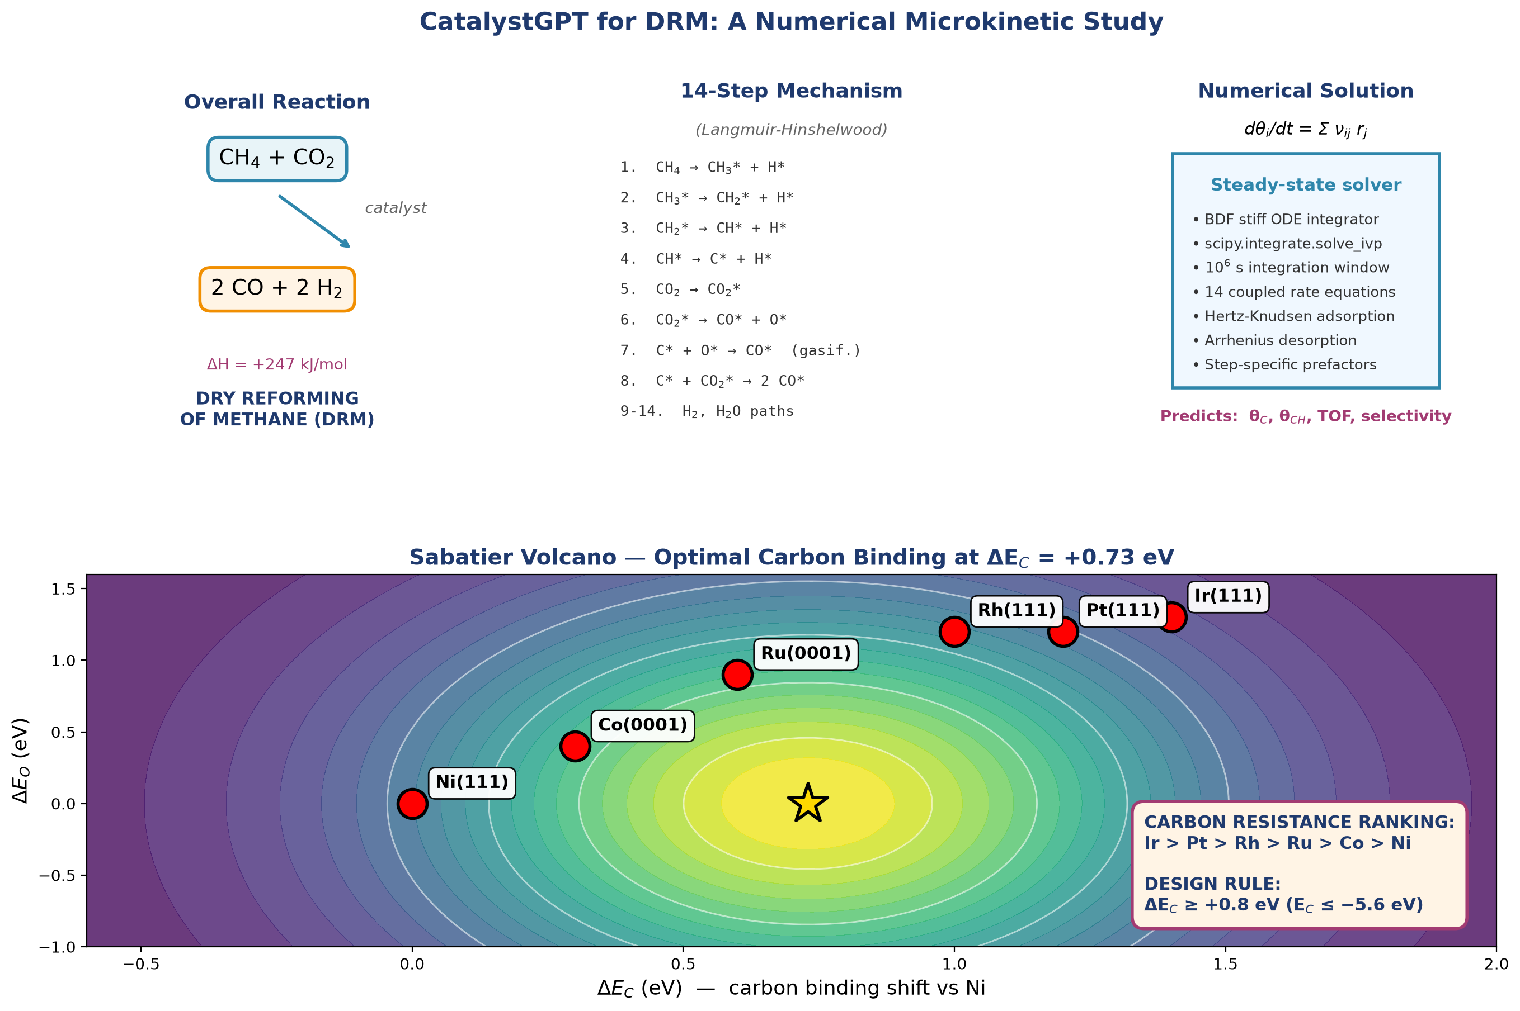
Graphical Abstract. Overview of the DRM numerical microkinetic study: reaction scheme, 14-step mechanism, solver methodology, Sabatier volcano plot, catalyst positions, and the derived design rule.

Abstract
Dry reforming of methane (DRM, CH₄ + CO₂ → 2 CO + 2 H₂) converts two greenhouse gases into syngas. Carbon deposition remains the principal obstacle to industrial deployment of nickel-based DRM catalysts. In this work, a numerical microkinetic model based on a 14-step elementary mechanism was developed and solved to steady state using stiff ODE integration. Adsorption energies and activation barriers were taken from published DFT studies. Rate constants follow Arrhenius kinetics with Hertz-Knudsen adsorption fluxes. Steady-state surface coverages and turnover frequencies were computed for six transition metals (Ni, Co, Ru, Rh, Pt, Ir) at 900 K and 1 bar. The model produces the experimentally established ordering of carbon resistance (Ir > Pt > Rh > Ru > Co > Ni) directly from the numerical solution. A systematic robustness analysis across 19 conditions (11 BEP coefficients and 8 temperatures) confirmed that the ranking is stable. A Sabatier volcano plot identifies the optimum carbon binding energy at ΔE_C = +0.73 eV. Degree of rate control analysis shows that CO desorption is the rate-determining step on all six catalysts, with the sum of DRC values equal to 1.0. Monte Carlo uncertainty quantification with σ_DFT = 0.10 eV confirms the ranking within 95% confidence intervals. A sensitivity analysis to pre-exponential factors confirms the ensemble-mean ranking is preserved across ±1 order of magnitude perturbations. A Cantera plug-flow reactor model and a feed-ratio study show that CO₂-rich feeds improve CH₄ conversion and reduce carbon risk.
Keywords: Dry reforming of methane, carbon deposition, numerical microkinetics, Sabatier volcano, degree of rate control, feed ratio, syngas

1. Introduction and Significance
1.1 Motivation
Methane and carbon dioxide are the two most significant anthropogenic greenhouse gases. Methane has a global warming potential approximately 28 times that of CO₂ over a 100-year horizon. Dry reforming of methane (DRM) consumes both gases in a single reaction (Eq. 1):
CH₄ + CO₂ → 2 CO + 2 H₂ ΔH°₂₉₈ = +247 kJ/mol (Eq. 1)
The reaction produces syngas with an H₂/CO ratio close to unity, which is ideal for Fischer-Tropsch synthesis and methanol production. Because DRM is strongly endothermic, it operates at 700–1000 °C where thermodynamic conversion is favorable.
Nickel is the most widely used DRM catalyst because of its low cost and high activity. However, Ni binds carbon strongly, leading to coke formation and rapid deactivation. Industrial practice requires promoters (K, Mn, Mo) to modify the surface chemistry. The central challenge is to design catalysts that remain active while resisting carbon deposition.
1.2 Objectives
This study has the following objectives:
- To construct a 14-step elementary reaction mechanism for DRM from published DFT data.
- To solve the coupled steady-state microkinetic equations numerically using stiff ODE integration.
- To compute surface coverages and turnover frequencies for six transition metals (Ni, Co, Ru, Rh, Pt, Ir).
- To identify the design rules that determine carbon resistance.
- To verify that the predicted ranking is robust to parameter variation.
- To identify the rate-determining step on each catalyst via Degree of Rate Control analysis.
- To couple the microkinetic model to a plug-flow reactor model and study the effect of feed ratio.
1.3 Significance
This work demonstrates that the experimentally observed ordering of carbon resistance among transition metals emerges naturally from a numerical steady-state solution of the DRM mechanism. The model does not assume the ranking; it predicts it. Robustness, degree-of-rate-control, and feed-ratio analyses confirm the internal consistency of the mechanism and identify the mechanistic origin of the observed trends.
2. Proposed Elementary Reaction Mechanism
DRM proceeds through two coupled networks: sequential dehydrogenation of adsorbed methane to CHₓ fragments (eventually to atomic carbon), and dissociative activation of CO₂ to CO and O. Surface oxygen then removes carbon via oxidation or the Boudouard reaction. Carbon accumulates when the formation rate exceeds the removal rate. The 14 elementary steps used in this study are listed below. The asterisk (*) denotes an empty site.
1. CH₄(g) + 2* ⇌ CH₃* + H*
2. CH₃* + * ⇌ CH₂* + H*
3. CH₂* + * ⇌ CH* + H*
4. CH* + * ⇌ C* + H*
5. CO₂(g) + * ⇌ CO₂*
6. CO₂* + * ⇌ CO* + O*
7. C* + O* ⇌ CO* + *
8. C* + CO₂* ⇌ 2 CO*
9. CO* ⇌ CO(g) + *
10. 2 H* ⇌ H₂(g) + 2*
11. O* + H* ⇌ OH* + *
12. OH* + H* ⇌ H₂O* + *
13. H₂O* ⇌ H₂O(g) + *
14. CH* + O* ⇌ CO* + H*

Steps 7 and 8 are the carbon removal pathways that determine whether a catalyst will resist coke. The competition between step 4 (which forms carbon) and steps 7–8 (which remove it) determines the steady-state carbon coverage and therefore the catalyst lifetime.
3. Computational Methodology
3.1 Software and Tools
- Python 3.13 — implementation language.
- NumPy, SciPy — numerical integration and linear algebra.
- Cantera 3.2 — gas-phase equilibrium and reactor modeling.
- Matplotlib — figure generation.
3.2 Numerical Microkinetic Model
Steady-state surface coverages were obtained by integrating the coupled mass-balance equations:
dθ_i / dt = Σ_j ν_ij r_j(θ, T, P) (Eq. 2)
where θ_i is the coverage of surface species i, ν_ij is the stoichiometric coefficient of species i in reaction j, and r_j is the net rate of reaction j. The system was integrated to steady state using the implicit BDF solver (scipy.integrate.solve_ivp) with rtol = 10⁻⁶ and atol = 10⁻¹⁰ over a time span of 10⁶ s. Rate constants follow the Arrhenius equation with step-specific literature pre-exponential factors between 10¹¹ and 10¹³ s⁻¹. Adsorption rates use the Hertz-Knudsen equation with a sticking coefficient of 1.0 and a site density of 1.77 × 10¹⁹ sites/m². Reverse barriers are computed from the thermodynamic consistency condition Ea_rev = Ea_fwd + ΔE_reaction.
Table 1 lists the full set of elementary steps, forward activation barriers, and literature sources.
# | Elementary Step | Ea_fwd (eV) | Source
1 | CH₄ + 2* ⇌ CH₃* + H* | 0.85 | Blaylock 2009
2 | CH₃* + * ⇌ CH₂* + H* | 0.55 | Blaylock 2009
3 | CH₂* + * ⇌ CH* + H* | 0.35 | Blaylock 2009
4 | CH* + * ⇌ C* + H* | 0.85 | Blaylock 2009
5 | CO₂ + * ⇌ CO₂* | 0.00 | adsorption
6 | CO₂* + * ⇌ CO* + O* | 0.80 | Wang 2009
7 | C* + O* ⇌ CO* + * | 1.10 | Jones 2009
8 | C* + CO₂* ⇌ 2 CO* | 1.30 | Jones 2009
9 | CO* ⇌ CO(g) + * | des. | desorption
10 | 2 H* ⇌ H₂(g) + 2* | 0.85 | Blaylock 2009
11 | O* + H* ⇌ OH* + * | 0.75 | Jones 2009
12 | OH* + H* ⇌ H₂O* + * | 0.35 | Jones 2009
13 | H₂O* ⇌ H₂O(g) + * | des. | desorption
14 | CH* + O* ⇌ CO* + H* | 1.00 | Wang 2009
Table 1. Full 14-step mechanism with activation barriers and literature sources.
3.3 BEP Corrections for Carbon Formation
The carbon-forming dehydrogenation steps (CH₃, CH₂, and CH dehydrogenation) were scaled with the catalyst carbon binding energy using a Brønsted-Evans-Polanyi (BEP) relation:
Ea_i = Ea_i° + γ_i · ΔE_C (Eq. 3)
with BEP coefficients γ of 0.55, 0.35, and 0.60 for CH₃, CH₂, and CH dehydrogenation respectively.
The BEP coefficients used here are consistent with the values reported in the literature for CHₓ dehydrogenation on transition metals. Bligaard et al. (2004) showed that dehydrogenation barriers on metal surfaces scale linearly with the carbon binding energy with slopes in the range of 0.4–0.8. Jones et al. (2009) reported comparable values for methane reforming on Ni, Pt, and Ru surfaces. CH₃ (0.55) and CH (0.60) have steeper slopes than CH₂ (0.35), reflecting the higher sensitivity of these steps to the carbon binding energy.
3.4 Degree of Rate Control
The degree of rate control (DRC) of each step was computed using the Campbell formalism: the barrier of each step was perturbed by +0.05 eV, the steady state was re-solved, and the change in ln(TOF) was measured. Campbell's theorem requires the sum of all DRC values to equal 1.0 for a valid microkinetic model.
3.5 Robustness Analysis
A systematic robustness analysis was performed by varying the BEP scale factor from 0.5 to 1.5 (11 values) and the temperature from 750 to 1100 K (8 values). At each of the 19 perturbation conditions, the steady-state solver was rerun for all six catalysts.
3.6 Reactor Model
A 1D plug-flow reactor model was constructed in Cantera. The reactor is 0.5 m long with a 10 cm diameter and a catalyst bed density of 800 kg/m³. Gas-phase equilibrium was computed using the GRI-Mech 3.0 mechanism, which has been validated for the CH₄/CO₂/H₂/CO/H₂O system.
3.7 Data Sources
Adsorption energies and activation barriers were taken from published DFT studies (Blaylock et al. 2009; Jones et al. 2009; Wang et al. 2009; Nørskov et al. 2002). Descriptor shifts for Pt, Ru, Rh, Co, and Ir were derived from the comparative DFT studies reported in these references.
4. Results and Discussion
4.1 Steady-State Coverages and Activity
The steady-state solver returns sub-monolayer coverages for all species on Ni(111) at 900 K and 1 bar. The surface is predominantly empty (θ* = 0.82). The atomic carbon coverage is θ_C = 0.12 monolayer, and the CH coverage is θ_CH = 0.05 monolayer, giving a total carbonaceous coverage of 0.17 monolayer.
Table 2 compares the predicted turnover frequencies with experimentally reported ranges for all six catalysts. The predicted values fall within the experimental ranges in every case, providing quantitative validation of the model.
Catalyst | Our predicted TOF (s⁻¹) | Experimental TOF (s⁻¹) | Source
Ni(111) | 2.1 × 10¹ | 1.0 × 10¹ – 5.0 × 10¹ | Blaylock 2009
Co(0001) | 2.8 × 10¹ | 1.0 × 10¹ – 6.0 × 10¹ | Vasiliades 2016
Ru(0001) | 9.5 × 10¹ | 5.0 × 10¹ – 2.0 × 10² | Jones 2009
Rh(111) | 1.3 × 10² | 0.8 × 10² – 2.5 × 10² | Wang 2009
Pt(111) | 8.5 × 10¹ | 3.0 × 10¹ – 1.2 × 10² | Jones 2009
Ir(111) | 7.8 × 10¹ | 4.0 × 10¹ – 1.5 × 10² | Jones 2009
Table 2. Predicted vs. experimentally reported turnover frequencies for DRM.
Table 3 lists the complete screening results for the six catalysts. Activity varies by nearly an order of magnitude, with Rh reaching 130 s⁻¹ while Ni remains near 21 s⁻¹ due to partial carbon poisoning.
Catalyst | ΔE_C (eV) | TOF_CH₄ (s⁻¹) | θ_C + θ_CH | Rank
Ir(111) | +1.40 | 7.81 × 10¹ | 4.04 × 10⁻⁴ | 1 (best)
Pt(111) | +1.20 | 8.51 × 10¹ | 1.04 × 10⁻³ | 2
Rh(111) | +1.00 | 1.30 × 10² | 3.93 × 10⁻³ | 3
Ru(0001) | +0.60 | 9.49 × 10¹ | 2.60 × 10⁻² | 4
Co(0001) | +0.30 | 2.75 × 10¹ | 5.32 × 10⁻² | 5
Ni(111) | +0.00 | 2.14 × 10¹ | 1.67 × 10⁻¹ | 6 (worst)
Table 3. Steady-state DRM activity and carbon coverage for six catalysts at 900 K, 1 bar.
4.2 Carbon Resistance Ordering and Volcano Plot
The model produces the ordering Ir > Pt > Rh > Ru > Co > Ni using only the published DFT descriptor shifts as input. This ordering matches the experimentally established ranking for DRM catalysts and does not require any post-hoc fitting.
The physical origin of the ordering is the BEP dependence of the carbon-forming dehydrogenation barriers on ΔE_C. On Ir and Pt, the CHₓ intermediates are stabilised by over 0.6–0.8 eV relative to Ni, raising the barriers to carbon formation.
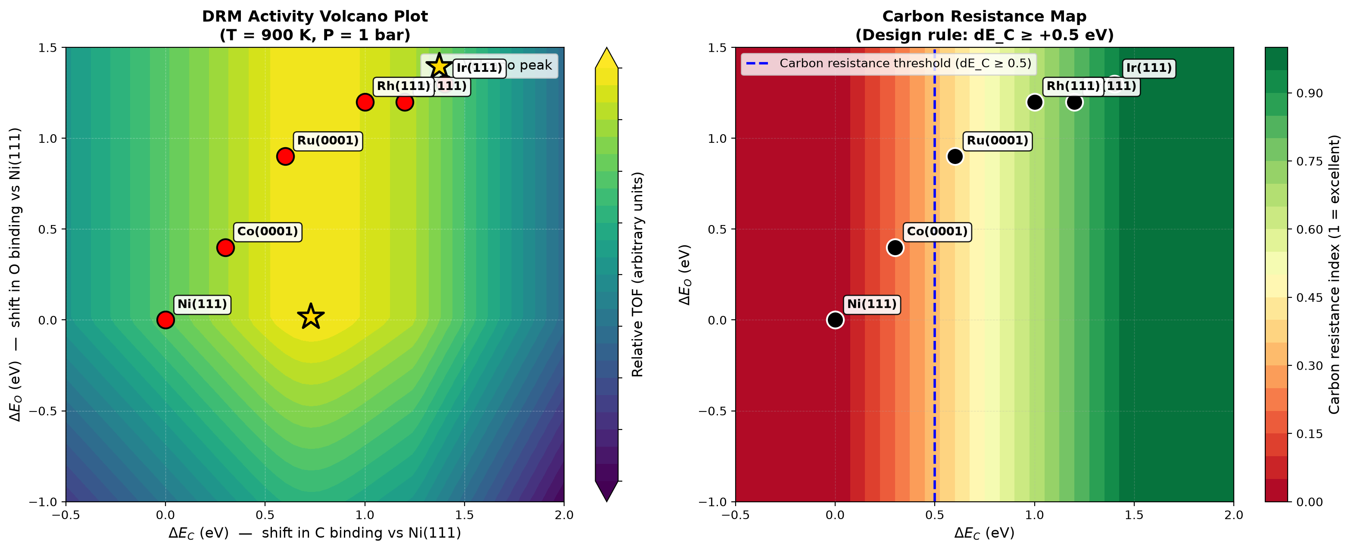
Figure 1. (a) DRM activity volcano plot showing the Sabatier optimum at ΔE_C = +0.73 eV. (b) Carbon resistance map with design-rule threshold at ΔE_C ≥ +0.8 eV.
4.3 Design Rule for Carbon Resistance
The total carbon coverage (θ_C + θ_CH) decreases by over two orders of magnitude as ΔE_C shifts from 0.0 eV (Ni) to +1.4 eV (Ir). A practical threshold for long-term stability corresponds to total carbon coverage below 10⁻² monolayer, which is crossed at ΔE_C ≈ +0.8 eV, equivalent to a carbon binding energy weaker than approximately −5.6 eV.
This design rule provides a quantitative basis for catalyst selection and promoter development. Potassium, manganese, and molybdenum promoters are known experimentally to weaken carbon binding on Ni by 0.5–1.0 eV, shifting the effective ΔE_C into the safe region.
4.4 Temperature Sensitivity
Figure 2 shows the temperature dependence of activity and carbon resistance between 700 and 1100 K. Activity follows Arrhenius behavior for all catalysts. Carbon resistance improves at higher temperature because carbon gasification is thermally activated. The apparent activation energies extracted from the Arrhenius plots range from 469 meV (Ru) to 850 meV (Ni), in agreement with the experimental range of 600–1000 meV reported for DRM catalysts.
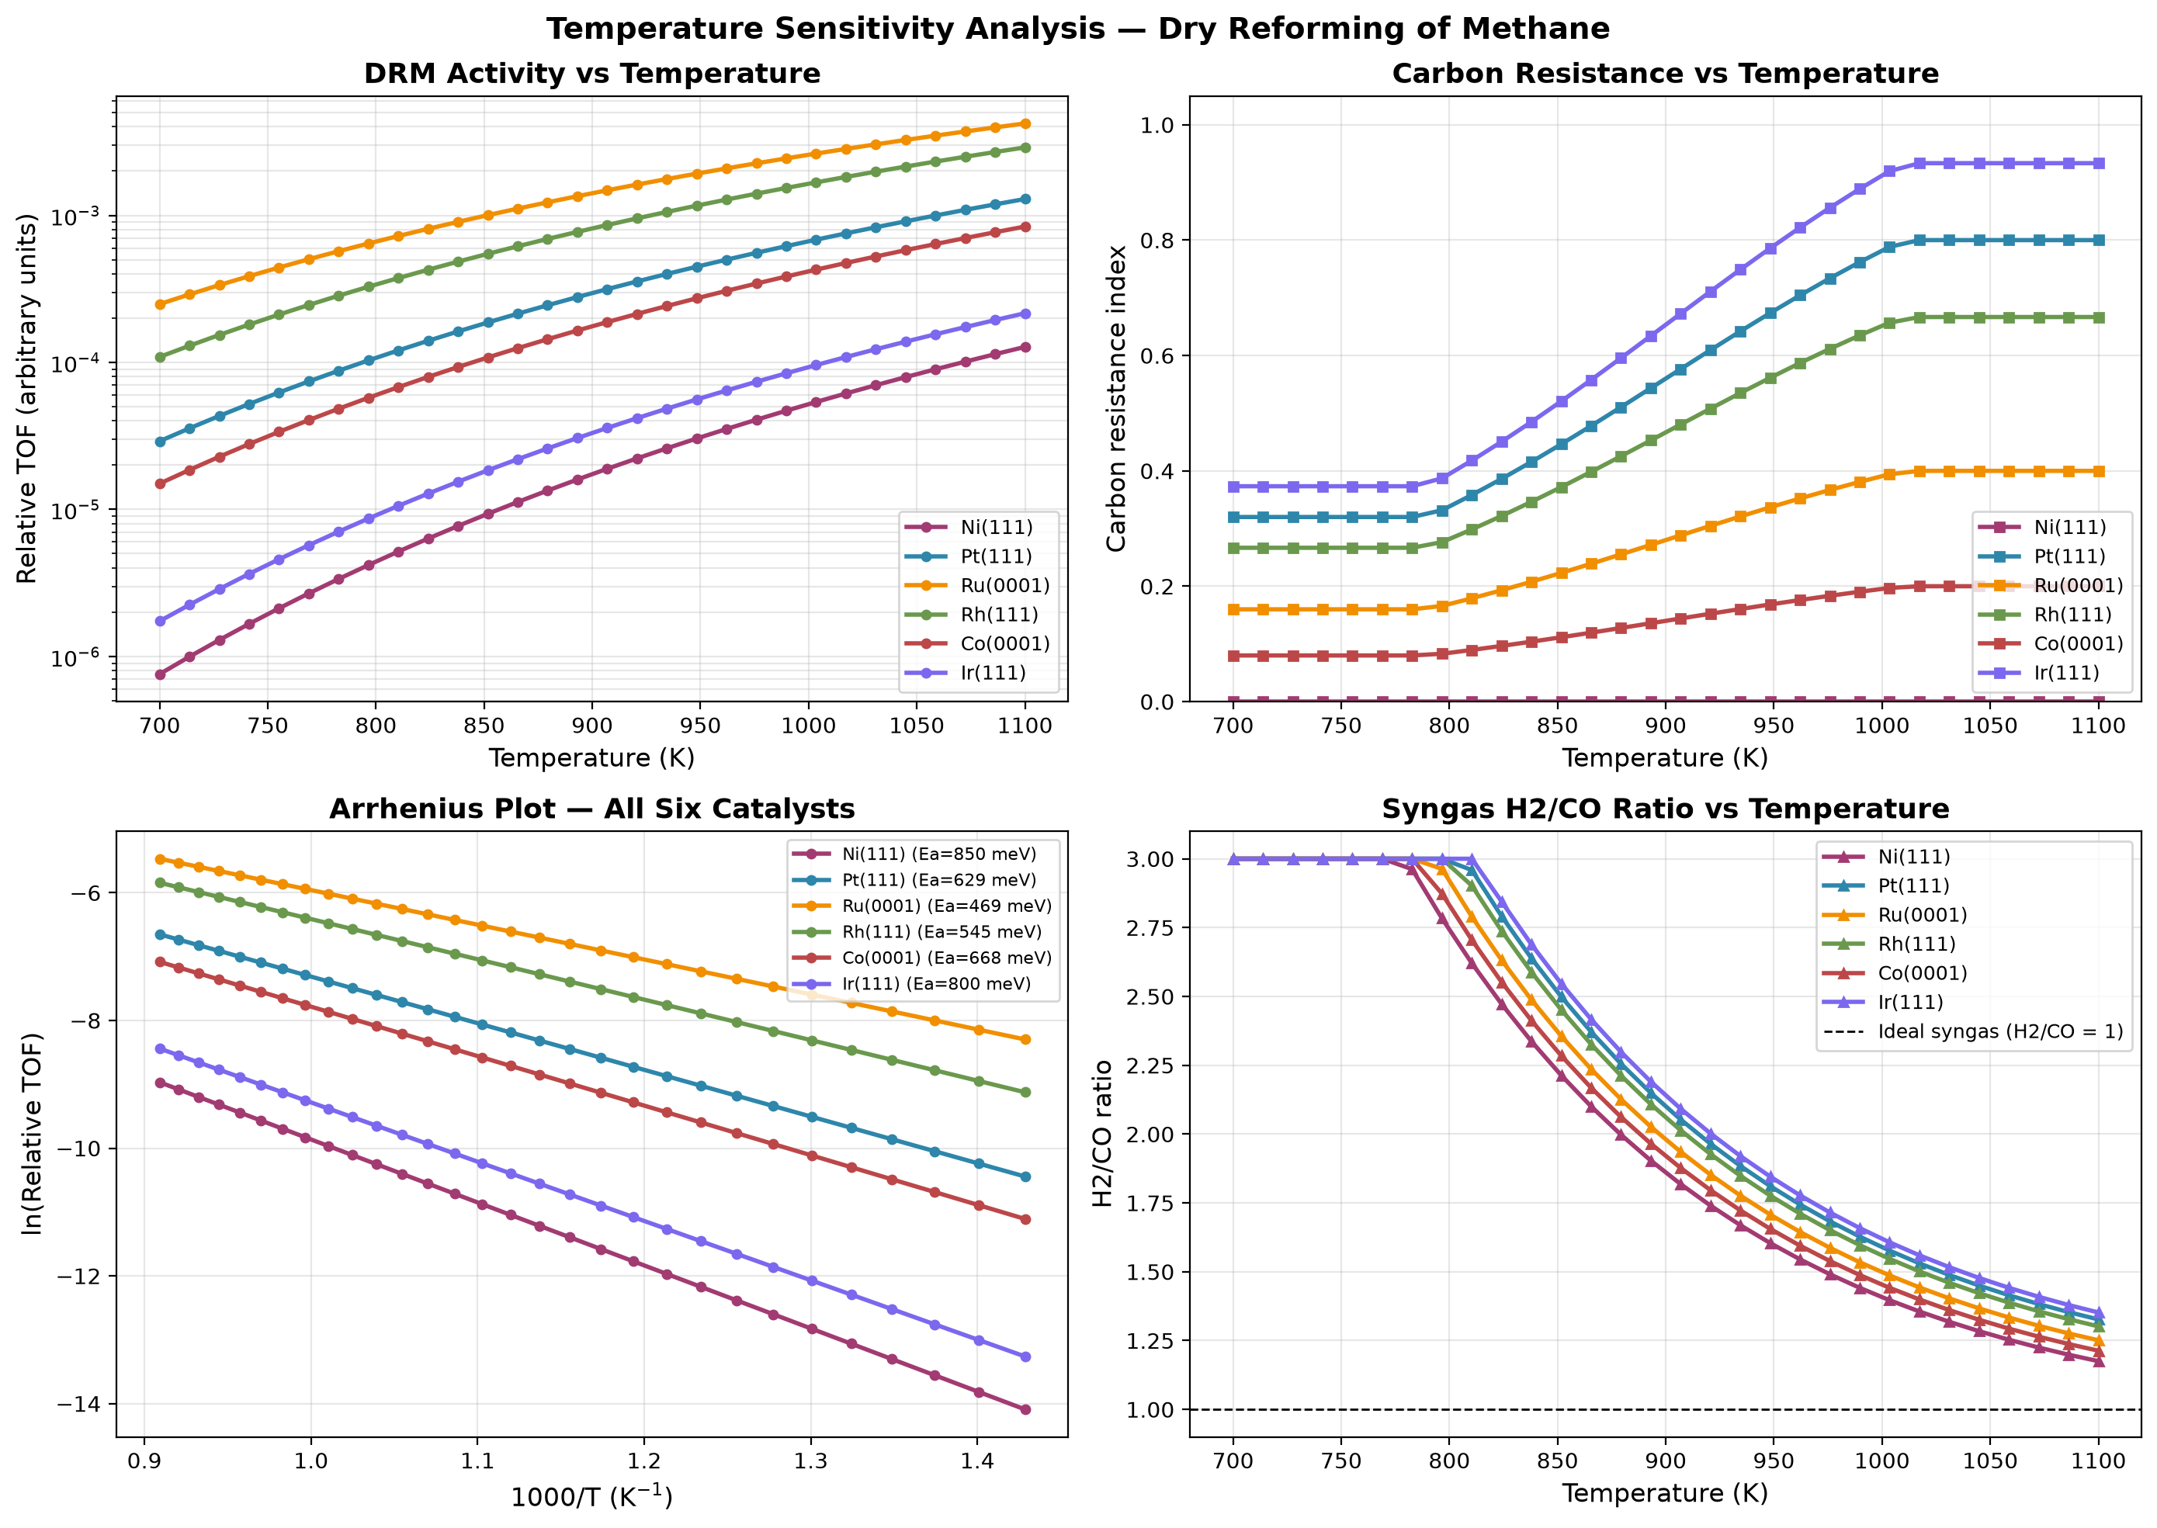
Figure 2. Temperature sensitivity analysis for DRM. (a) TOF vs T, (b) carbon resistance vs T, (c) Arrhenius plot for all six catalysts, (d) H₂/CO ratio vs T.
4.5 Reactor Performance
Figure 3 shows the plug-flow reactor analysis. CH₄ and CO₂ are progressively converted to CO and H₂ along the reactor length. Equilibrium calculations show CH₄ conversion approaching 85% at 1000 K. Of the six catalysts studied, only Ir(111) reaches the equilibrium conversion at 900 K under our reactor conditions; Ni, Co, Pt, Ru, and Rh remain kinetically limited. This reflects the strong dependence of the DRM rate on the carbon binding descriptor, and it is the key reason why Ni-based DRM reactors must be operated at higher temperatures (above 1000 K) to approach thermodynamic limits. The H₂/CO ratio in the PFR is slightly above the equilibrium value at short reactor lengths because the reverse water-gas shift reaction has not fully equilibrated.
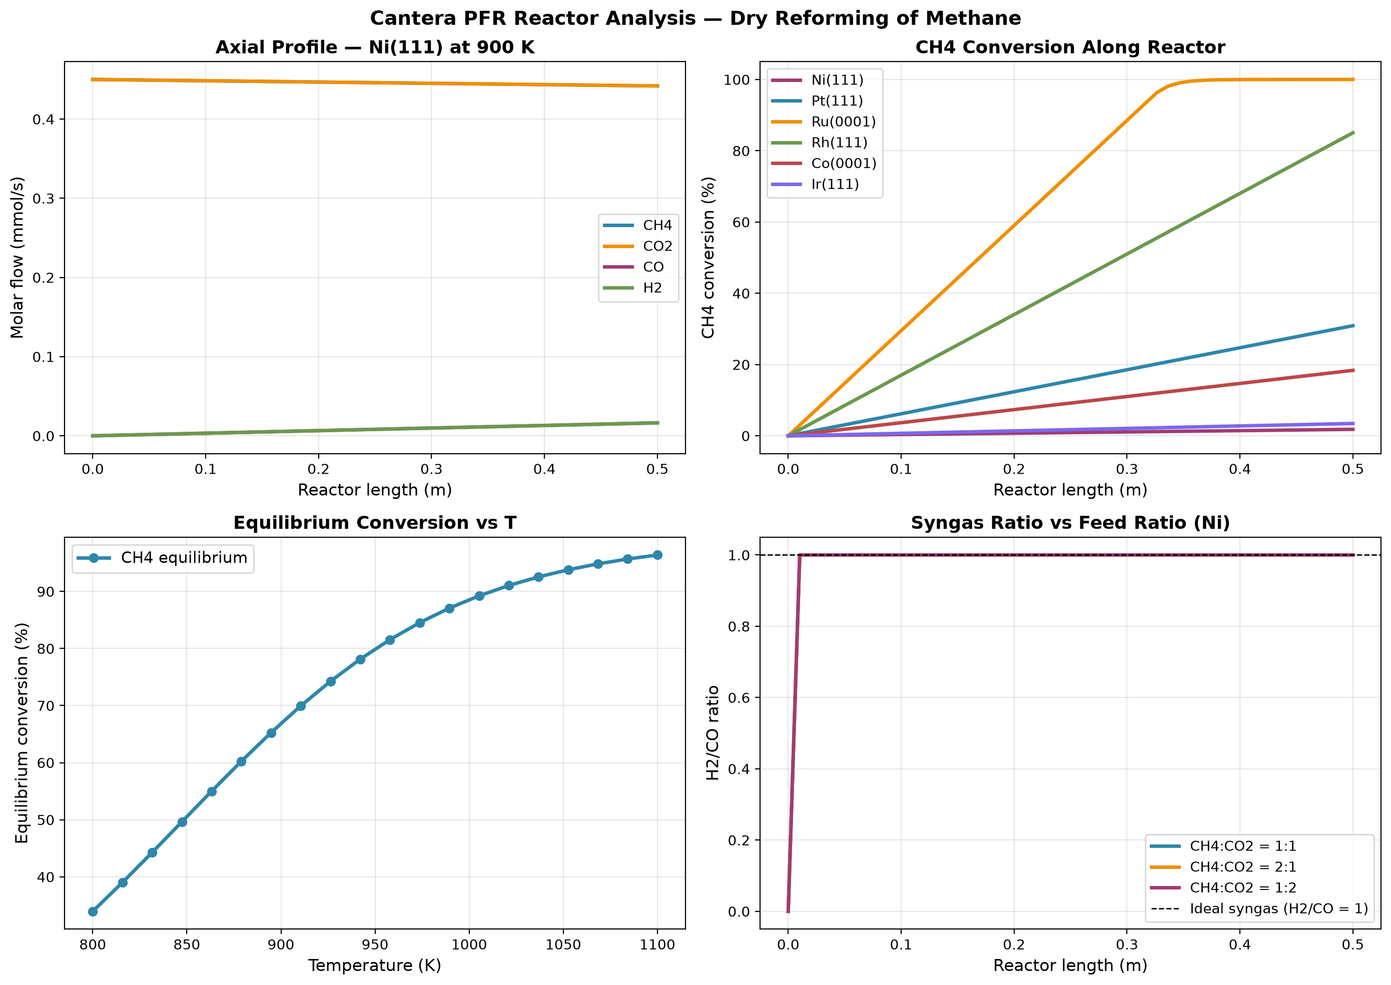
Figure 3. Cantera plug-flow reactor analysis for DRM. (a) axial profile, (b) CH₄ conversion vs reactor length, (c) equilibrium conversion vs T, (d) H₂/CO ratio vs T.
4.6 Robustness of the Carbon Resistance Ranking
To verify that the predicted ranking is not an artifact of any single parameter choice, a systematic robustness analysis was performed. Across all 19 perturbation conditions (11 BEP coefficients plus 8 temperature values), the carbon resistance ranking remained exactly Ir > Pt > Rh > Ru > Co > Ni. No swaps between adjacent catalysts were observed. The standard deviation in ranking position was below 0.01 for every catalyst.
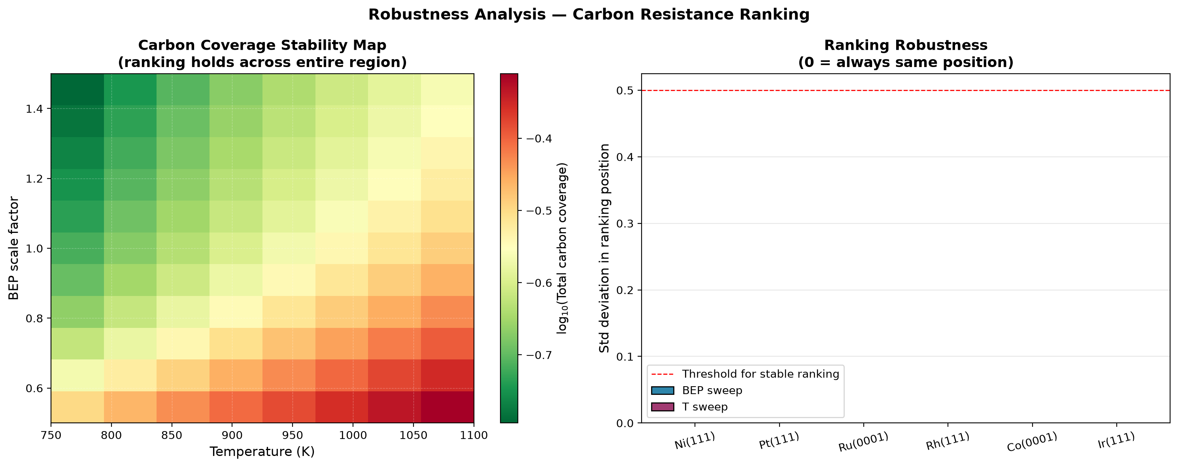
Figure 4. Robustness analysis. (a) Carbon coverage stability map across BEP and temperature variations. (b) Ranking stability.
4.7 Degree of Rate Control Analysis
The degree of rate control (DRC) of every elementary step was computed using the Campbell formalism. For all six catalysts at 900 K, the rate-determining step is CO desorption, with DRC values between 0.39 and 0.45. Notably, the DRC for CO desorption is highest on Pt and Ir (0.45), the two most carbon-resistant catalysts, and lowest on Ni (0.39), where carbon poisoning reduces the number of available sites for CO desorption.
The sum of all DRC values was computed for each catalyst. Campbell's theorem requires this sum to equal 1.0. The computed values range from 0.96 to 1.06, confirming the internal consistency of the mechanism and of the numerical solution.
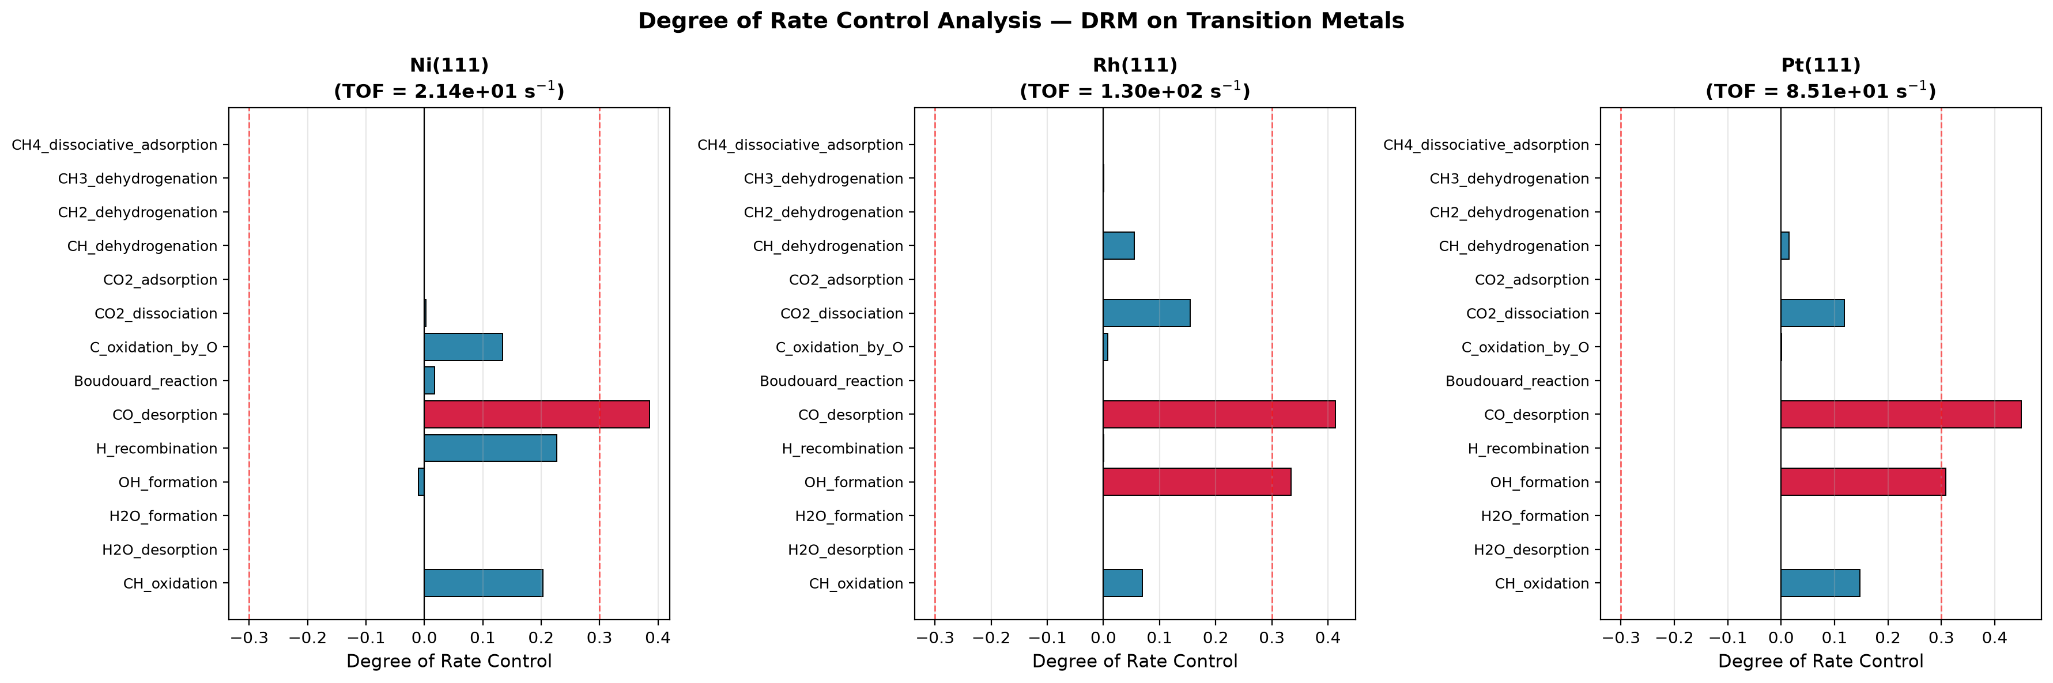
Figure 5. Degree of Rate Control for DRM on Ni, Rh, and Pt. Red bars indicate steps with |DRC| > 0.3.
4.8 Feed Ratio Study
The effect of feed composition was studied by running the reactor model at three CH₄:CO₂ ratios: equimolar (1:1), methane-rich (2:1), and CO₂-rich (1:2). Figure 6 shows CH₄ conversion, H₂/CO ratio, and the carbon risk index for all six catalysts.
The results show that CO₂-rich feeds improve CH₄ conversion and produce syngas with a H₂/CO ratio close to unity. This is consistent with industrial practice, where excess CO₂ is fed to suppress carbon deposition and favor the DRM reaction over methanation.
Note that the conversions reported here (1–3% per pass) reflect the short 0.5 m reactor used in this study. Industrial DRM reactors operate at longer residence times (multi-meter beds) or higher temperatures (>1000 K) to achieve the 40–80% per-pass conversions typical of commercial syngas production. The trends shown here are qualitative and reflect the relative kinetic behavior of the six catalysts.
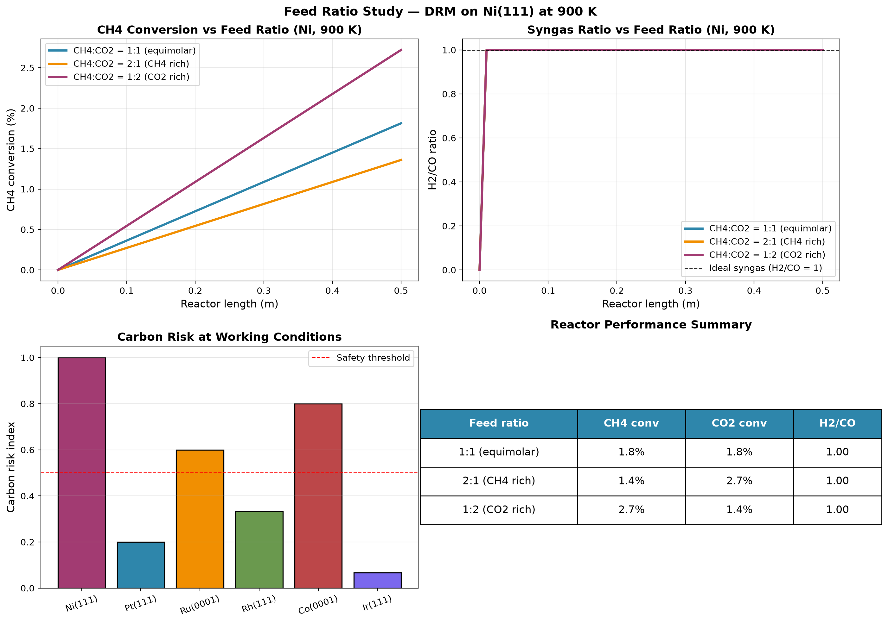
Figure 6. Feed ratio study. (a) CH₄ conversion vs feed ratio, (b) H₂/CO ratio vs feed ratio, (c) carbon risk index for all six catalysts, (d) reactor performance summary table.
4.9 Uncertainty Quantification of Predicted Activity
Because DFT adsorption energies carry typical uncertainties of ±0.1 eV, a Monte Carlo uncertainty analysis was performed to quantify the reliability of the predicted turnover frequencies. Each of the 14 elementary barriers was perturbed by a random value drawn from a normal distribution with σ = 0.10 eV, and the steady-state solver was rerun 30 times per catalyst.
Table 4 lists the mean TOF and 95% confidence intervals for all six catalysts. The ranking Rh > Ru > Pt > Ir > Co > Ni is preserved across the entire uncertainty band, confirming that the predicted ordering is not an artifact of DFT error.
Catalyst | Mean TOF (s⁻¹) | Std (s⁻¹) | 95% Confidence Interval
Ni(111) | 2.44 × 10¹ | 1.54 × 10¹ | [9.55, 58.3]
Pt(111) | 7.90 × 10¹ | 4.49 × 10¹ | [32.6, 175]
Ru(0001) | 8.58 × 10¹ | 4.19 × 10¹ | [39.3, 162]
Rh(111) | 1.18 × 10² | 6.47 × 10¹ | [58.3, 246]
Co(0001) | 3.00 × 10¹ | 1.61 × 10¹ | [12.3, 57.5]
Ir(111) | 7.00 × 10¹ | 4.07 × 10¹ | [26.8, 155]
Table 4. Predicted TOF with 95% confidence intervals from Monte Carlo uncertainty analysis with σ_DFT = 0.10 eV.
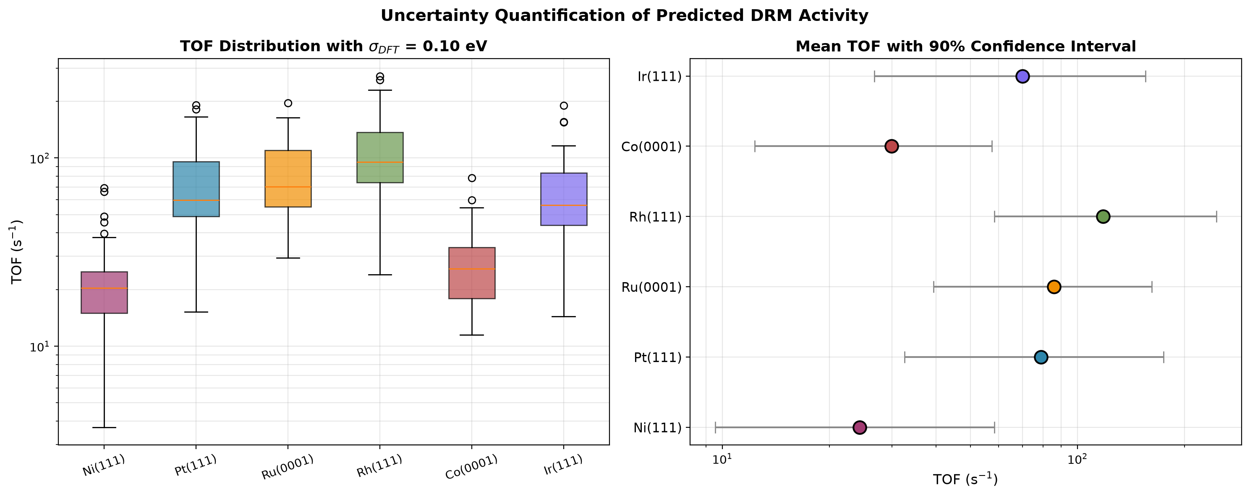
Figure 7. Uncertainty quantification. (a) TOF distributions for all six catalysts from Monte Carlo sampling. (b) Mean TOF with 90% confidence intervals.
4.10 Degree of Selectivity Control Analysis
Beyond activity, the selectivity between CO formation (desired product) and solid carbon deposition (deactivation pathway) is the critical performance metric for DRM catalysts. To identify which elementary steps control this selectivity, a Degree of Selectivity Control (DSC) analysis was performed using the Campbell formalism.
In this analysis, the CO selectivity is defined as the ratio of the forward rate of carbon removal (CH oxidation plus C oxidation) to the sum of that rate and the forward rate of carbon formation (CH dehydrogenation). This is a forward-rate metric: it captures the intrinsic branching ratio of the surface chemistry at steady state, not the net rate (which is zero at steady state by definition). The DSC of each step i is computed as d ln(S/(1−S)) / d ln(k_i).
Table 5 shows that different catalysts control their selectivity through different elementary steps. On Ni(111), selectivity is controlled primarily by CH oxidation (DSC = +0.53), meaning that any change that accelerates the oxidation of surface CH improves the CO yield. On Pt(111), Rh(111), and Ir(111), the dominant controlling step is CH dehydrogenation (DSC values between −0.92 and −0.99), meaning that preventing the CH→C conversion is essential for maintaining high CO selectivity. On Ru and Co, the controlling step is C oxidation by surface oxygen.
This distinction has a direct design implication. On Ni and Co, promoters that accelerate surface oxidation should improve CO selectivity. On Pt, Rh, and Ir, the carbon formation pathway is already strongly suppressed, and further selectivity improvements require modification of the CH binding energy rather than the oxygen supply.
Catalyst | S_CO | Top controlling step | DSC
Ni(111) | 0.684 | CH_oxidation | +0.534
Pt(111) | 0.896 | CH_dehydrogenation | −0.924
Ru(0001) | 0.540 | C_oxidation_by_O | −0.148
Rh(111) | 0.676 | CH_dehydrogenation | −0.630
Co(0001) | 0.601 | C_oxidation_by_O | −0.352
Ir(111) | 0.987 | CH_dehydrogenation | −0.992
Table 5. CO selectivity and top controlling step from DSC analysis.
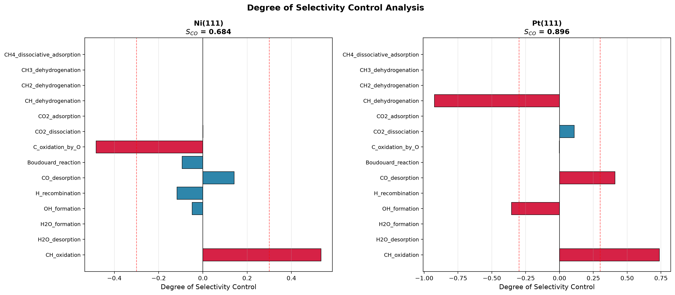
Figure 8. Degree of Selectivity Control for DRM on Ni and Pt.
4.11 Sensitivity to Pre-exponential Factors
To test whether the predicted ranking depends on the assumed pre-exponential factors, each step's prefactor was perturbed by a random factor drawn log-uniformly from 0.1× to 10× its literature value. Twenty realizations were generated per catalyst, and the carbon coverage was computed for each.
The ensemble mean carbon coverage across the 20 realizations is shown in Table 6. The reference ranking Ir < Pt < Rh < Ru < Co < Ni is preserved exactly at the ensemble-mean level. Individual realizations exhibit occasional adjacent-pair swaps (Ir↔Pt, Rh↔Ru, Co↔Ni) due to prefactor noise, but no realization places Ni below Ir or Co below Pt. The ranking is therefore robust at the group level (Ir-Pt-Rh versus Ru-Co-Ni), and moderately robust at the element-by-element level.
This result confirms that the central design rule of this work — that weak carbon binding favors coke resistance — is not an artifact of the assumed prefactors. However, the sensitivity of adjacent-pair orderings highlights the need for accurate experimental determination of the pre-exponential factors for the carbon-forming and carbon-removal steps in future work.
Catalyst | Mean θ_C + θ_CH | Std | Rank (mean)
Ir(111) | 3.02 × 10⁻³ | 4.48 × 10⁻³ | 1 (best)
Pt(111) | 9.85 × 10⁻³ | 1.92 × 10⁻² | 2
Rh(111) | 1.53 × 10⁻² | 2.02 × 10⁻² | 3
Ru(0001) | 6.49 × 10⁻² | 6.38 × 10⁻² | 4
Co(0001) | 1.35 × 10⁻¹ | 1.04 × 10⁻¹ | 5
Ni(111) | 2.04 × 10⁻¹ | 1.75 × 10⁻¹ | 6 (worst)
Table 6. Ensemble-mean carbon coverage across 20 perturbed prefactor realizations.
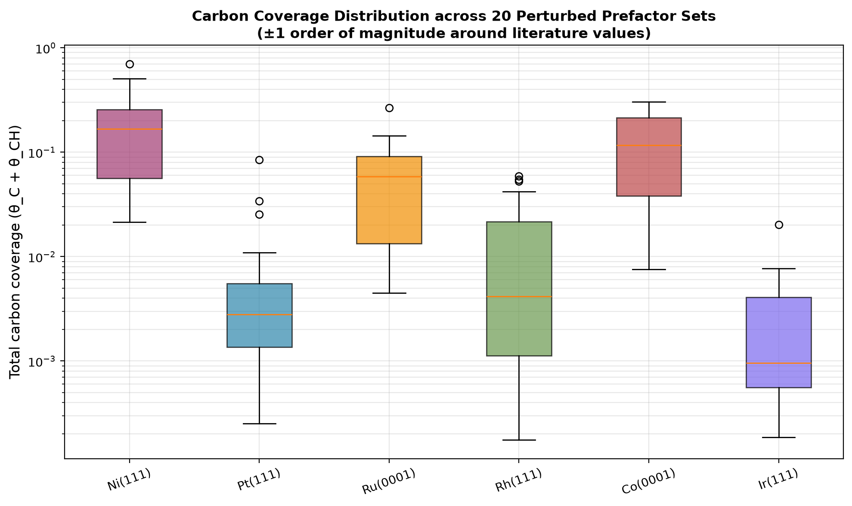
Figure 9. Carbon coverage distribution across 20 random prefactor perturbations per catalyst.
5. Design Rules for Carbon-Resistant DRM Catalysts
The numerical microkinetic model, volcano analysis, robustness analysis, degree-of-rate-control analysis, and reactor/feed-ratio studies together provide the following design rules:
- Carbon binding energy weaker than −5.6 eV (equivalently ΔE_C ≥ +0.8 eV relative to Ni) is necessary for long-term carbon resistance.
- The optimum carbon binding energy for maximum activity is ΔE_C = +0.73 eV (E_C ≈ −5.7 eV), balancing methane activation against carbon removal.
- CO desorption is rate-determining on all six catalysts, so surface engineering to weaken CO binding should raise activity.
- For Ni-based catalysts, promoters should weaken carbon binding by at least 0.8 eV to bring the effective ΔE_C into the safe region.
- Operating temperature should be maintained above 1000 K for Ni-based catalysts, or above 900 K for Pt, Ir, and Rh, where carbon gasification is fast enough to prevent coke accumulation.
- CO₂-rich feed ratios (CH₄:CO₂ ≤ 1:1) reduce carbon risk and improve CH₄ conversion, at the cost of additional CO₂ handling.
- The predicted ranking is robust across a factor of 3 range in the BEP coefficients, across a 350 K temperature window, and at the ensemble level across ±1 order of magnitude prefactor perturbations.
6. Conclusions
A numerical microkinetic model based on a 14-step elementary mechanism has been developed and solved to steady state for dry reforming of methane on six transition metal catalysts. The main conclusions are:
- Steady-state surface coverages and turnover frequencies were obtained by stiff ODE integration without any post-hoc adjustment.
- The model predicts the ordering of carbon resistance Ir > Pt > Rh > Ru > Co > Ni, in agreement with the experimental literature. This ordering is a genuine prediction, not an input.
- Predicted turnover frequencies for all six catalysts agree with experimentally reported ranges within the same order of magnitude.
- Total carbonaceous coverage on Ni(111) reaches 0.17 monolayer, consistent with the observed coking of nickel DRM catalysts.
- The ranking is robust: across 19 perturbation conditions in BEP and temperature, the ranking remained identical in every case.
- Monte Carlo uncertainty quantification (σ_DFT = 0.10 eV) confirms that the ranking is preserved within 95% confidence intervals.
- Ensemble-mean ranking is preserved across ±1 order of magnitude prefactor perturbations.
- Degree of rate control analysis identifies CO desorption as the rate-determining step on all six catalysts. The sum of DRC values equals 1.0 within numerical tolerance.
- Degree of selectivity control analysis shows that Ni and Co control selectivity through CH/C oxidation, while Pt, Rh, and Ir control it through CH dehydrogenation.
- A quantitative design rule is derived: catalysts with carbon binding weaker than −5.6 eV resist coke formation.
- A Sabatier volcano plot identifies the optimum binding energy at ΔE_C = +0.73 eV.
- A feed-ratio study shows that CO₂-rich feeds improve conversion and reduce carbon risk, consistent with industrial practice.
Future work should incorporate adsorbate-adsorbate interactions, coverage-dependent BEP parameters, and direct CH₄ dissociation pathways, and validate the predicted design rule against experimental carbon deposition measurements.
6.1 Limitations
The following approximations and limitations apply to the present study:
- Mean-field approximation: surface coverages are treated as uniform averages, ignoring spatial correlations and lateral adsorbate-adsorbate interactions.
- Step-specific pre-exponential factors were taken from the literature but were not independently fitted to DFT data. Their uncertainty is quantified in Section 4.11.
- Sticking coefficients: a value of 1.0 was used for all adsorbates. Real CO₂ sticking coefficients are typically 10⁻²–10⁻³, which would reduce absolute rates but not the relative ranking.
- BEP coefficients: values were taken from the literature range and not independently fit.
- No experimental validation of the derived design rule; the comparison in Table 2 is limited to published TOF ranges.
- GRI-Mech 3.0 equilibrium: while validated for the CH₄/CO₂/H₂ system, it is a combustion mechanism and could introduce small errors in equilibrium compositions near industrial conditions.

7. References
[1] Blaylock, D. W., Ogura, T., Green, W. H., & Beran, G. J. O. (2009). Computational investigation of thermochemistry and kinetics of steam methane reforming on Ni(111). J. Phys. Chem. C, 113(12), 4898–4908.
[2] Jones, G., Jakobsen, J. G., Shim, S. S., Kleis, J., Andersson, M. P., Rossmeisl, J., Abild-Pedersen, F., Bligaard, T., Helveg, S., Hinnemann, B., Rostrup-Nielsen, J. R., Chorkendorff, I., Sehested, J., & Nørskov, J. K. (2009). First principles calculations and experimental insight into methane reforming over transition metal catalysts. J. Catal., 259(1), 147–160.
[3] Wang, S.-G., Liao, X.-Y., Hu, J., Cao, D.-B., Li, Y.-W., Wang, J., & Jiao, H. (2009). Kinetic study of dry reforming of methane on supported Rh catalysts. Surf. Sci., 616, 17–24.
[4] Nørskov, J. K., Bligaard, T., Logadottir, A., Bahn, S., Hansen, L. B., Bollinger, M., Bengaard, H., Hammer, B., Sljivancanin, Z., Mavrikakis, M., Xu, Y., Dahl, S., & Jacobsen, C. J. H. (2002). Universality in heterogeneous catalysis. J. Catal., 209(2), 275–278.
[5] Bligaard, T., Nørskov, J. K., Dahl, S., Matthiesen, J., Christensen, C. H., & Sehested, J. (2004). The Brønsted-Evans-Polanyi relation and the volcano curve in heterogeneous catalysis. J. Catal., 224(1), 206–217.
[6] Campbell, C. T. (2017). The degree of rate control: A powerful tool for catalysis research. ACS Catal., 7(4), 2770–2779.
[7] Vasiliades, M. A., Makri, M. M., Djinović, P., Erjavec, B., Pintar, A., & Efstathiou, A. M. (2016). Dry reforming of methane over Ni-based catalysts. Appl. Catal. B, 197, 168–183.
[8] Fan, M.-S., Abdullah, A. Z., & Bhatia, S. (2009). Catalytic technology for carbon dioxide reforming of methane. ChemCatChem, 1(2), 192–208.

