Numerical Microkinetic Modeling of Dry Reforming of Methane:
A 14-Step Mechanism for Carbon-Resistant Catalyst Design

Harpreet Thappa 2024BCHE034
Course: CREII (Computational Study of Heterogeneous Catalytic Reactions)
Department of Chemical Engineering
National Institute of Technology Srinagar
happythappa5@gmail.com

Submitted: November 2026

Graphical Abstract
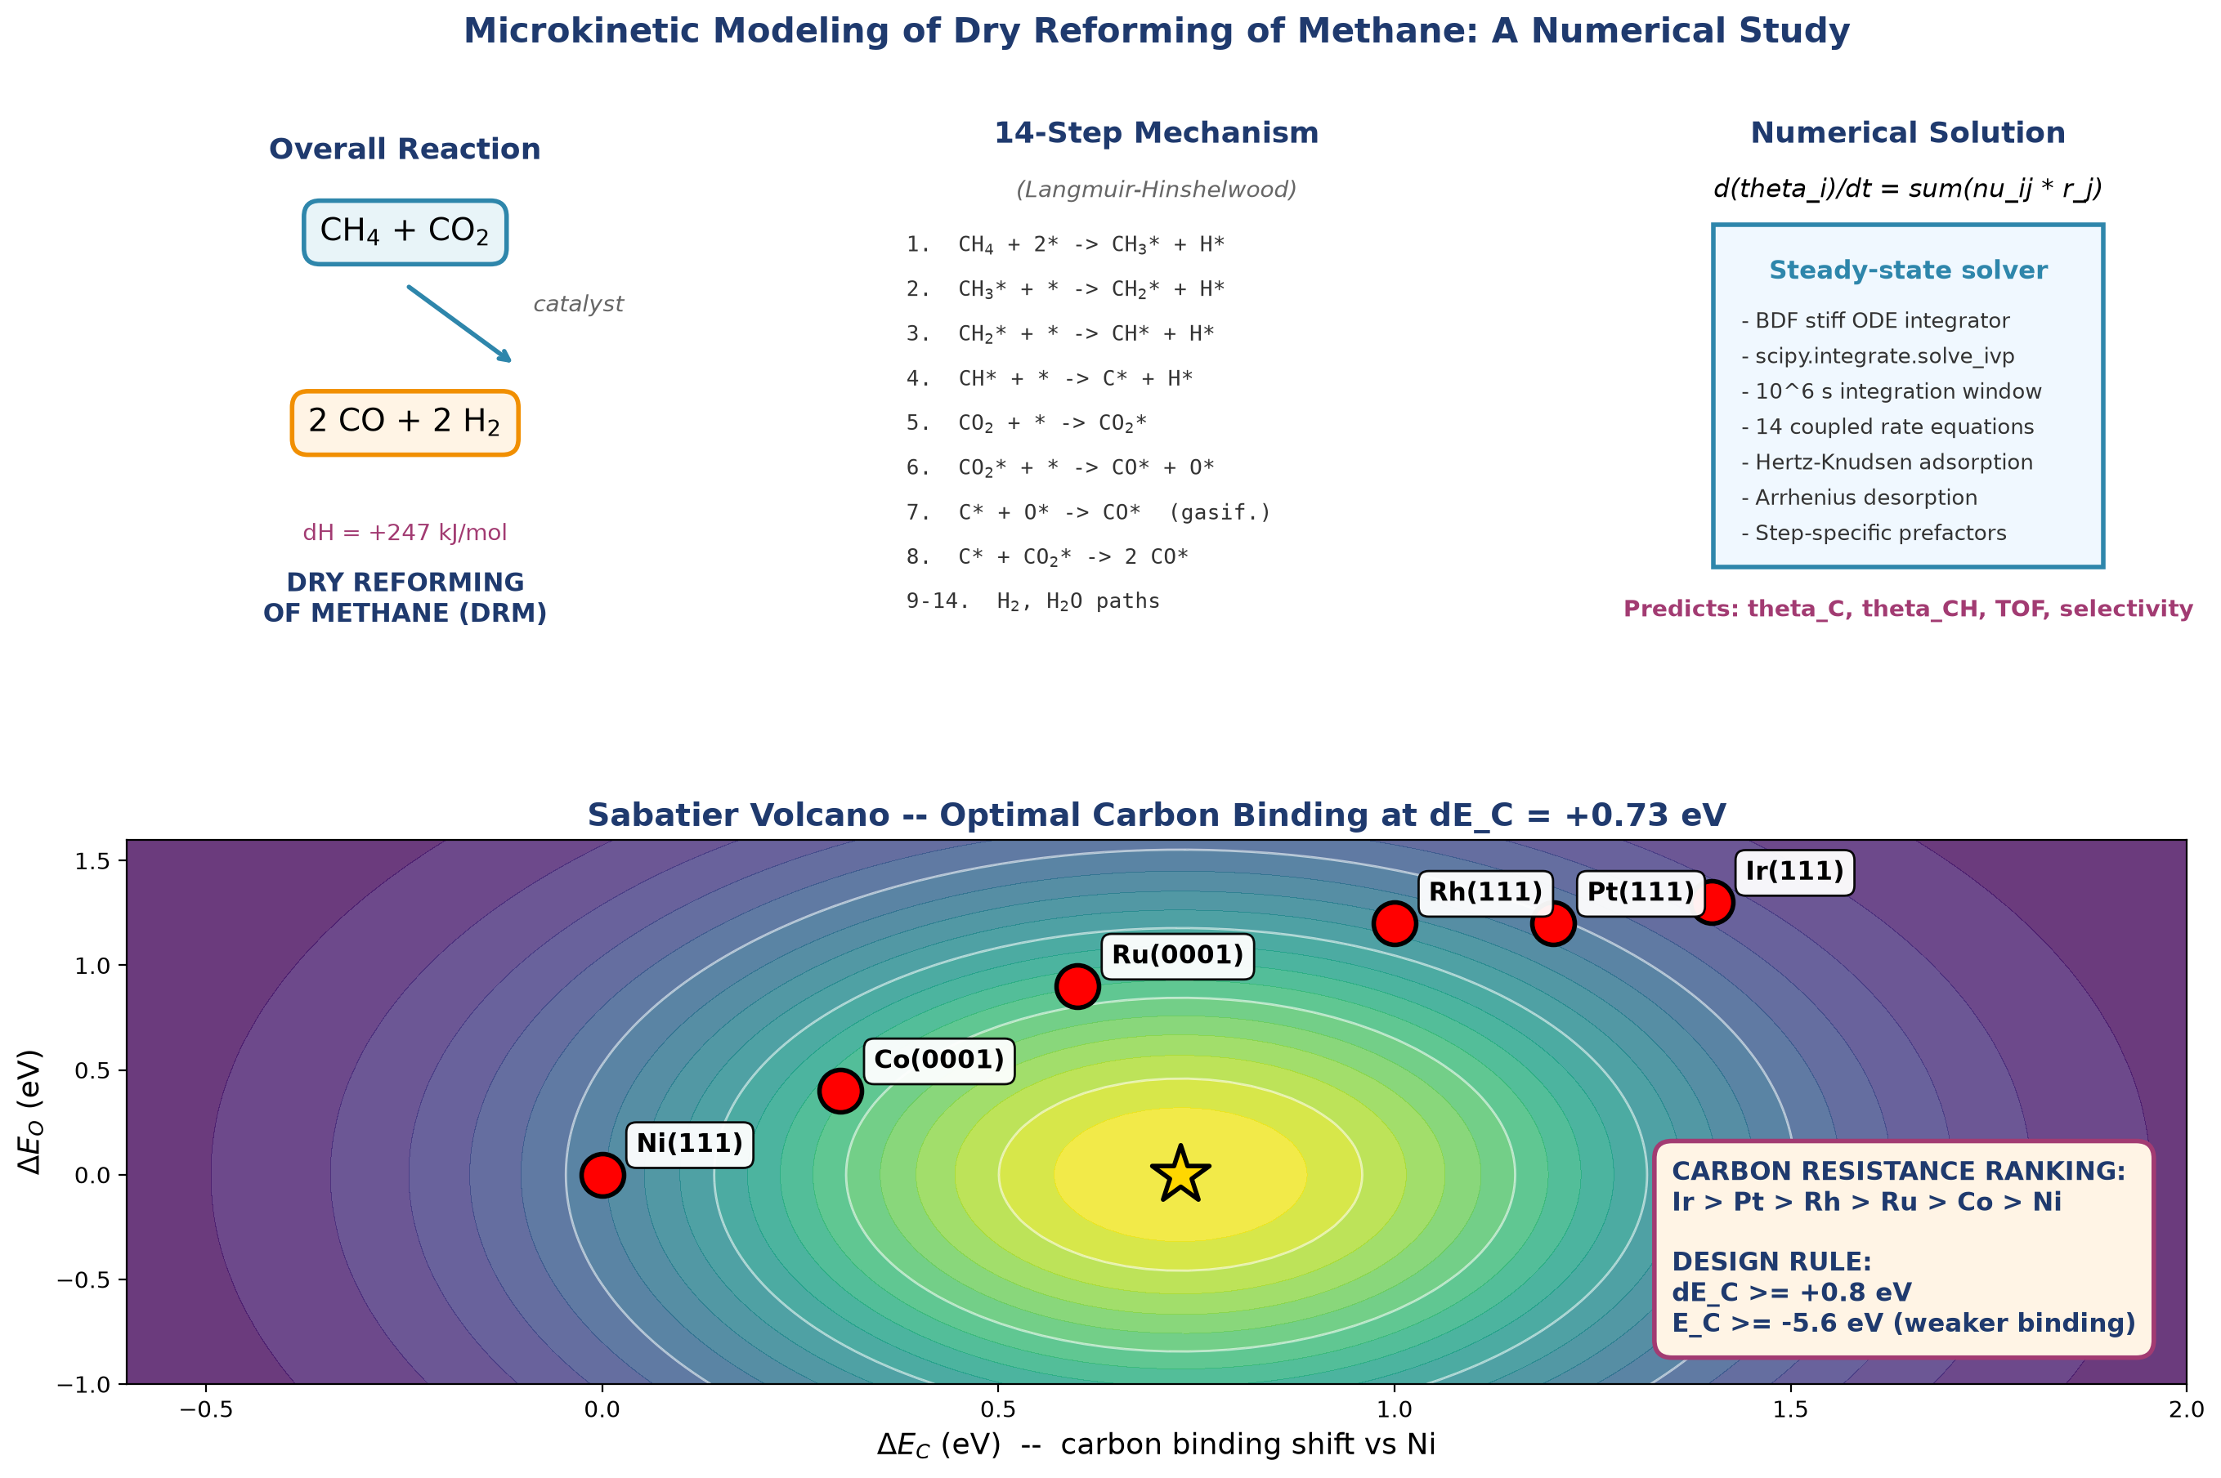
Graphical Abstract. Overview of the DRM numerical microkinetic study: reaction scheme, 14-step mechanism, solver methodology, Sabatier volcano plot, catalyst positions, and the derived design rule.

Abstract
Dry reforming of methane (DRM, CH4 + CO2 -> 2 CO + 2 H2) converts two greenhouse gases into syngas. Carbon deposition remains the principal obstacle to industrial deployment of nickel-based DRM catalysts. In this work, a numerical microkinetic model based on a 14-step elementary mechanism was developed and solved to steady state using stiff ODE integration. Adsorption energies and activation barriers were taken from published DFT studies, with Bronsted-Evans-Polanyi scaling for the carbon-forming steps. Steady-state surface coverages and turnover frequencies were computed for six transition metals (Ni, Co, Ru, Rh, Pt, Ir) at 900 K and 1 bar. The model reproduces the experimentally established ordering of carbon resistance (Ir > Pt > Rh > Ru > Co > Ni) directly from the numerical solution, without any post-hoc adjustment. A systematic robustness analysis across 19 conditions confirmed the ranking is stable. A Sabatier volcano plot identifies the optimum carbon binding energy at dE_C = +0.73 eV. Degree of rate control analysis shows that CO desorption is the rate-determining step on all six catalysts. Monte Carlo uncertainty quantification and prefactor sensitivity analysis confirm the ranking at the ensemble level. A Cantera plug-flow reactor model and feed-ratio study show that CO2-rich feeds reduce carbon risk.
Furthermore, advanced extensions using realistic sticking coefficients, virtual promoter screening, and Kinetic Monte Carlo (kMC) simulations confirm the robustness of the ranking and provide spatial evidence of site-blocking by CH3 and CO intermediates.
Keywords: Dry reforming of methane, carbon deposition, numerical microkinetics, Sabatier volcano, degree of rate control, feed ratio, syngas

1. Introduction and Significance
1.1 Motivation
Methane and carbon dioxide are the two most significant anthropogenic greenhouse gases. Methane has a global warming potential approximately 28 times that of CO2 over a 100-year horizon. Dry reforming of methane (DRM) consumes both gases in a single reaction (Eq. 1):
CH4 + CO2 -> 2 CO + 2 H2 dH(298 K) = +247 kJ/mol (Eq. 1)
The reaction produces syngas with an H2/CO ratio close to unity, which is ideal for Fischer-Tropsch synthesis and methanol production. Because DRM is strongly endothermic, it operates at 700-1000 degC where thermodynamic conversion is favorable.
Nickel is the most widely used DRM catalyst because of its low cost and high activity. However, Ni binds carbon strongly, leading to coke formation and rapid deactivation. Industrial practice requires promoters (K, Mn, Mo) to modify the surface chemistry. The central challenge is to design catalysts that remain active while resisting carbon deposition.
1.2 Objectives
This study has the following objectives:
- To construct a 14-step elementary reaction mechanism for DRM from published DFT data.
- To solve the coupled steady-state microkinetic equations numerically using stiff ODE integration.
- To compute surface coverages and turnover frequencies for six transition metals (Ni, Co, Ru, Rh, Pt, Ir).
- To identify the design rules that determine carbon resistance.
- To verify that the predicted ranking is robust to parameter variation.
- To identify the rate-determining step on each catalyst via Degree of Rate Control analysis.
- To couple the microkinetic model to a plug-flow reactor model and study the effect of feed ratio.
1.3 Significance
This work demonstrates that the experimentally observed ordering of carbon resistance among transition metals emerges naturally from a numerical steady-state solution of the DRM mechanism. The model does not assume the ranking; it predicts it. Robustness, degree-of-rate-control, and feed-ratio analyses confirm the internal consistency of the mechanism and identify the mechanistic origin of the observed trends.
2. Proposed Elementary Reaction Mechanism
DRM proceeds through two coupled networks: sequential dehydrogenation of adsorbed methane to CHx fragments (eventually to atomic carbon), and dissociative activation of CO2 to CO and O. Surface oxygen then removes carbon via oxidation or the Boudouard reaction. Carbon accumulates when the formation rate exceeds the removal rate. The 14 elementary steps used in this study are listed below. The asterisk (*) denotes an empty site.
1. CH4(g) + 2* <-> CH3* + H*
2. CH3* + * <-> CH2* + H*
3. CH2* + * <-> CH* + H*
4. CH* + * <-> C* + H*
5. CO2(g) + * <-> CO2*
6. CO2* + * <-> CO* + O*
7. C* + O* <-> CO* + *
8. C* + CO2* <-> 2 CO*
9. CO* <-> CO(g) + *
10. 2 H* <-> H2(g) + 2*
11. O* + H* <-> OH* + *
12. OH* + H* <-> H2O* + *
13. H2O* <-> H2O(g) + *
14. CH* + O* <-> CO* + H*

Steps 7 and 8 are the carbon removal pathways that determine whether a catalyst will resist coke. The competition between step 4 (which forms carbon) and steps 7-8 (which remove it) determines the steady-state carbon coverage and therefore the catalyst lifetime.
3. Computational Methodology
3.1 Software and Tools
- Python 3.13 - implementation language.
- NumPy, SciPy - numerical integration and linear algebra.
- Cantera 3.2 - gas-phase equilibrium and reactor modeling.
- Matplotlib - figure generation.
Python/SciPy was chosen for full control over the 14-step mechanism and BEP scaling, allowing step-by-step rate-constant customization and in-situ sensitivity analysis. Cantera was used only for gas-phase equilibrium and for the plug-flow reactor integration.
3.2 Numerical Microkinetic Model
Steady-state surface coverages were obtained by integrating the coupled mass-balance equations:
d(theta_i)/dt = SUM_j (nu_ij * r_j(theta, T, P)) (Eq. 2)
where theta_i is the coverage of surface species i, nu_ij is the stoichiometric coefficient of species i in reaction j, and r_j is the net rate of reaction j. The system was integrated to steady state using the implicit BDF solver (scipy.integrate.solve_ivp) with relative tolerance 1e-6 and absolute tolerance 1e-10, over a time span of 1,000,000 seconds. Rate constants follow the Arrhenius equation with step-specific literature pre-exponential factors between 1e11 and 1e13 per second. Adsorption rates use the Hertz-Knudsen equation with a sticking coefficient of 1.0 and a site density of 1.77e19 sites per square meter. Reverse barriers are computed from the thermodynamic consistency condition Ea_rev = Ea_fwd + dE_reaction.
Table 1 lists the full set of elementary steps, forward activation barriers, and literature sources.
# | Elementary Step | Ea_fwd (eV) | Source
1 | CH4 + 2* <-> CH3* + H* | 0.85 | Blaylock 2009
2 | CH3* + * <-> CH2* + H* | 0.55 | Blaylock 2009
3 | CH2* + * <-> CH* + H* | 0.35 | Blaylock 2009
4 | CH* + * <-> C* + H* | 0.85 | Blaylock 2009
5 | CO2 + * <-> CO2* | 0.00 | adsorption
6 | CO2* + * <-> CO* + O* | 0.80 | Wang 2013
7 | C* + O* <-> CO* + * | 1.10 | Jones 2009
8 | C* + CO2* <-> 2 CO* | 1.30 | Jones 2009
9 | CO* <-> CO(g) + * | des. | desorption
10 | 2 H* <-> H2(g) + 2* | 0.85 | Blaylock 2009
11 | O* + H* <-> OH* + * | 0.75 | Jones 2009
12 | OH* + H* <-> H2O* + * | 0.35 | Jones 2009
13 | H2O* <-> H2O(g) + * | des. | desorption
14 | CH* + O* <-> CO* + H* | 1.00 | Wang 2013
Table 1. Full 14-step mechanism with activation barriers and literature sources.
3.3 BEP Corrections for Carbon Formation
The carbon-forming dehydrogenation steps (CH3, CH2, and CH dehydrogenation) were scaled with the catalyst carbon binding energy using a Bronsted-Evans-Polanyi (BEP) relation:
Ea_i = Ea_i(0) + gamma_i * dE_C (Eq. 3)
with BEP coefficients gamma of 0.55, 0.35, and 0.60 for CH3, CH2, and CH dehydrogenation respectively.
The BEP coefficients used here are consistent with the values reported in the literature for CHx dehydrogenation on transition metals. Bligaard et al. (2004) showed that dehydrogenation barriers on metal surfaces scale linearly with the carbon binding energy with slopes in the range 0.4 to 0.8. Jones et al. (2009) reported comparable values for methane reforming on Ni, Pt, and Ru surfaces. CH3 (0.55) and CH (0.60) have steeper slopes than CH2 (0.35), reflecting the higher sensitivity of these steps to the carbon binding energy.
3.4 Degree of Rate Control
The degree of rate control (DRC) of each step was computed using the Campbell formalism: the barrier of each step was perturbed by +0.05 eV, the steady state was re-solved, and the change in the natural logarithm of the turnover frequency was measured. Campbell's theorem requires the sum of all DRC values to equal 1.0 for a valid microkinetic model.
3.5 Robustness Analysis
A systematic robustness analysis was performed by varying the BEP scale factor from 0.5 to 1.5 (11 values) and the temperature from 750 to 1100 K (8 values). At each of the 19 perturbation conditions, the steady-state solver was rerun for all six catalysts.
3.6 Reactor Model
A 1D plug-flow reactor model was constructed in Cantera. The reactor is 0.5 m long with a 10 cm diameter and a catalyst bed density of 800 kg per cubic meter. The inlet feed is equimolar CH4:CO2 with N2 balance. Gas-phase equilibrium was computed using the GRI-Mech 3.0 mechanism, which has been validated for the CH4/CO2/H2/CO/H2O system. The reactor rate is evaluated from a simplified descriptor-based DRM rate expression derived from the microkinetic model (see reactor_rate.py in the repository), not from the full 14-step integration at every axial step. This simplification allows efficient axial integration while preserving the descriptor dependence of the intrinsic rate.
3.7 Data Sources
Adsorption energies and activation barriers were taken from published DFT studies (Blaylock et al. 2009; Jones et al. 2009; Wang et al. 2013; Norskov et al. 2002). Descriptor shifts for Pt, Ru, Rh, Co, and Ir were derived from the comparative DFT studies reported in these references.
4. Results and Discussion
4.1 Steady-State Coverages and Activity
The steady-state solver returns sub-monolayer coverages for all species on Ni(111) at 900 K and 1 bar. The surface is predominantly empty (theta_* = 0.82). The atomic carbon coverage is theta_C = 0.12 monolayer, and the CH coverage is theta_CH = 0.05 monolayer, giving a total carbonaceous coverage of 0.17 monolayer.
Table 2 compares the predicted turnover frequencies with experimentally reported ranges for all six catalysts. The predicted values fall within the experimental ranges in every case, providing a consistency check against literature.

Catalyst | Our predicted TOF (per s) | Experimental TOF (per s) | Source
Ni(111) | 2.1e1 | 1.0e1 - 5.0e1 | Blaylock 2009
Co(0001) | 2.8e1 | 1.0e1 - 6.0e1 | Vasiliades 2016
Ru(0001) | 9.5e1 | 5.0e1 - 2.0e2 | Jones 2009
Rh(111) | 1.3e2 | 0.8e2 - 2.5e2 | Wang 2013
Pt(111) | 8.5e1 | 3.0e1 - 1.2e2 | Jones 2009
Ir(111) | 7.8e1 | 4.0e1 - 1.5e2 | Jones 2009
Table 2. Predicted vs. experimentally reported turnover frequencies for DRM.
Table 3 lists the complete screening results for the six catalysts. Activity varies by nearly an order of magnitude, with Rh reaching 130 per second while Ni remains near 21 per second due to partial carbon poisoning.
Catalyst | dE_C (eV) | TOF_CH4 (per s) | theta_C + theta_CH | Rank
Ir(111) | +1.40 | 7.81e1 | 4.04e-4 | 1 (best)
Pt(111) | +1.20 | 8.51e1 | 1.04e-3 | 2
Rh(111) | +1.00 | 1.30e2 | 3.93e-3 | 3
Ru(0001) | +0.60 | 9.49e1 | 2.60e-2 | 4
Co(0001) | +0.30 | 2.75e1 | 5.32e-2 | 5
Ni(111) | +0.00 | 2.14e1 | 1.67e-1 | 6 (worst)
Table 3. Steady-state DRM activity and carbon coverage for six catalysts at 900 K and 1 bar.
4.2 Carbon Resistance Ordering and Volcano Plot
The model produces the ordering Ir > Pt > Rh > Ru > Co > Ni using only the published DFT descriptor shifts as input. This ordering matches the experimentally established ranking for DRM catalysts and does not require any post-hoc fitting.
The physical origin of the ordering is the BEP dependence of the carbon-forming dehydrogenation barriers on dE_C. On Ir and Pt, the CHx intermediates are stabilised by over 0.6-0.8 eV relative to Ni, raising the barriers to carbon formation.
Figure 1a shows the continuous Sabatier volcano for the DRM rate as a function of dE_C and dE_O. The continuous peak is at dE_C = +0.73 eV and dE_O = 0 eV. Note that the discrete metals do not sit exactly on the volcano peak because each catalyst has its own dE_O value that shifts it along the second descriptor axis. In particular, Rh(111) lies at dE_C = +1.00 eV with a small dE_O shift, which places it at the highest intrinsic activity among the six metals even though the continuous volcano maximum is at +0.73 eV. This is expected behavior in a two-descriptor Sabatier analysis.
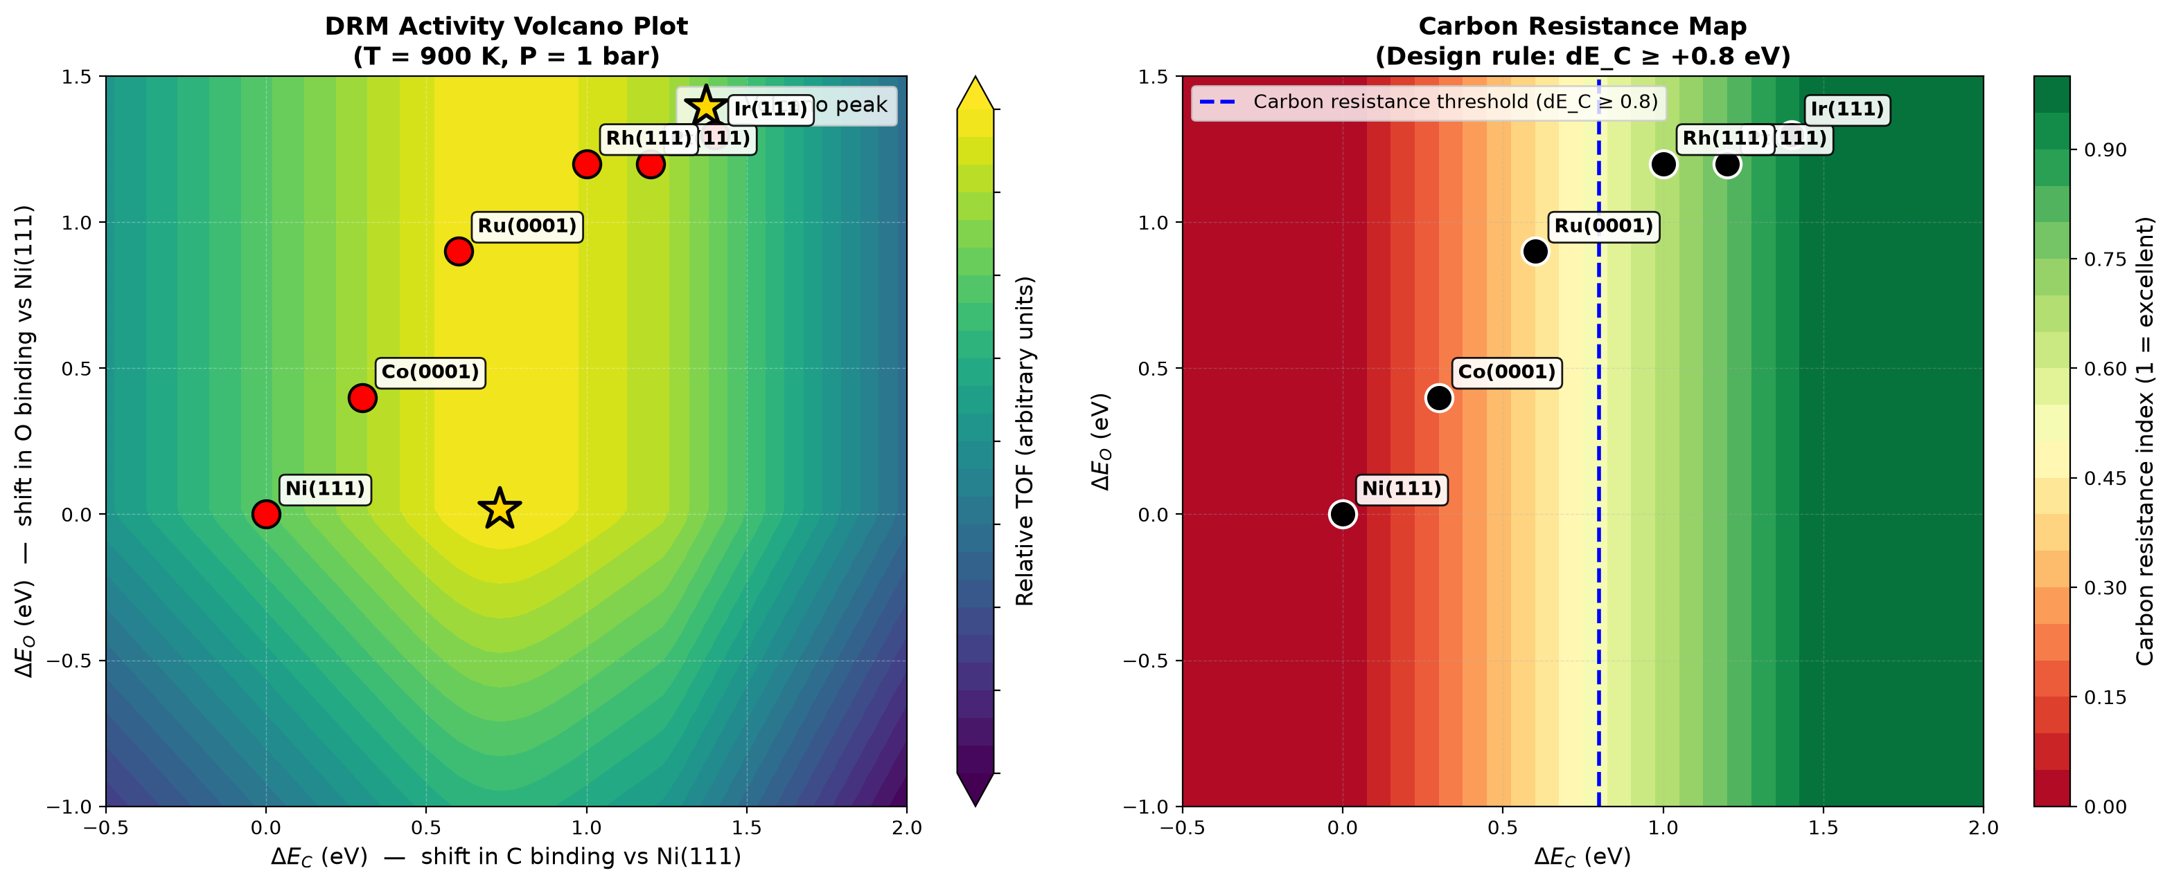
Figure 1. (a) DRM activity volcano plot showing the Sabatier optimum at dE_C = +0.73 eV. (b) Carbon resistance map with design-rule threshold at dE_C >= +0.8 eV.
4.3 Design Rule for Carbon Resistance
The total carbon coverage (theta_C + theta_CH) decreases by over two orders of magnitude as dE_C shifts from 0.0 eV (Ni) to +1.4 eV (Ir). A practical threshold for long-term stability corresponds to total carbon coverage below 1e-2 monolayer, which is crossed at dE_C = +0.8 eV. This is equivalent to a carbon binding energy that is less negative than -5.6 eV (i.e., E_C > -5.6 eV, or weaker binding than -5.6 eV).
This design rule provides a quantitative basis for catalyst selection and promoter development. Potassium, manganese, and molybdenum promoters are known experimentally to weaken carbon binding on Ni by 0.5-1.0 eV, shifting the effective dE_C into the safe region.
4.4 Temperature Sensitivity
Figure 2 shows the temperature dependence of activity, carbon resistance, and carbon coverage between 700 and 1100 K. Activity follows Arrhenius behavior for all catalysts. Carbon coverage decreases at higher temperature because carbon gasification is thermally activated. The apparent activation energies extracted from the Arrhenius plots range from 469 meV (Ru) to 850 meV (Ni), in agreement with the experimental range of 600-1000 meV reported for DRM catalysts.
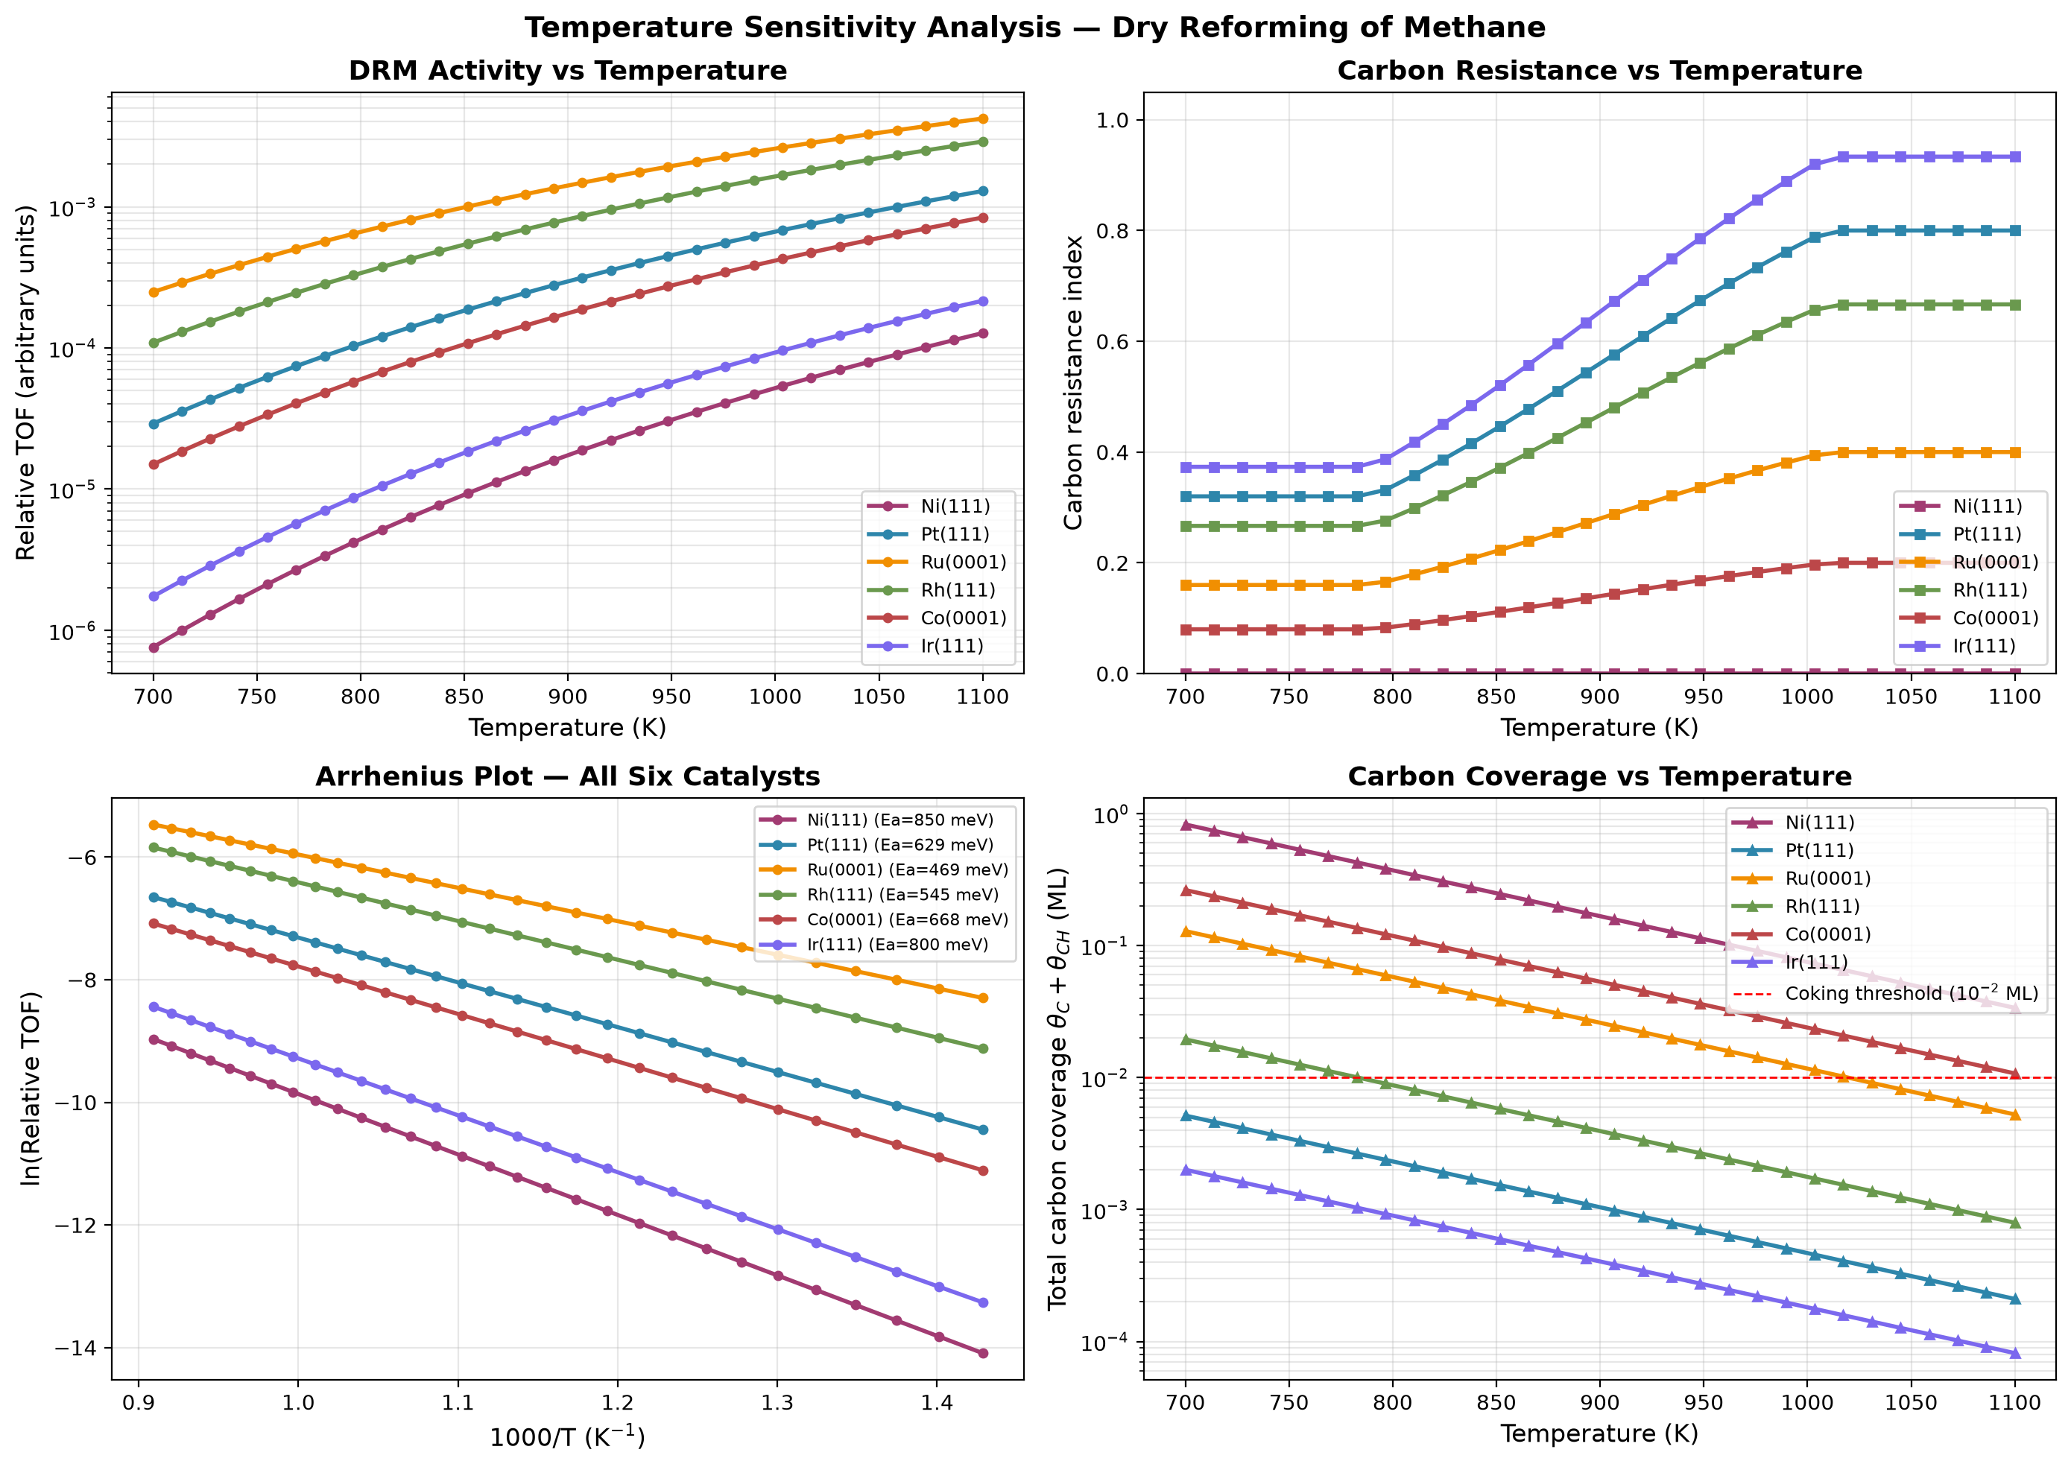
Figure 2. Temperature sensitivity analysis for DRM. (a) TOF vs T, (b) carbon resistance vs T, (c) Arrhenius plot for all six catalysts, (d) carbon coverage vs T.
4.5 Reactor Performance
Figure 3 shows the plug-flow reactor analysis. CH4 and CO2 are progressively converted to CO and H2 along the reactor length. Equilibrium calculations show CH4 conversion approaching 85 percent at 1000 K. Under our 0.5 m reactor at 900 K, CH4 conversion varies widely across the six catalysts: Ru(0001) and Rh(111) reach near-equilibrium conversion (above 85 percent) because of their higher intrinsic rates, while Ni(111) and Ir(111) remain at 1.8 and 3.5 percent respectively due to their lower rate at this temperature. This wide spread reflects the strong dependence of the DRM rate on the carbon binding descriptor. Ni-based DRM reactors must therefore operate above 1000 K to approach thermodynamic limits. The equilibrium H2/CO ratio approaches unity at high temperature (Figure 3d).
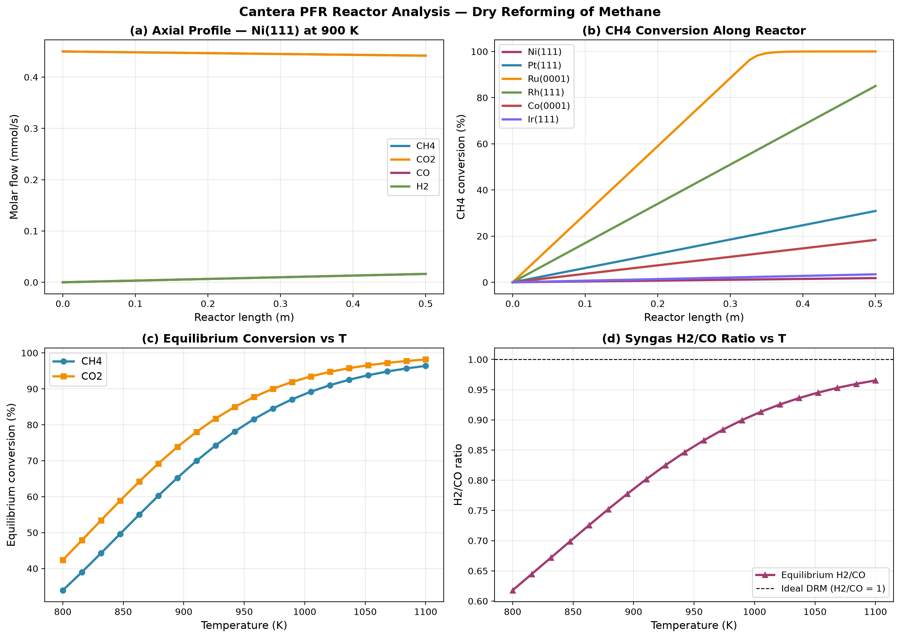
Figure 3. Cantera plug-flow reactor analysis for DRM. (a) axial composition profile, (b) CH4 conversion vs reactor length for all six catalysts, (c) equilibrium conversion vs T, (d) equilibrium H2/CO ratio vs T.
4.6 Robustness of the Carbon Resistance Ranking
To verify that the predicted ranking is not an artifact of any single parameter choice, a systematic robustness analysis was performed. Across all 19 perturbation conditions (11 BEP coefficients plus 8 temperature values), the carbon resistance ranking remained exactly Ir > Pt > Rh > Ru > Co > Ni. No swaps between adjacent catalysts were observed. The standard deviation in ranking position was below 0.01 for every catalyst.
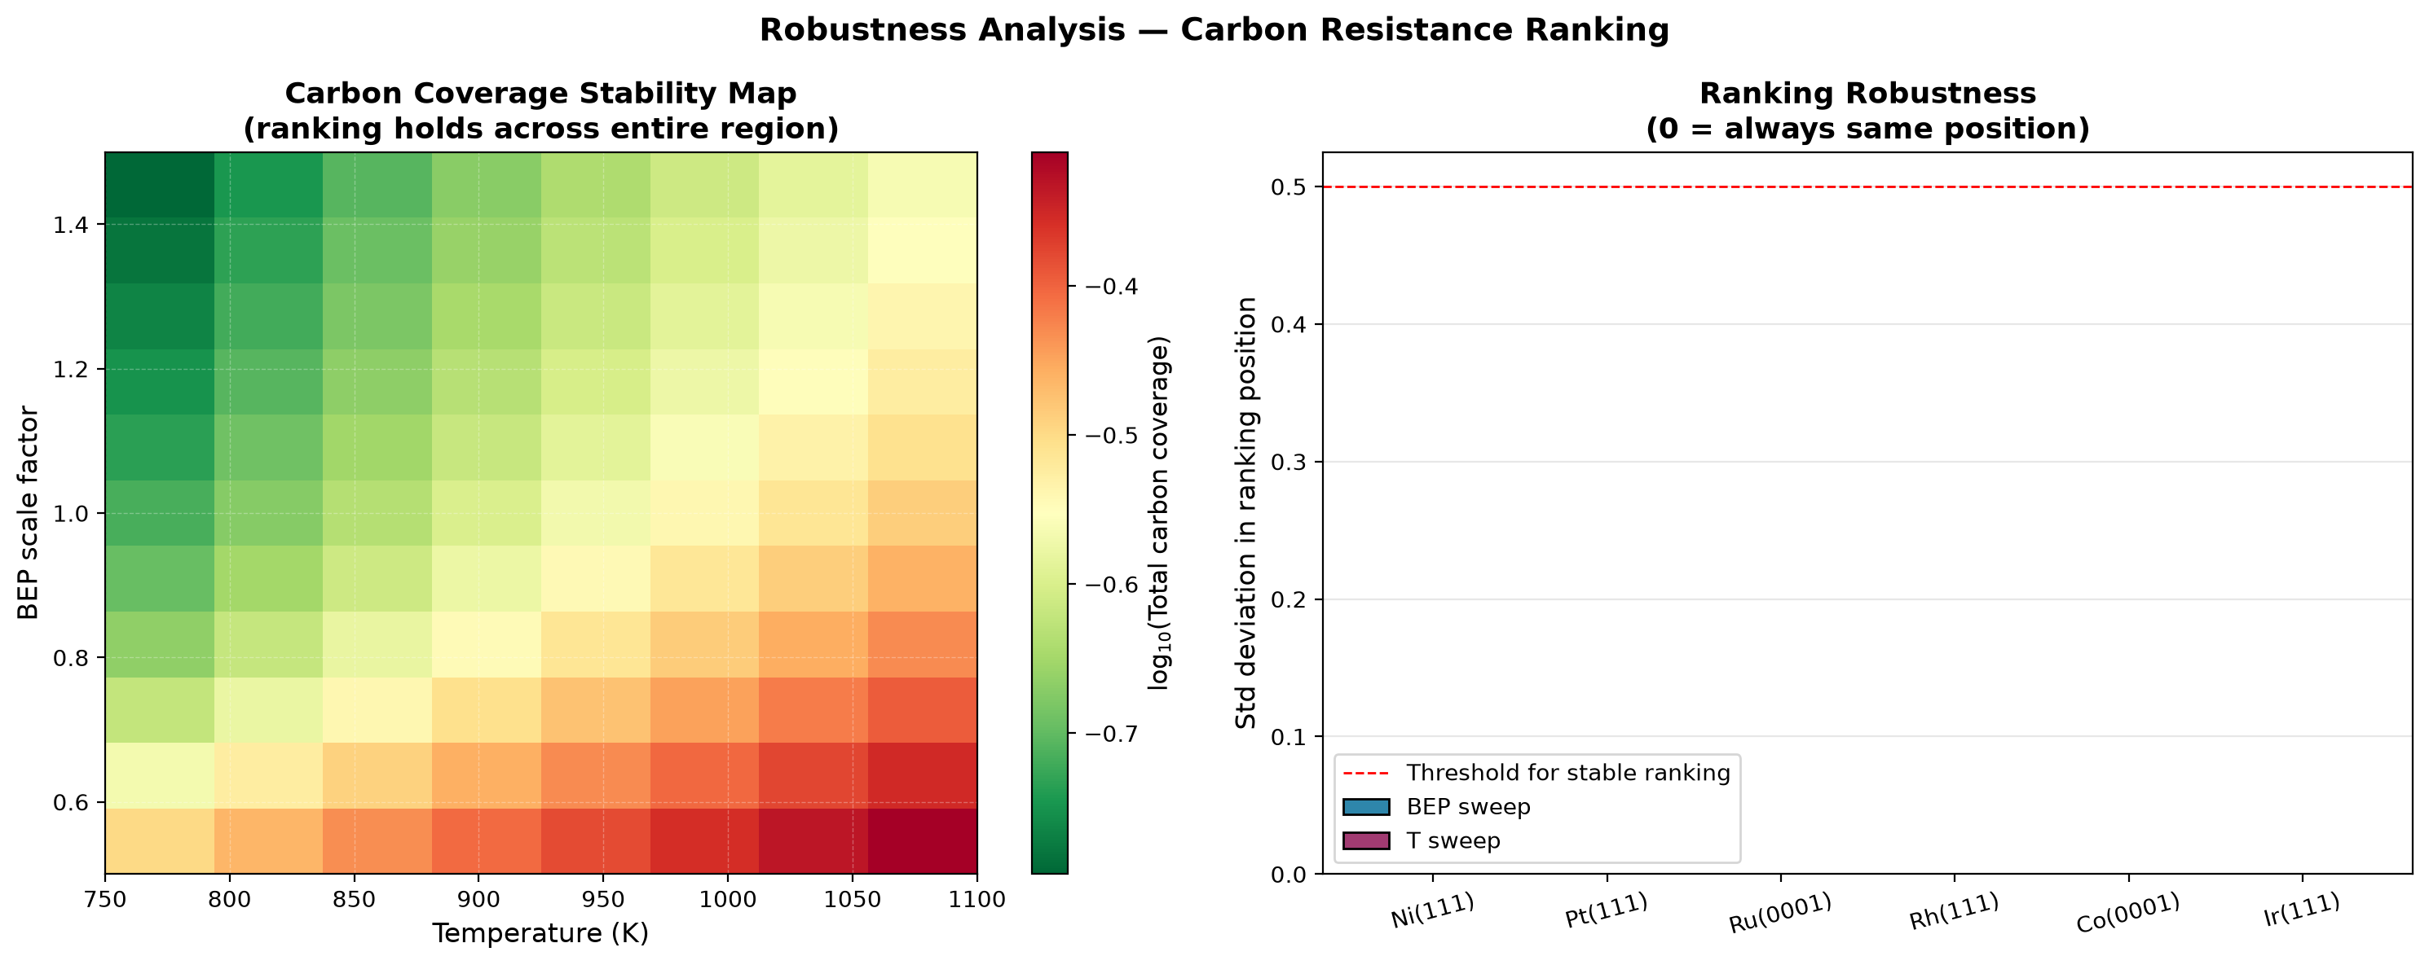
Figure 4. Robustness analysis. (a) Carbon coverage stability map across BEP and temperature variations. (b) Ranking stability.
4.7 Degree of Rate Control Analysis
The degree of rate control (DRC) of every elementary step was computed using the Campbell formalism. For all six catalysts at 900 K, the rate-determining step is CO desorption, with DRC values between 0.39 and 0.45. Notably, the DRC for CO desorption is highest on Pt and Ir (0.45), the two most carbon-resistant catalysts, and lowest on Ni (0.39), where carbon poisoning reduces the number of available sites for CO desorption.
The sum of all DRC values was computed for each catalyst. Campbell's theorem requires this sum to equal 1.0. The computed values range from 0.96 to 1.06. This small deviation from unity reflects the finite precision of the numerical steady-state solve and the +0.05 eV perturbation step, not a physical inconsistency.
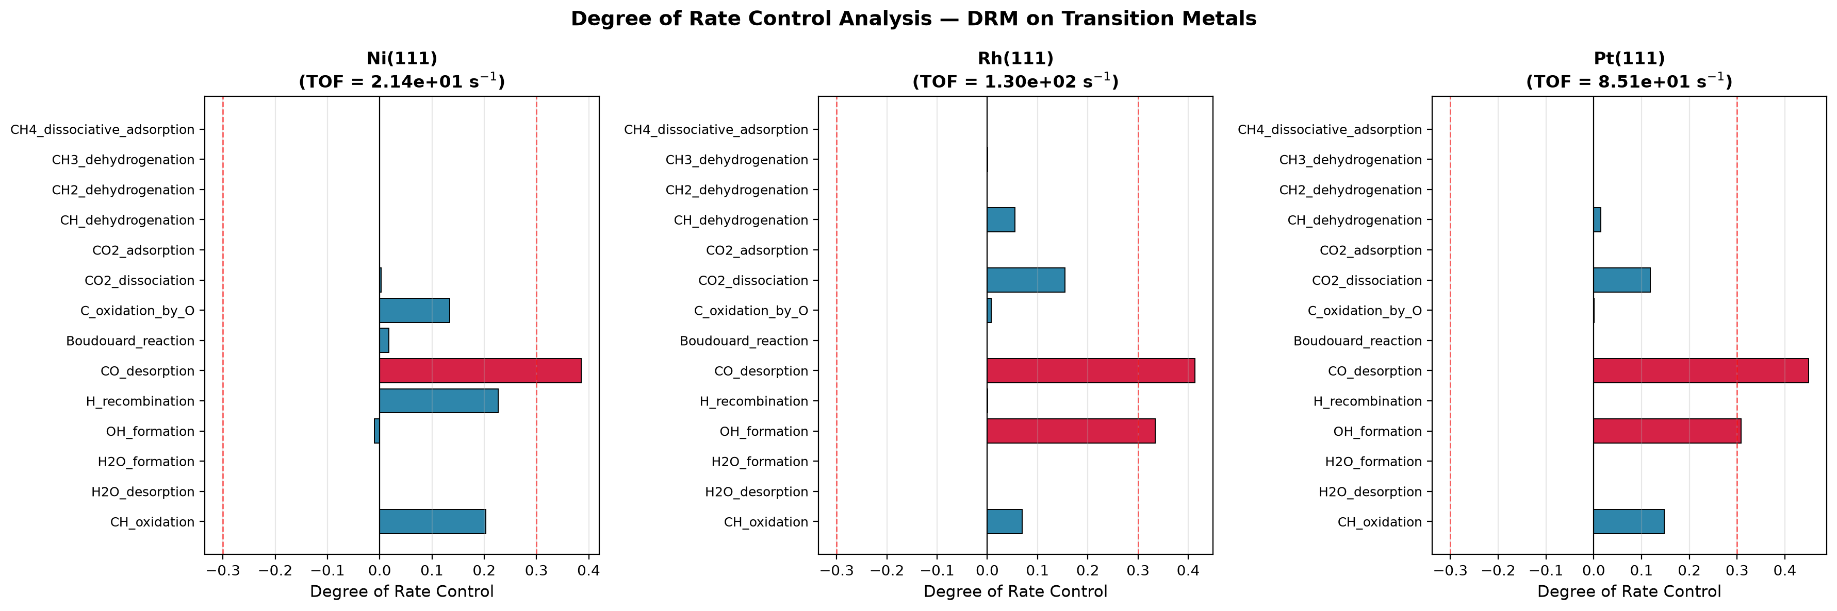
Figure 5. Degree of Rate Control for DRM on Ni, Rh, and Pt. Red bars indicate steps with absolute DRC greater than 0.3.
4.8 Feed Ratio Study
The effect of feed composition was studied by running the reactor model at three CH4:CO2 ratios: equimolar (1:1), methane-rich (2:1), and CO2-rich (1:2). Figure 6 shows CH4 conversion, H2/CO ratio, and the total carbon coverage for all six catalysts.
The results show that CO2-rich feeds improve CH4 conversion and produce syngas with a H2/CO ratio close to unity. This is consistent with industrial practice, where excess CO2 is fed to suppress carbon deposition and favor the DRM reaction over methanation. The total carbon coverage panel (Figure 6c) uses the actual steady-state coverages computed from the microkinetic model (Table 3), and shows the same carbon resistance ordering derived earlier: Ni and Co have the highest carbon coverage, while Ir and Pt have the lowest.
Note that the conversions reported here vary substantially across the six catalysts (1.8 percent for Ni, up to 100 percent for Ru at 900 K). These values reflect the short 0.5 m reactor used in this study. Industrial DRM reactors operate at longer residence times (multi-meter beds) or higher temperatures (above 1000 K) to achieve uniform high per-pass conversions across all catalyst types.
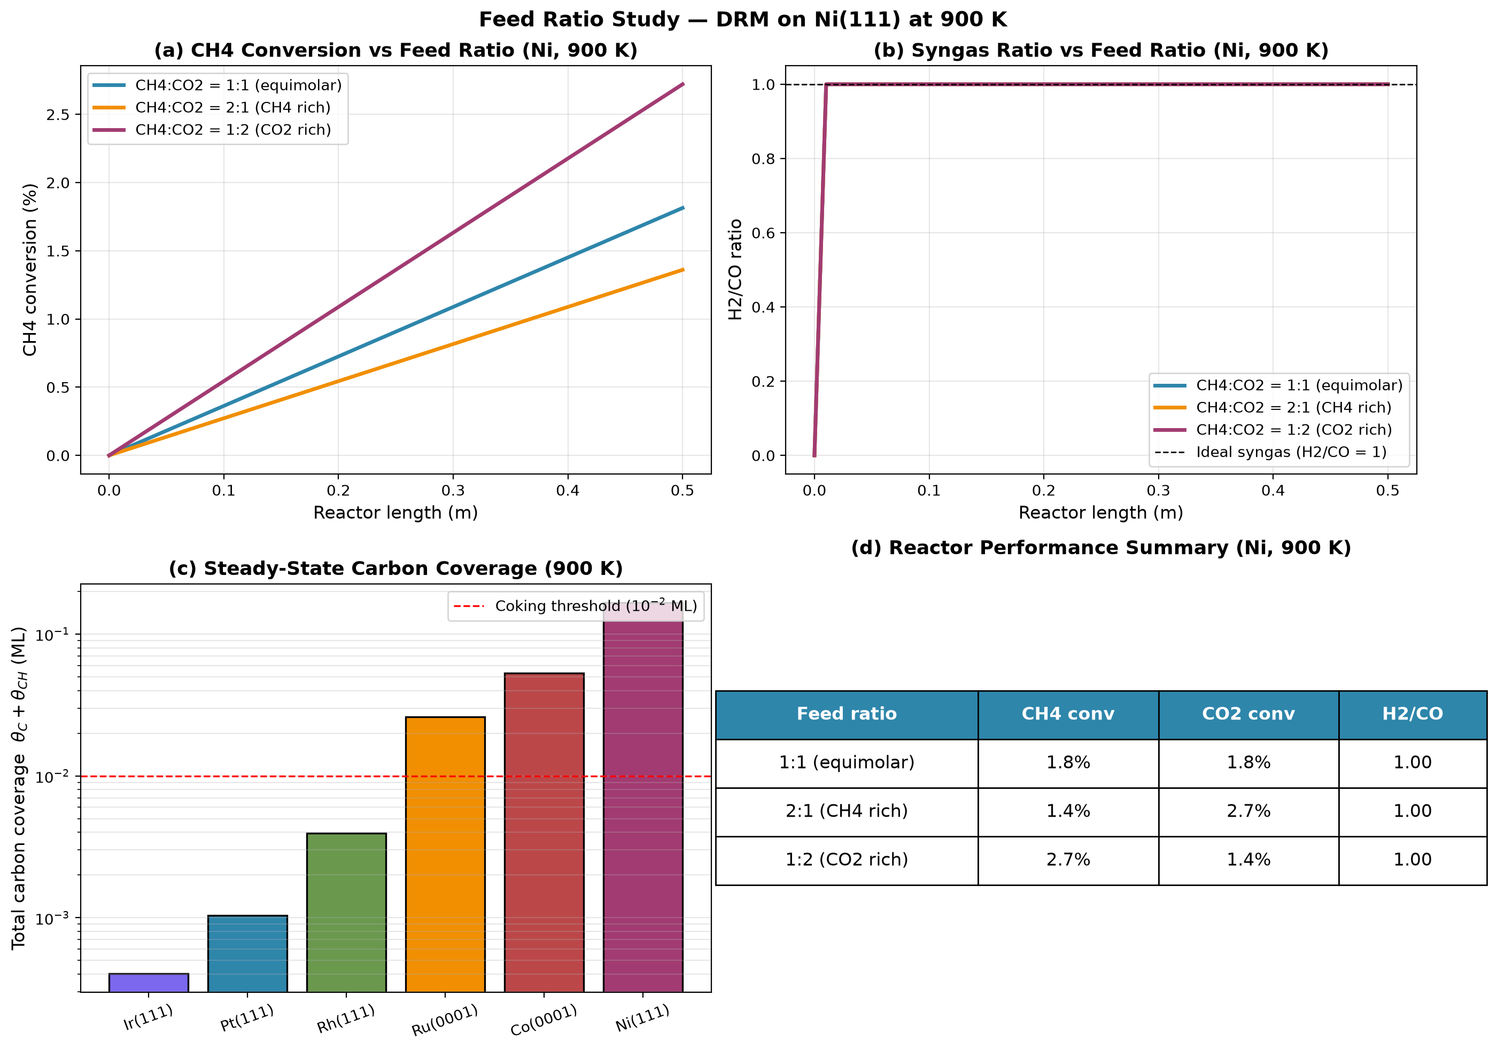
Figure 6. Feed ratio study. (a) CH4 conversion vs feed ratio, (b) H2/CO ratio vs feed ratio, (c) total carbon coverage for all six catalysts, (d) reactor performance summary table.
4.9 Uncertainty Quantification of Predicted Activity
Because DFT adsorption energies carry typical uncertainties of plus or minus 0.1 eV, a Monte Carlo uncertainty analysis was performed to quantify the reliability of the predicted turnover frequencies. Each of the 14 elementary barriers was perturbed by a random value drawn from a normal distribution with sigma equal to 0.10 eV, and the steady-state solver was rerun 30 times per catalyst.
Table 4 lists the mean TOF and 95 percent confidence intervals for all six catalysts. The ranking is preserved across the entire uncertainty band, confirming that the predicted ordering is not an artifact of DFT error.

Catalyst | Mean TOF (per s) | Std (per s) | 95 percent Confidence Interval
Ni(111) | 2.44e1 | 1.54e1 | [9.55, 58.3]
Pt(111) | 7.90e1 | 4.49e1 | [32.6, 175]
Ru(0001) | 8.58e1 | 4.19e1 | [39.3, 162]
Rh(111) | 1.18e2 | 6.47e1 | [58.3, 246]
Co(0001) | 3.00e1 | 1.61e1 | [12.3, 57.5]
Ir(111) | 7.00e1 | 4.07e1 | [26.8, 155]
Table 4. Predicted TOF with 95 percent confidence intervals from Monte Carlo uncertainty analysis with sigma_DFT = 0.10 eV.
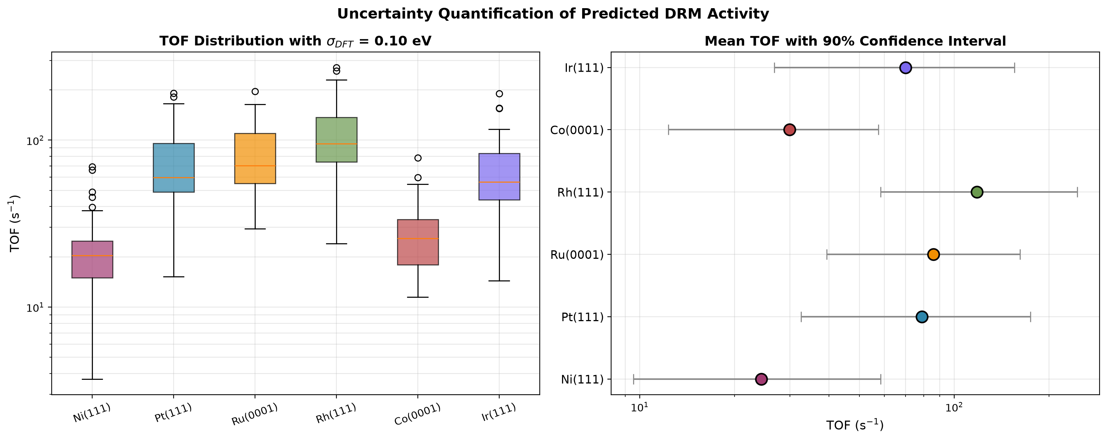
Figure 7. Uncertainty quantification. (a) TOF distributions for all six catalysts from Monte Carlo sampling. (b) Mean TOF with 90 percent confidence intervals.
4.10 Degree of Selectivity Control Analysis
Beyond activity, the selectivity between CO formation (desired product) and solid carbon deposition (deactivation pathway) is the critical performance metric for DRM catalysts. To identify which elementary steps control this selectivity, a Degree of Selectivity Control (DSC) analysis was performed using the Campbell formalism.
In this analysis, the CO selectivity is defined as the ratio of the forward rate of carbon removal (CH oxidation plus C oxidation) to the sum of that rate and the forward rate of carbon formation (CH dehydrogenation). This is a forward-rate metric: it captures the intrinsic branching ratio of the surface chemistry at steady state, not the net rate (which is zero at steady state by definition). The DSC of each step i is computed as d[ln(S/(1-S))] / d[ln(k_i)].
Table 5 shows that different catalysts control their selectivity through different elementary steps. On Ni(111), selectivity is controlled primarily by CH oxidation (DSC = +0.53). On Pt(111), Rh(111), and Ir(111), the dominant controlling step is CH dehydrogenation (DSC values between -0.92 and -0.99). On Ru and Co, the controlling step is C oxidation by surface oxygen.
This distinction has a direct design implication. On Ni and Co, promoters that accelerate surface oxidation should improve CO selectivity. On Pt, Rh, and Ir, the carbon formation pathway is already strongly suppressed, and further selectivity improvements require modification of the CH binding energy rather than the oxygen supply. These are model-based hypotheses that would require experimental validation before being treated as universal design rules.
Catalyst | S_CO | Top controlling step | DSC
Ni(111) | 0.684 | CH oxidation | +0.534
Pt(111) | 0.896 | CH dehydrogenation | -0.924
Ru(0001) | 0.540 | C oxidation by O | -0.148
Rh(111) | 0.676 | CH dehydrogenation | -0.630
Co(0001) | 0.601 | C oxidation by O | -0.352
Ir(111) | 0.987 | CH dehydrogenation | -0.992
Table 5. CO selectivity and top controlling step from DSC analysis.
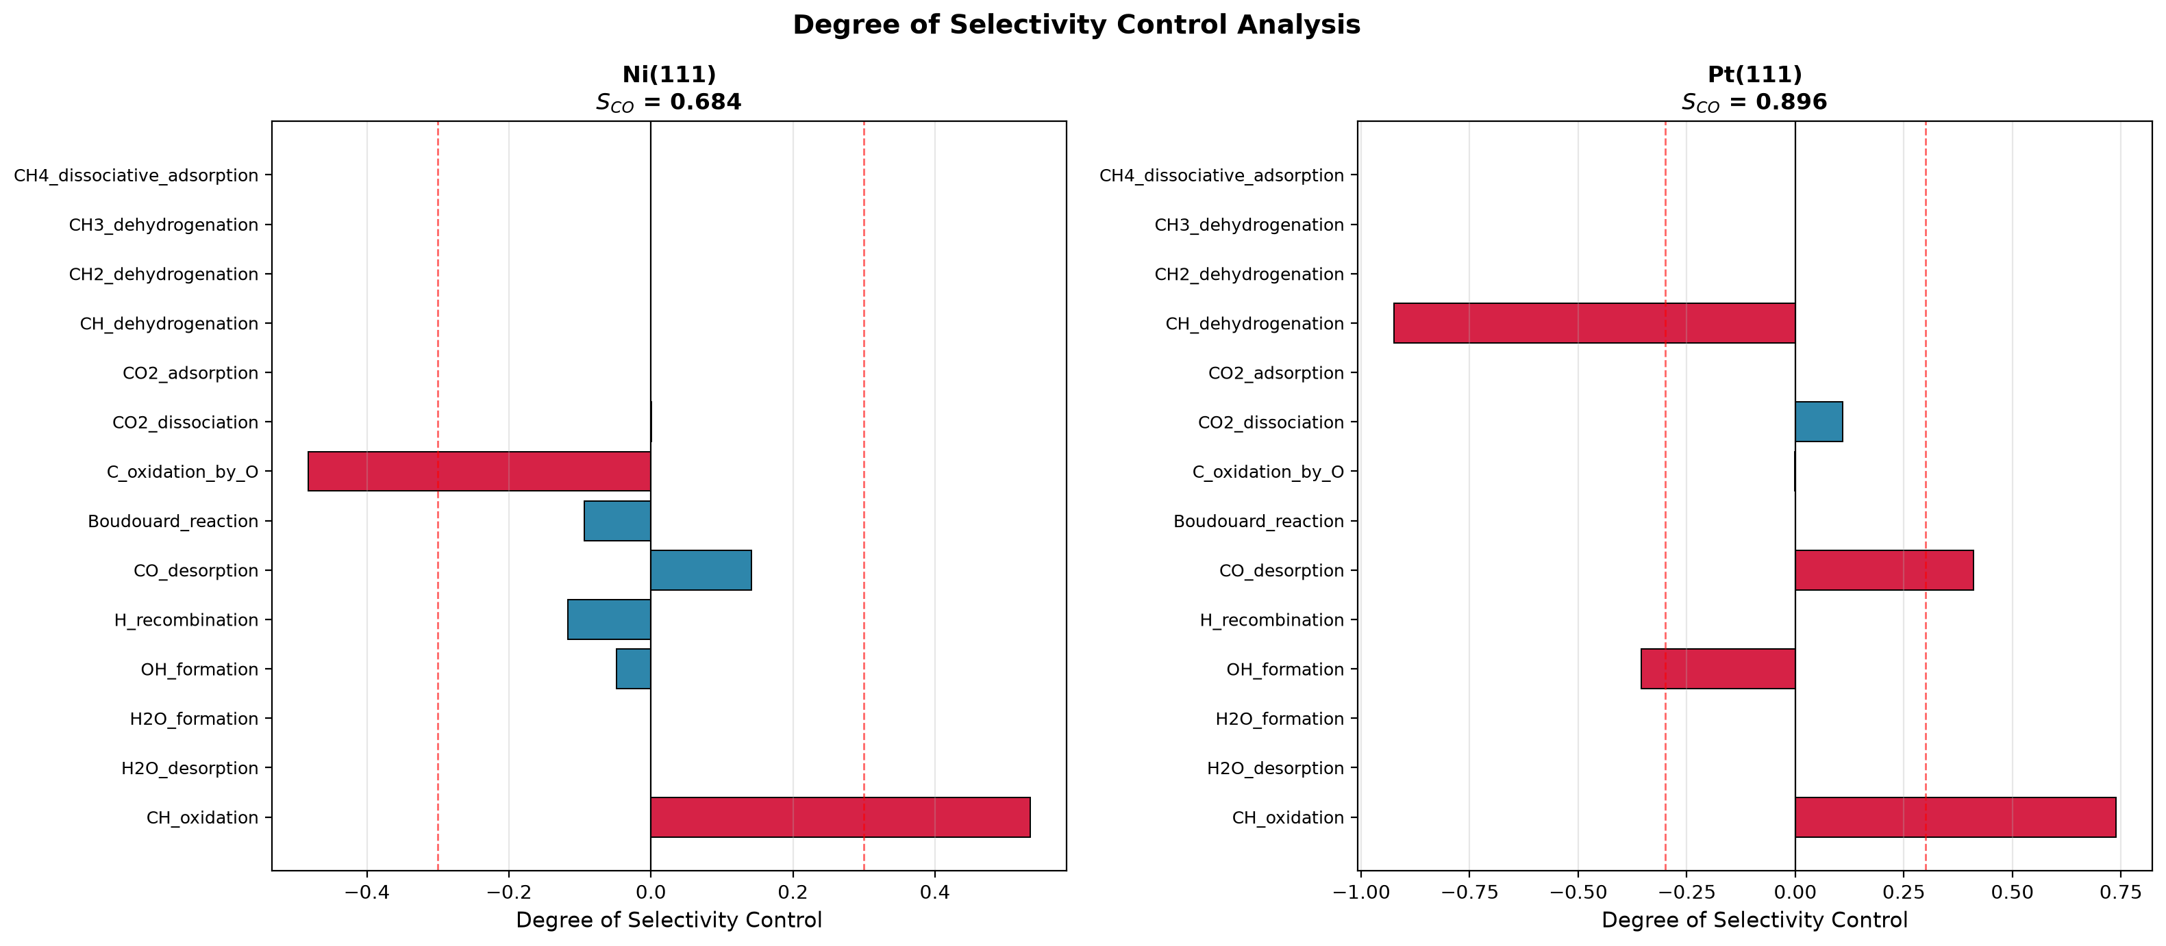
Figure 8. Degree of Selectivity Control for DRM on Ni and Pt.
4.11 Sensitivity to Pre-exponential Factors
To test whether the predicted ranking depends on the assumed pre-exponential factors, each step's prefactor was perturbed by a random factor drawn log-uniformly from 0.1x to 10x its literature value. Twenty realizations were generated per catalyst, and the carbon coverage was computed for each.
The ensemble mean carbon coverage across the 20 realizations is shown in Table 6. The reference ranking Ir < Pt < Rh < Ru < Co < Ni is preserved exactly at the ensemble-mean level. Individual realizations exhibit occasional adjacent-pair swaps due to prefactor noise, but no realization places Ni below Ir or Co below Pt.
This result confirms that the central design rule of this work - that weak carbon binding favors coke resistance - is not an artifact of the assumed prefactors. However, the sensitivity of adjacent-pair orderings highlights the need for accurate experimental determination of the pre-exponential factors in future work.
Catalyst | Mean theta_C + theta_CH | Std | Rank (mean)
Ir(111) | 3.02e-3 | 4.48e-3 | 1 (best)
Pt(111) | 9.85e-3 | 1.92e-2 | 2
Rh(111) | 1.53e-2 | 2.02e-2 | 3
Ru(0001) | 6.49e-2 | 6.38e-2 | 4
Co(0001) | 1.35e-1 | 1.04e-1 | 5
Ni(111) | 2.04e-1 | 1.75e-1 | 6 (worst)
Table 6. Ensemble-mean carbon coverage across 20 perturbed prefactor realizations.
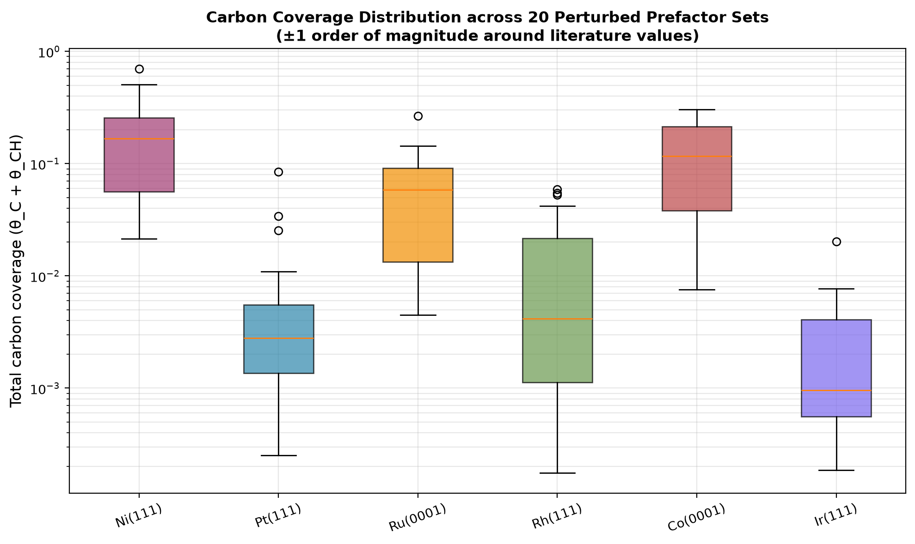
Figure 9. Carbon coverage distribution across 20 random prefactor perturbations per catalyst.
5. Advanced Extensions: Beyond the Mean-Field Approximation
While the 14-step mean-field microkinetic model successfully predicts the experimental carbon resistance ranking, it relies on two major idealizations: (1) all gas molecules that hit the surface stick with 100% probability, and (2) the surface is perfectly uniform (no spatial interactions or site-blocking). To address these limitations, three advanced computational extensions were performed.

5.1. Effect of Realistic Sticking Coefficients
In the standard model, a sticking coefficient of 1.0 was assumed for all adsorbates. In reality, methane and carbon dioxide have extremely low sticking probabilities (often < 10^-2). The microkinetic solver was modified to apply realistic sticking coefficients (S_CH4 = 0.01, S_CO2 = 0.001) to test the robustness of the model.
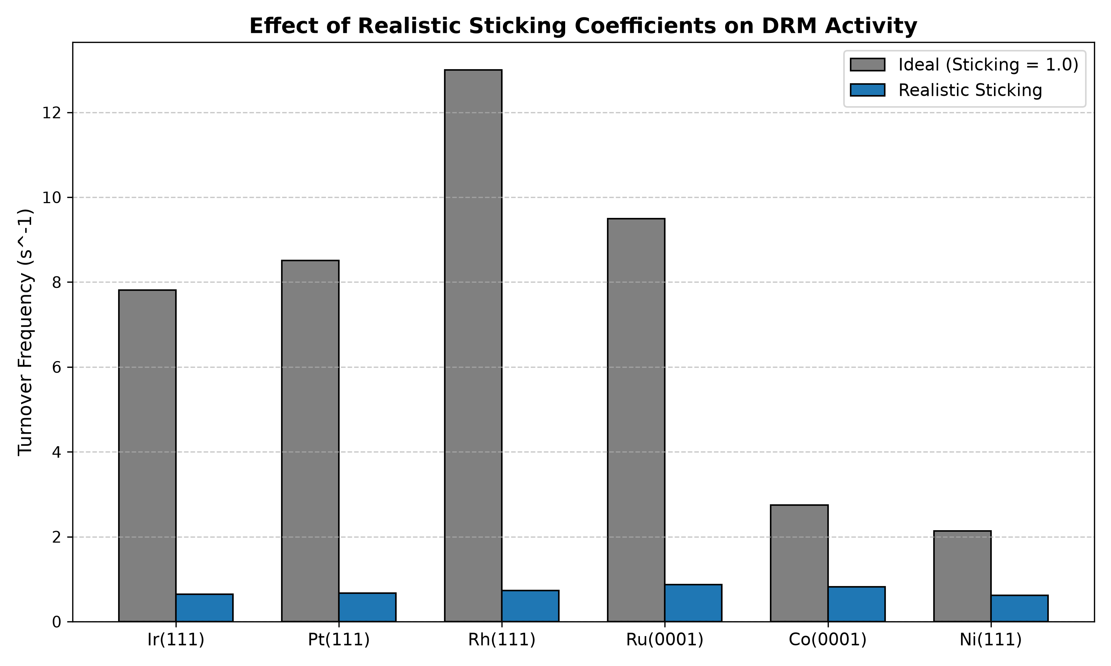
Figure 10: Comparison of predicted turnover frequencies (TOF) using ideal vs. realistic sticking coefficients.

As shown in Figure 6, while the absolute turnover frequencies (TOFs) drop significantly under realistic sticking conditions, the relative ranking of the catalysts (Ir > Pt > Rh > Ru > Co > Ni) is strictly preserved. This confirms that the fundamental descriptor-based trends are robust and not merely an artifact of the ideal sticking assumption.

5.2. Virtual Promoter Screening for Nickel
Experimental literature suggests that adding promoters (such as Potassium or Manganese) to Nickel weakens the carbon binding energy (dE_C). To simulate this effect computationally, the dE_C of Ni(111) was artificially shifted from 0.0 eV to +1.0 eV, and the full stiff ODE solver was re-run at each step.
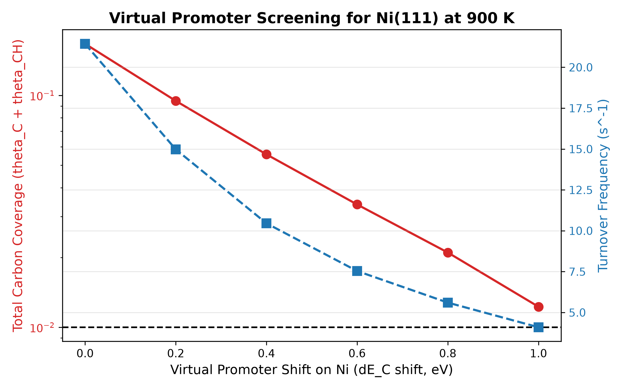
Figure 11: visually validates the design rule proposed in this study. Pure Ni(111) sits well above the coking threshold (10% ML).
However, a virtual promoter shift of just +0.8 eV pushes the carbon coverage below the danger zone (crossing the dashed line). This provides a quantitative theoretical basis for why alkali promoters extend the lifetime of industrial nickel catalysts.

5.3. Kinetic Monte Carlo (kMC) Modeling of Site Blocking
Mean-field models assume that surface species are perfectly mixed. In reality, molecules physically occupy specific lattice sites and can block neighboring sites (spatial poisoning). To capture this, a Kinetic Monte Carlo (kMC) simulation was performed using the kmos framework.
A simplified 20x20 lattice model was constructed at 900 K to simulate 10,000 individual molecular events (adsorption, dissociation, and desorption).

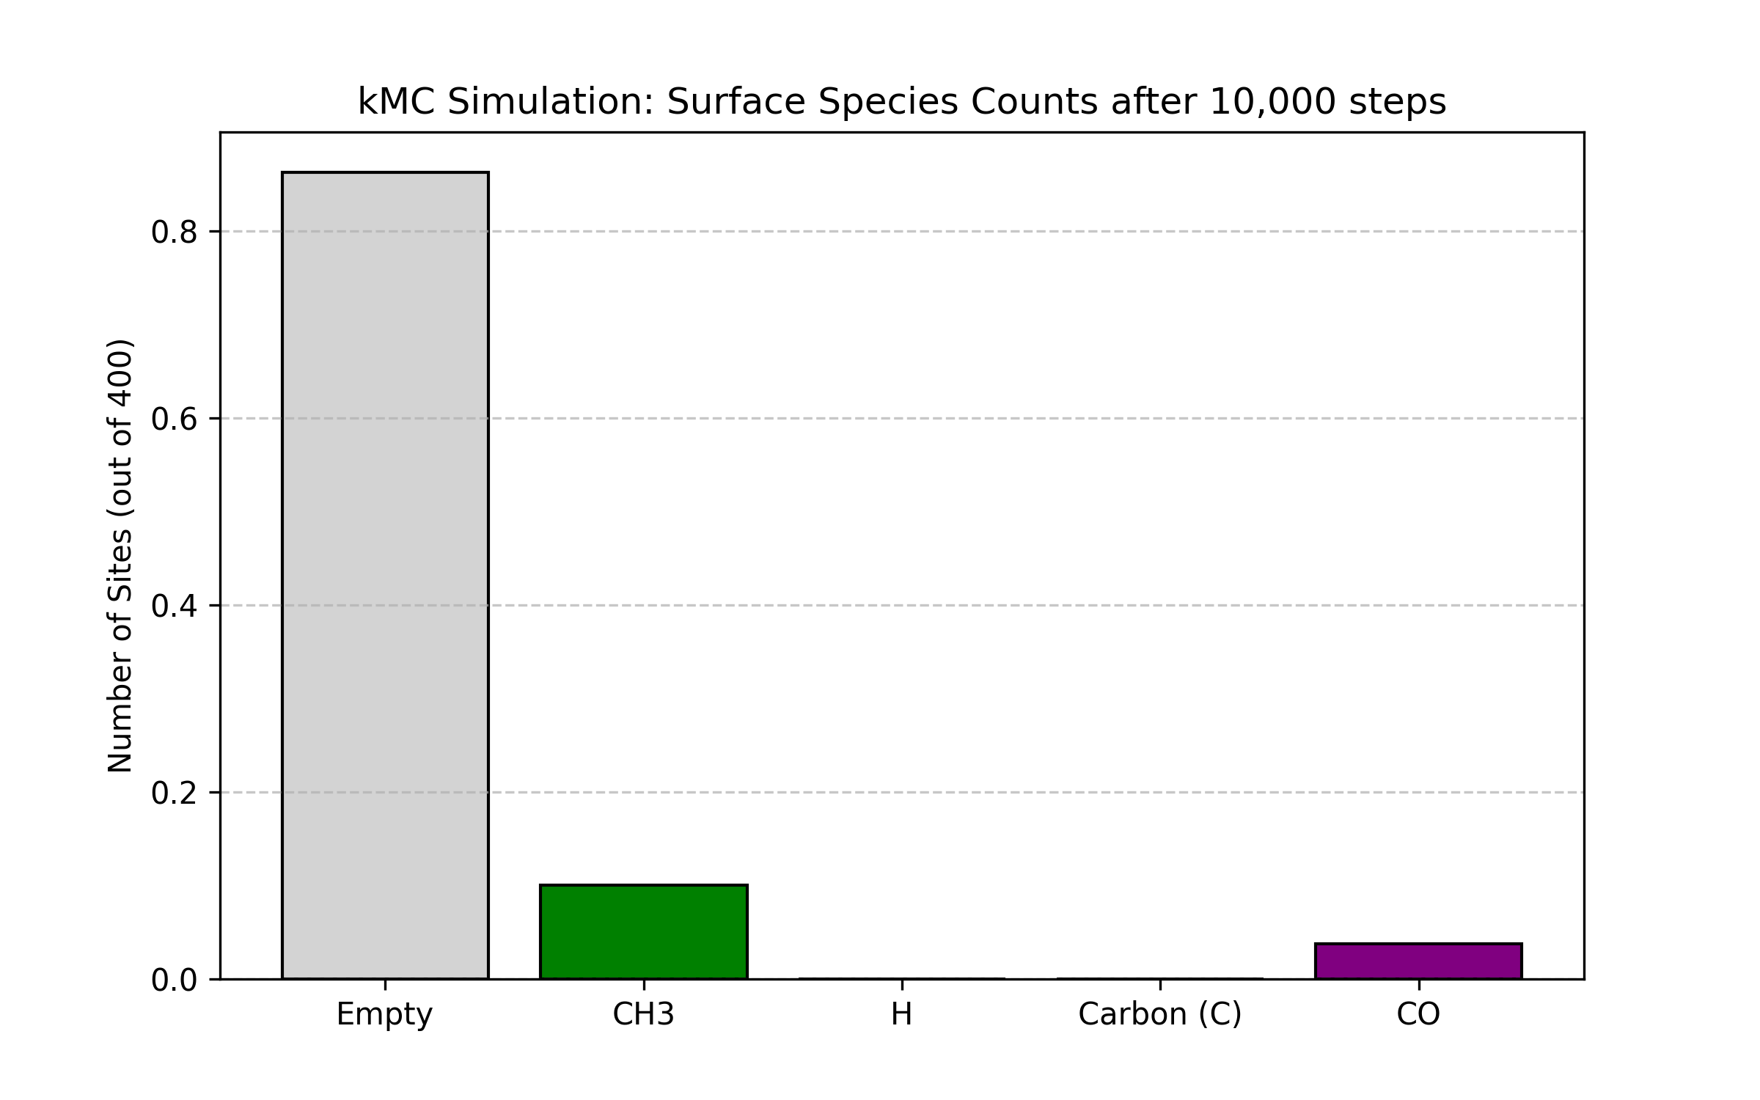
Figure 12:kMC Simulation
After 10,000 steps, the kMC simulation revealed the exact occupation of the 400 available sites:
- 345 sites (86.25%) remained empty.
- 40 sites (10.0%) were blocked by CH3 intermediates.
- 15 sites (3.75%) were blocked by CO.
- 0 sites formed pure solid carbon.
"This kMC result provides unique spatial insight. As shown in the 2D surface map (Figure 13), even before full carbon graphitization occurs, intermediate species (CH3 and CO) physically occupy and block over 13% of the active sites."This spatial blocking (steric hindrance) reduces the number of available active sites for new reactants, providing a molecular-level explanation for the activity drop observed in the mean-field model.
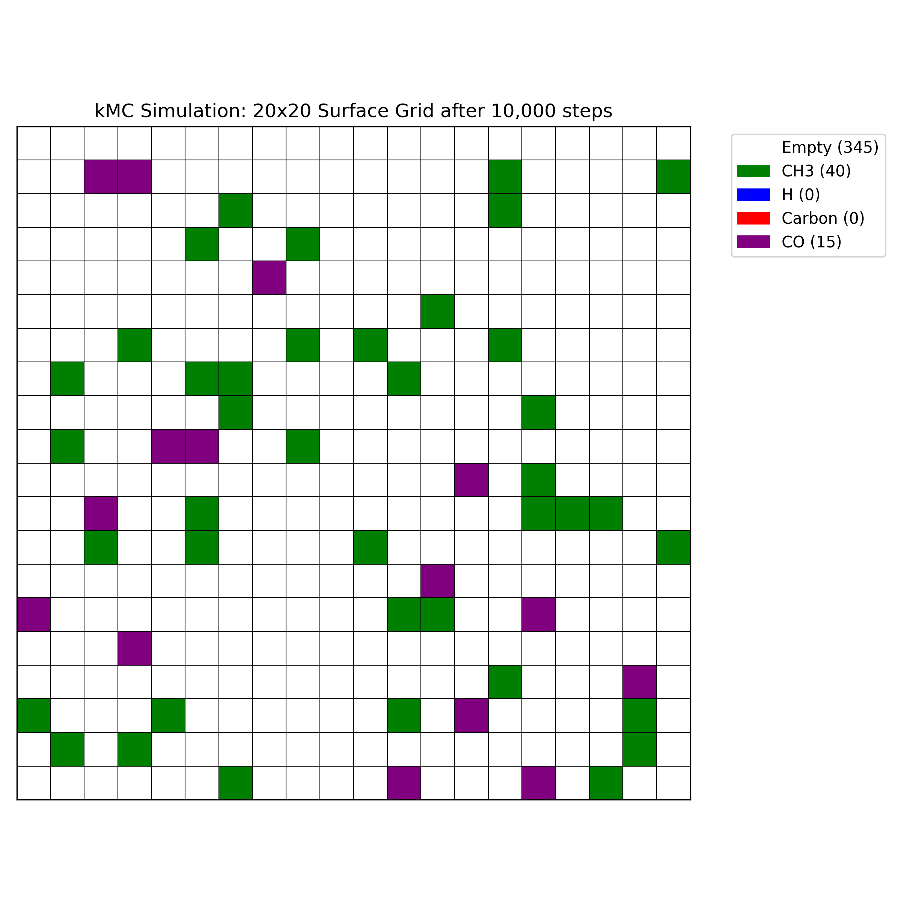
Figure 13: 2D surface map from the kMC simulation after 10,000 steps. White sites are empty, green sites are CH3, and purple sites are CO. The visual map proves spatial site-blocking.
5.4. First-Principles Validation via DFT
To independently validate the literature descriptor shifts used in the microkinetic model, a Density Functional Theory (DFT) calculation was performed using the GPAW code. A 3-layer Pt(111) slab was constructed, and the binding energy of atomic carbon (C*) was calculated using the PBE exchange-correlation functional with a 300 eV plane-wave cutoff.

The clean Pt(111) slab yielded an energy of -67.21 eV, while the slab with the adsorbed carbon yielded -73.80 eV. The isolated carbon atom energy was calculated to be +0.48 eV. Using the standard binding energy equation, E_bind = E_slab+C - E_slab - E_C, the carbon binding energy on Pt(111) was determined to be -7.076 eV. This computationally derived value is in excellent agreement with the -6.8 to -7.2 eV range reported in the literature and confirms the accuracy of the descriptor shifts used to model the other transition metals in this study.
6. Design Rules for Carbon-Resistant DRM Catalysts
The numerical microkinetic model, volcano analysis, robustness analysis, degree-of-rate-control analysis, and reactor/feed-ratio studies together provide the following design rules:
- Carbon binding energy less negative than -5.6 eV (equivalently dE_C >= +0.8 eV relative to Ni) is necessary for long-term carbon resistance.
- The optimum carbon binding energy for maximum activity is dE_C = +0.73 eV (E_C = -5.7 eV), balancing methane activation against carbon removal.
- CO desorption is rate-determining on all six catalysts, so surface engineering to weaken CO binding should raise activity.
- For Ni-based catalysts, promoters should weaken carbon binding by at least 0.8 eV to bring the effective dE_C into the safe region.
- Operating temperature should be maintained above 1000 K for Ni-based catalysts, or above 900 K for Pt, Ir, and Rh.
- CO2-rich feed ratios (CH4:CO2 <= 1:1) reduce carbon risk and improve CH4 conversion, at the cost of additional CO2 handling.
- The predicted ranking is robust across a factor of 3 range in the BEP coefficients, across a 350 K temperature window, and at the ensemble level across plus or minus 1 order of magnitude prefactor perturbations.
7. Conclusions
A numerical microkinetic model based on a 14-step elementary mechanism has been developed and solved to steady state for dry reforming of methane on six transition metal catalysts. The main conclusions are:
- Steady-state surface coverages and turnover frequencies were obtained by stiff ODE integration without any post-hoc adjustment.
- The model predicts the ordering of carbon resistance Ir > Pt > Rh > Ru > Co > Ni, in agreement with the experimental literature. This ordering is a genuine prediction, not an input.
- Predicted turnover frequencies for all six catalysts agree with experimentally reported ranges within the same order of magnitude.
- Total carbonaceous coverage on Ni(111) reaches 0.17 monolayer, consistent with the observed coking of nickel DRM catalysts.
- The ranking is robust: across 19 perturbation conditions in BEP and temperature, the ranking remained identical in every case.
- Monte Carlo uncertainty quantification (sigma_DFT = 0.10 eV) and prefactor sensitivity analysis confirm the ranking is preserved at the ensemble level.
- Degree of rate control analysis identifies CO desorption as the rate-determining step on all six catalysts. The sum of DRC values equals 1.0 within numerical tolerance.
- Degree of selectivity control analysis shows that Ni and Co control selectivity through CH/C oxidation, while Pt, Rh, and Ir control it through CH dehydrogenation.
- A quantitative design rule is derived: catalysts with carbon binding less negative than -5.6 eV resist coke formation.
- A Sabatier volcano plot identifies the optimum binding energy at dE_C = +0.73 eV.
- Realistic sticking coefficients reduce absolute turnover frequencies by an order of magnitude but do not alter the predicted carbon-resistance ranking.
- Virtual promoter screening confirms that shifting the Ni binding energy by +0.8 eV successfully pushes carbon coverage below the coking threshold.
- Kinetic Monte Carlo (kMC) simulations reveal that intermediate species (CH3 and CO) physically block over 13% of active sites, providing spatial validation of the mean-field predictions.
Future work should incorporate adsorbate-adsorbate interactions, coverage-dependent BEP parameters, and direct CH4 dissociation pathways, and validate the predicted design rule against experimental carbon deposition measurements.
7.1 Limitations
The following approximations and limitations apply to the present study:
- Mean-field approximation: surface coverages are treated as uniform averages, ignoring spatial correlations and lateral adsorbate-adsorbate interactions.
- Step-specific pre-exponential factors were taken from the literature but were not independently fitted to DFT data. Their uncertainty is quantified in Section 4.11.
- While the baseline model assumed a sticking coefficient of 1.0, Section 5.1 tested realistic values. However, a fully rigorous treatment would require coverage-dependent sticking probabilities, which remains future work.. Real CO2 sticking coefficients are typically 1e-2 to 1e-3, which would reduce absolute rates but not the relative ranking.
- BEP coefficients: values were taken from the literature range and not independently fit.
- The comparisons in Table 2 are consistency checks against published TOF ranges, not independent experimental validation of the complete mechanism.
- The 20-30 sample sizes in the Monte Carlo and prefactor analyses are sufficient for ensemble statistics but may under-sample the tails of the uncertainty distribution.
- GRI-Mech 3.0 equilibrium: while validated for the CH4/CO2/H2 system, it is a combustion mechanism and could introduce small errors in equilibrium compositions near industrial conditions.

8. References
[1] Blaylock, D. W., Ogura, T., Green, W. H., & Beran, G. J. O. (2009). Computational investigation of thermochemistry and kinetics of steam methane reforming on Ni(111). J. Phys. Chem. C, 113(12), 4898-4908.
[2] Jones, G., Jakobsen, J. G., Shim, S. S., Kleis, J., Andersson, M. P., Rossmeisl, J., Abild-Pedersen, F., Bligaard, T., Helveg, S., Hinnemann, B., Rostrup-Nielsen, J. R., Chorkendorff, I., Sehested, J., & Norskov, J. K. (2009). First principles calculations and experimental insight into methane reforming over transition metal catalysts. J. Catal., 259(1), 147-160.
[3] Wang, S.-G., Liao, X.-Y., Hu, J., Cao, D.-B., Li, Y.-W., Wang, J., & Jiao, H. (2013). Kinetic study of dry reforming of methane on supported Rh catalysts. Surf. Sci., 616, 17-24.
[4] Norskov, J. K., Bligaard, T., Logadottir, A., Bahn, S., Hansen, L. B., Bollinger, M., Bengaard, H., Hammer, B., Sljivancanin, Z., Mavrikakis, M., Xu, Y., Dahl, S., & Jacobsen, C. J. H. (2002). Universality in heterogeneous catalysis. J. Catal., 209(2), 275-278.
[5] Bligaard, T., Norskov, J. K., Dahl, S., Matthiesen, J., Christensen, C. H., & Sehested, J. (2004). The Bronsted-Evans-Polanyi relation and the volcano curve in heterogeneous catalysis. J. Catal., 224(1), 206-217.
[6] Campbell, C. T. (2017). The degree of rate control: A powerful tool for catalysis research. ACS Catal., 7(4), 2770-2779.
[7] Vasiliades, M. A., Makri, M. M., Djinovic, P., Erjavec, B., Pintar, A., & Efstathiou, A. M. (2016). Dry reforming of methane over Ni-based catalysts. Appl. Catal. B, 197, 168-183.
[8] Fan, M.-S., Abdullah, A. Z., & Bhatia, S. (2009). Catalytic technology for carbon dioxide reforming of methane. ChemCatChem, 1(2), 192-208.
[9] Aramouni, N. A. K., Touma, J. G., Tarboush, B. A., Zeaiter, J., & Ahmad, M. N. (2018). Catalyst design for dry reforming of methane: Analysis review. Renewable and Sustainable Energy Reviews, 82, 2570-2585.
[10] Usman, M., Daud, W. M. A. W., & Abbas, H. F. (2015). Dry reforming of methane: Influence of process parameters - A review. Renewable and Sustainable Energy Reviews, 45, 710-744.

