**What is inheritance?**

This is when an object or even a class is based on another class or object. For example it gets functions and features off the main class and makes a sub class. In object oriented programing it allows classes to inherit the commonly used behaviours and functions from other classes.

Here is an example of inheritance

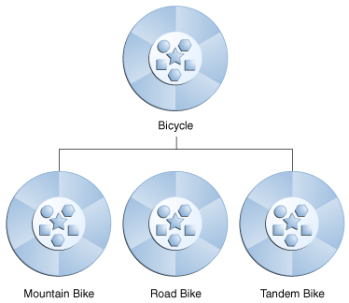

Here is the parent class / Main Class

Here are the sub classes/ child class

The subclasses inherit properties off the main class, for example in this diagram it shows that Bicycle is the main class and the subclasses are Mountain bike, Road bike and also Tandem bike, they have inherited features and properties from the main class.

**Types of Inheritance**

Single Inheritance – this is when a sub class inherits features of a single super class.

Multiple Inheritance - this allows a class to be able to have more than one super class and it inherits features from all of the parent classes

Hierarchical Inheritance – this is when a single class serves as an actual superclass for more than just one sub class.

Multilevel Inheritance – this is when a subclass inherits something from another subclass.

Hybrid Inheritance – this is now a mixture of all of the different types of inheritance

Inheritance occurs in many different types of programs for example many game programmers would use Object orientated programming to make their life easier for example in a race car game instead of the programmer programming a million different types of cars he would program one main class of a car and then for the sub sets he would have things like different make of a car. Now the subclass could inherit things from the main class for example colour, speed, engine or things along this line.

**Method Overriding**

In object orientated programming this is a language that allows features that will allow a subclass to run a specific implementation of the method that is provided by one of the super classes.

**Base Class** – This occurs when the class is created with the purpose of being deriving other classes from it.

**Child Class** -This is the class where it was derived from another class, the class where it derived from will be the parent class.

**Parent Class –** this is the class where it was derived from to create another class (child class).

**Reference**

<http://docs.oracle.com/javase/tutorial/java/concepts/inheritance.html> - 7th February 2015

http://en.wikipedia.org/wiki/Inheritance_%28object-oriented_programming%29 - 7th February 2015

[http://en.wikipedia.org/wiki/Method_overriding - 7th February 2015](http://en.wikipedia.org/wiki/Method_overriding%20-%207th%20February%202015) 7th February 2015

<http://en.wikibooks.org/wiki/C++_Programming/Classes/Inheritance> - 7th February 2015