[**Use Case Diagrams**](http://www.smartdraw.com/resources/tutorials/UML-Use-Case-Diagram)

**User**

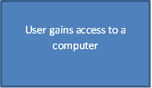

After all of this has happen now the code will now finish and close

The user will now be required to open python

The user will now give feedback to the designer’s programmers and creators of the project

**User**

The user would now load and run the code on python



The programme should allow the user to select and place different types of treasure and there must be a number of hidden traps that are randomly generated within an arena.

**Creator**

It should now provide a brief description for each treasure and assign each treasure with a score.

**Desinger**

**Programmers**

It should now provide a brief description for each treasure and assign each treasure with a score.

Every time the robot falls into the hidden trap it will lose some treasure

The treasures should first be displayed in an unsorted order.

.

The robot will then show how the treasure (according to score) are sorted in a animation using a sorting algorithm.