

**Note:-The source code of the outputs are attached in the folder**

Outputs of AI practical.

Question 1. Write a prolog program to calculate the sum of two numbers.

Output.

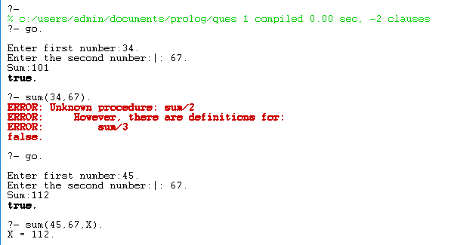

Question 2 . Write a Prolog program to implement max(X, Y, M) so that M is the maximum of two numbers X and Y.

Output.

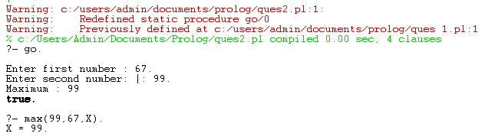

Question 3 . Write a program in PROLOG to implement factorial (N, F) where F represents the factorial of a number N

Output.

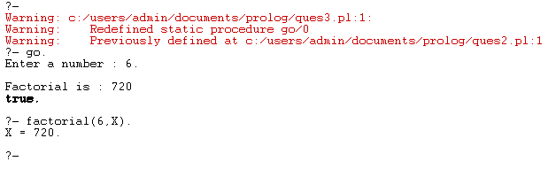

Question 4. Write a program in PROLOG to implement generate_fib(N,T) where T represents the Nth term of the fibonacci series.

Output.

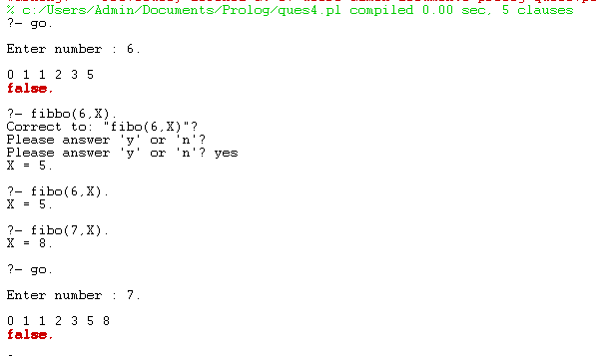

Question 5. Write a Prolog program to implement GCD of two numbers.

Output.

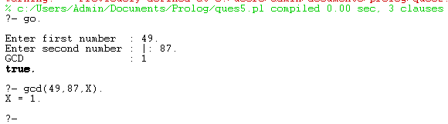

Question 6. Write a Prolog program to implement power (Num,Pow, Ans) : where Num is raised to the power Pow to get Ans.

Output.

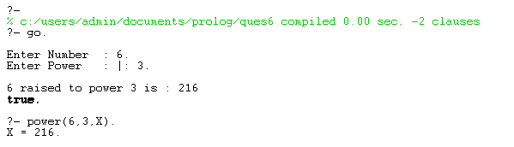

Question 7. Prolog program to implement multi (N1, N2, R) : where N1 and N2 denotes the numbers to be multiplied and R represents the result.

Output.

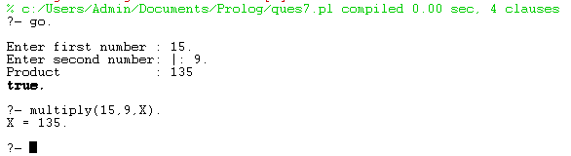

Question 8. Write a Prolog program to implement memb(X, L): to check whether X is a member of L or not.

Output.

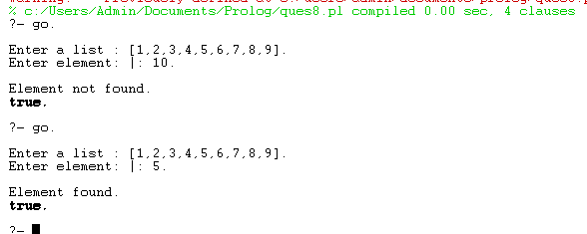

Question 9. Write a Prolog program to implement conc (L1, L2, L3) where L2 is the list to be appended with L1 to get the resulted list L3

Output.

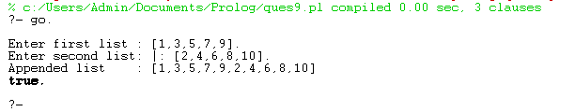

Question 10. Write a Prolog program to implement reverse (L, R) where List L is original and List R is reversed list.

Output.

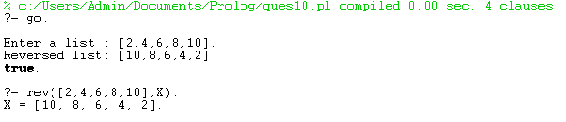

Question11. Write a program in PROLOG to implement palindrome (L) which checks whether a list L is a palindrome or not.

Output.

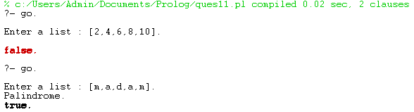

Question12. Write a Prolog program to implement sumlist(L, S) so that S is the sum of a given list L.

Output.

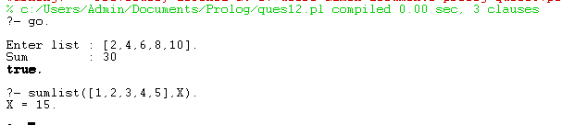

Question 13. Write a Prolog program to implement two predicates evenlength(List) and oddlength(List) so that they are true if their argument is a list of even or odd length respectively.

Output.

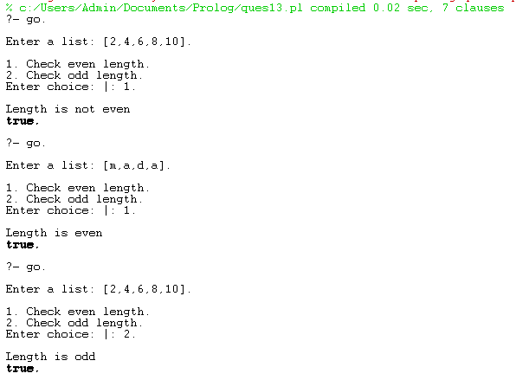

Question 14. Write a Prolog program to implement nth_element (N, L, X) where N is the desired position, L is a list and X represents the Nth element of L.

Output.

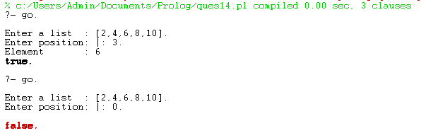

Question 15. Write a Prolog program to implement maxlist(L, M) so that M is the maximum number in the list.

Output.

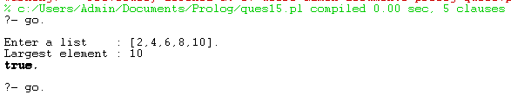

Question 16. Write a prolog program to implement insert_nth (I, N, L, R) that inserts an item I into Nth position of list L to generate a list R

Output.

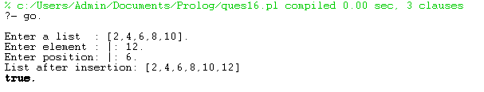

Question 17. Write a Prolog program to implement delete_nth (N, L, R) that removes the element on Nth position from a list L to generate a list R

Output.

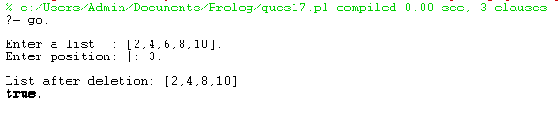

Question 18. Write a program in PROLOG to implement merge (L1, L2, L3) where L1 is first ordered list and L2 is second ordered list and L3 represents the merged list

Output.

