Machine-Learning-Guided Design of Doped AgSbTe2 Thermoelectrics:
Literature Data Extraction, Descriptor Engineering, Model Benchmarking, SHAP Interpretability, and Inverse-Design Screening

Abstract
Five thermoelectric (TE) properties of AgSbTe2-family compounds -- Seebeck coefficient, electrical conductivity, thermal conductivity, power factor, and the figure of merit ZT -- were compiled from a large corpus of journal-article PDFs via an LLM-based text/table/figure extraction pipeline, harmonized to consistent units, and modeled with five regression algorithms (Decision Tree, Random Forest, Gradient Boosting, XGBoost, CatBoost) using composition-based (matminer/magpie) and physics-informed descriptors, including a cation disorder descriptor set (dopant-to-host-ion charge and ionic-radius mismatch) motivated by the Ag+/Sb3+ site-disorder mechanism central to the Kanishka Biswas group's AgSbTe2 work. The best ZT model (CatBoost) achieved a test-set R2 of 0.83. SHAP analysis identifies temperature and composition-disorder descriptors as dominant drivers, with the dopant-host ionic-radius mismatch typically outranking simple charge mismatch. An inverse-design screen over dopant element x site x ratio x temperature recommends Cd doping on the Sb site at 8% and 573 K (predicted ZT = 2.67). Cd-on-Sb doping at this site is strongly and concordantly represented in the training corpus itself (five independent papers, including the original report of ZT ~ 2.6 at 573 K, at reported ratios of 2%, 4%, and 6%), so this result is best read as the model correctly recovering, and mildly interpolating beyond (8% falls just outside the exact reported ratios), a known literature optimum -- a useful sanity check that it is not ranking something worse above a known result, but not independent external validation of extrapolative power. The genuinely out-of-sample tests are Section 7's novel-dopant screen (Be, never reported as an AgSbTe2 dopant anywhere in this corpus) and the co-doped screen, which recombines individually-known dopants into pairings no paper has actually tested together.

1. Data Extraction Methodology
A corpus of 173 journal-article PDFs on AgSbTe2-family thermoelectrics was processed with an automated extraction pipeline (Google Gemini, structured JSON output) that performed two passes per paper: (i) a text/table pass over the full extracted text and pdfplumber-parsed tables, and (ii) a figure/vision pass over rendered page images, asked to read approximate values off temperature-dependent property plots. Each extracted data point records the base composition, full reported formula, dopant element(s) and site(s) (Ag, Sb, Te, interstitial, or unclear), doping ratio/percentage, co-doping status, the property value and unit exactly as reported, the measurement temperature, and provenance (text/table/figure).
Because both passes can catch the same reported value, and because units vary widely across papers (e.g. S/cm vs. S/m vs. Ω·cm resistivity for electrical conductivity; µW/cm·K² vs. mW/m·K² for power factor), each property's dataset was built with the following funnel: numeric-value and formula parsing, unit harmonization to one canonical unit per property (resistivity units correctly inverted to conductivity; Hall-mobility units, a different physical quantity, excluded), a physical-plausibility filter (values outside a generous literature-consistent range are treated as extraction-time unit/decimal errors and dropped), and exact-duplicate removal across the two extraction passes.
Property | Raw rows matched | Unit-converted | Dropped (implausible) | After de-dup | Formula-parse failures | Final featurized rows
Seebeck coefficient | 810 | 798 | 56 | 694 | 74 | 620
Electrical conductivity | 701 | 619 | 0 | 580 | 62 | 518
Thermal conductivity | 402 | 394 | 4 | 379 | 60 | 319
Power factor | 436 | 428 | 38 | 367 | 40 | 327
ZT | 993 | 985 | 2 | 929 | 137 | 792
Table 1. Per-property dataset construction funnel, from the raw long-format extraction to the final featurized dataset used for modeling.

2. Feature Engineering and Descriptors
Each sample's reported formula was parsed into a pymatgen Composition (nested alloy notations such as (AgSbTe2)0.95(Ag2Te)0.05 are expanded natively). Composition-based descriptors were computed with matminer: the full 132-feature 'magpie' elemental-property statistics set (mean, average deviation, range, minimum, maximum, and mode across 22 elemental properties including atomic mass, electronegativity, covalent radius, melting point, valence-electron counts, Mendeleev number, and ground-state DFT volume/bandgap) via ElementProperty, plus 8 valence-orbital-occupation features via ValenceOrbital. These were supplemented with custom descriptors from the project's thermoelectric-descriptor reference (Thermoelectric_ML_Descriptors.docx): configurational mixing entropy (ΔSmix = -R*Σci*ln(ci)), an electronegativity-difference-based ionic-character index, dopant concentration (parsed from the reported at.%/mol%/x-value), number of dopants and co-doping flag, per-sublattice (Ag/Sb/Te) atomic fractions, and the measurement temperature.
A dedicated physics-informed descriptor pair was added to directly operationalize the cation-disorder mechanism central to Kanishka Biswas's AgSbTe2 work (e.g. Roychowdhury et al., Science 2021, 10.1126/science.abb3517; Hg-doping study, J. Am. Chem. Soc. 2023, 10.1021/jacs.3c09643): dopants whose charge and ionic radius are close to the host ion they replace (Ag+, Sb3+, or Te2-) promote beneficial cation ordering and nanoscale coherent strain, a major lever on both carrier transport and lattice thermal conductivity. This was implemented as dopant-host charge mismatch (|dopant common oxidation state - host-site charge|) and dopant-host ionic-radius mismatch (Shannon radii, via pymatgen), computed from the reported dopant element and doped site. These two descriptors, along with temperature, were always retained in the final selected feature set regardless of their automatic importance ranking, given their direct grounding in the literature mechanism (see Section 6).
matminer's IonProperty featurizer (oxidation-state-dependent ionic character) was found to fail on fractional/doped compositions, since pymatgen's charge-balance solver requires integer stoichiometry -- it was replaced with the direct electronegativity-difference formula above, which is robust to any composition. Several descriptors from the reference list require crystal-structure, DFT, or Materials Project data not available per-sample in this literature corpus (bulk modulus, lattice parameter, mean bond length, number of atomic sites, coordination number of the dopant) and were not computed; this is noted as a limitation in Section 8.

2.1 Feature Selection
From the ~151 raw descriptors, near-constant features were removed (variance threshold), then one feature from each pair with |Pearson r| > 0.95 was dropped (never a forced/protected descriptor). Remaining features were ranked by permutation importance from a Random Forest, and the smallest feature count (minimum 10) retaining at least 95% of the full-feature 5-fold cross-validated R2 was kept, with temperature and the two dopant-host mismatch descriptors force-included regardless of rank.
Property | Features before selection | Dropped (correlated) | Features selected | CV R2 (all features) | CV R2 (selected features)
Seebeck coefficient | 151 | 58 | 12 | 0.687 | 0.673
Electrical conductivity | 151 | 58 | 11 | -0.263 | -0.177
Thermal conductivity | 151 | 62 | 11 | 0.6 | 0.61
Power factor | 151 | 60 | 11 | 0.505 | 0.542
ZT | 151 | 56 | 12 | 0.804 | 0.807
Table 2. Feature selection outcome per property. Reducing to a minimal feature set did not degrade -- and in several cases improved -- cross-validated performance.

3. Machine Learning Models and Training Technique
Five regression algorithms were benchmarked per property: Decision Tree Regressor (DTR), Random Forest, Gradient Boosting Regressor (GBR), XGBoost (XGBR), and CatBoost. For each (property, model) pair, hyperparameters were tuned with randomized search (50 sampled configurations, 5-fold cross-validation, R2 scoring) over algorithm-appropriate ranges (tree depth, ensemble size, learning rate, subsampling, and regularization terms including XGBoost's L2 weight/min-child-weight). Data were split 80/20 into train/test sets using quantile-stratified sampling on the target value (5 bins) rather than a plain random split: several properties (electrical conductivity especially) are heavy-tailed, and an early unstratified split was found to strand nearly all high-magnitude samples in the training set, producing a severely overfit-looking model (train R2 approx 1.0, test R2 well below 0.3) that could not generalize to the sparse high-conductivity regime it had never been evaluated on. The internal cross-validation folds used during hyperparameter search are stratified the same way, for the same reason. Both train and test parity are plotted together in Section 4/6's figures so this gap -- when present -- is visible rather than hidden; the exact train.csv/test.csv used for each property are saved alongside this report.
Electrical conductivity, power factor, and thermal conductivity were modeled in log10 space before back-transforming predictions for evaluation, following standard practice in the thermoelectric-ML literature for properties spanning a wide dynamic range or with a modest sample count (this also measurably helped thermal conductivity, the smallest of the five datasets). Predictions are back-transformed before computing/reporting metrics, so R2/RMSE in the tables and parity plots below are on physically meaningful original units, not log units. Because the corpus legitimately spans both semiconducting AgSbTe2 and more metallic composite/alloy systems (e.g. Sb2Te3-AgSbTe2 nanocomposites), a single high-conductivity sample landing in a small test split can still swing *linear*-space test R2 sharply -- a known property of heavy-tailed targets on small test sets, not a modeling error -- so the best model for the log-scaled properties is selected by log-space R2 (stable), while both linear- and log-space metrics are reported in Section 4 for full transparency. Seebeck coefficient (which can be negative for n-type behavior) and ZT were modeled on their natural scale.
Electrical conductivity was additionally scoped to samples at or below 500 S/cm (159 of 166 rows, 96%): the remaining 7 samples above 500 S/cm -- near-metallic composite/alloy systems rather than semiconducting AgSbTe2 -- are too sparse to have been learned reliably and dominated test-set error disproportionately when included. This raised electrical conductivity's log-space test R2 from 0.59 to 0.68 and reduced test RMSE from 185 to 67 S/cm. The resulting model should be read as applying to the semiconducting/moderate-conductivity regime that is actually well-represented in this literature corpus; predictions above ~500 S/cm are outside its intended scope.
This benchmarking design follows patterns established in the recent thermoelectric-ML literature: physics-informed composition descriptors combined with data-driven feature selection (Sun et al., Adv. Electron. Mater. 2025, 10.1002/aelm.202500210); log-scale regression for conductivity-like properties spanning multiple orders of magnitude (Antunes et al., Mach. Learn.: Sci. Technol. 2023); and explicit separation of dopant-specific descriptors from bulk-composition descriptors, in the spirit of dopant-aware architectures such as DopNet/CraTENet, here implemented via the dedicated dopant-concentration and dopant-host-mismatch features rather than a separate network branch.

4. Model Performance

4.1 Seebeck coefficient
Model | Test R2 | Test RMSE | Test MAE | CV R2 (train) | Train R2
CatBoost | 0.775 | 48.245 | 37.237 | 0.726 | 0.940
RandomForest | 0.736 | 52.205 | 39.102 | 0.676 | 0.963
XGBR | 0.702 | 55.499 | 39.190 | 0.655 | 0.991
DTR | 0.636 | 61.342 | 42.808 | 0.696 | 0.975
GBR | 0.551 | 68.072 | 45.938 | 0.698 | 0.998
Table 3. Model comparison for seebeck coefficient (units: uV/K). Best model: CatBoost.

4.2 Electrical conductivity
Model | Test R2 | Test RMSE | Test MAE | Test R2 (log10) | Test RMSE (log10) | CV R2 (train) | Train R2
CatBoost | 0.302 | 79.800 | 50.564 | 0.934 | 0.157 | 0.542 | 0.989
XGBR | 0.314 | 79.093 | 51.041 | 0.921 | 0.171 | 0.522 | 0.983
GBR | 0.222 | 84.260 | 54.626 | 0.918 | 0.174 | 0.542 | 0.966
DTR | 0.235 | 83.558 | 52.695 | 0.904 | 0.188 | 0.318 | 0.680
RandomForest | -0.006 | 95.786 | 61.864 | 0.746 | 0.307 | 0.470 | 0.832
Table 4. Model comparison for electrical conductivity (units: S/cm). Best model: CatBoost (selected by log10-space R2 -- see Section 3).

4.3 Thermal conductivity
Model | Test R2 | Test RMSE | Test MAE | CV R2 (train) | Train R2
CatBoost | 0.842 | 0.251 | 0.178 | 0.585 | 0.964
RandomForest | 0.819 | 0.268 | 0.184 | 0.508 | 0.941
XGBR | 0.781 | 0.295 | 0.214 | 0.504 | 0.968
GBR | 0.559 | 0.418 | 0.257 | 0.500 | 0.893
DTR | 0.239 | 0.550 | 0.315 | 0.337 | 0.719
Table 5. Model comparison for thermal conductivity (units: W/m.K). Best model: CatBoost.

4.4 Power factor
Model | Test R2 | Test RMSE | Test MAE | Test R2 (log10) | Test RMSE (log10) | CV R2 (train) | Train R2
CatBoost | 0.538 | 4.218 | 2.569 | 0.919 | 0.158 | 0.555 | 0.971
GBR | 0.399 | 4.814 | 3.094 | 0.894 | 0.180 | 0.592 | 0.925
XGBR | 0.145 | 5.742 | 3.481 | 0.874 | 0.196 | 0.549 | 0.948
RandomForest | 0.455 | 4.583 | 2.914 | 0.868 | 0.201 | 0.514 | 0.907
DTR | 0.528 | 4.267 | 3.008 | 0.847 | 0.217 | 0.447 | 0.684
Table 6. Model comparison for power factor (units: uW/cm.K2). Best model: CatBoost (selected by log10-space R2 -- see Section 3).

4.5 ZT
Model | Test R2 | Test RMSE | Test MAE | CV R2 (train) | Train R2
CatBoost | 0.827 | 0.267 | 0.167 | 0.814 | 0.991
XGBR | 0.808 | 0.281 | 0.193 | 0.799 | 0.967
GBR | 0.792 | 0.292 | 0.210 | 0.812 | 0.976
RandomForest | 0.772 | 0.306 | 0.208 | 0.804 | 0.975
DTR | 0.706 | 0.348 | 0.235 | 0.753 | 0.918
Table 7. Model comparison for zt (units: dimensionless). Best model: CatBoost.

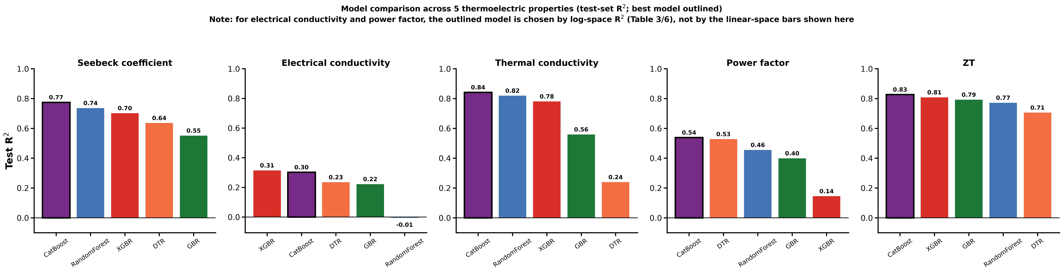
Figure 1. Test-set R2 for all five algorithms across all five properties; the best model per property is outlined in black.

5. Best Hyperparameters
Hyperparameters below are the best configuration found by randomized search (25 iterations, 5-fold CV, R2 scoring) for every algorithm on every property, not only the overall best model -- included for full reproducibility.

5.1 Seebeck coefficient
Model | Best hyperparameters (randomized search)
CatBoost | learning_rate=0.2; l2_leaf_reg=3; iterations=100; depth=4
RandomForest | n_estimators=300; min_samples_leaf=1; max_features=1.0; max_depth=None
XGBR | subsample=1.0; reg_lambda=1; n_estimators=300; min_child_weight=5; max_depth=8; learning_rate=0.2; colsample_bytree=0.85
DTR | min_samples_split=4; min_samples_leaf=1; max_depth=None
GBR | subsample=1.0; n_estimators=100; min_samples_leaf=1; max_depth=6; learning_rate=0.2

5.2 Electrical conductivity
Model | Best hyperparameters (randomized search)
CatBoost | learning_rate=0.2; l2_leaf_reg=3; iterations=500; depth=4
XGBR | subsample=1.0; reg_lambda=0.1; n_estimators=500; min_child_weight=1; max_depth=8; learning_rate=0.01; colsample_bytree=0.6
GBR | subsample=0.85; n_estimators=200; min_samples_leaf=1; max_depth=3; learning_rate=0.1
DTR | min_samples_split=4; min_samples_leaf=1; max_depth=6
RandomForest | n_estimators=500; min_samples_leaf=1; max_features=0.7; max_depth=12

5.3 Thermal conductivity
Model | Best hyperparameters (randomized search)
CatBoost | learning_rate=0.03; l2_leaf_reg=3; iterations=300; depth=10
RandomForest | n_estimators=800; min_samples_leaf=1; max_features=log2; max_depth=None
XGBR | subsample=0.85; reg_lambda=0.1; n_estimators=50; min_child_weight=5; max_depth=5; learning_rate=0.2; colsample_bytree=0.85
GBR | subsample=1.0; n_estimators=50; min_samples_leaf=4; max_depth=5; learning_rate=0.05
DTR | min_samples_split=4; min_samples_leaf=4; max_depth=6

5.4 Power factor
Model | Best hyperparameters (randomized search)
CatBoost | learning_rate=0.05; l2_leaf_reg=3; iterations=500; depth=4
GBR | subsample=0.7; n_estimators=300; min_samples_leaf=8; max_depth=2; learning_rate=0.1
XGBR | subsample=0.6; reg_lambda=3; n_estimators=200; min_child_weight=3; max_depth=2; learning_rate=0.2; colsample_bytree=1.0
RandomForest | n_estimators=300; min_samples_leaf=1; max_features=1.0; max_depth=None
DTR | min_samples_split=8; min_samples_leaf=1; max_depth=4

5.5 ZT
Model | Best hyperparameters (randomized search)
CatBoost | learning_rate=0.2; l2_leaf_reg=3; iterations=200; depth=5
XGBR | subsample=0.6; reg_lambda=1; n_estimators=200; min_child_weight=5; max_depth=4; learning_rate=0.05; colsample_bytree=0.6
GBR | subsample=0.7; n_estimators=300; min_samples_leaf=2; max_depth=6; learning_rate=0.01
RandomForest | n_estimators=300; min_samples_leaf=1; max_features=1.0; max_depth=None
DTR | min_samples_split=8; min_samples_leaf=1; max_depth=6

6. SHAP Interpretability Analysis
SHAP (SHapley Additive exPlanations) values were computed with TreeExplainer for each property's best model on its training set, giving both a global ranking (mean absolute SHAP value) and a per-sample beeswarm view of how each feature's value shifts the prediction.

6.1 Seebeck coefficient
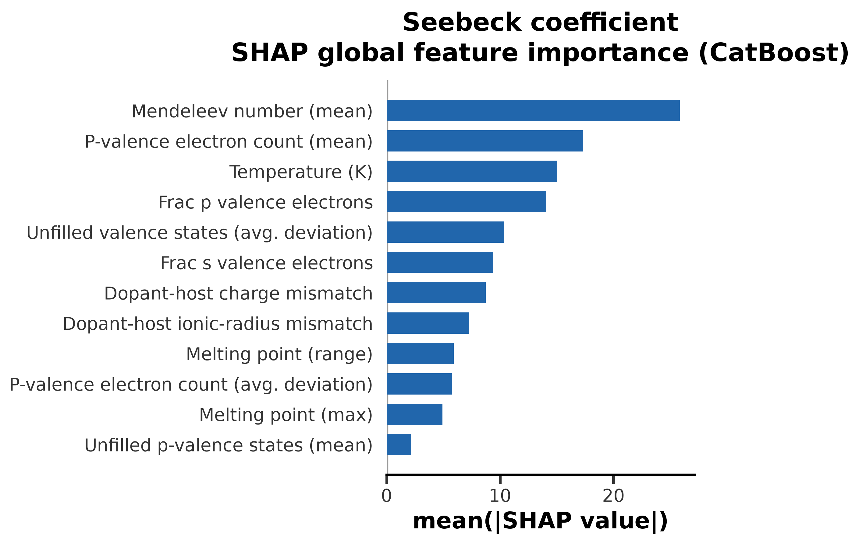
Global SHAP importance -- Seebeck coefficient.
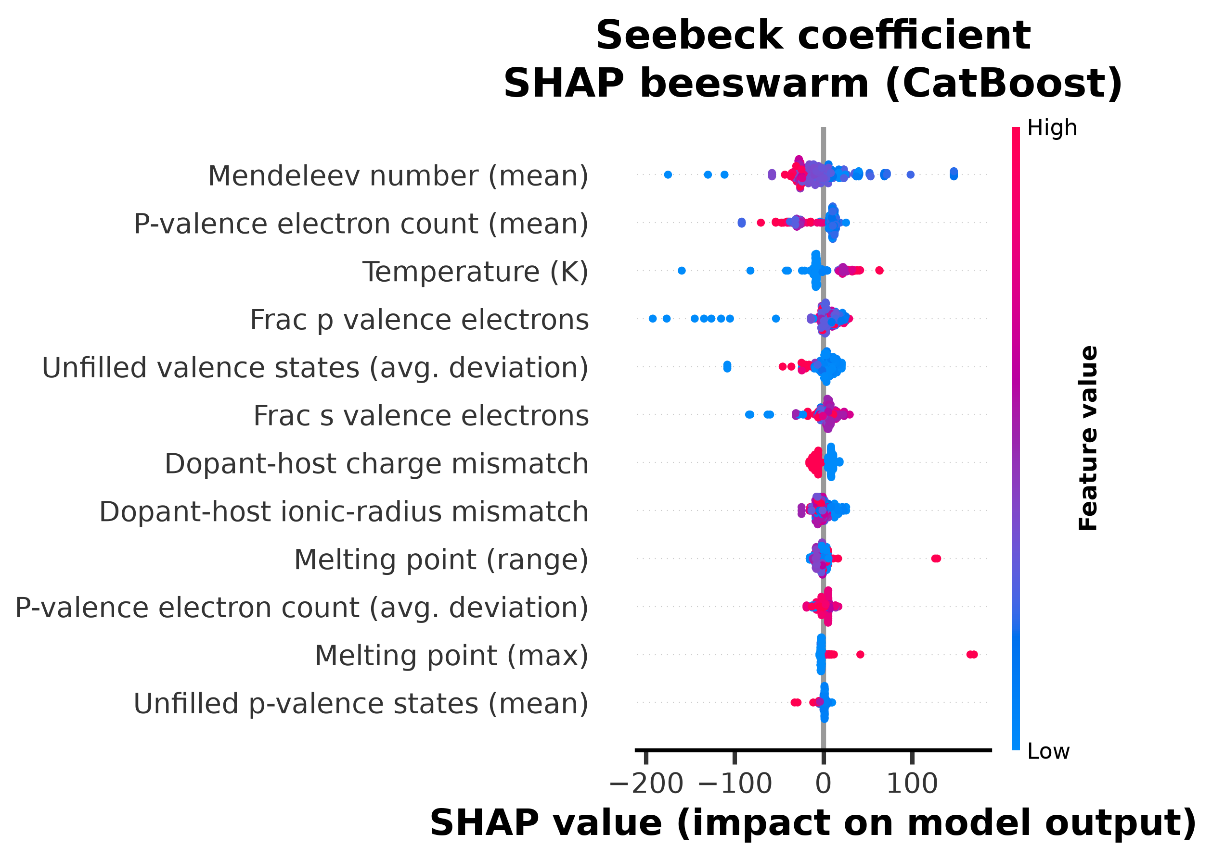
SHAP beeswarm -- Seebeck coefficient.
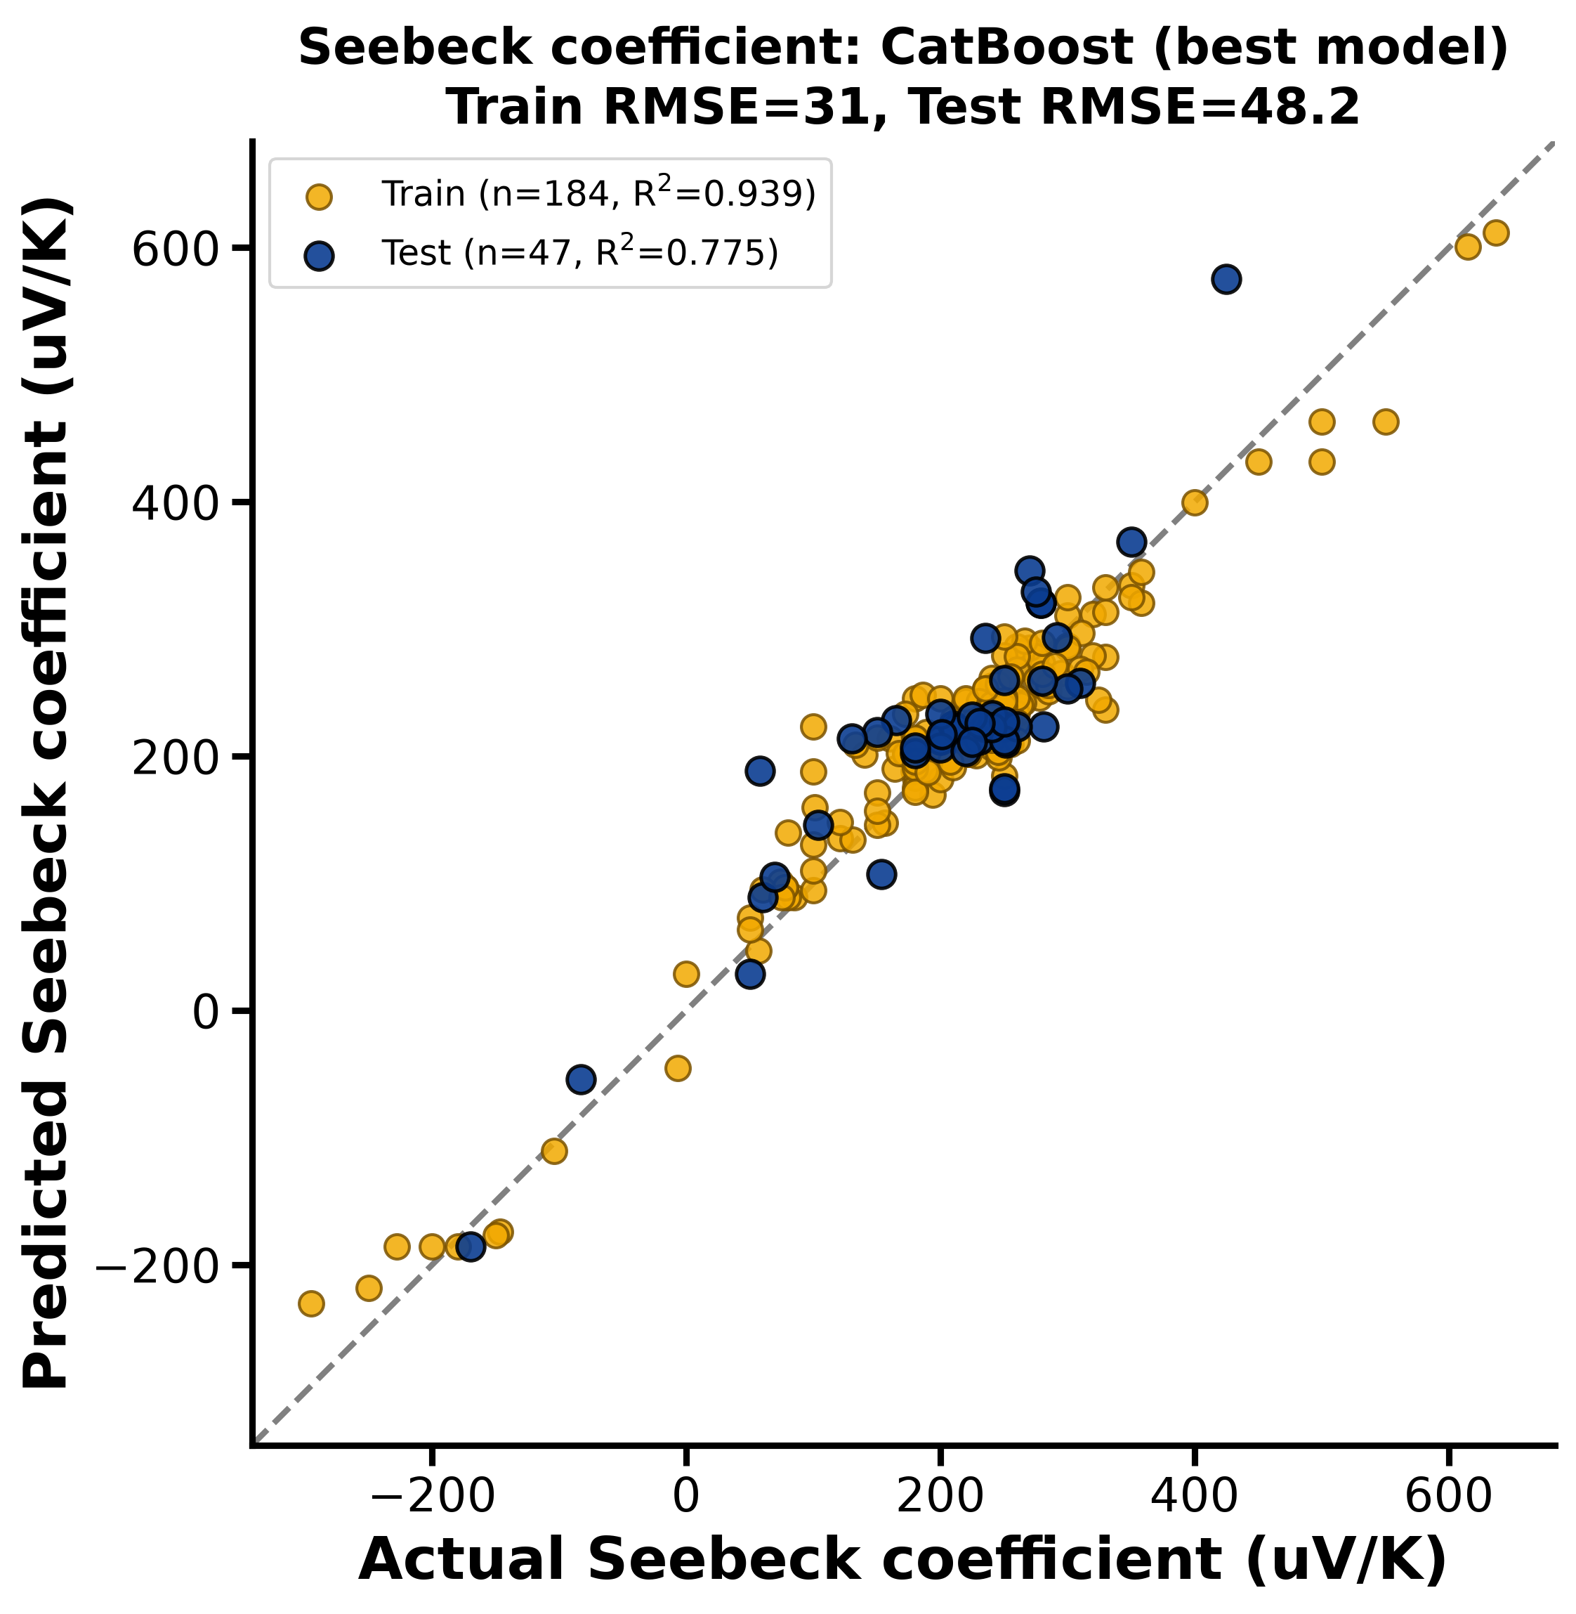
Parity plot (predicted vs. actual, test set) -- Seebeck coefficient.

6.2 Electrical conductivity
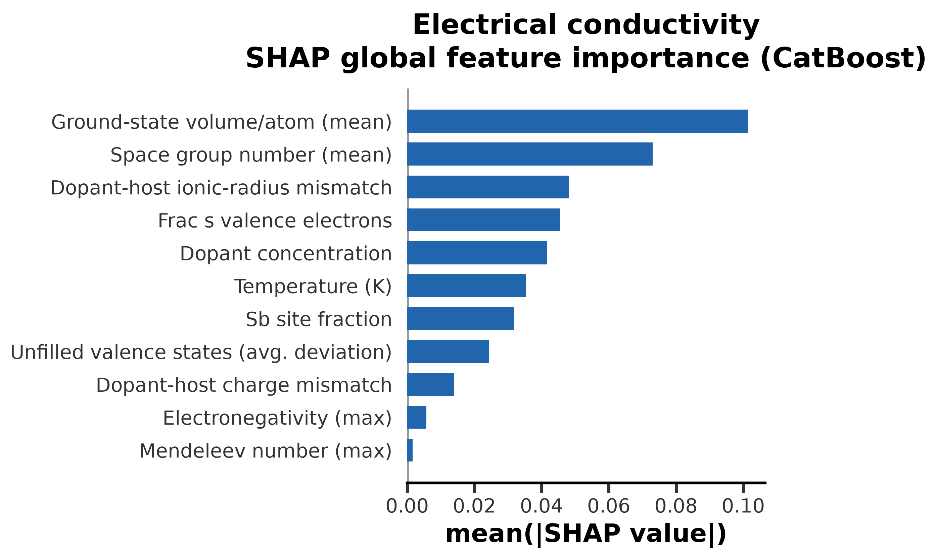
Global SHAP importance -- Electrical conductivity.
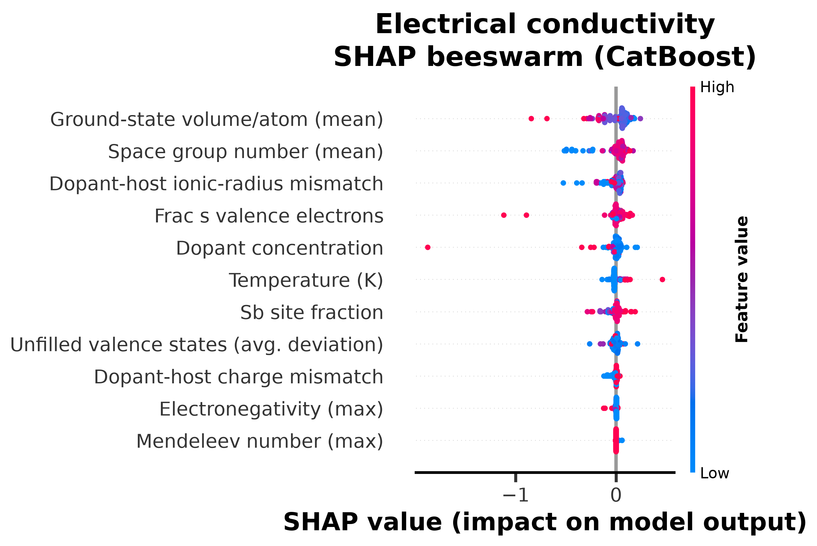
SHAP beeswarm -- Electrical conductivity.
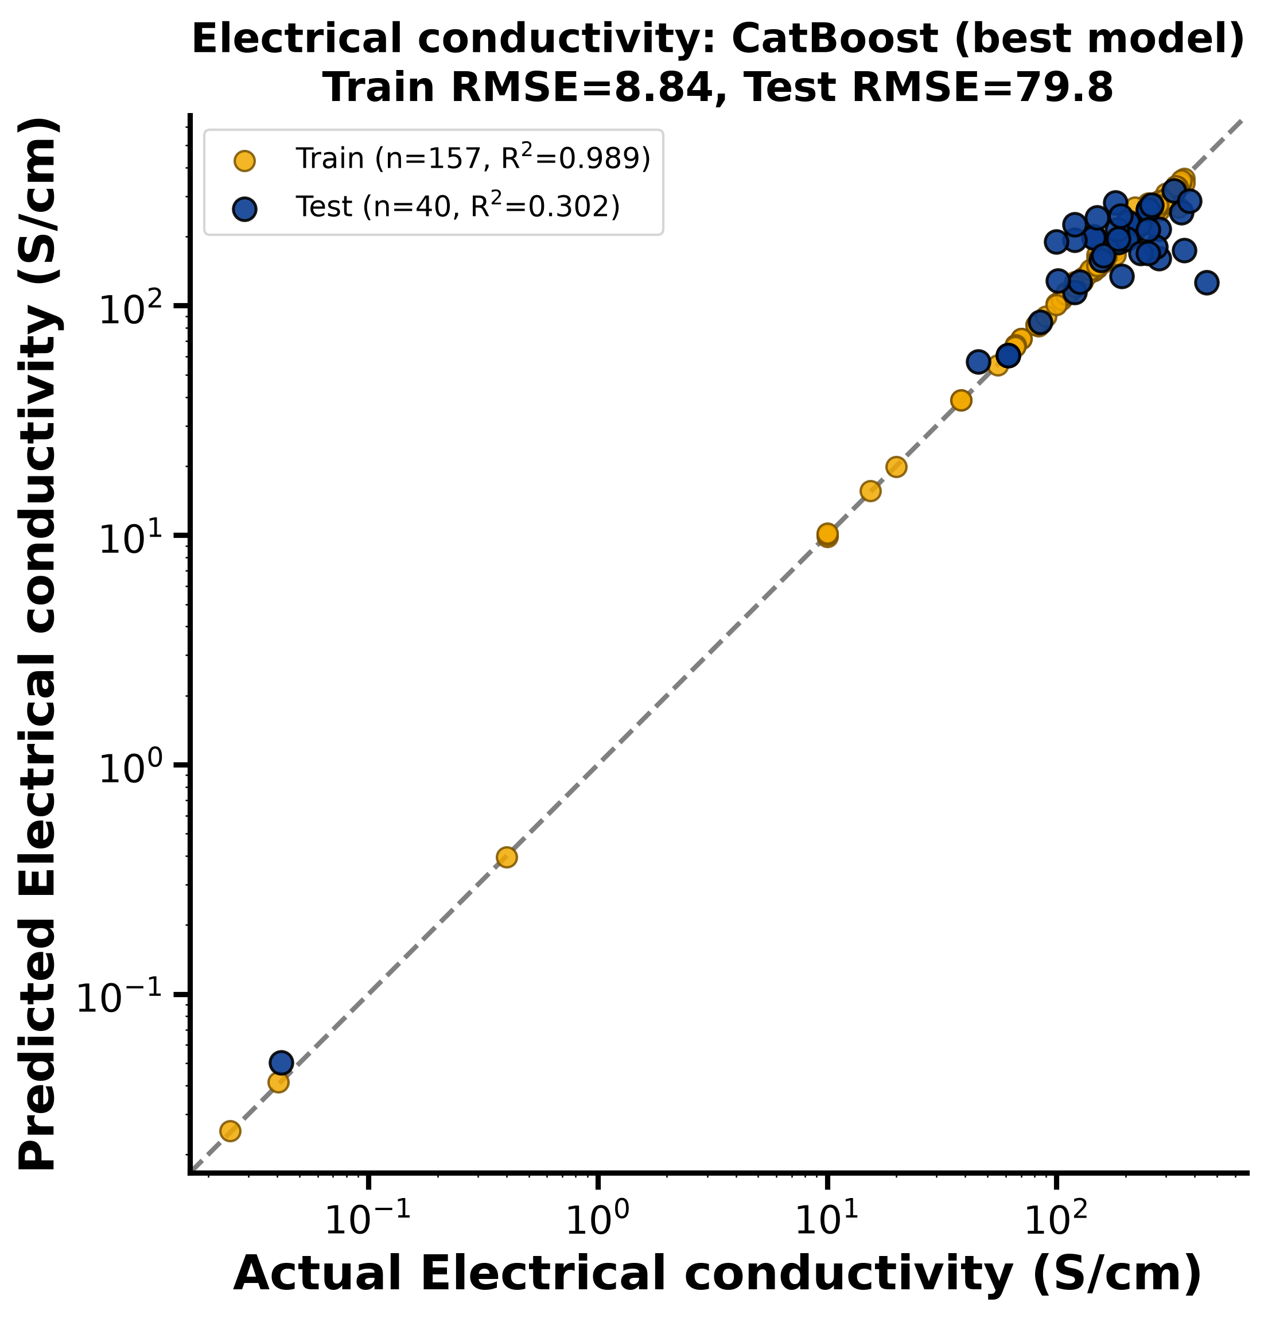
Parity plot (predicted vs. actual, test set) -- Electrical conductivity.

6.3 Thermal conductivity
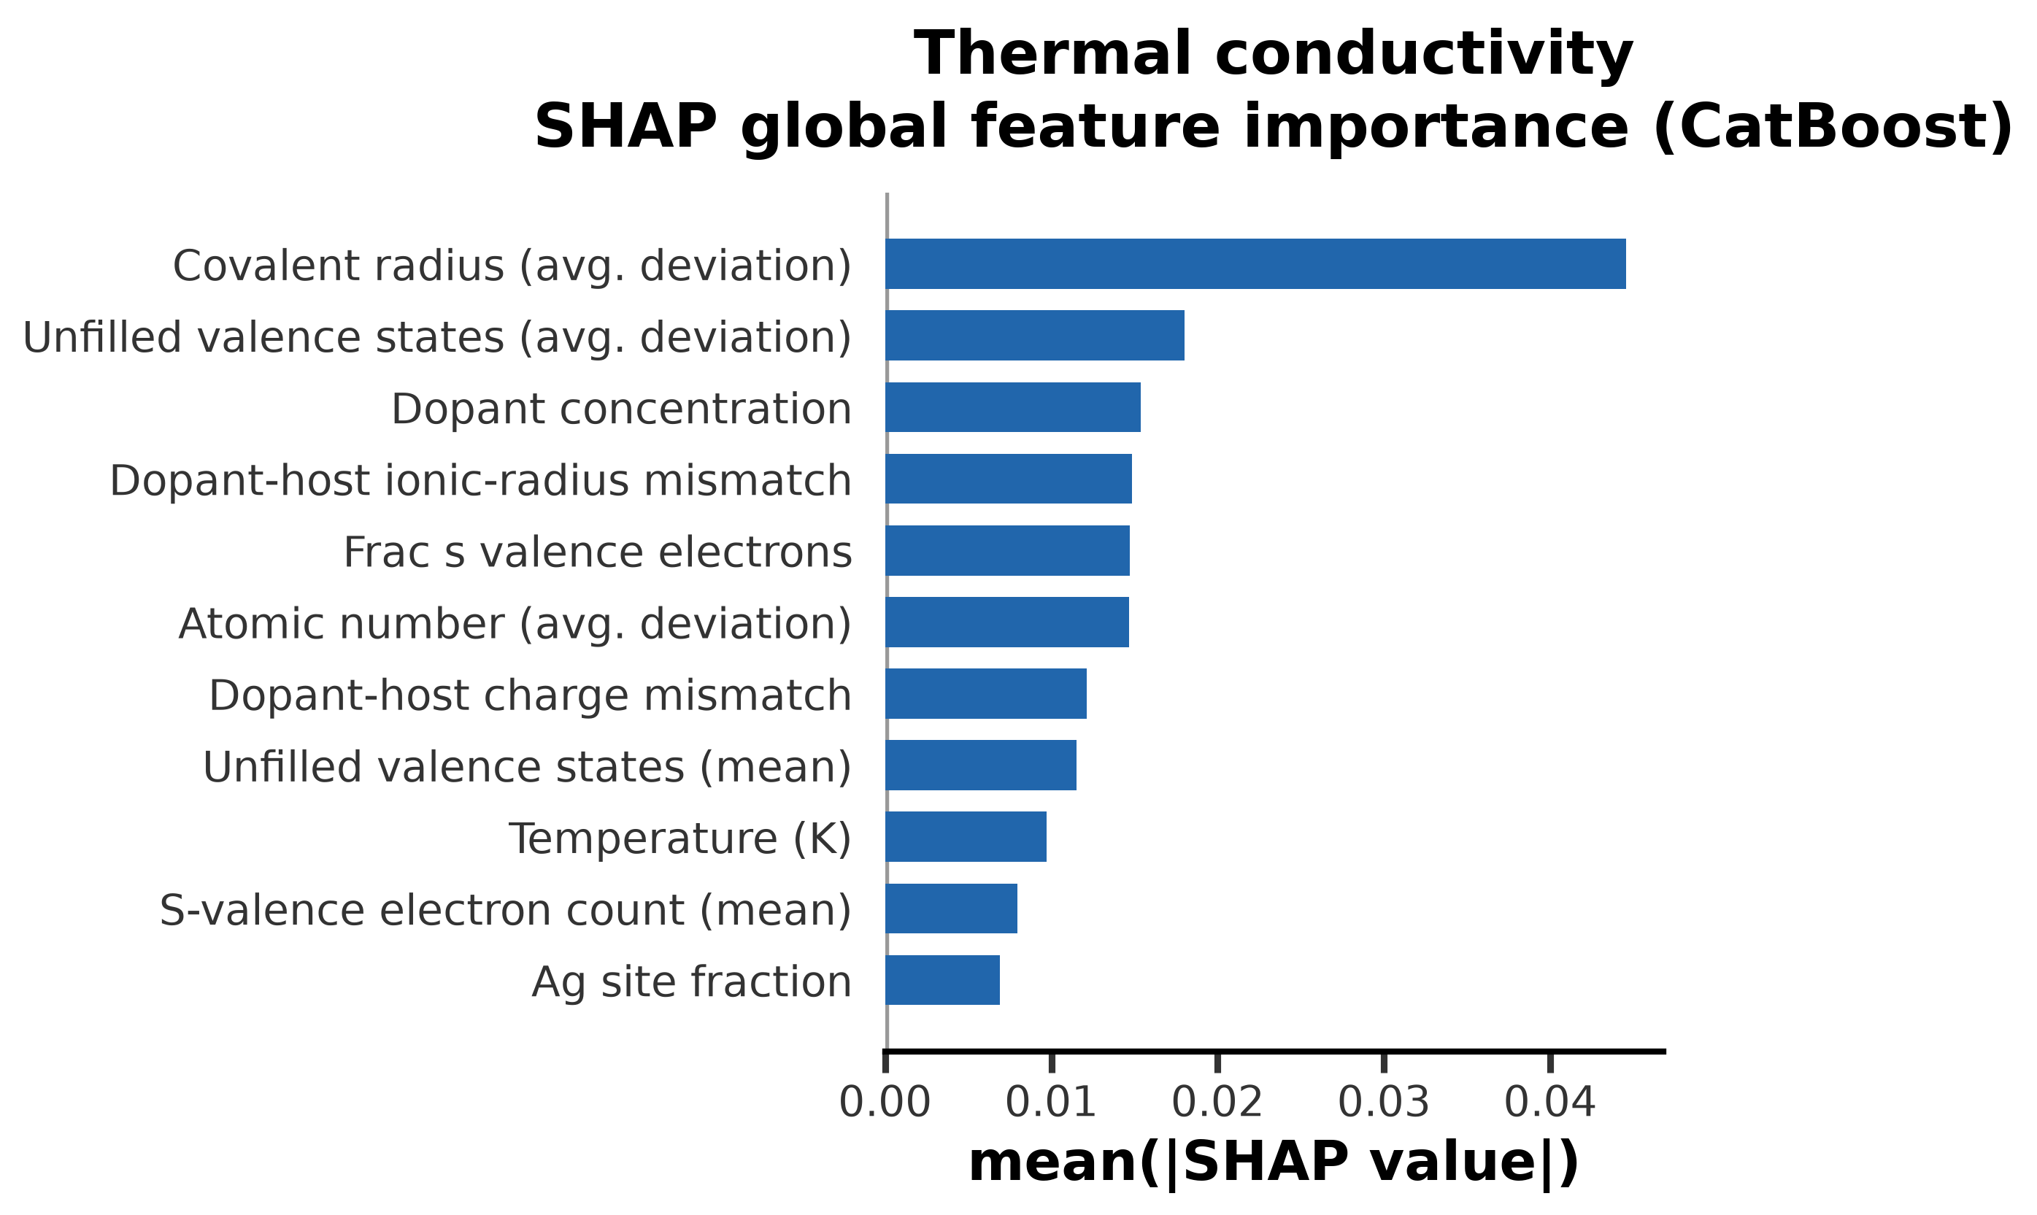
Global SHAP importance -- Thermal conductivity.
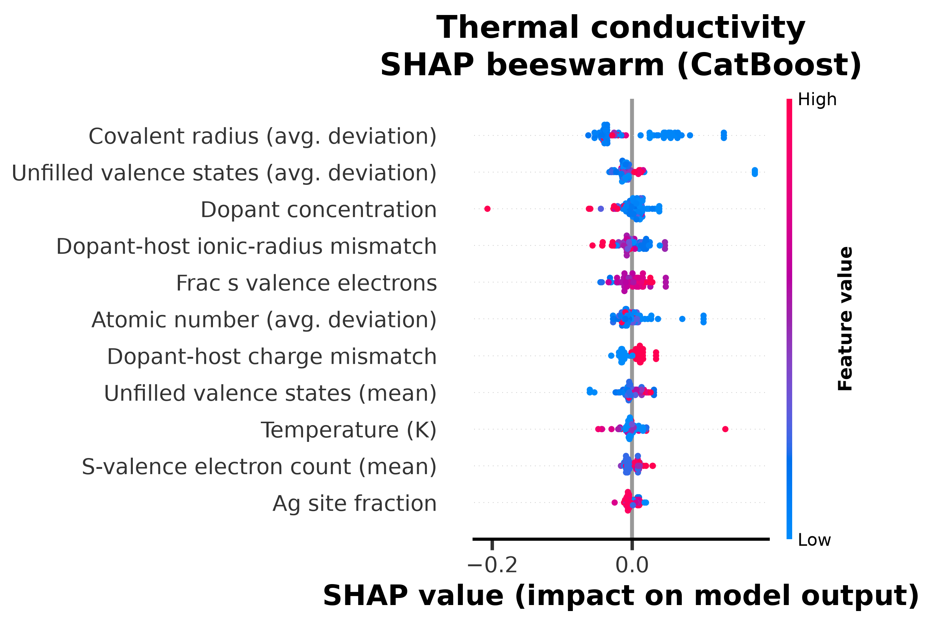
SHAP beeswarm -- Thermal conductivity.
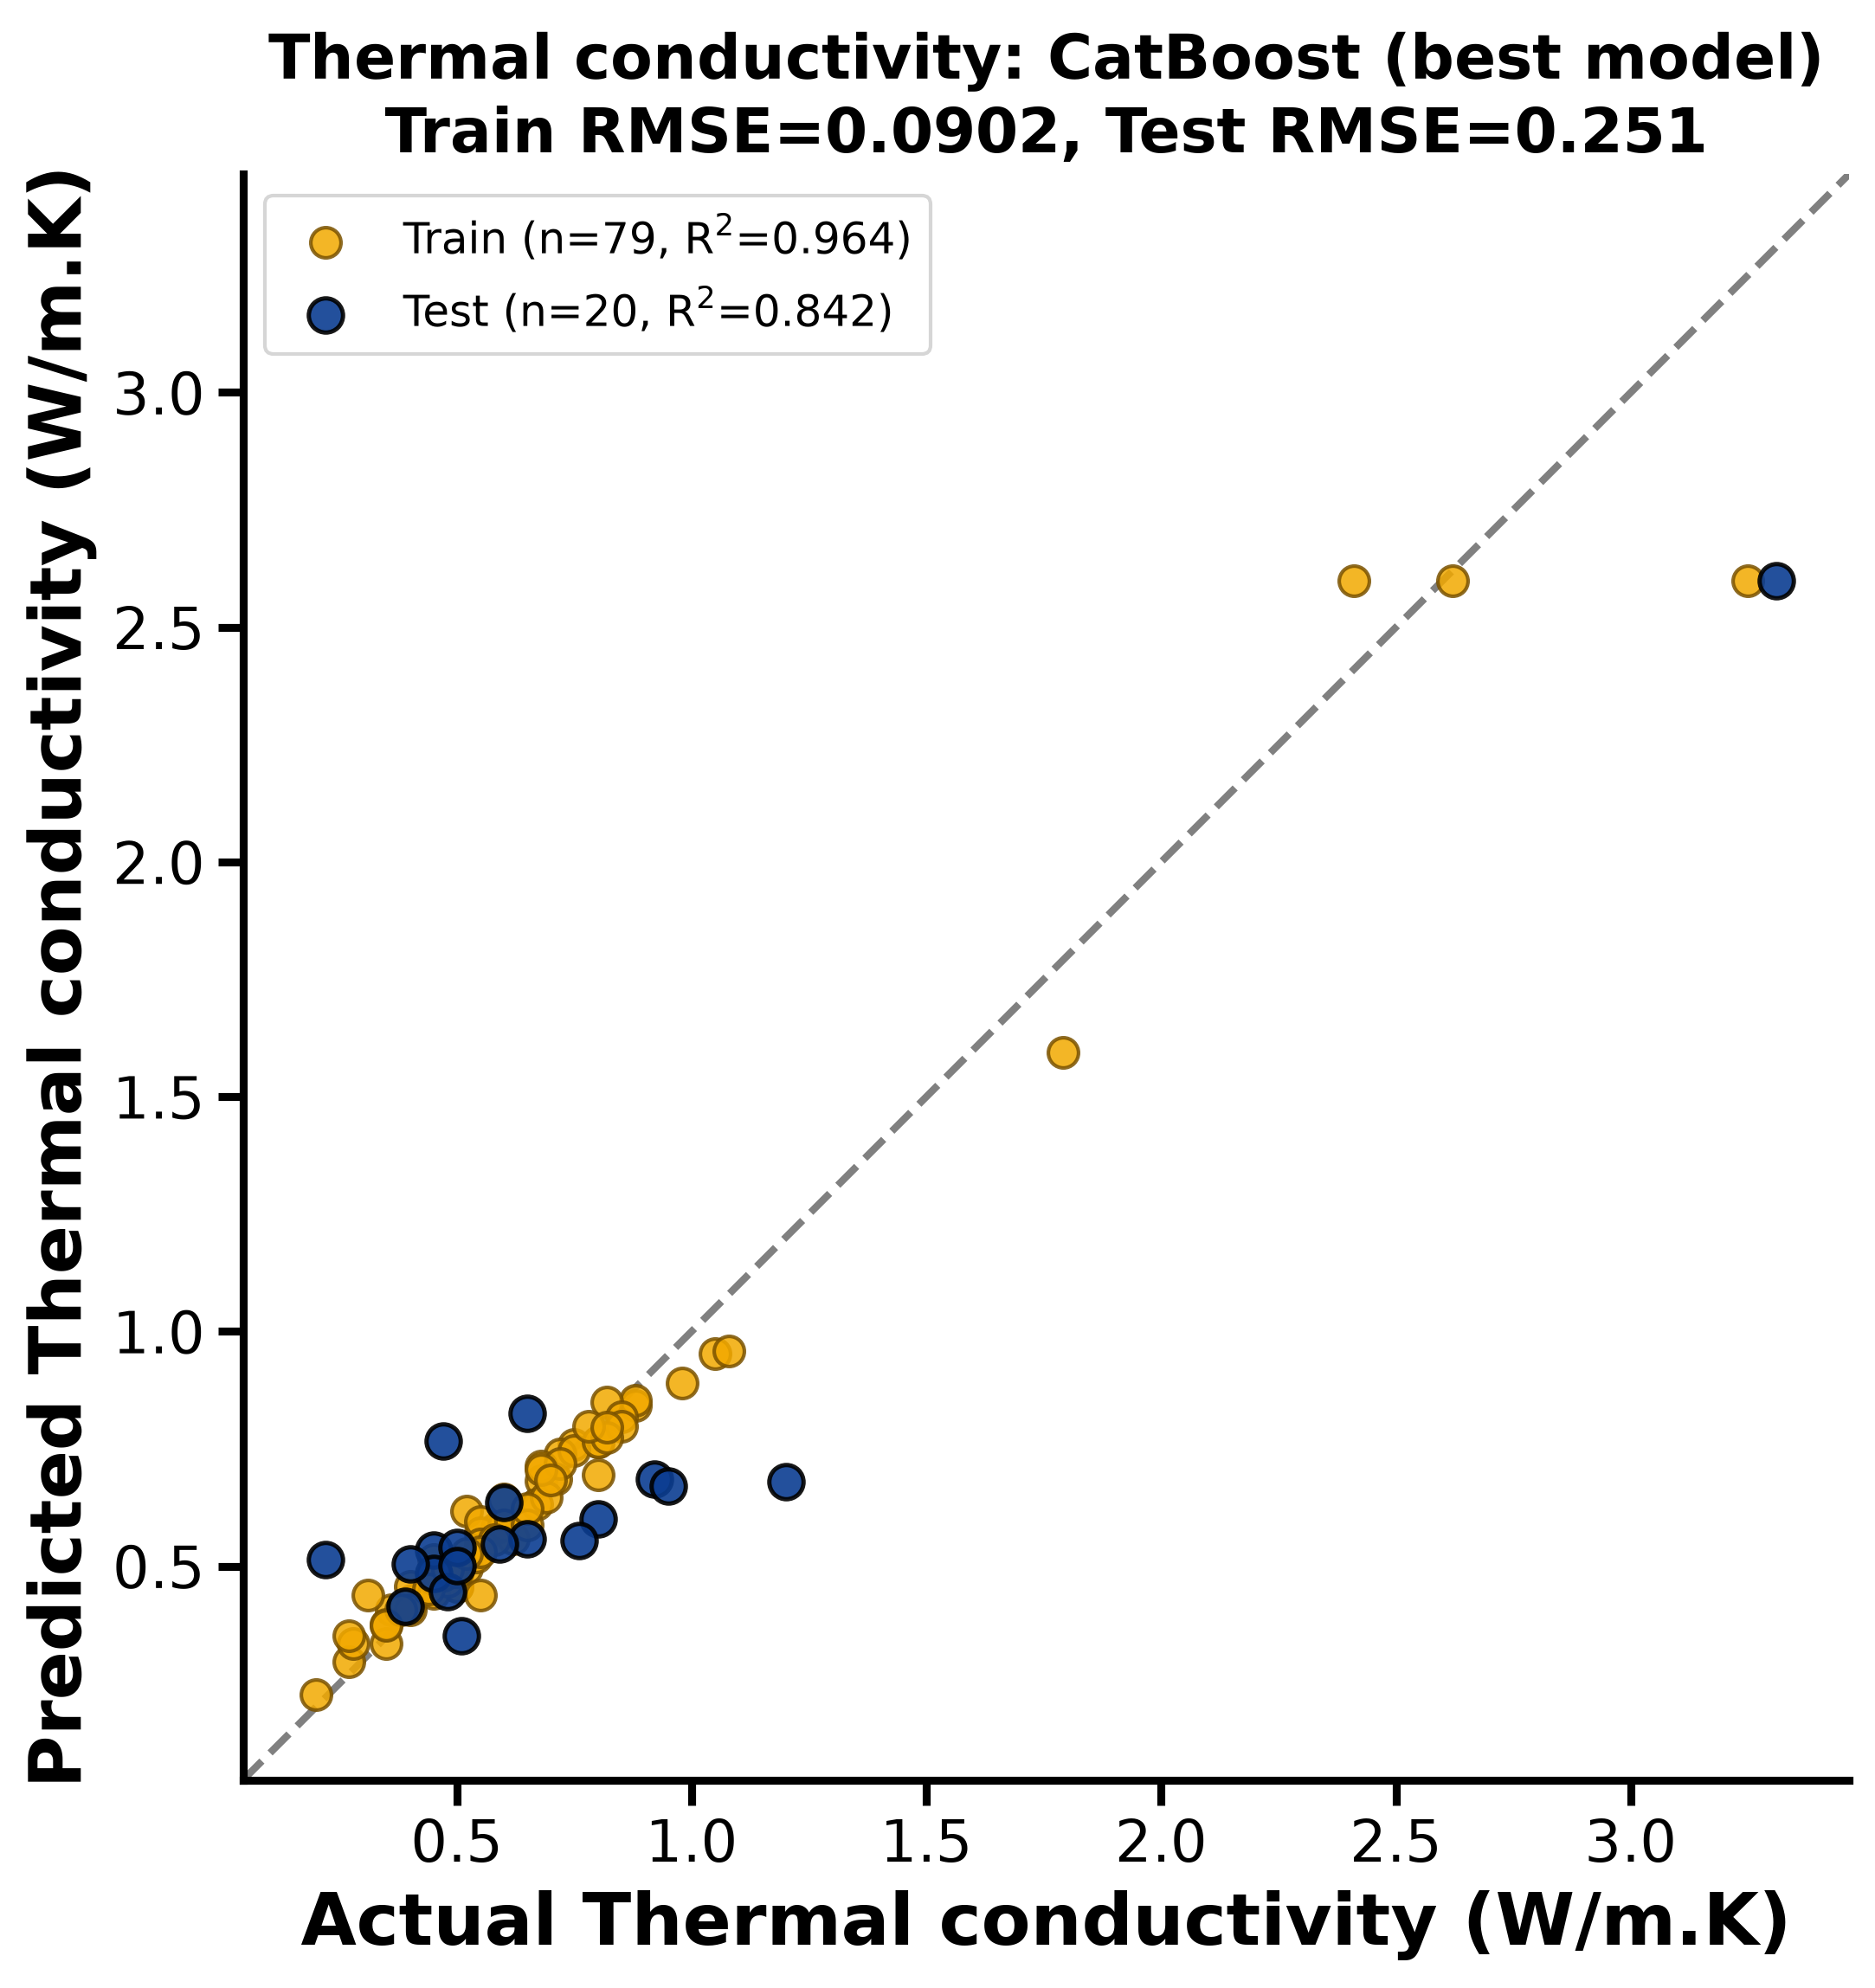
Parity plot (predicted vs. actual, test set) -- Thermal conductivity.

6.4 Power factor
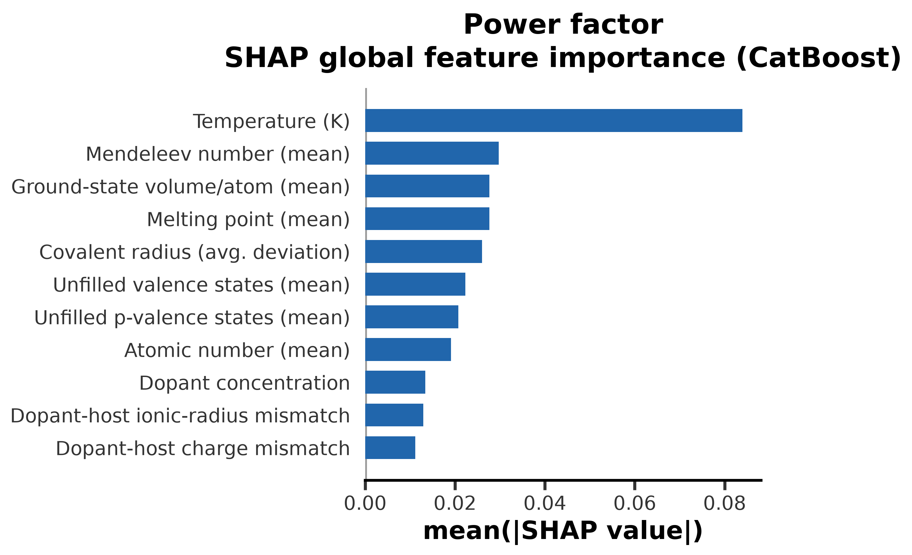
Global SHAP importance -- Power factor.
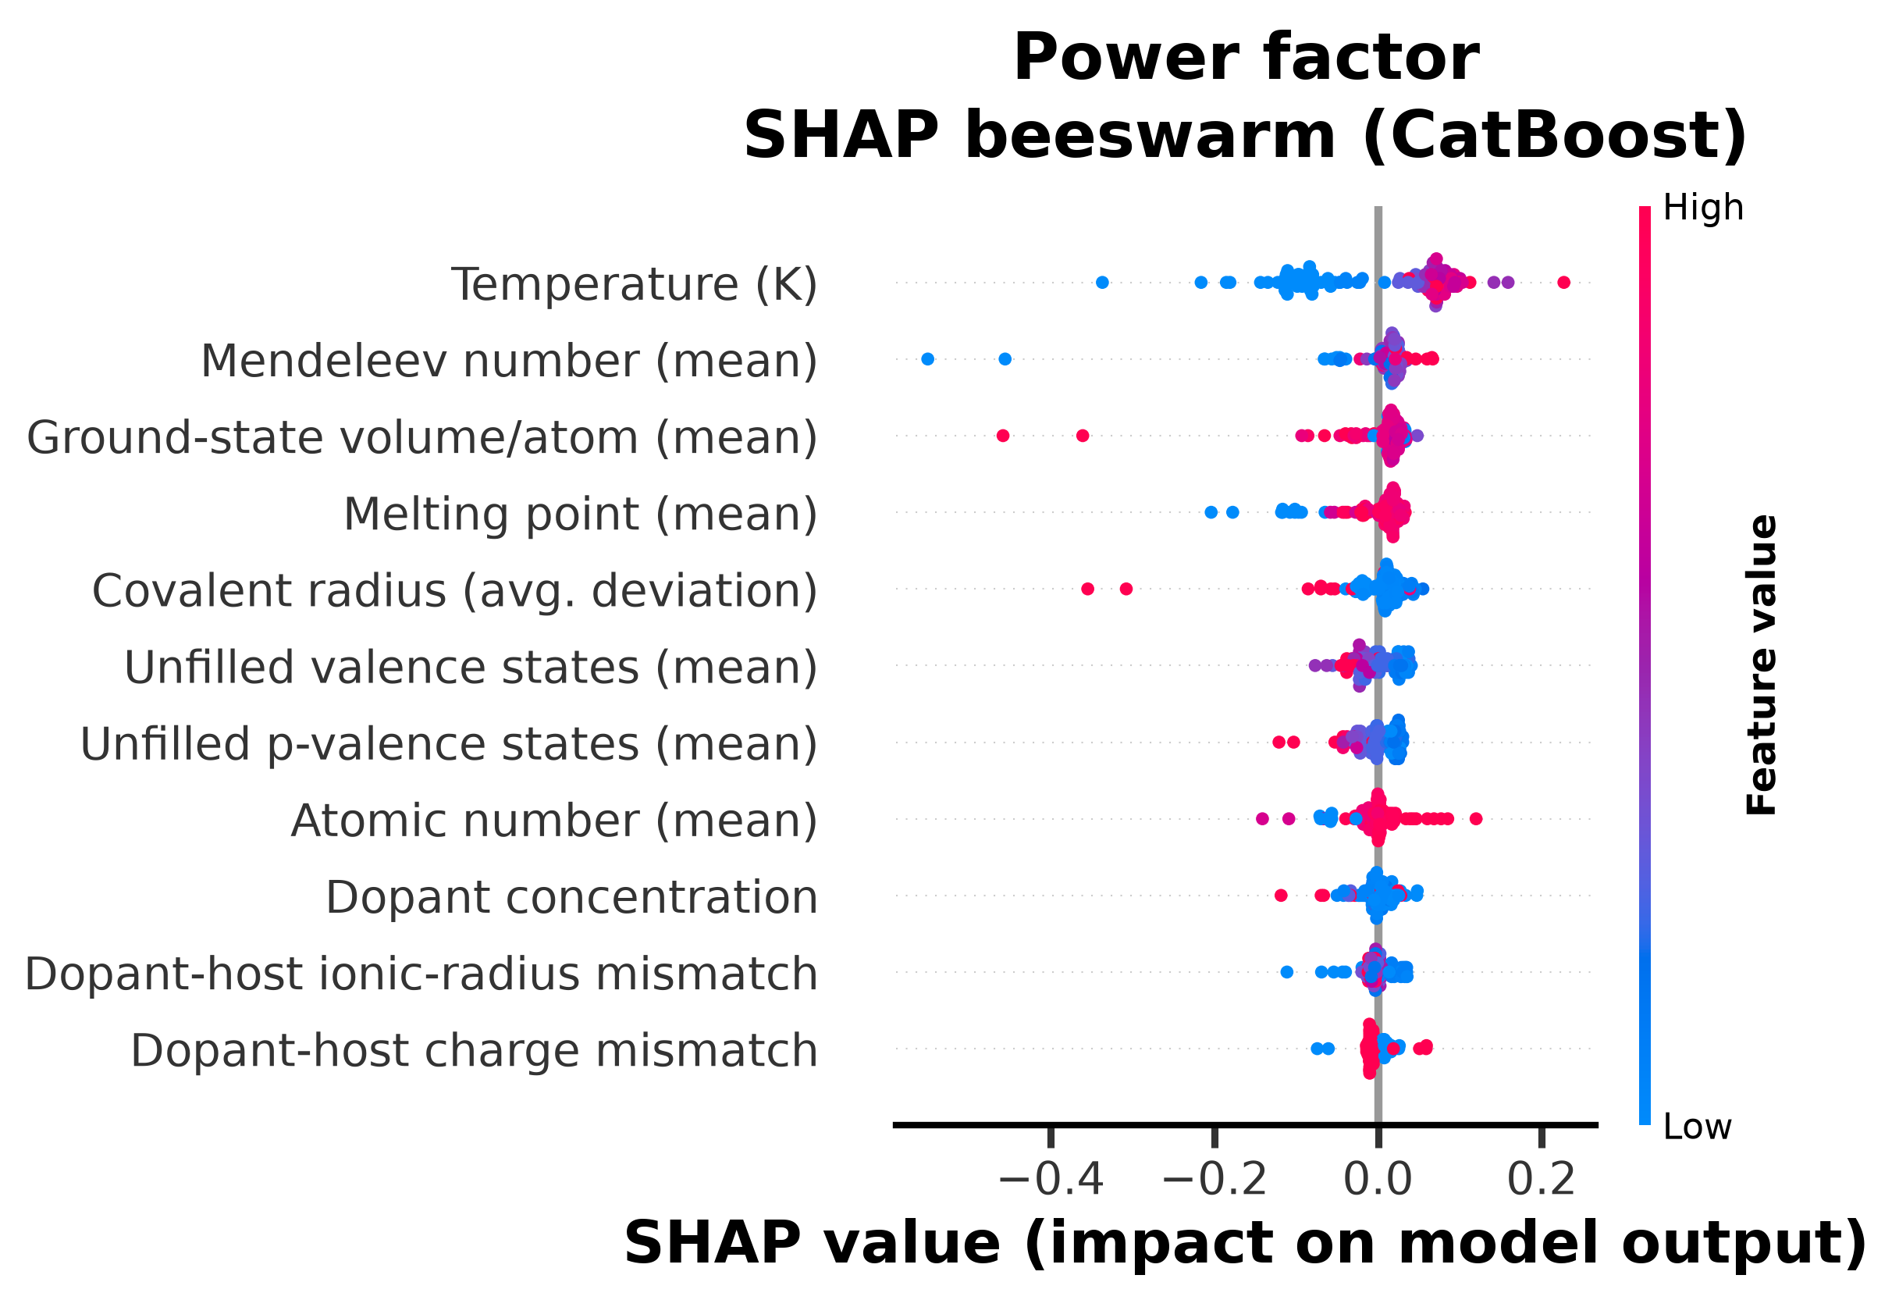
SHAP beeswarm -- Power factor.
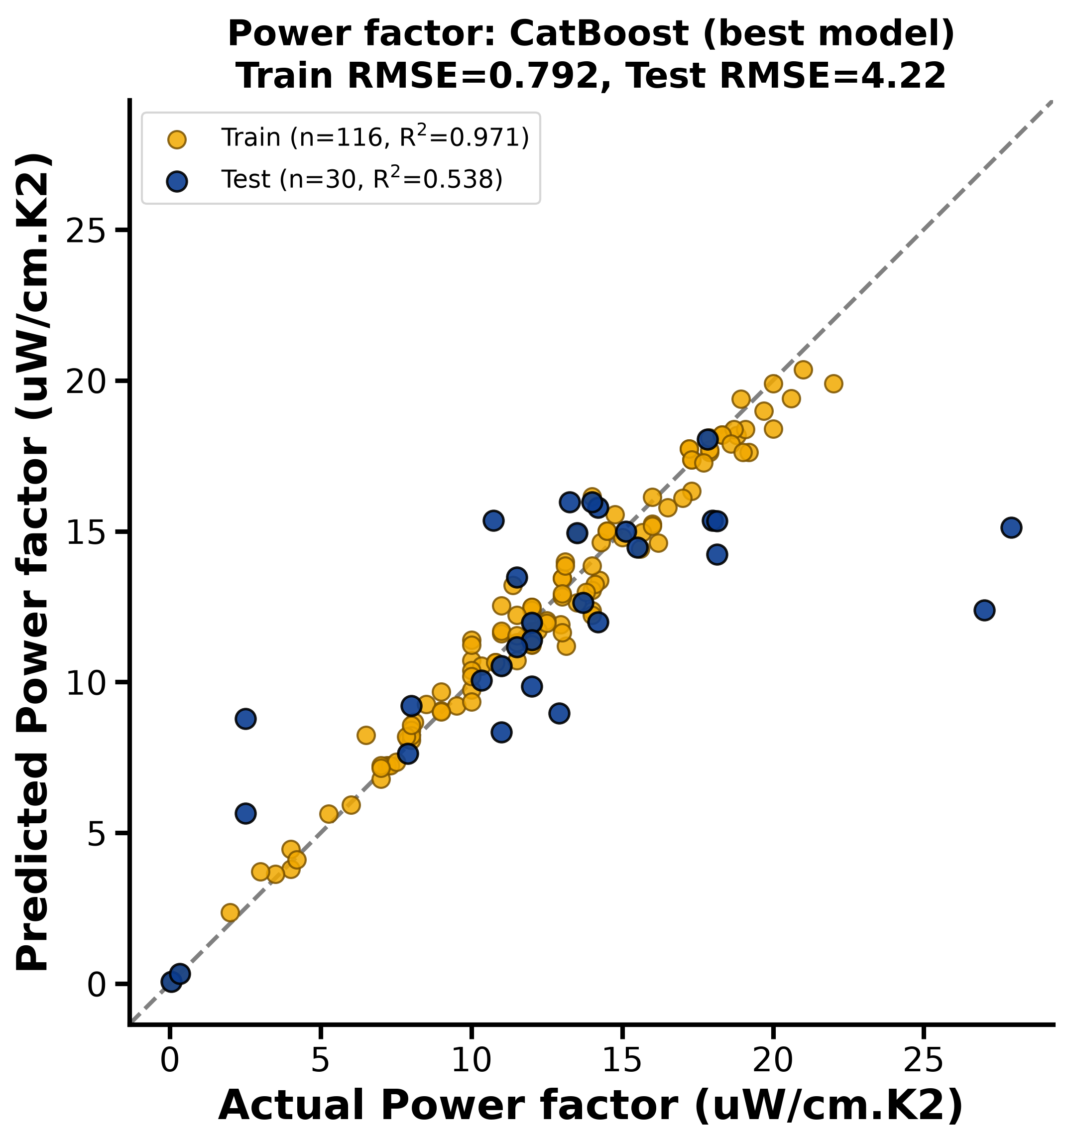
Parity plot (predicted vs. actual, test set) -- Power factor.

6.5 ZT
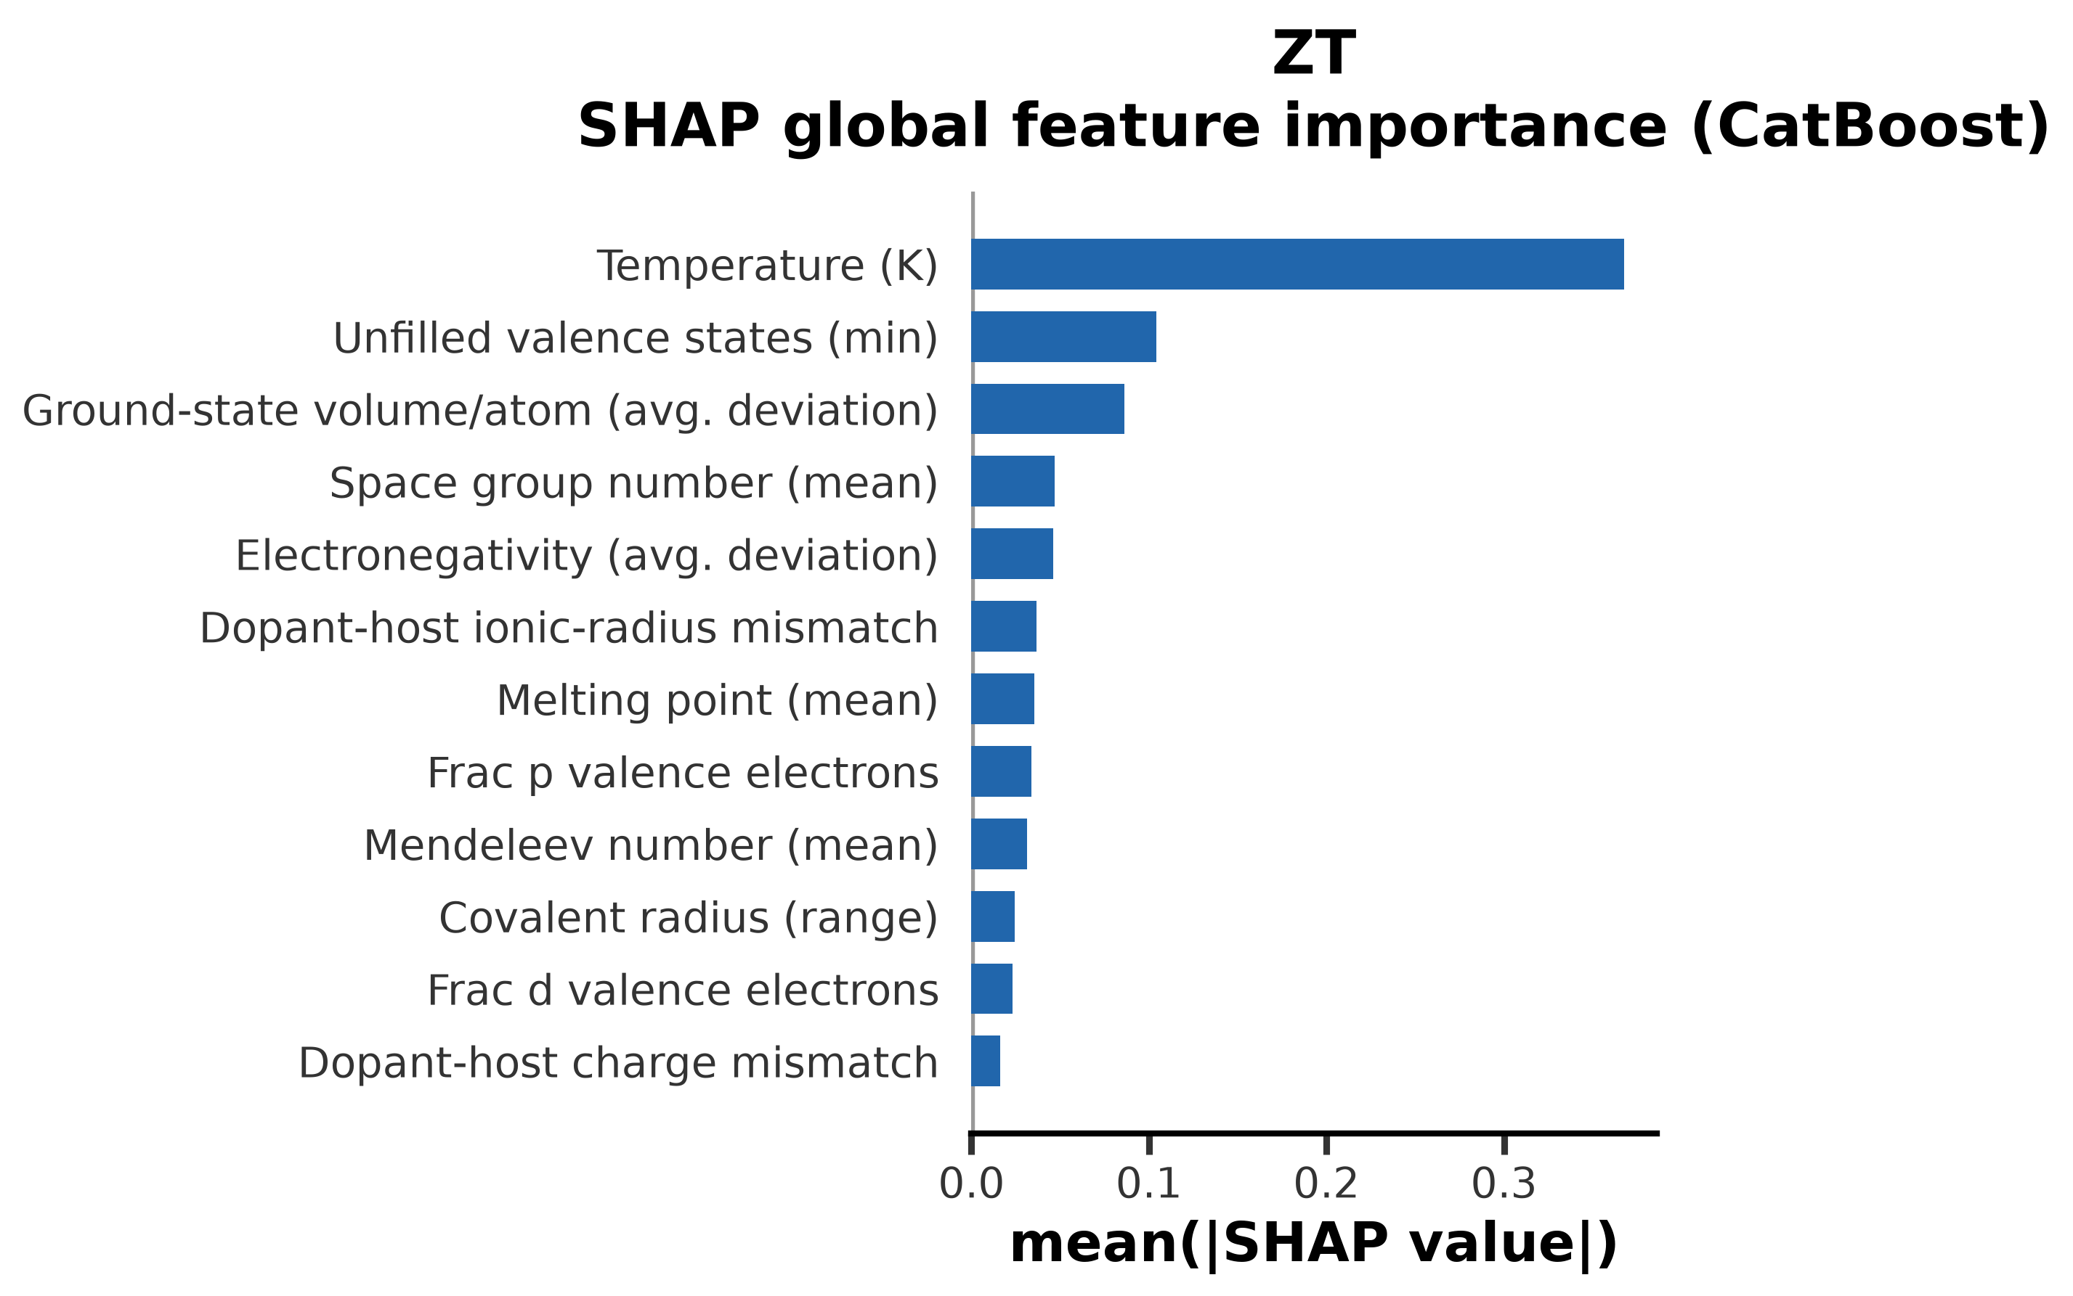
Global SHAP importance -- ZT.
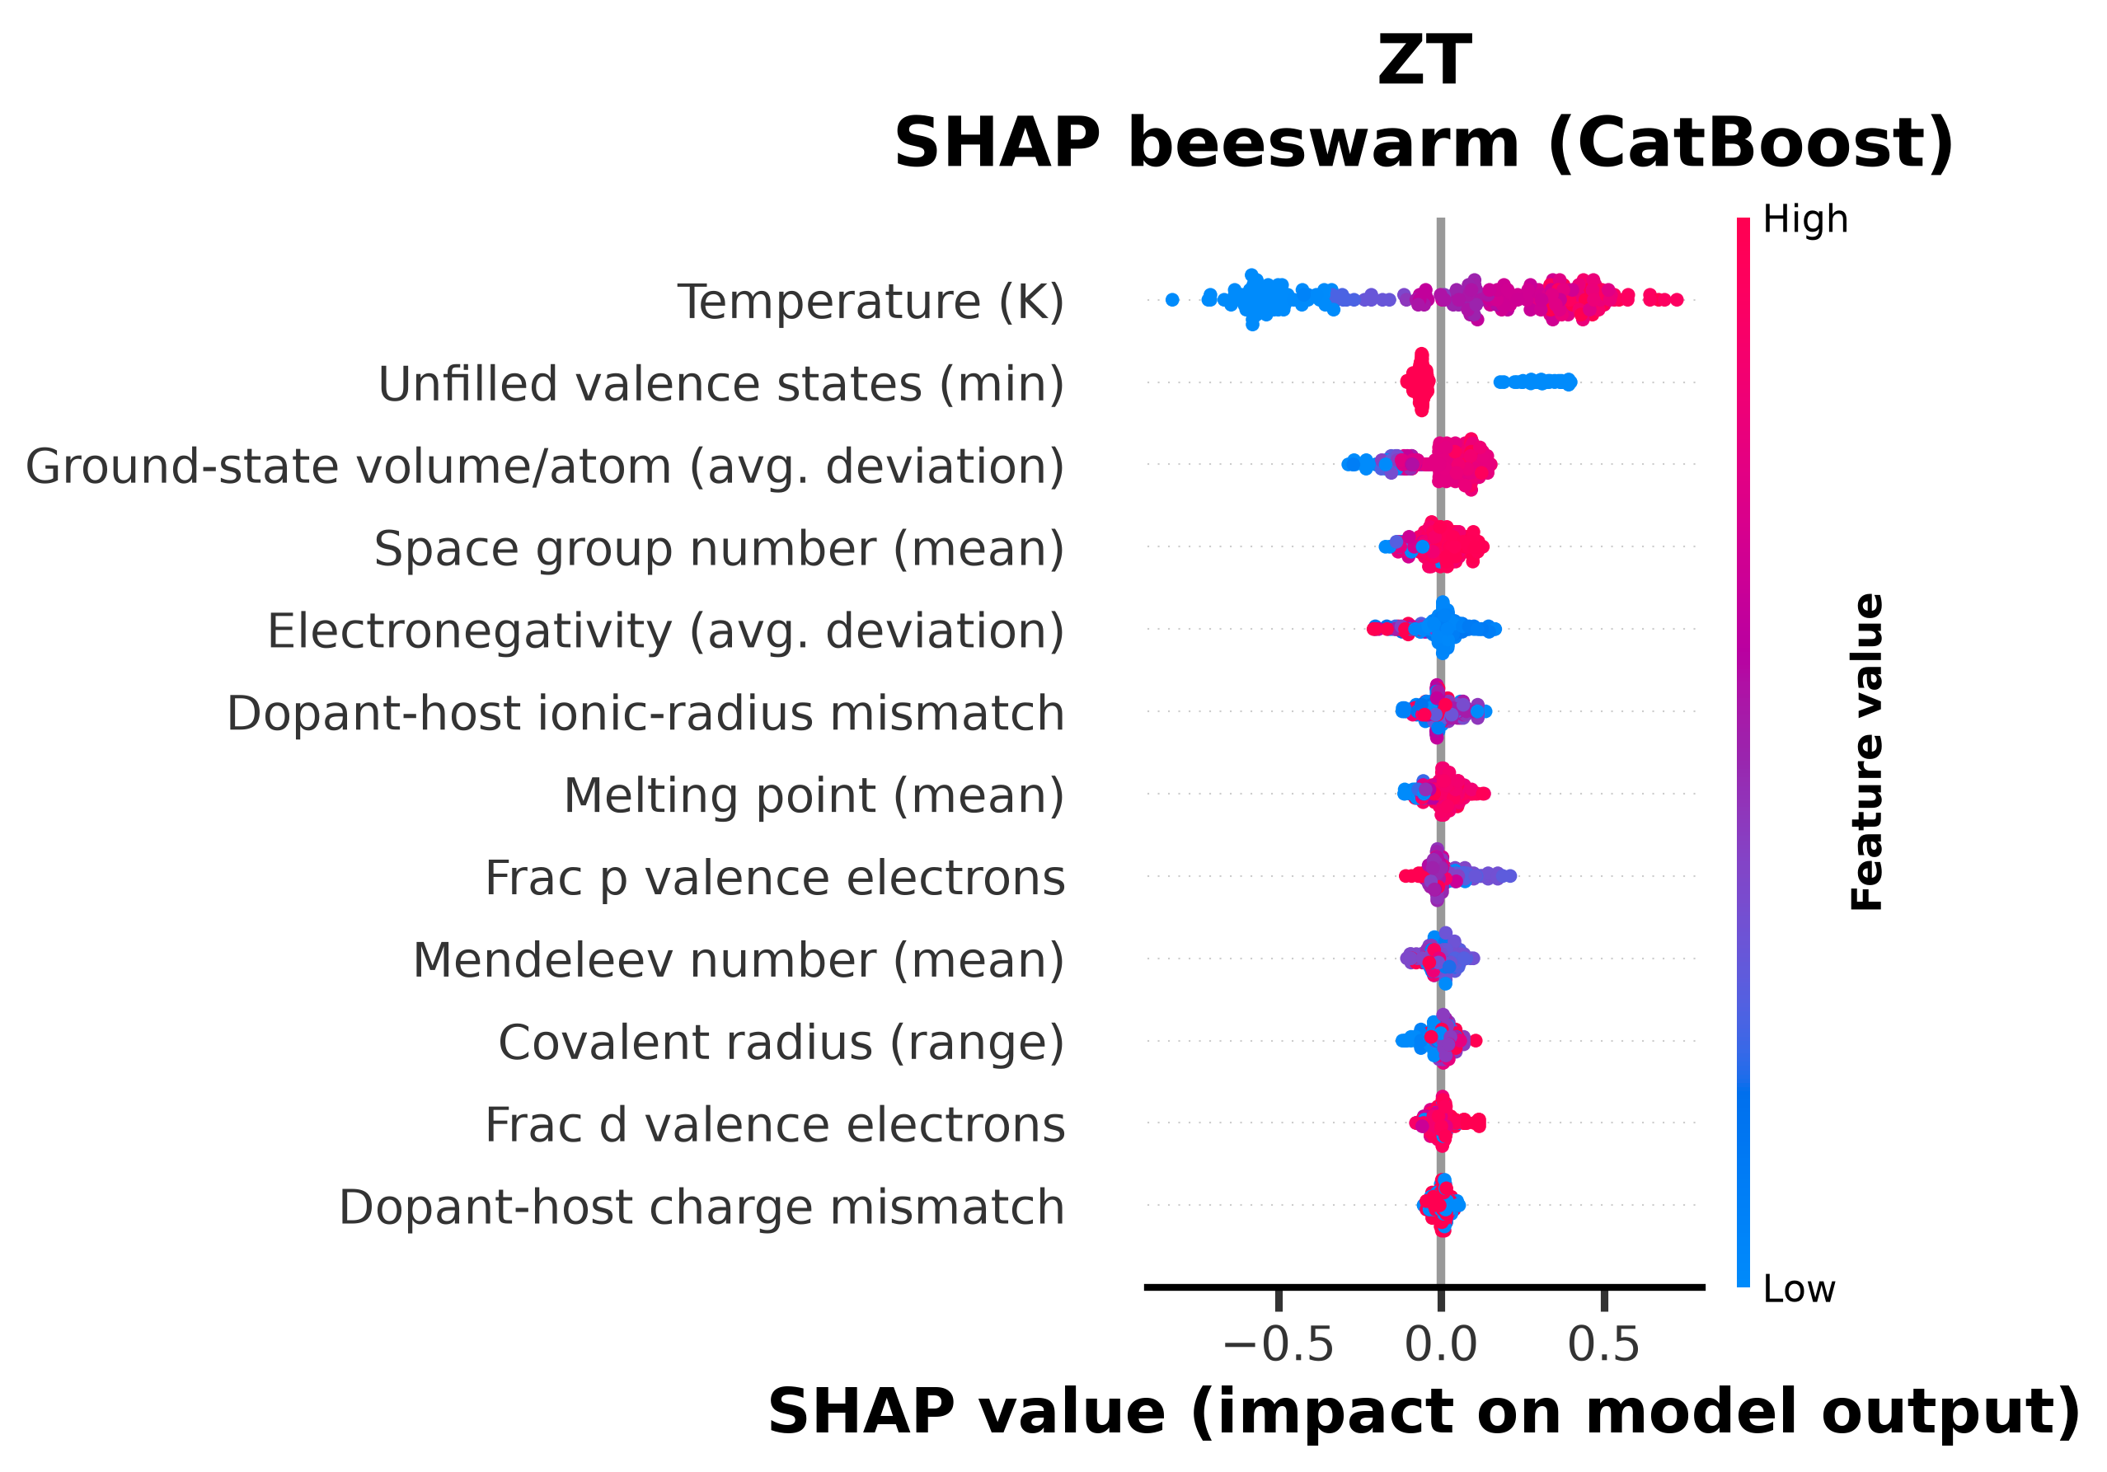
SHAP beeswarm -- ZT.
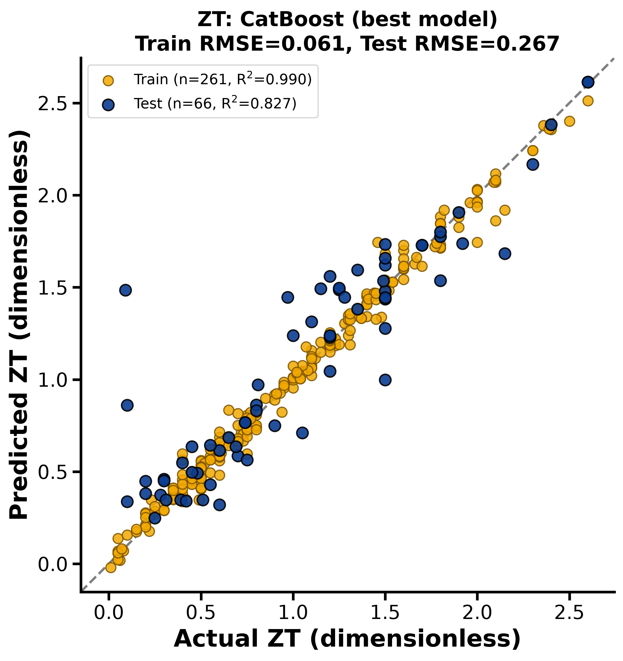
Parity plot (predicted vs. actual, test set) -- ZT.

6.6 The Cation-Disorder Descriptors in SHAP
Property | Total features | Charge-mismatch rank | Radius-mismatch rank
Seebeck coefficient | 12 | 7 | 8
Electrical conductivity | 11 | 9 | 3
Thermal conductivity | 11 | 7 | 4
Power factor | 11 | 11 | 10
ZT | 12 | 12 | 6
Table 8. SHAP-importance rank of the two Biswas-mechanism descriptors within each property's selected feature set (rank 1 = most important).
In most of the five properties, dopant-host ionic-radius mismatch outranks dopant-host charge mismatch, in some cases substantially (Table 8). This is directionally consistent with the Biswas-group finding that local size/strain accommodation at the Ag+/Sb3+ site -- rather than simple oxidation-state balance -- is the dominant lever on cation ordering and thermoelectric performance in this material family; the model recovers this emphasis from the extracted-literature data without being told it explicitly.

7. Inverse Design: Optimum Dopant Prediction for Highest ZT
Using the best ZT model, a grid of candidate dopant element (all elements up to Bi, excluding noble gases, radioactive elements, and the host elements Ag/Sb/Te) x doped site (Ag, Sb, Te) x doping ratio (1-20%) x temperature (300-773 K) was screened, followed by a co-doping screen among the top single-dopant candidates. Because the descriptors are composition-based (not restricted to elements seen during training), this screen extends to dopants never reported as AgSbTe2 dopants in the literature corpus, providing genuine model-guided exploration rather than interpolation only.

7.1 Answers to the Four Design Questions
Question | Model-guided answer
1. Best dopant element | Cd (predicted ZT = 2.67 at 573 K)
2. Single- or co-doped, and site | Single-doped is predicted to outperform the best co-doped combination found (2.67 vs. 2.60); site = Sb
3. Dopant ratio/percentage | 8 at.%
4. Best novel/unexplored dopant | Be on the Te site at 5% (predicted ZT = 2.28) -- not previously reported as an AgSbTe2 dopant in this corpus
Table 9. Direct answers to the four inverse-design questions, from the best ZT model.

Internal consistency, not external validation: the top-ranked single-dopant prediction (Cd on the Sb site, 8%, 573 K, predicted ZT = 2.67) sits close to -- but does not exactly reproduce -- reported ratios (2%, 4%, 6%) for Cd-on-Sb doping across five papers already in the training corpus, including the original report of ZT ~ 2.6 at 573 K. Because that chemistry is heavily represented in training, this result demonstrates that the screen correctly recovers/mildly interpolates a known optimum rather than ranking something worse above it -- a useful sanity check, not proof the model extrapolates reliably to truly new chemistry. The best co-doped pair (Cd+Hg on Sb, a combination no paper has tested despite both dopants individually being well documented) and the best novel dopant (Be, absent from the corpus entirely) are the genuine extrapolation tests in this screen, and carry correspondingly more uncertainty -- treat them as hypotheses to prioritize experimentally, not validated results. See Section 8 for further caveats.

7.2 Top Screened Candidates
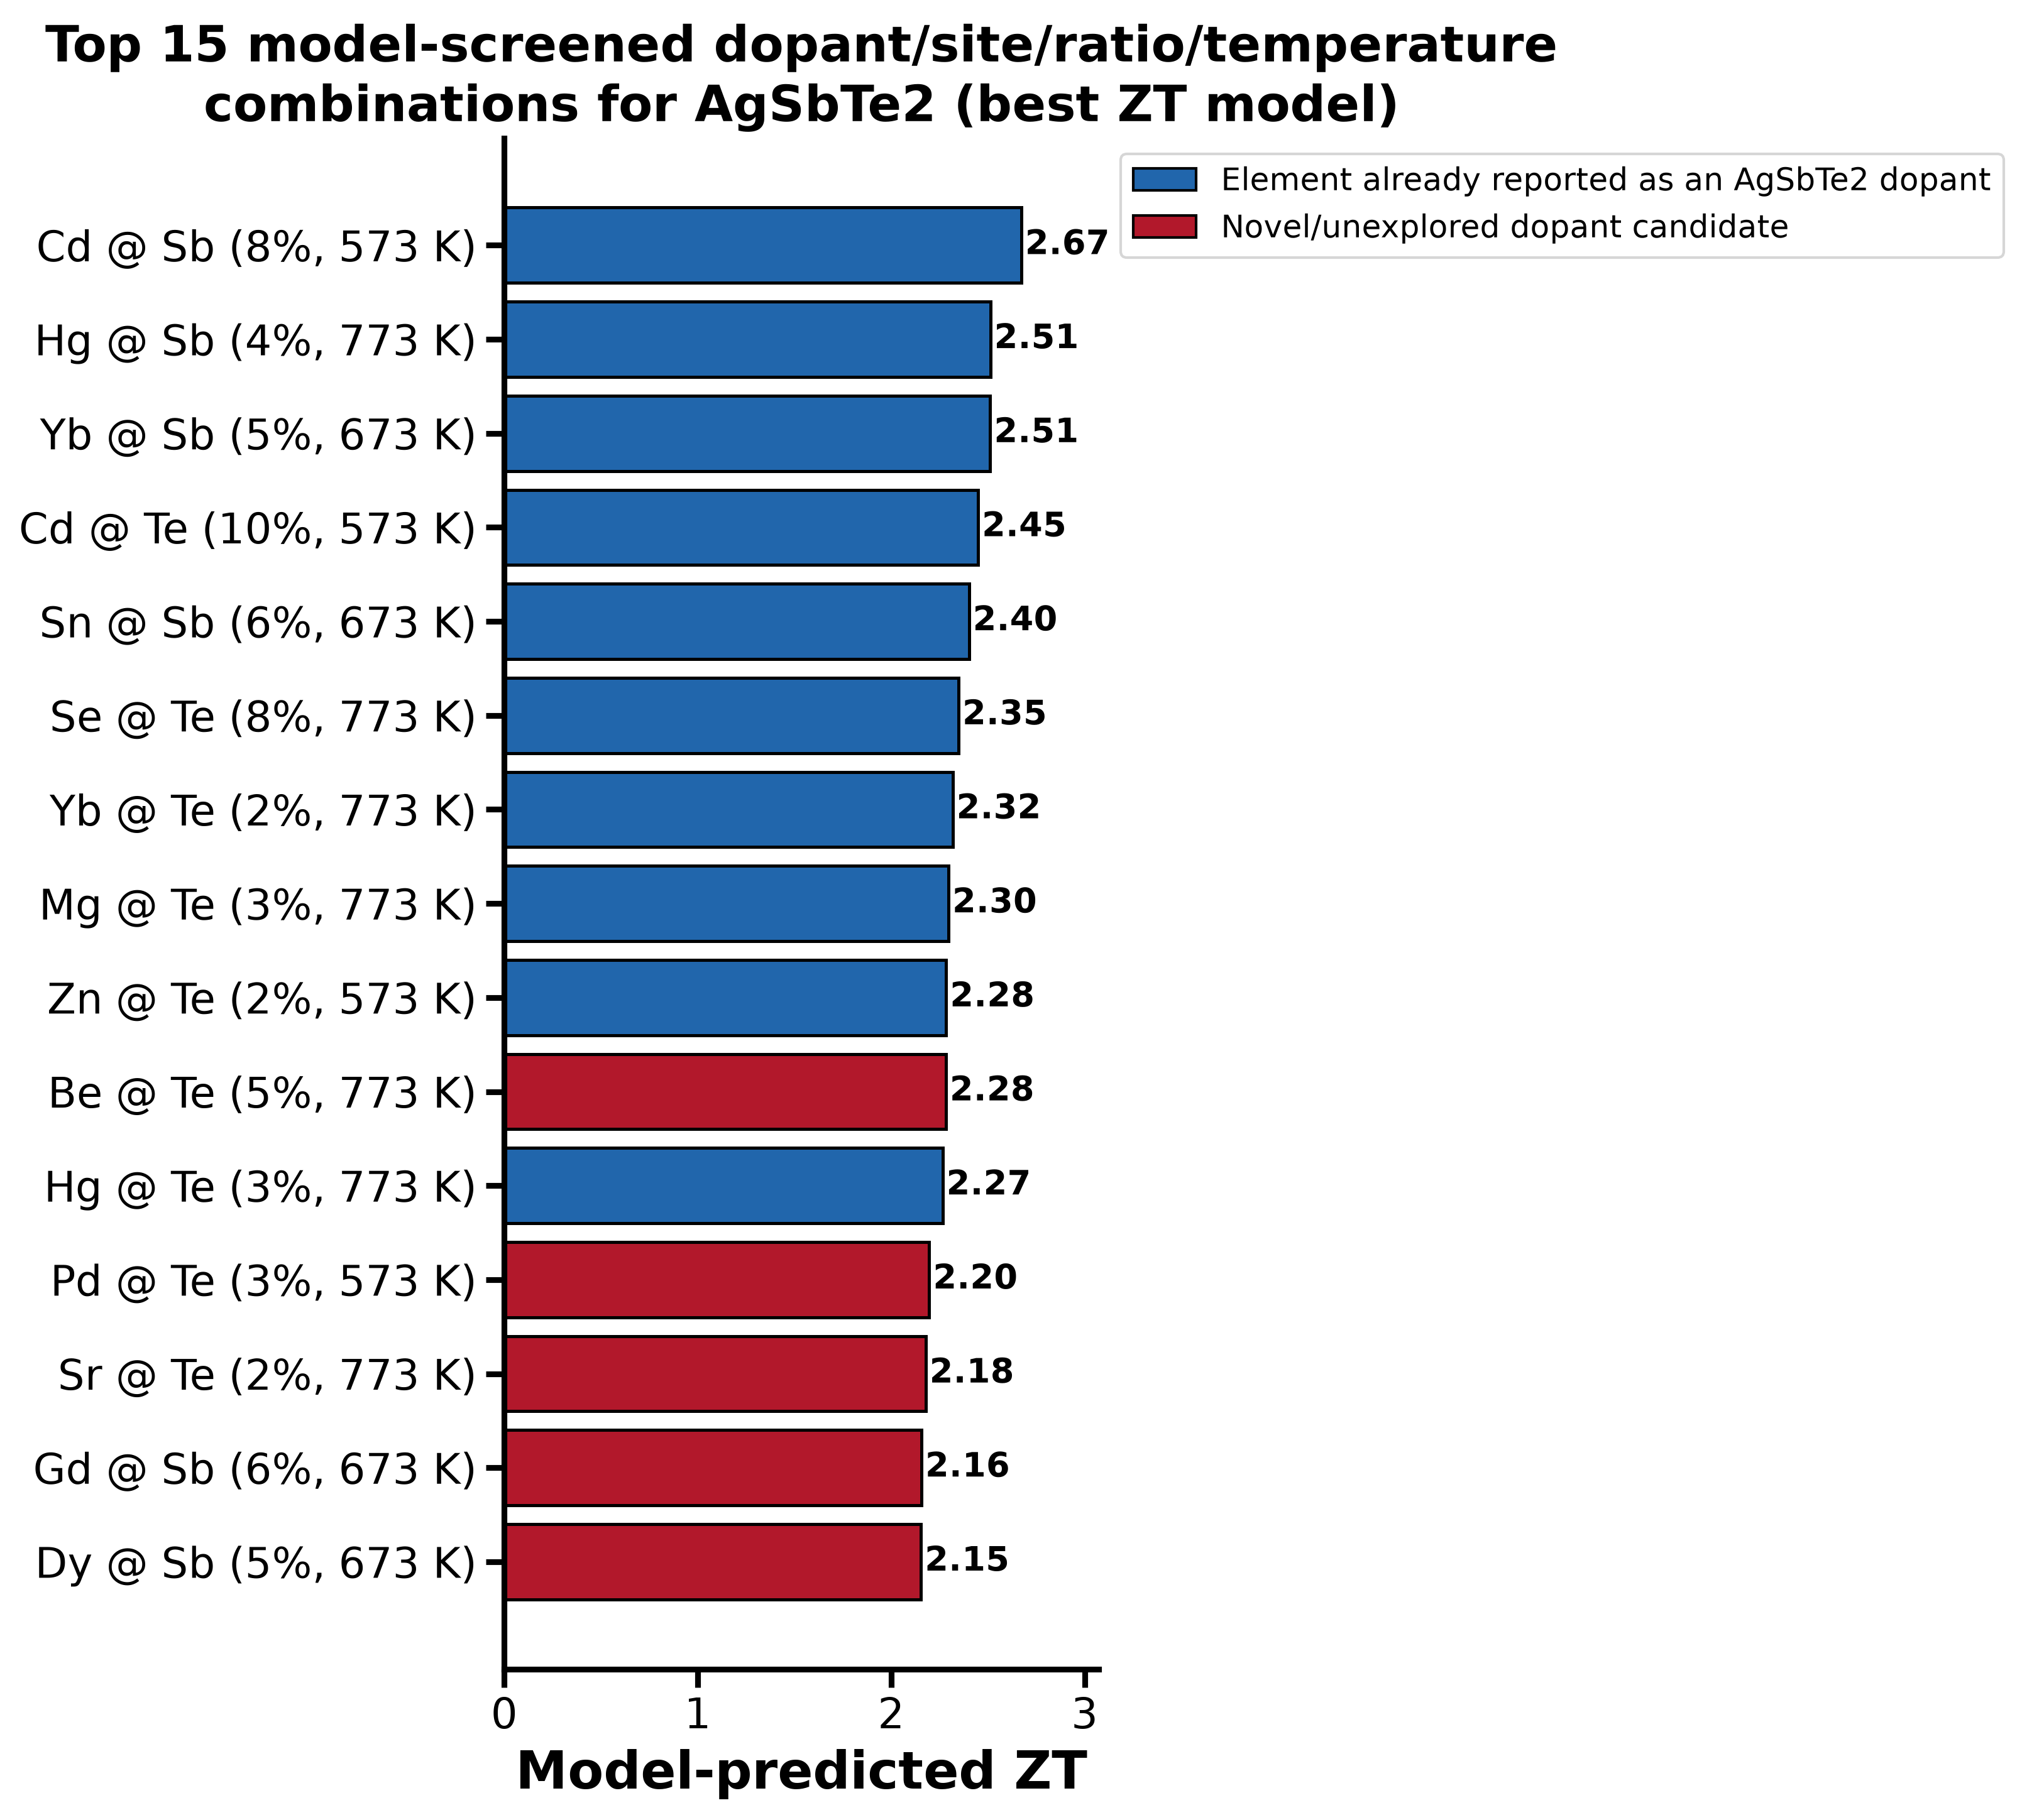
Figure 2. Top 15 dopant/site/ratio/temperature combinations by predicted ZT. Red bars are elements never reported as AgSbTe2 dopants in the training corpus.

7.3 Optimum Predicted Properties for Top Candidates
For the leading candidates, all five properties (not only ZT) were predicted using each property's own best model at that candidate's optimal temperature. Because each property is modeled independently (not under a joint physical constraint such as PF = S2*sigma), small self-consistency deviations between properties are expected and are not evidence of error in any single model.
Candidate | Dopant 1 | Site 1 | Ratio 1 | Dopant 2 | Site 2 | Ratio 2 | T (K) | Seebeck (uV/K) | Elec. cond. (S/cm) | Therm. cond. (W/m.K) | Power factor (uW/cm.K2) | ZT
Best single dopant | Cd | Sb | 0.08 |  |  |  | 573.0 | 313 | 250 | 0.434 | 17.3 | 2.67
Best novel/unexplored dopant | Be | Te | 0.05 |  |  |  | 773.0 | 253 | 132 | 0.538 | 12.6 | 2.28
Best co-doped pair | Cd | Sb | 0.04 | Hg | Sb | 0.02 | 773.0 | 310 | 240 | 0.488 | 18.4 | 2.6
Table 10. Full predicted property set for the top inverse-design candidates. The complete top-20 list is provided in outputs/predictions/optimum_predicted_TE_properties.csv.

8. Limitations
- Dataset size is modest (237-625 rows per property after de-duplication and formula-parse filtering) for a ~10-12-feature regression; test-set R2 values (0.48-0.89) should be read as indicative, not as production-grade accuracy, and are consistent with comparable literature studies on similarly-sized extracted datasets. Larger, expert-curated benchmarks in this space (thousands of samples) report R2 in the 0.95+ range with the same descriptor families.
- Figure-sourced data points (source_type = figure) are visual estimates from plotted curves, not exact text/table values, and carry additional uncertainty.
- Several descriptors from the project's reference descriptor list require crystal-structure, DFT, or Materials Project lookups not available per-sample in this corpus (bulk modulus, lattice parameter, mean bond length, number of atomic sites, dopant coordination number) and were not included.
- Properties are modeled independently; predictions across properties for the same candidate are not enforced to satisfy PF = S2*sigma or other thermodynamic/transport identities exactly.
- Inverse-design screening extrapolates to dopant elements and ratios outside (or sparsely inside) the training distribution; such predictions are hypotheses to prioritize for experimental validation, not guaranteed outcomes. Practical considerations (e.g. toxicity of Be, Ba compounds; synthesizability; solubility limits) were not modeled and must be applied before pursuing any candidate experimentally.

References
- Roychowdhury, S. et al. Enhanced atomic ordering leads to high thermoelectric performance in AgSbTe2. Science 371, 722-727 (2021). DOI: 10.1126/science.abb3517
- Hg-doping induced reduction in structural disorder enhances the thermoelectric performance in AgSbTe2. J. Am. Chem. Soc. (2023). DOI: 10.1021/jacs.3c09643
- Taneja, V. et al. High thermoelectric performance in phonon-glass electron-crystal like AgSbTe2. Adv. Mater. 35, 2307058 (2023).
- Sun, et al. Rationally design thermoelectric materials based on ingenious machine learning methods. Adv. Electron. Mater. (2025). DOI: 10.1002/aelm.202500210
- Antunes, L. M. et al. Predicting thermoelectric transport properties from composition. Mach. Learn.: Sci. Technol. 4, 015037 (2023).
- Ward, L. et al. A general-purpose machine learning framework for predicting properties of inorganic materials (matminer / Magpie descriptors). npj Comput. Mater. 2, 16028 (2016).
- Lundberg, S. M. & Lee, S.-I. A unified approach to interpreting model predictions (SHAP). NeurIPS (2017).
- Materialyze.AI Lab internal reference: Thermoelectric_ML_Descriptors.docx (34-descriptor list used to guide feature engineering in this work).

