

Software Developer Apprenticeship
Portfolio

2019 - 2021

Harris Hanley

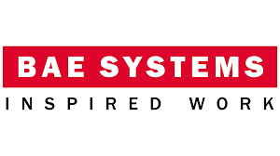

1. The How

1.1 The Organisation

1.1.1 Introduction

BAE Systems Applied Intelligence is an IT consultancy organisation with over 40 years experience within the industry. The company was founded in 1971 as Smiths Associates which was later renamed as Detica in 2001 before being acquired by BAE Systems in 2008 becoming a subsidiary of BAE Systems Group. Over the years the company have produced a wide range of solutions for the financial sector, international governments and military clients. Cybersecurity, data services and consultancy are the organisation main areas of expertise; their main products include technical solutions for the prevention of cybercrime fraud and threat intelligence collection.

1.1.2 Goals, Vision and Values

The motto of the organisation is ‘Trusted, Innovative, Bold’ which summarises the values of the organisation. BAE Systems Applied Intelligence seek to become a trusted partner in helping its customers protect their business from cybercrime and fraud whilst seeking new and innovative ways to stay ahead of their adversaries. The vision of the organisation and of BAE Systems Group as a whole is to be the premier defence, aerospace and security company with a stated mission of “provide a vital advantage to help our customers protect what really matters”. Underlying this are three main strategic priorities that will help the organisation achieve its mission and these are:

- Drive operational excellence
- Continuously improve competitiveness and efficiency
- Advance and further leverage our technology

1.1.3 Organisational Culture

BAE Systems Applied Intelligence have set out 9 key behaviours that will enable success and are sought after by the organisation. These behaviours are as follows:

- Customer Focus
- Creativity – balances imagination and information to identify solutions.
- Adaptability – respond to change with positive action.
- Collaboration – drives high standard of performance through co-operation and teamwork.
- Develops People – create an inclusive workspace where all individuals can thrive and give their best.
- Integrity – demonstrate commitment to BAE Systems’ values.
- Courage – take appropriate risks and leads with humility.
- Strategic vision – anticipates and plans for future business landscape.
- Inspiration – inspire others to be their best.

1.1.3 Contribution to Goals, Vision and Values

The project currently being worked on by our team is an internal project that aims to improve inter-colleague communication and appreciation. The tool will provide a way for colleagues to give each other ‘Kudos’ for their recent hard work; embedded within the tool are the core behaviours mentioned previously and employees are encouraged to cite them when giving ‘Kudoses’ to others. It is hoped that this tool will help in forging better relationships between workers thereby increasing productivity and further innovation.

1.1.4 Commercial Objectives of Projects

The current project being worked on in an internal one and has no direct commercial value however it will improve the commercial output of the company overall by encouraging workers to display and embody the core behaviours which are set out to achieve the goals of the organisation.

1.1.5 Working Culture

The organisation is very much a people-oriented workplace where collaboration and teamwork are highly encouraged. To facilitate this, there are various social networks and clubs within the workplace and time within the workday is allotted for social activities to help with team cohesion and cohesion of workers within the organisation as a whole.

1.2 The Environment

1.2.1 The Organisation and the Economy

BAE Systems Applied Intelligence occupies an essential place in the UK’s economy as it works in partnership with various governmental agencies to pursue national security objectives as well as providing cybersecurity solutions to the financial sector. In addition, the company is committed to promoting diversity in the workplace and support various programmes within which the company operates such as armed forces charities and STEM for young people. The organisation trains nearly 2,000 apprentices and 500 graduates across its UK business and invests £90 million a year towards skills, training and education outreach. Below is a summary of BAE Systems’ contribution to the UK economy in 2018:

- Contributed £9.3 billion to the UK’s GDP in 2018, contributing a total of £330 for every £100 supported across the economy.
- Exported £3 billion, equivalent to nearly 1% of the UK’s total exports and contributed £2 billion to the UK’s balance of payments.
- Supported 124,000 full time jobs across the UK including nearly 34,100 at BAE Systems itself.
- Spent £3.7 billion with 6,000 UK suppliers.
- Made a total tax contribution of £2.4 billion including £700 million paid directly by the Company.
- Invested £1.2 billion in research and development on behalf of customers and partners.
- Was highly productive – with each employee contributing £83,000 to the UK economy – 27% more than the national average.

1.2.2 Regulation

The organisation’s business lies within the defence and security sector and as such the products and services provided are subject to strict controls and regulations of the governments of the respective locations in which the organisation operates. For example, in the UK products are controlled by the Export Control Act and the Export Control Order and in the US by the Arms Export Control Act and the International Traffic in Arms Regulations. These are controls are in place to protect the national security and foreign policy of the clients by ensuring that relevant products are kept out of the hands of unauthorised users and not used for unauthorised purposes. In addition to this, the organisation maintains strict internal controls that governs how the organisation carries out its business. Below are the ‘Responsible Trading Principles’ that outline how the organisation conducts business:

- We understand and support our customers’ national security and other requirements .

- We work to BAE Systems’ Values in all that we do - Trusted, Bold, Innovative.

- We assess carefully our products and services with the objective that neither BAE Systems nor our customers are exposed to significant reputational risk

- We are as open as practicable about the nature of our business .

1.2.3 Gaining Advantage in the Industry

As a technology company, the organisation aims to attract new talents to keep up with the rapid pace of technological advancement; developing the skills of our people and attracting new employees is critical to the success of the business. The organisation work closely with schools, colleges and universities as well as engineering and business organisations in all markets to promote and inspire people about Science, Technology, Engineering and Maths (STEM). To this end, the organisation supports many programs such as apprenticeships and graduate schemes, an example is the National Security Academy – a software engineering apprenticeship that recruits graduates and non-graduates for the national security division of the company.

1.3 The Job

1.3.1 Scope and Role

My formal job role with BAE Systems Applied Intelligence is as a software engineer apprentice grade A02. The primary responsibility of a software engineer is to create and test code across all layers of a software product which include the client-side, server-side and database layers. Typically, engineers work as part of a scrum team where each member will be responsible for a component of the overall project. Project requirements would be negotiated and and agreed upon between the customer and a business analyst or systems architect working alongside the team.

1.3.2 Skills and Personal Attributes

In addition to the core behaviours mentioned previously, engineers must be competent in or have knowledge of several technologies and programming practices that are employed within the industry. There are a variety of technology stacks and programming language that are used for each layer of an application however, underlying these are a set of skills that are needed in order to use them effectively. These key skills are summarised follows:

- Apply problem solving skills to debug code.
- Creating and interpreting documentation.
- creating user stories from project requirements.
- Creating wireframes for user interfaces and implementing them.
- Object-Oriented Programming.
- Writing test cases for integration and unit tests.
- Effectively use version control systems e.g. git.
- Able to apply agile methodologies to software development.
- Effective use of virtual environments and other cloud technologies.

As an engineer, my contributions lie in my ability to effectively use several different operating systems as well as my experience in system administration. This is in addition to some of the skills mentioned previously such as problem solving skills, writing and interpreting documentation and Object-Oriented Programming. Key skills that I need to focus relate to designing and creating user interfaces, writing tests and applying agile methodologies to software development.

1.3.3 Role of Colleagues and Stakeholders

Collaboration in teams and between teams is heavily emphasised and encouraged by the organisation, as such all employees within the organisation play an integral role in the success of each others jobs. In addition, the organisation works very closely with clients along every step of contracts and projects as part of agile and scaled-agile ways of working and so they are directly involved in the roles of all workers within the organisation.

1.3.4 Risk and Compliance Related to the Job

The nature of the job means that there are a lot of risks involved, in particular, there major risks involving security and confidentiality of sensitive information, however, there are rules and regulations in place to help mitigate these risks. For example, sensitive documents and correspondence are protectively marked which indicate their level of sensitivity and how they should be handled. Failure to abide will result in disciplinary action.

2. The What – Project Examples

2.1 Training Group Project : Full-Stack Data Retrieval Application

2.1.1 Introduction

As part of our training, we were tasked by BAE Systems Applied to develop a full-stack application that intelligently retrieve data based on user queries and return them in a presentable way. The data for this project was supplied by BAE Systems in the form of CSV (Comma Separated Values) files. To give some context to the project, the team was given the role of a National Investigation Unit who has been given some data by third-party provider known only as REDSHIFT and has been tasked with sorting the data as well as creating a retrieval program. REDSHIFT specialises in collecting call records, financial
transactions, and Automatic Number Plate Recognition (ANPR) sightings.

2.1.2 Requirements

The project brief and requirements was communicated to the team via a face-to-face meeting along with a brief summary given to the designated product owner prior to project commencement. Project requirements were given as potential use case scenarios for the app from which we were to extract technical features and capabilities. In addition to this, handling requirements were also placed on the data provided by REDSHIFT. The scenarios and data handling requirements are summarised as follows:

- The data must not be stored in public repositories such as GitHub and S3 buckets.
- Access to the data must be audited
- The data has been provided need to be presented and explored using simple-to-use interface.

Scenarios:

- Detained suspect – provide biographical information, financial transactions, geographical information and list of known associations when given the name of a detained suspect.

- An incident has occurred – provide a list of people given a location and a radius and present the information in a graphical manner. An example of this scenario is depicted in (Figure 1).

In addition, the brief stipulated the use of agile software development methodologies throughout the development cycle and a deadline of three weeks.
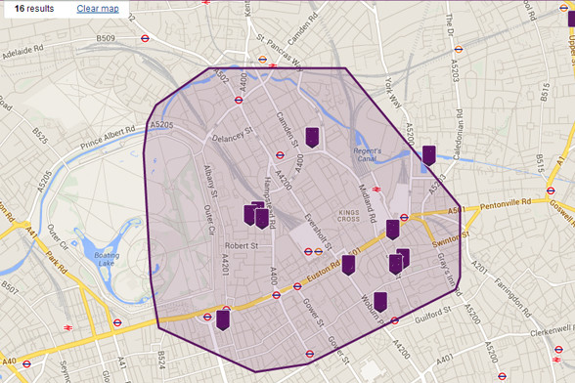
Figure 1. A map of London with a radius and location markers drawn on as an example of scenario 2.

- Suspect flees the scene – provide ownership details and previous spotted locations of a vehicle given its registration number.

2.1.3 Planning

The team was organised according to the Scrum framework to facilitate agile ways of working. Broadly speaking, the framework consists of 3 roles:

- Product Owner – represents the voice of the customer and is responsible for product delivery. This role has been predetermined by brief and is assigned to a training supervisor.

- Scrum Master – acts as a facilitator, responsible for team well-being and resolution of grievances relating to team productivity and progress.

- Development Team – the core engineering team responsible for development, testing and deployment of the product.

The team self-organised into their desired roles; the small size of the team meant conflict was minimal however, the role of Scrum Master had to be taken alongside development duties by a team member. The development team was further divided into a front-end team and a back-end team.

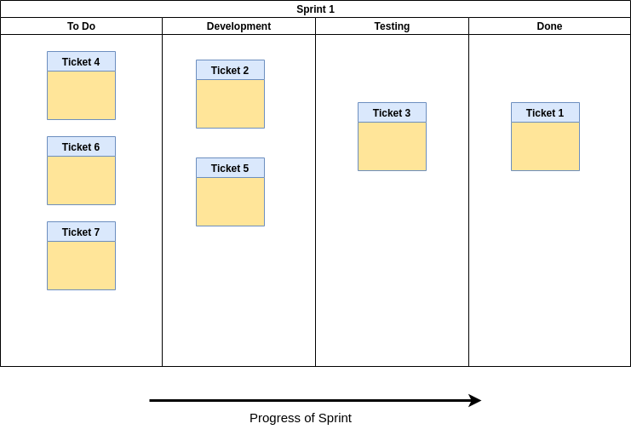
Work on the application was split into ‘sprints’ each lasting one week. A sprint begins with a ceremony called ‘sprint planning’ which lays out the projected progress for that week. Everyday begins with another ceremony called ‘daily stand-ups’ where each member talks about their progress from the day before and their plans for the day ahead. It is here that the Scrum Master is notified of any grievances and problems encountered the day before that it should be resolved as soon as possible. On the last day of the sprint a ‘sprint review’ takes place, this is where the team presents their current progress to the product owner for his feedback which will be taken into consideration in the next sprint. At the end of the last day of the sprint the team conducts a ‘sprint retrospective’ which is a discussion as to what when well and problems encountered in the course of sprint and points to improve in the next sprint.

To facilitate these processes, the team used a Kanban board tool called Trello (Figure 2) to organise sprints as well as manage the design and analysis phase of development. A Kanban board visualises the status and progress of a project by arranging cards representing features of the product in columns indicating its progress (Figure 3).
Figure 3. A schematic diagram of a kanban board showing progress of a software development sprint.

As the sprint progresses, features of a product represented by tickets moves across from left to right such that by the end of sprint all intended work should be under the ‘done’ column. Note that features need not be done in order as work is taken on by individual members of the team and should be independent of other features, in other words, features are worked on in parallel. This enables faster development as each phase of the development cycle occur concurrently creating smaller feedback loops which is a major advantage of agile over waterfall methodologies.

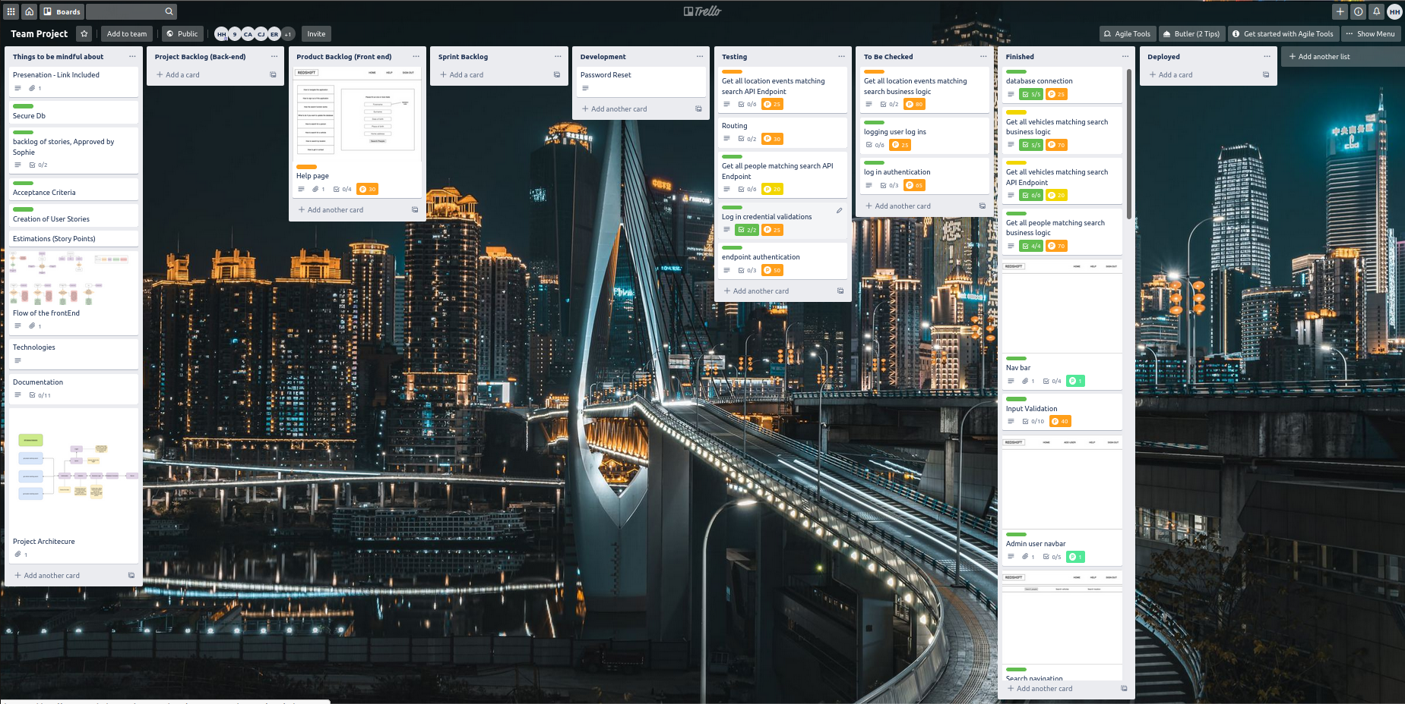
Figure 2. A screenshot of the kanban or Trello board used in the training group project.

2.1.4 Communication

Communication and collaboration is a major theme within agile methodologies and as such careful consideration were taken by the team as to the communication methods employed. Face-to-face communication was the primary method for formal meetings with the Product Owner and for Scrum ceremonies where clear and concise communication is of the highest priority to gain an understanding of the issues at hand. For day-to-day communications and collaboration work, where speed and is of a higher priority, a tool called Slack was used - an online platform that provides for instant messaging, chat rooms and content sharing (Figure 4). Communications on this platform tends to also be more informal which promotes collaboration between teams.

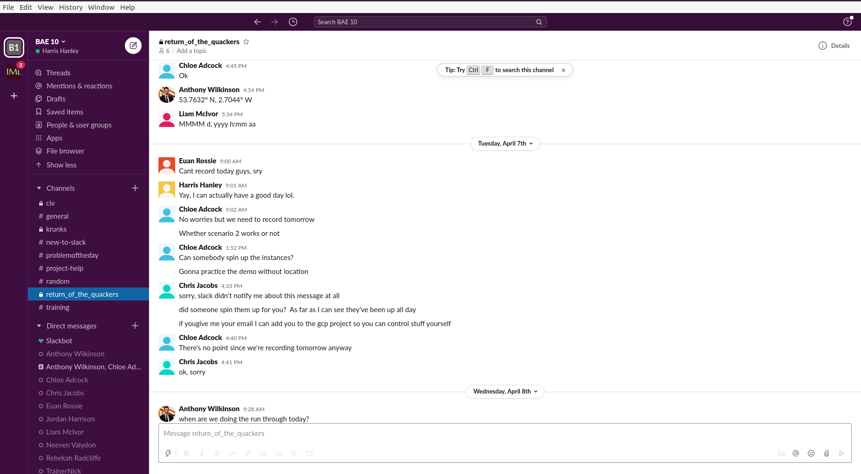
Figure 4. A screenshot of Slack channel dedicated to the group project.
2.1.5 Analysis

The Analysis phase of the software development cycle is where customer or business requirements for a product are analysed and then re-interpreted to a set of technical requirements which for this project, the brief represents business requirements to be fulfilled. Following the agile framework, technical requirements were extracted from the brief scenarios and documented as ‘user stories’ and ‘acceptance criteria’. Each scenario was interpreted as a feature of the product the priority of which were categorised by the team using the MoSCoW principle which are defined as:

- Must have – required to meet minimum expectations or Minimum Viable Product (MVP). Product is not regarded as usable if features categorised as ‘must haves’ are not completed.

- Should have – important but not critical features, not part of the MVP however some business value will be lost if these features are not completed.

- Could have – desirable features that should be considered. No business value will be lost if these features are omitted.

- Won’t have at this time – features that will not be included within the development cycle due to lack of capacity or it being out of scope for the project. This is usually an agreement between the team and the product owner.

For large-scale applications, business use case scenarios are broken down more generally into ‘user epics’ which are then progressively reduced to ‘user stories’ and ‘sub-tasks’.

It was decided by the team that scenario 1 and scenario 3 are to be categorised as ‘Must have’ and scenario 2 as ‘Should have’. ‘User stories’ and ‘acceptance criteria’ were then created as tickets to be put into the product backlog (Figure 5). These tickets are the representation of features that were mentioned in the planning section, here they are given structure and content. To keep these tickets consistent, user stories and acceptance criteria are written in a particular format (Table 1).

Content | Format
User Story | As a user, I want to be able to execute <functionality> and be given <output>
Acceptance Criteria | Given that I perform <functionality> I should be retuned <expected results>
Table 1. A general format of user stories and acceptance criteria. Note, acceptance criteria should be a list

The user story together with the acceptance criteria make up the ‘definition done’, an agreed condition upon which a ticket is considered finished.

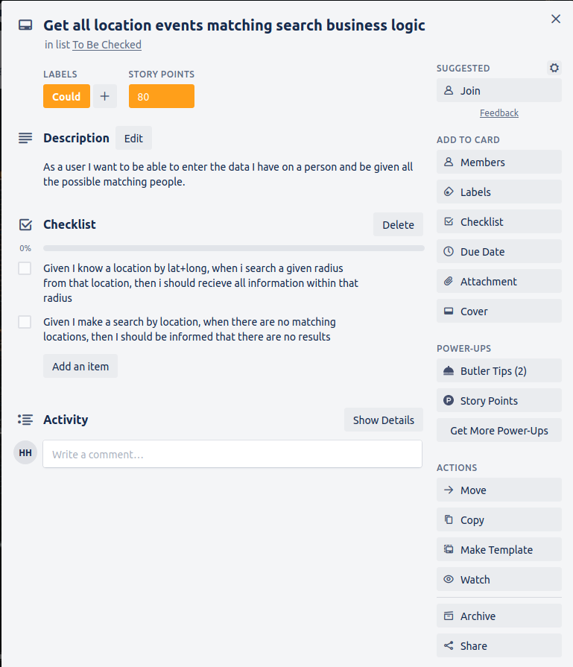
Figure 5. An example of a ticker from the Trello board.

2.1.6 Design

the overall architecture of the application, details and number of components and choice of technologies were decided by team during this phase. The functionalities and features detailed in the analysis phase acts as constraints to what technologies should be used and what kind of components should be built. The choice of programming paradigm depends on what the team is comfortable with and what is most efficient for the application. For this project, it was decided that the SERN stack would be used – a JavaScript stack consisting of:

- SQL Database
- Express – Web Application Framework
- React.js – Client-side JavaScript library
- Node.js – Runtime Environment for server-side JavaScript

The overall architecture (Figure 6) was designed as a team however the components that make up the front-end and back-end were designed separately by the respective sub-teams.

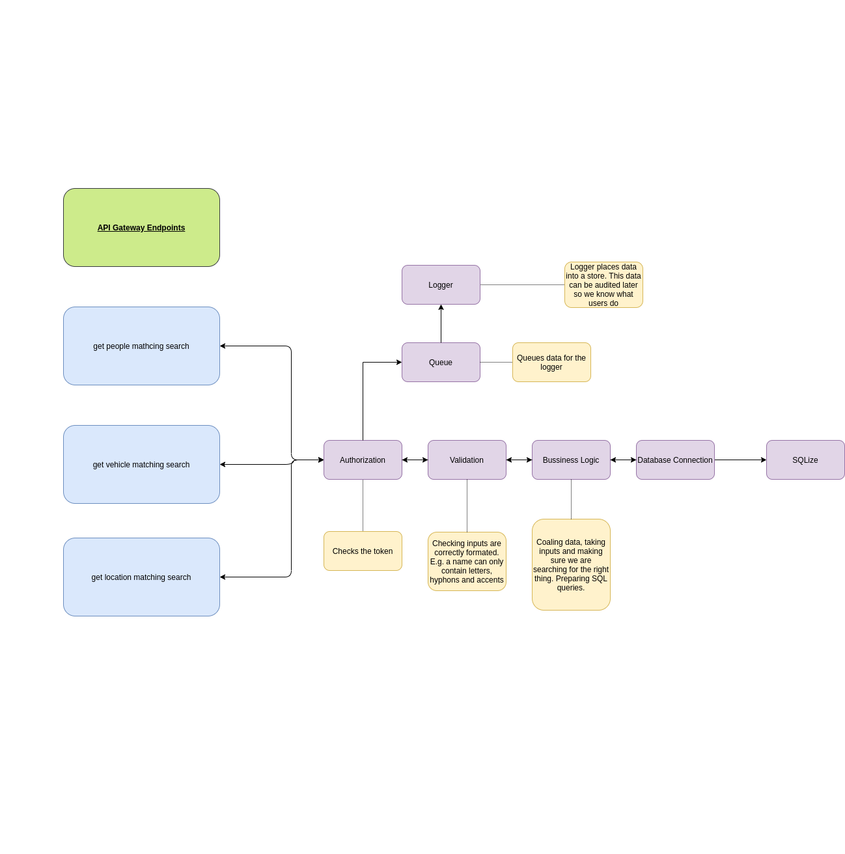
Figure 6. A diagram of of architecture of the backend.

The logic layer of the app lies in the backend which includes the database as the storage component. with REST API

The frontend was designed as a series of wireframes – visual mock ups of the web pages showing their layouts and components. These wireframes are attached to each frontend ticket and forms part of the acceptance criteria (Figure 7). The architecture

2.1.7 Development

The development phase of the project involves taking the design diagrams and documentation from the previous phase and producing functional software as the output. For this project it was decided that a universal of tools would be used by the team to enable better collaboration. Below are the set tools used throughout the development phase:

- Visual Studio Code – Integrated development environments
- Git – Source Control Protocol
- GitHub – source control repository
- DataGrip – Integrated Development Environment (Databases, SQL)

The decision to use these tools were based on experience and training prior to the project.

The first stage in the development process was to establish a source control repository in GitHub and setting up branches and branching strategies to ensure that the codebase is versioned correctly and prevent bugs persisting across versions.

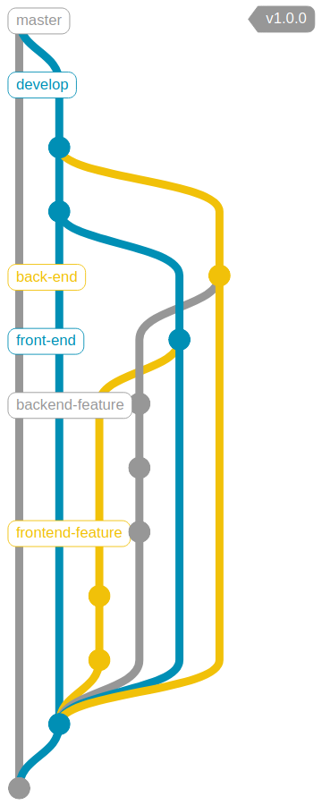

Figure 8. A flow diagram of the git branching strategy used for the project

