1）n = 1 and constant function with output of all 0s
note how the output is |0> indicating constant function
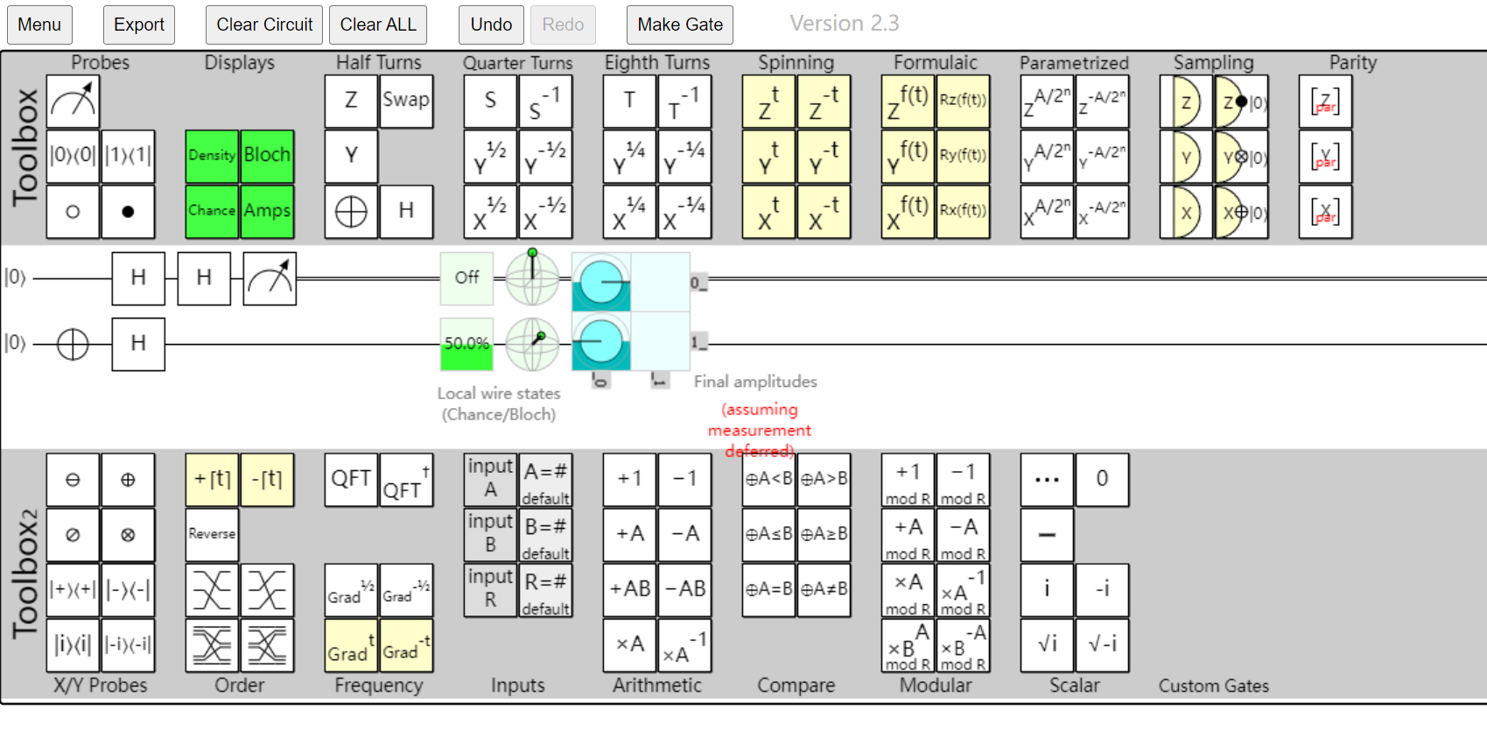
Figure 1
2）n = 1 and balanced function with output of [0, 1]
note how the output is |1>, indicating balanced function
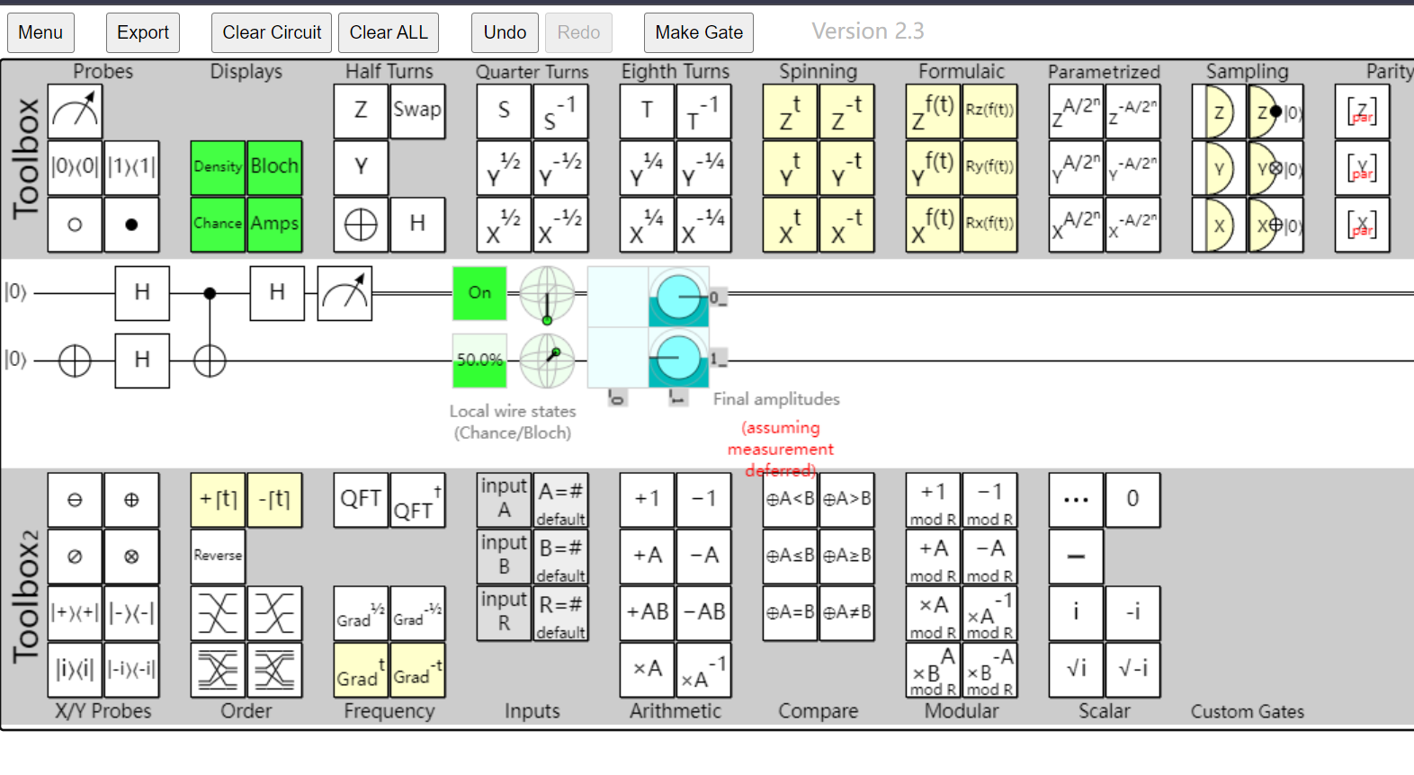
Figure 2
3）n = 2 and constant function with output of [0, 0, 0, 0]
note how output is |00>, indicating constant function
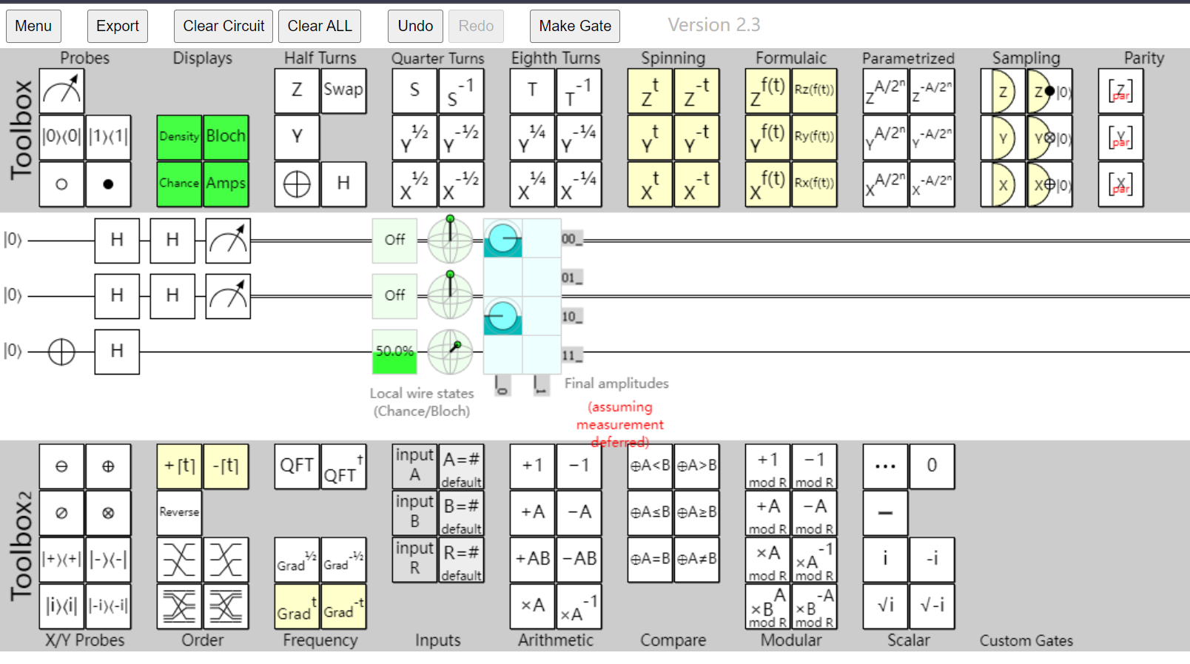
Figure 3
4）n = 2 and balanced function with output of [0, 0, 1, 1]
note how output is |10>, indicating balanced function
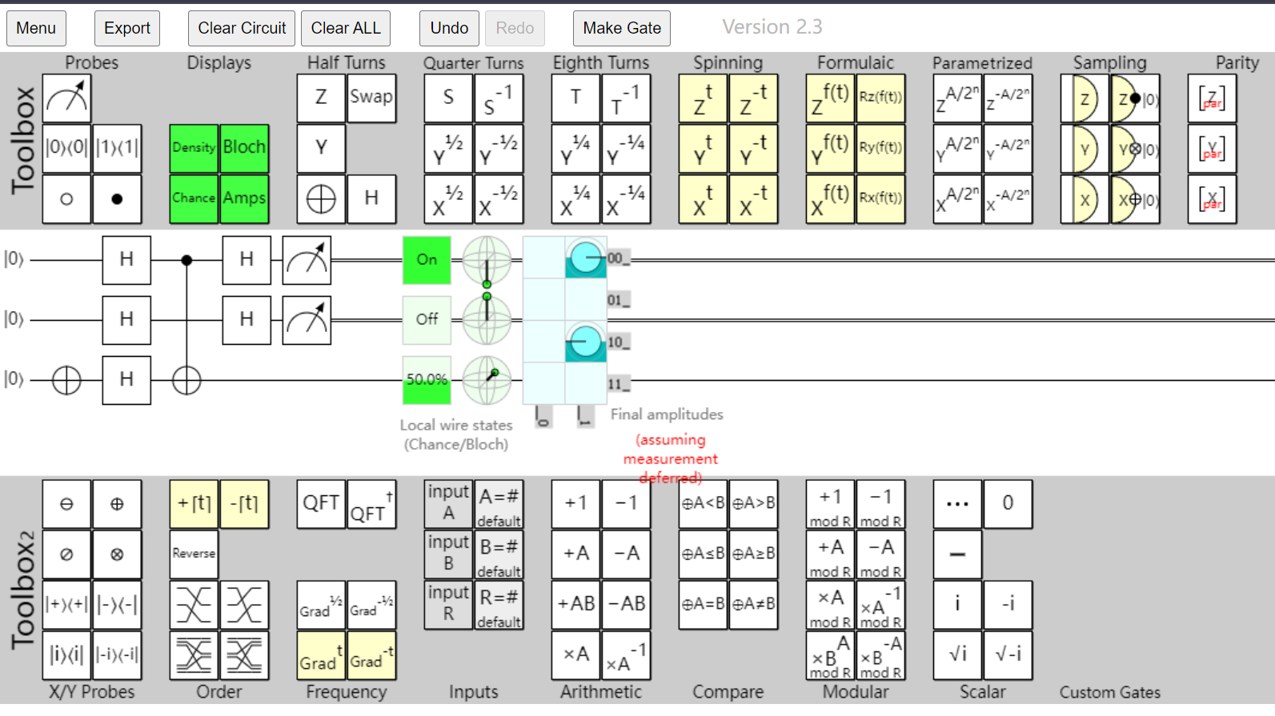
Figure 4

