**Harren D. Aguinaldo**

#1326 Sunny Villas Fairview, Quezon City

09497767507

[ren_agui121@yahoo.com](mailto:ren_agui121@yahoo.com)

April 03, 1995

**Career Objective**

 Work in a well-established organization where I can use my skills, knowledge and my abilities and to respond to the needs of the company, its clients and the clients’ customers with the application of driving competence in providing world class solutions.

**Educational Background**

**Tertiary**

**Our Lady of Fatima University**

Lagro,Quezon City

Bachelor of Science in Information Technology



**Secondary**

**National College of Business and Arts**

Cor. Regalado St. Commonwealth Ave.,

Fairview, Quezon City

**Primary**

**North Fairview Elementary School**

Avon corner Astor Street, North Fairview

**Work Experience**

**Shore Solutions Inc.**

Customer Service Representative for a                         August 31, 2014 - September 1, 2015

Telephone Company.

**Expert Global Solutions**

Technical Support Representative

**Teleperformance Phil.**

Technical Support Representative

**VXI Global Inc.**

Technical Support Representative

**Collective Solutions**

Customer Service Representative

**Concentrix Phils. Inc**

Technical Support

**Convergys Philippines Inc.**

Technical Support Representative               Aug. 30, 2016 – September 4, 2020

Escalations Desk Representative

**Everise (C3)**              Nov 2021 - December 2021

Technical Support Representative

**Howsy - Quaeito Qualitas Inc** Feb 2021 - Feb 2021

Customer Support Associate

**TaskUS PH.**

Customer Support Representative              March 10,2021 - Feb 09, 2022

Client Analyst Mentor

**Wells Fargo**

Customer Success Representative              Feb 14, 2022 - April 21, 2022

**Optum Global Solutions**

Customer Success Representative             May 25, 2022 – June 2022

**Reed Elsevier Philippines**

Operations Generalist Specialist August 22, 2022 up to present

**Seminars Attended**

⚫ ⚫ Disaster Preparedness during Fire, Earthquake and First Aid.

⚫ ⚫ Behavior of future Leaders in changing times.

⚫ ⚫ Maya Software

⚫ ⚫ Internet TV

⚫ ⚫ Innovative IT Capstone

⚫ ⚫ Internet Security

⚫ ⚫ Business Technology

⚫ ⚫ Radar Technology

**Skills**

⚫ ⚫ Computer Literate

⚫ ⚫ Has good communication and listening skills.

⚫ ⚫ Has knowledge in trouble shooting.

⚫ ⚫ Knowledge in Adobe Photoshop CS5 and other versions

⚫ ⚫ Knowledge in Microsoft office Word,Excel,Powerpoint,Publisher 2007 and other versions

⚫ ⚫ Knowledge in Web Programming Languages Like Visual HTML,CSS PHP and JAVA SCRIPT

⚫ ⚫ Knowledge in Computer Programming Languages Like C/C++,Visual Basic 6.0 and Visual Basic.NET

⚫ ⚫ Knowledge in Managing Database Systems

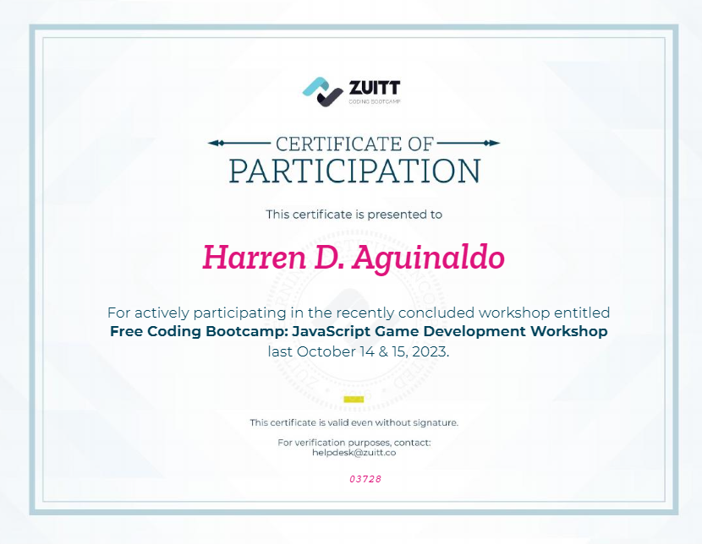Joined JavaScripting for Interactive Game