**WAP ONLINE DICTIONARY PROJECT**

**SCREENSHOTS**

**MYSQL workbench setup successfully and English Dictionary added**

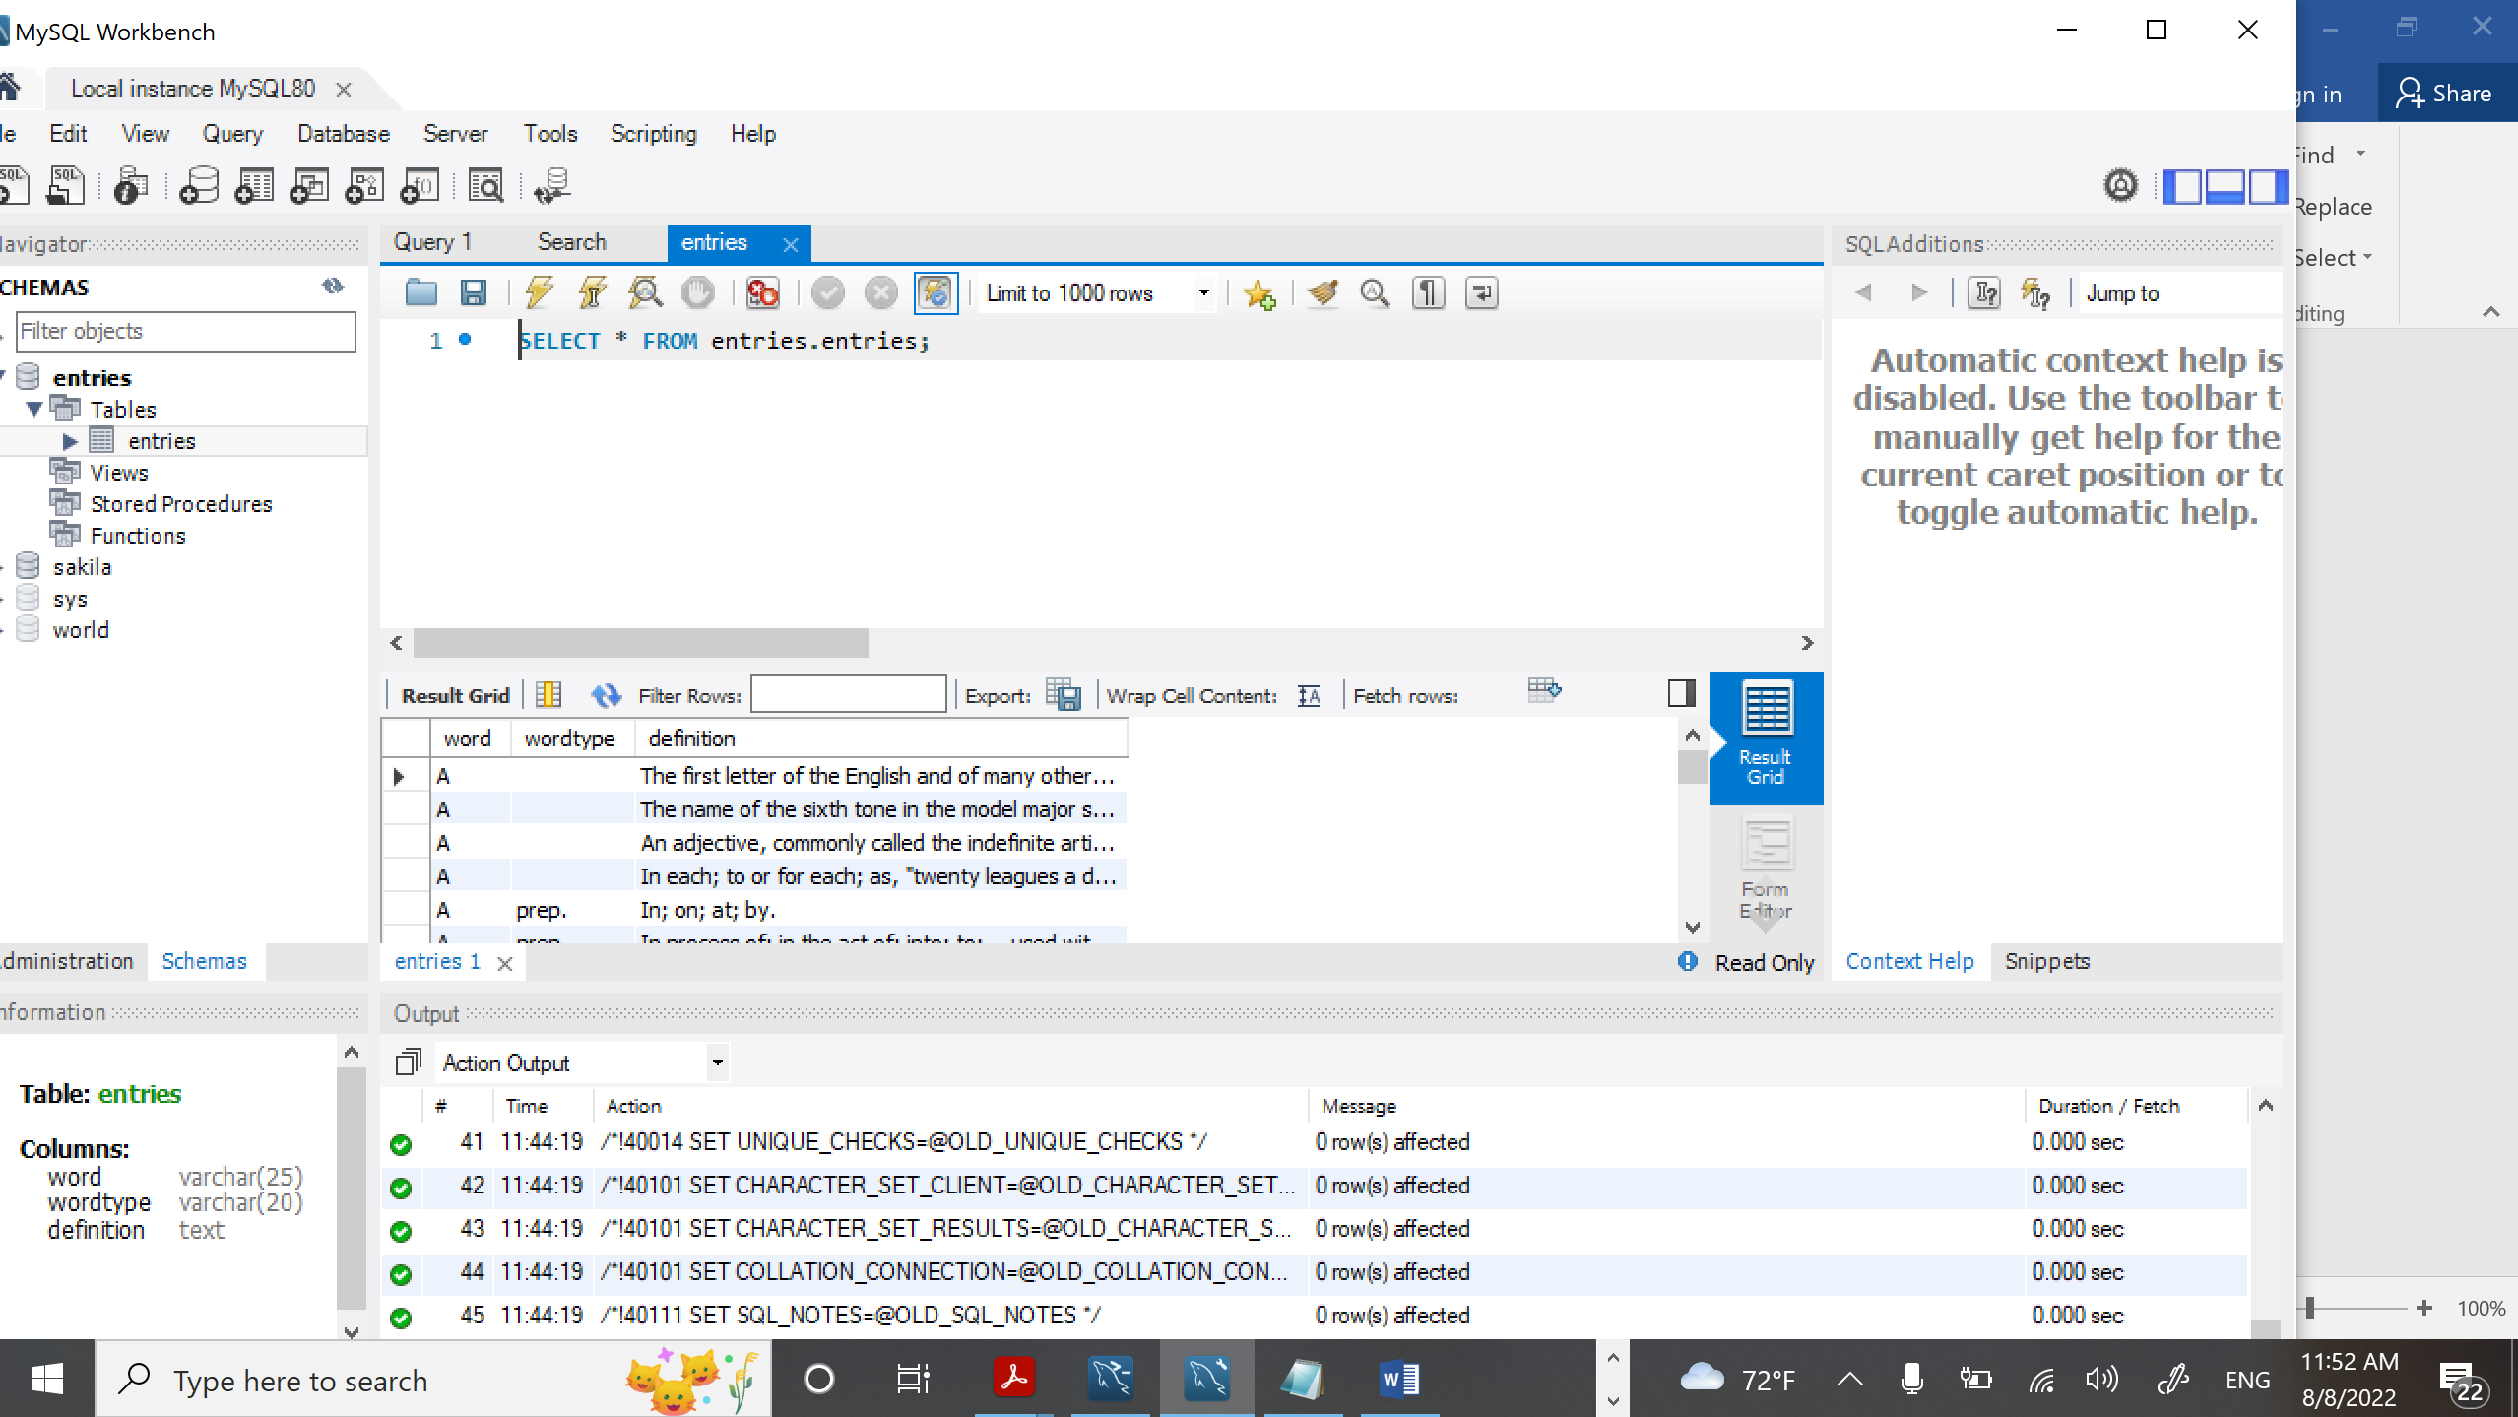

**dictionary.js**

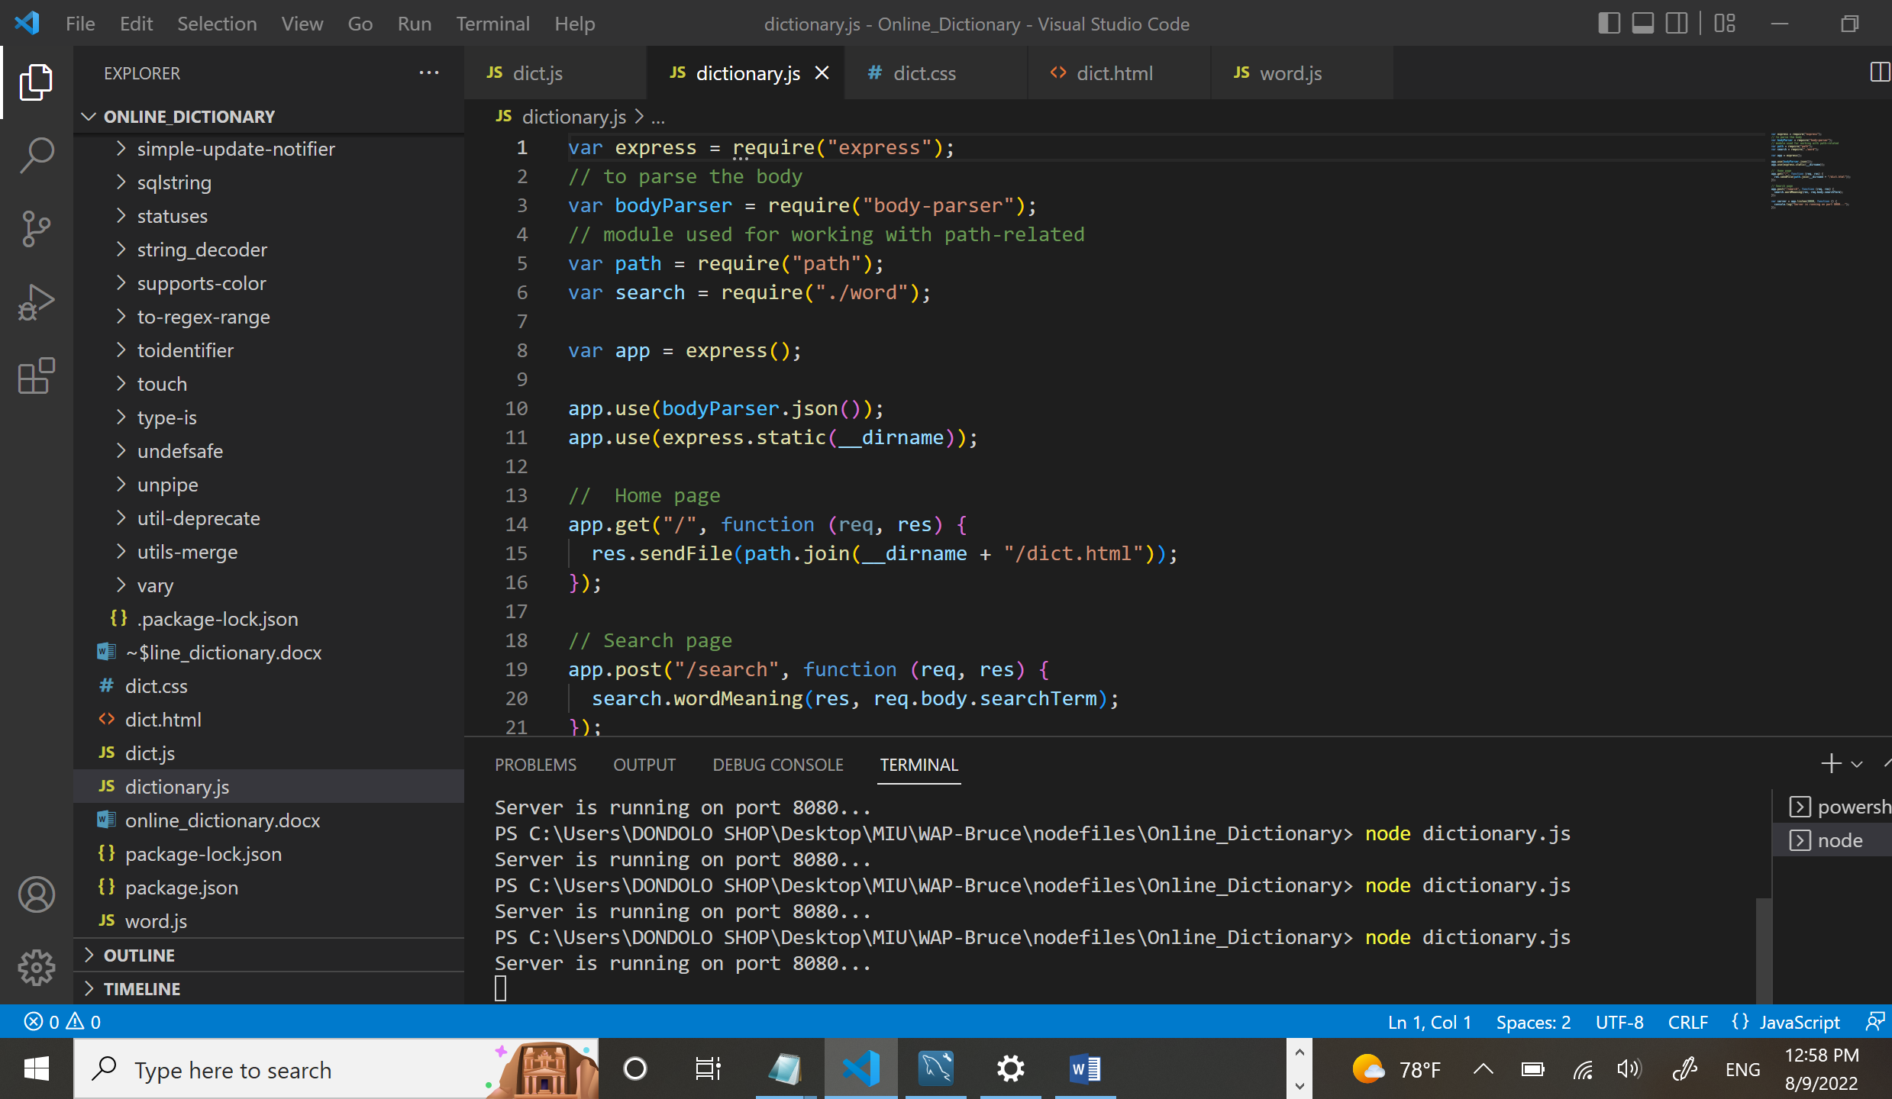

**Home page**

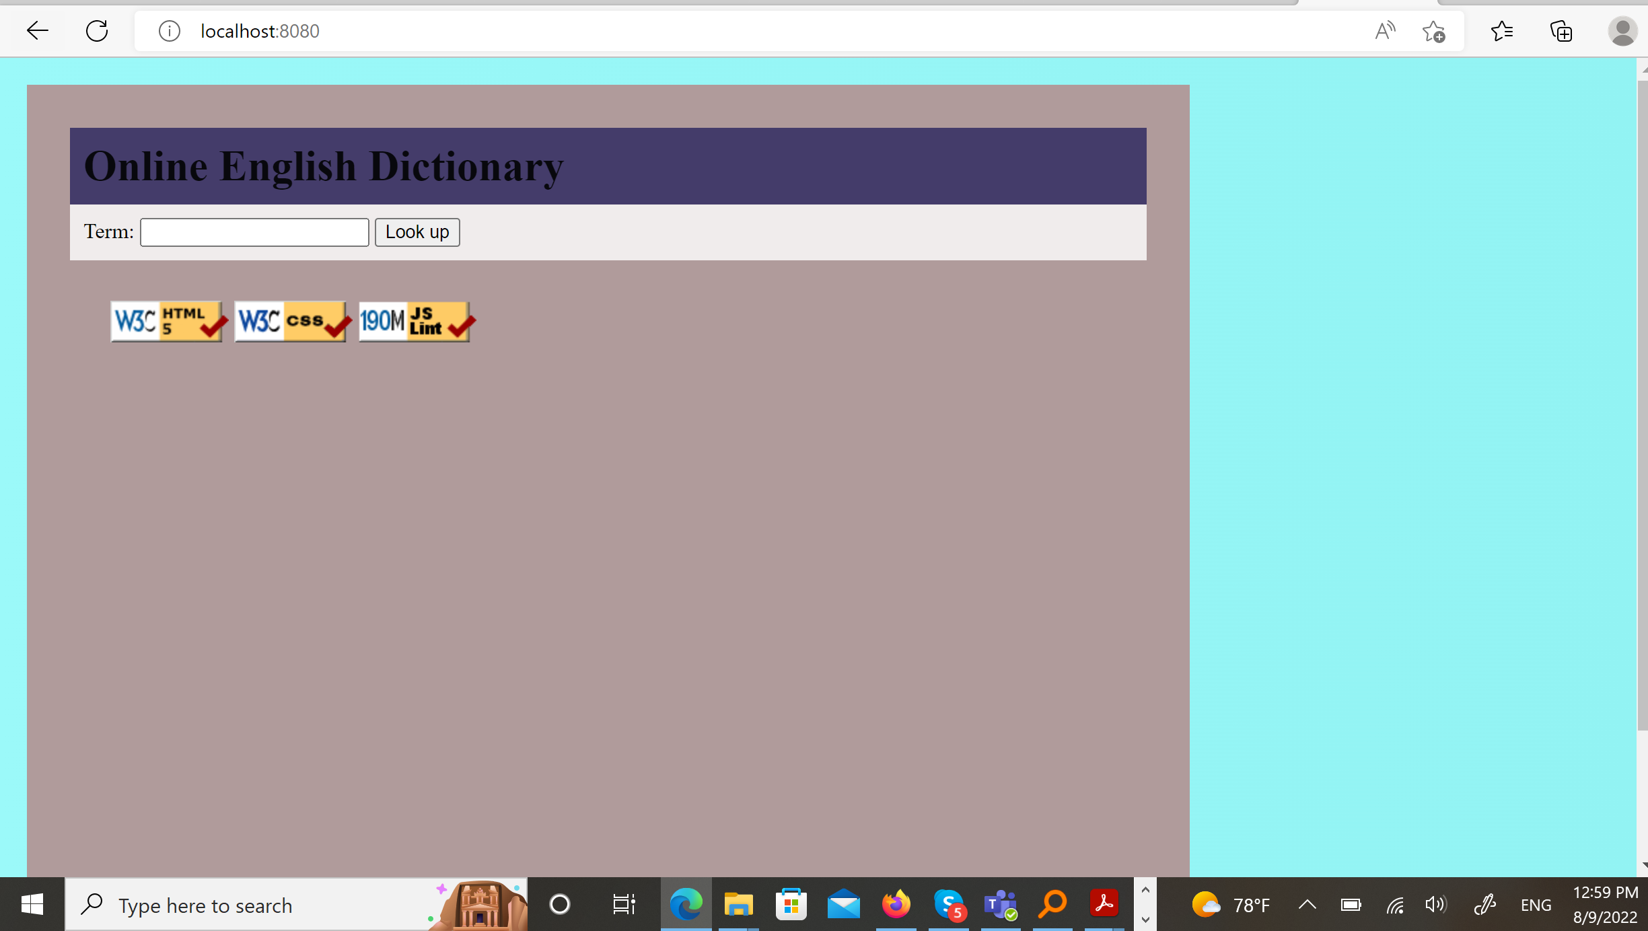

**Search for a word that exists in the dictionary**

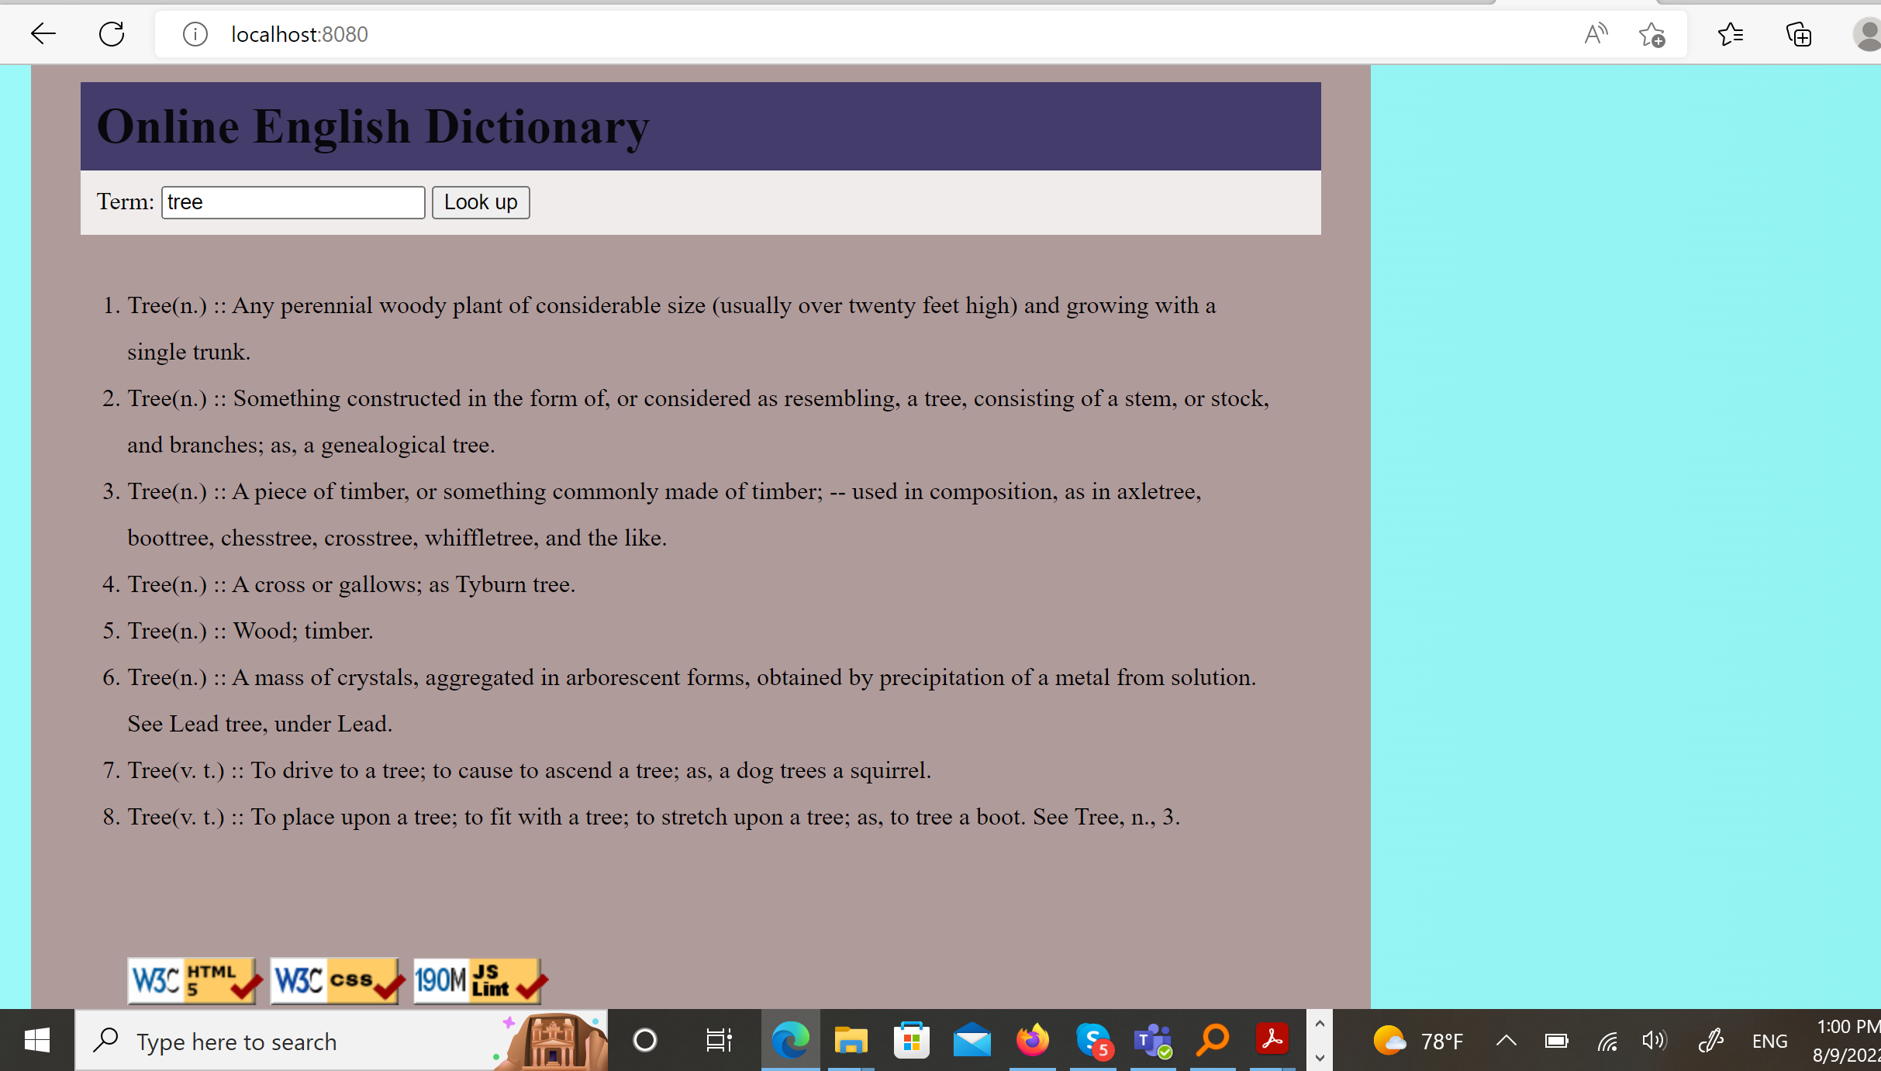

**Search for a word that does not exist in the dictionary**

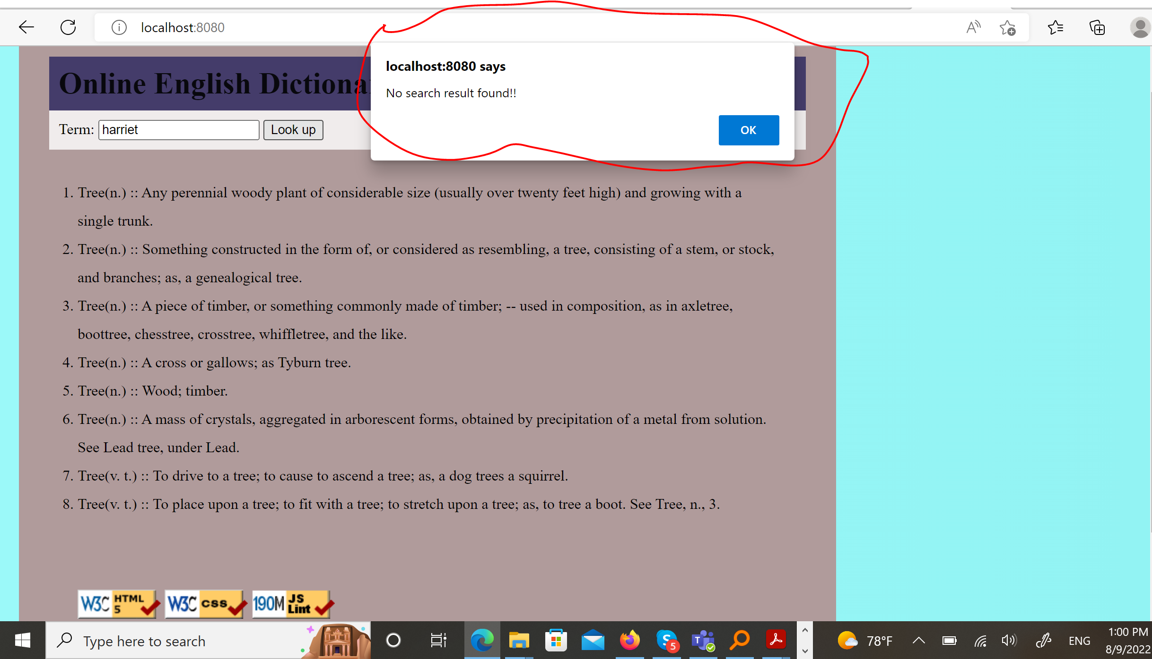

**Wrong route**

