**Simple calculator using Express.js**

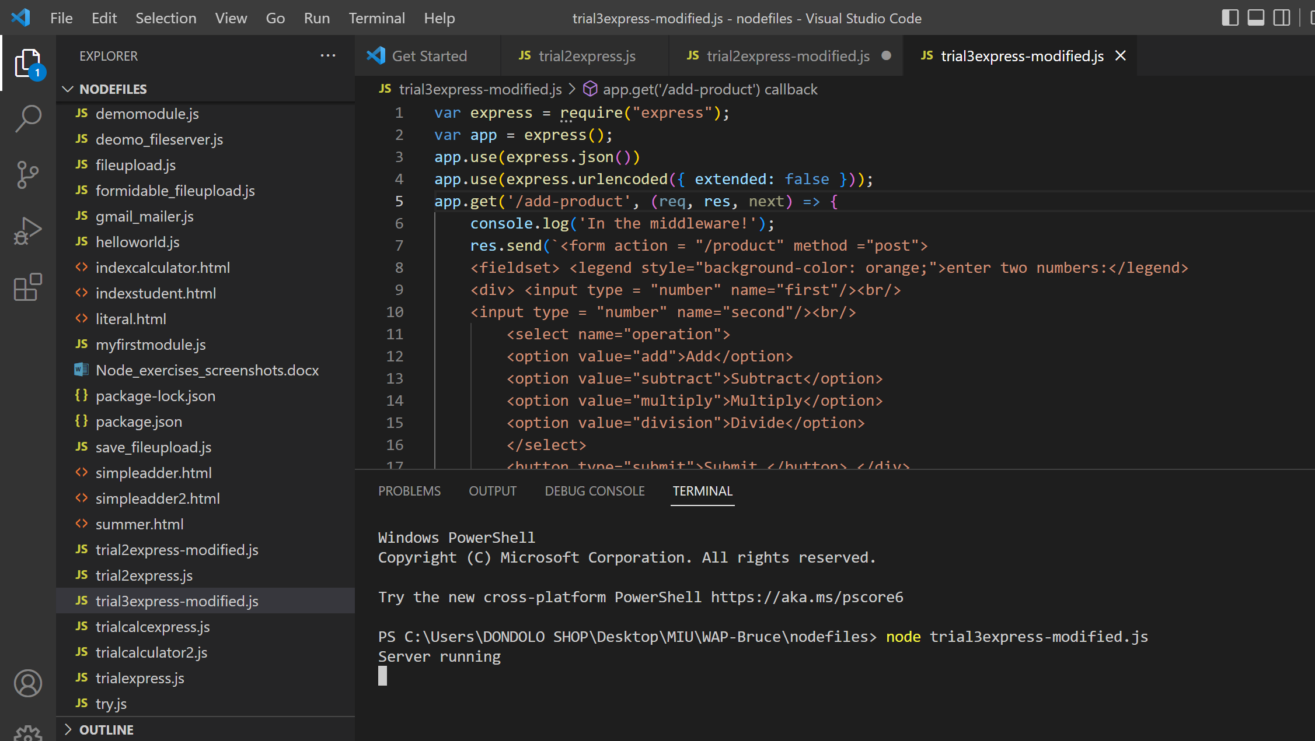

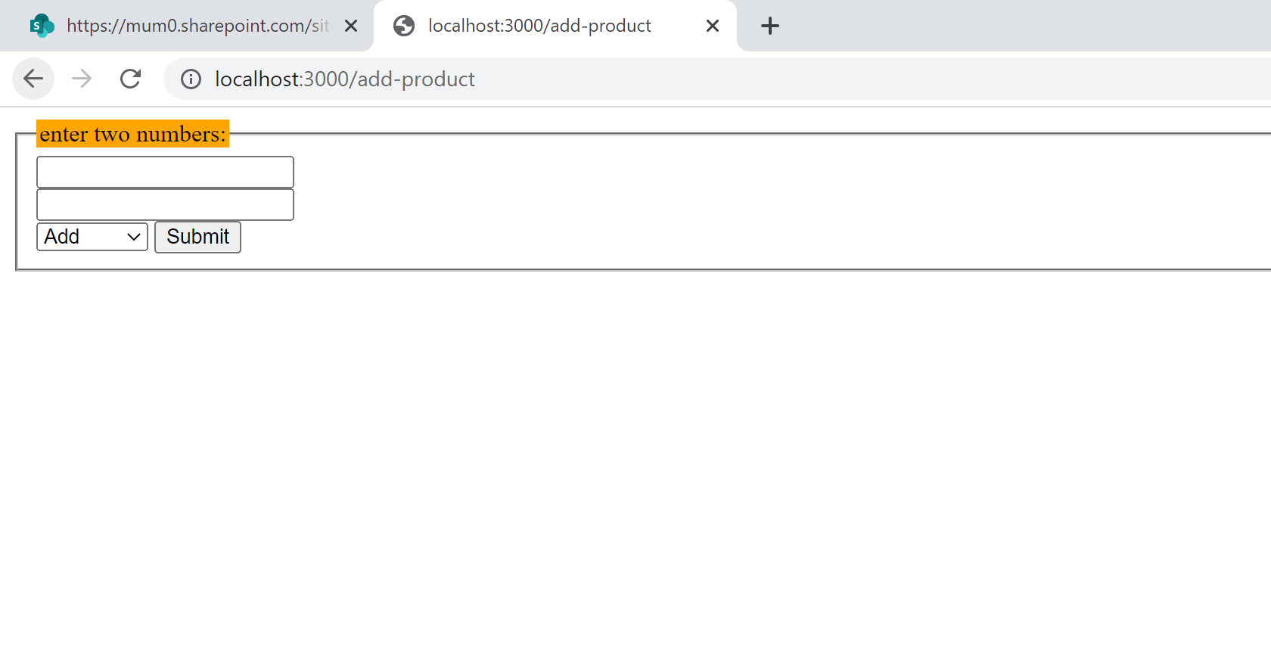

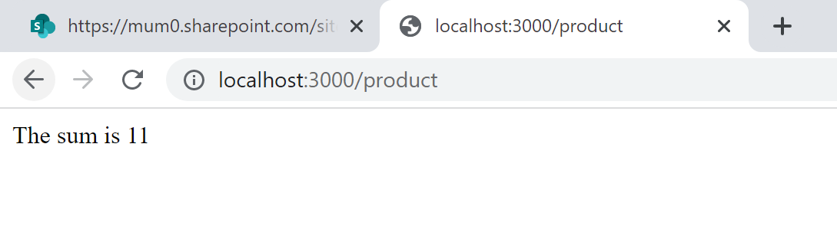

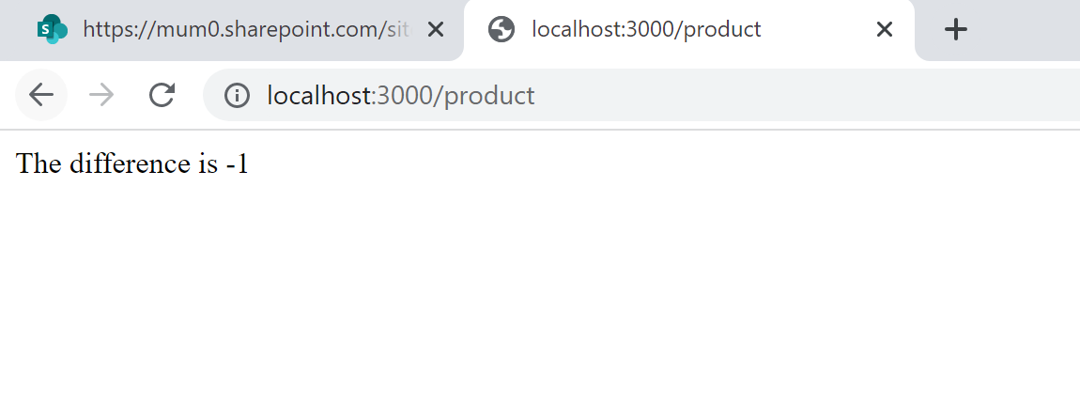

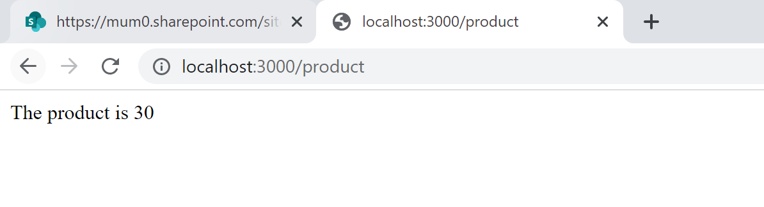

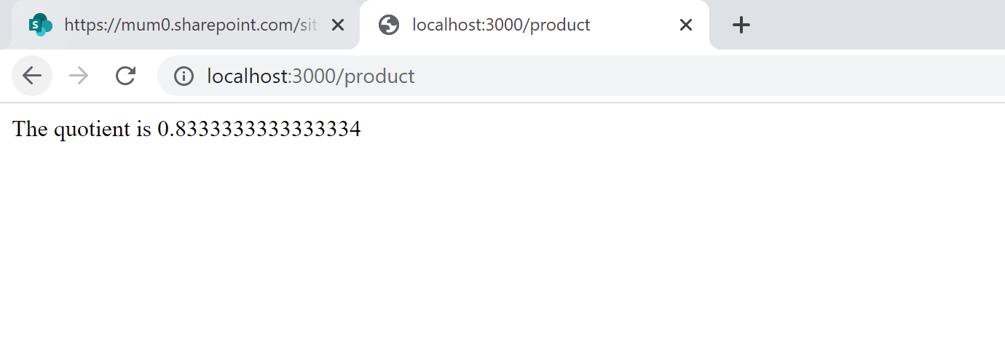

Code

var express = require("express");

var app = express();

app.use(express.json())

app.use(express.urlencoded({ extended: false }));

app.get('/add-product', (req, res, next) => {

    console.log('In the middleware!');

    res.send(`<form action = "/product" method ="post">

    <fieldset> <legend style="background-color: orange;">enter two numbers:</legend>

    <div> <input type = "number" name="first"/><br/>

    <input type = "number" name="second"/><br/>

        <select name="operation">

        <option value="add">Add</option>

        <option value="subtract">Subtract</option>

        <option value="multiply">Multiply</option>

        <option value="division">Divide</option>

        </select>

        <button type="submit">Submit </button> </div>

        </fieldset>

        </form>`);

});

app.post('/product', (req, res, next) => {

    console.log(req.body);

    var operator = req.body.operation;

    var num1 = parseInt(req.body.first);

    var num2 = parseInt(req.body.second);

    let result;

    switch (operator) {

        case "add":

            result = num1 + num2;

            res.send("The sum is " + result)

            break;

        case "subtract":

            result = num1 - num2;

            res.send("The difference is " + result)

            break;

        case "multiply":

            result = num1 * num2;

            res.send("The product is " + result)

            break;

        case "division":

            result = num1 / num2;

            res.send("The quotient is " + result)

            break;

        default:

            result = "Sorry, please enter a valid operator!"

    }

});

app.listen(3000, () => {

    console.log('Server running');

})

Code name on git

simplecalculatorexpress