# Carbon Reverse

## Summary

The carbon reverse program is a provision that SG Fleet offers where SG Fleet purchases carbon credits to offset a customer’s car emission for the lease of their term.

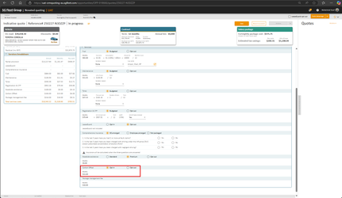

## Features and Benefits (inclusions)

* Carbon credits that are on-sold to the customer from the Carbon Credit Trading Scheme
* Offsets the average car emissions for the lease term
* Customer is issued a certificate to show the amount of carbon they have offset

## Exclusions

## FAQ

**Common Questions & Responses**

 What is Carbon Reverse?

Together with your employer and as part of our green initiative, we have included Carbon Reverse as part of your package.  This is to help offset the carbon emissions of your vehicle for the life of the lease.  Our main business is placing cars on the road so we have included this as a way of doing our part and giving back to help the environment.  Plus it helps to further reduce your taxable income so you will pay less tax as a bonus.

When you decide to include a Carbon Reverse provision, SG Fleet purchases carbon credits to offset your car’s emissions for the life of the lease.  The average Australian car emits approximately 4.5 tonnes of carbon dioxide per year.  One carbon credit offsets one tonne of carbon dioxide emitted.  We calculate the number of carbon credits required to offset your car’s carbon emissions for the life of your lease.  This forms the basis of your Carbon Reverse certificate.  For example, a four-year lease x 4.5 tonnes will require the purchase of 18 carbon credits.

## Objection Handling Tips

**Question: “What is the Carbon Offset?”**

The Carbon Offset component in your novated lease is a contribution toward our Climate Active initiative.  By being listed as a Climate Active organisation, SG Fleet contributes this credit toward creating sustainable infrastructure for the future.  The production and use of a vehicle, whether combustion engine or electric, has a negative impact on the ecosystem.  Carbon Offset helps provide important research and action into mitigating the effect the car industry has on the planet.

**Question: “Do I have to include it?”**

Although the product is optional, we encourage our drivers to join us in minimising the footprint our services provide.  The contribution is entirely pre-tax.

**Question: “Isn’t this a bullshit nothing product?”**

If you wish to see the impact of where our contributions go, I’d encourage you to have a look on the Climate Active website.  It explains that our emissions have been reduced to a carbon neutral level.

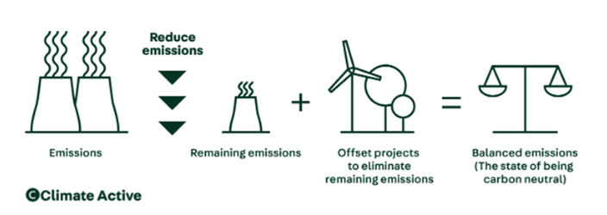

<https://www.climateactive.org.au/buy-climate-active/certified-members/sg-fleet>