# Leaseguard

## Summary

Leaseguard is an involuntary redundancy insurance cover that is introduced to the customer by SG Fleet. It covers up to 11 months lease payments or $15,000 (whichever comes first) in the event the customer is made involuntarily redundant. Should the customer be unable to find work, they have the option in months 3-6 to hand back the car and whatever is remaining of the $15,000 is able to be used to cover the gap to the finance payout from the trade in value.

## Features and Benefits (inclusions)

* Covers for involuntary redundancy.
* Monthly premium packaged through the balance management.
* No excess when claiming.
* Covers up to 11 months' worth of lease payments or up to $15,000 whichever comes first.
* Vehicle handback option between months 3 and 6 with GAP cover up to $15,000 less finance payments already made under policy.
* Doesn’t contribute to the FBT Cost Base.

## Exclusions

* No cover if claimable event occurs within 30 days of lease commencement.
* There is a 30-day waiting period following redundancy, customer must pay the first month’s lease payment.
* Insurance premium is paid monthly, not paid in total upfront.
* If driver leaves their employer, the insurance ceases.
* No cover in the event that the driver doesn’t pass initial probation.
* GAP benefit is less finance payments covered.
* Vehicle hand back can only occur after three months but before six months of benefit payments starting.
* No driver age limits.
* No positive equity if LeaseGuard covers more than payout figure at handback.

## FAQ

* Can we send Leaseguard documents to the customer at any point of the quoting process?

A: Before talking about or sending any info on Leaseguard, we need to get permission from the driver.

* How do we introduce leaseguard in a conversation?

A: “We have a redundancy insurance product to offer protection on your lease, are you happy for me to send you some information about it?”

## Deferred Sales Model

LeaseGuard follows a deferred sales model and requires consent from the customer to receive information in relation to the product before quoting or supplying a PDS to the customer. If the customer opts out of LeaseGuard or does not consent to the information being supplied, no further quotes or information can be given and the LeaseGuard opt out master flag must be ticked.

The image below shows where Leaseguard can be toggled to opt in or out during the quoting process, the flag at the top of the screen is the master flag.

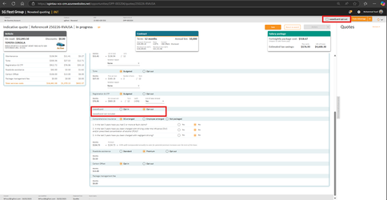

## Objection Handling Tips

Leaseguard cannot be objection handled and if the customer answers with ‘No’ when Leaseguard is offered, it should not be brought up again unless the customer prompts a revision of the product.