# Minor Damage Repair

## Summary

Minor Damage Repair is a feature offered by SG Fleet that gives a customer access to a membership that gives you the benefit of on-site minor damage repairs for $50 per repair. The $50 is claimable through maintenance/ lease account. Repairs are done on-site at customers work or home (or other arranged location if necessary)

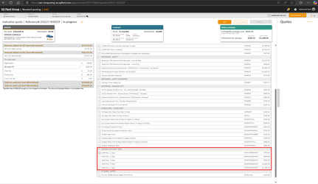

## Features and Benefits (inclusions)

* We price lower than the average dealer as well as avoiding stamp duty and LCT when purchased through us.
* MDR is **NOT** included in residual value or FBT calculations – which means that it is paid off entirely over the lease term and does not affect the post-tax deduction – this is because it is a membership and does not increase the capital value of the vehicle – it is not paid for as a packaged product in order to pay entire membership upfront.
* To make a claim/ request a repair: customer can call, email, download app.
* Repairers will go above and beyond and often not charge or undercharge the fees on that day.

## Exclusions

## FAQ

**How do I make a claim?**

1. Online through Schmick’s mobile application
2. Online through the Member’s page of the Schmick website
3. Calling 1300 946 677

**The Minor Damage Repair, where do they draw the line on what’s minor and what’s major?**

The guys that come out to do the repairs are really good, they’ve got a set of rules that I’ll send you through on what’s covered and what’s not, but realistically, if they can repair it on site they will do so, if it is something that needs to be done in a panel shop, they will tell you and not charge you and then refer you to a panel shop to get it repaired under insurance.

**What if they can’t get out to me?**

They actually offer us a nationwide service, so if they are unable to get out to you, they will get you to go to the nearest panel shop and the panel shop will repair and the team will only charge the $50 repair fee, even if the bill is higher for that single repair.

**Do I have to include this? Sounds like I wouldn’t use it.**

It is optional and is definitely designed to be used, everything we do is to offer benefit and savings, i.e. if you were looking to do an expensive car with low km we’d flag that as not the best way to setup a lease, if you purchase the membership and never use it, you won’t get the benefit, we offer it fully intending for you to use it as often as possible.

## Objection Handling Tips

**When loading quote yourself**

Assumptive: We have a program called Minor Damage Repair that is a membership that gives you access to on-site minor damage repairs for only $50 per repair so I’ll include that and send you some info about it.

Question: We have a program called Minor Damage Repair that is a membership that gives you access to on-site minor damage repairs for only $50 per repair, is that something you’d like to include or see some more info on?

**When introducing to a customer who has already quoted themselves but not included**

Assumptive: I can see when you’ve generated the quote online that you’ve not selected the Minor Damage Repair membership, we offer so I’ll flick you through some info on that for you to take a look at and decide if you’d like to include (send updated quote with MDR included and PDS)

Question: I can see when you’ve generated the quote online that you’ve not selected the Minor Damage Repair membership we offer, a lot of people miss this when they mean to include, did you want to add that in or see some costings and info on it?