# MotorOne Accessories

## Summary

**MotorOne offers:**

* Paint protection, Interior protection, Window Films
* Packages (i.e. ECO protection pack, interior & exterior protections, tint, driver safety kit)
* Electronics: Drive Recorders, DVD Players, Sat Nav, Reverse Camera Systems

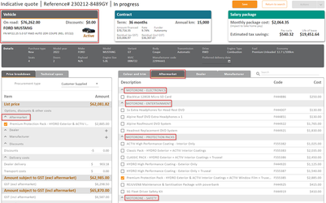

## Features and Benefits (inclusions)

* We price lower than the average dealer as well as avoiding stamp duty and LCT when purchased through us.
* Lifetime warranty on all protections (Interior, Exterior & Window Film), lease term matched warranty on electronics (3year minimum).
* All MotorOne products that are not MDR are included in residual value and FBT calculations.

## Exclusions

## FAQ

## Objection Handling Tips