# Roadside Assistance

## Summary

The Roadside Assistance Service ticks all the boxes. It ensures that SG Fleet drivers won’t be left stranded and offers them immediate assistance in case the unexpected happens. The service offers comprehensive feature benefits for members and has been tailored to the needs of drivers. This will save time and money as well as creating peace of mind motoring. The Roadside Assistance Service can be offered from day one, or at the end of the cover provided by the vehicle manufacturer.

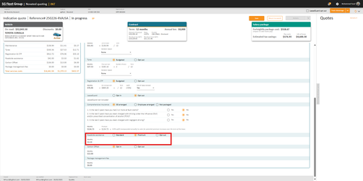

## Features and Benefits (inclusions)

* Australia wide assistance service coverage 24/7, with unlimited call outs
* FREE towing up to 50km, in the event of a breakdown, country or metro
* Emergency vehicle access, attempt vehicle entry in case of lost keys
* Jump start for flat or faulty battery and flat tyre change
* Out of fuel, provision of up to 5 litres or tow
* Tailored Customer Service Support Services where the incident is greater than 100km from the registered address and unable to repair within 24 hours
* Emergency accommodation up to 3 nights at $150 (Inc. GST) per night*
* Emergency car rental up to 3 days to the total of $120 (Inc. GST) per day*
* Combination of emergency support is limited to 2 nights’ accommodation up to $150 (Inc. GST) per night and 2 days car rental up to $120 (Inc. GST) per day
* Taxi ride up to the value of $50 (Inc. GST) in the event of a breakdown
* Upon completion of repairs, vehicle relocation of up to $1,000 (Inc. GST) (where a tow has been required) *
* Where a vehicle cannot be repaired in 3 days, ground transport to the driver's residence will be provided, covered up to $500 (Inc. GST) *
* *Please note these benefits are provided individually

## Exclusions

The following vehicles are excluded:

* Vehicles in excess of 8 years of age
* All commercial Vehicles
* Caravans and trailers (these will only be recovered to a place of safety at the Customer’s cost)
* Vehicles in Remote Locations
* Bogged Vehicles in Remote Locations
* Taxis
* Unattended Vehicles
* Towing of a Vehicle involved in an accident
* Unregistered Vehicles and
* Mis-fuelled Vehicles (All mechanical or travel to site repairs at Customer’s cost)

## FAQ

How do I access Roadside Assistance?

Who do I contact in the event my car breaks down and I need assistance?

## Objection Handling Tips

**I already have my own RSA**

I suggest you read our brochure and compare the SG Fleet Roadside Assistance with what you currently have.  With SG Fleet Roadside Assistance you have:

* 24/7 cover with unlimited call outs
* Australia wide coverage
* Covers any driver of the vehicle
* FREE towing up to 50km, in the event of a breakdown, country or metro
* Emergency accommodation up to 3 nights at $150 (Inc. GST) per night
* Emergency car rental up to 3 days to the total of $120 (Inc. GST) per day
* Paid from pre-tax dollars
* It works out to be less than $1 per week so most likely cheaper that what you can get on the market

Many of our customers decide to keep both in place just in case one of them falls over.

SG Fleet’s Roadside Assistance is slightly different to that of other providers, in that we contract the assistance out to the fastest provider at the time of your call.  Instead of just using one provider and relying on their response time, we are able to reach out to multiple providers and have faster response times.  Many Roadside Assistance policies may not cover you in the event that you have a breakdown in some regional areas.  SG Fleet Roadside Assistance provides Australia wide coverage.