# Vehicle Procurement

## Summary

Vehicle procurement is a service that SG Fleet provides where we take the car that the customer wants precisely (including colour, options, accessories and desired delivery timeframe). We send a request to each of the relevant dealers on our network (6-10 manufacturers per state) and request them to quote the exact same car. Vehicle Procurement Specialists collect the quotes and review for quality and pricing. VP specialists sit within each sales team to assist with the team deals that come through.

## How to

* Build the car to exact specifications required by customer into quoting system
* Once car is correct and double checked, save and create a firm quote
* Once firmed, the dropdown box for ‘send VSSS’ will show a section for ‘request pricing’
* A box will generate to add extra info as required, then ‘send’
* Once quotes are back, VP will send directly to the consultant via email.

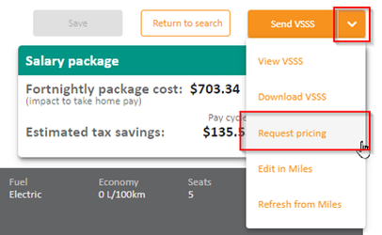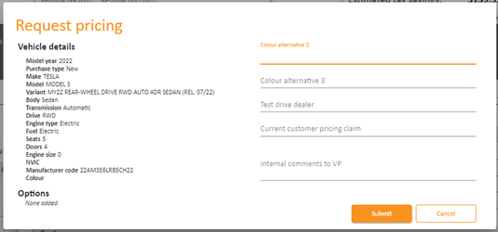

## Features and Benefits (inclusions)

* VP Specialists collect the most relevant quotes (i.e. cheapest or closest arrival time or both) to the consultant for presenting to the customer.
* VP specialists will work with the consultants to work out a deal wherever is needed (i.e. customer has obtained a cheaper quote elsewhere and we need to beat it).
* We negotiate on behalf of the customer (price and convenience) and we manage the delivery process with a greater level of control over the deal (peace of mind).
* With our wide range of dealership network for each manufacturer, we make sure to get the best price for the customer.

## Exclusions

* Vehicle procurement does not apply where the customer has arranged their own vehicle with an external dealer.

## FAQ

* Why should I task SG Fleet with finding a vehicle for me when I can go directly to the dealer?

A: With our wide range of dealer network, we make sure we provide you with the most relevant quote and manage the delivery process with a greater level of control over the deal.

## Objection Handling Tips

* I have received a cheaper quote from elsewhere, can you guys beat it?

We will certainly try and see what we can do. Why don’t you send the invoice with the quote over to us and I will speak to our in-house vehicle procurement specialist to see what I can do for you?