**DS and Algo Sample Questions for Final Exams**

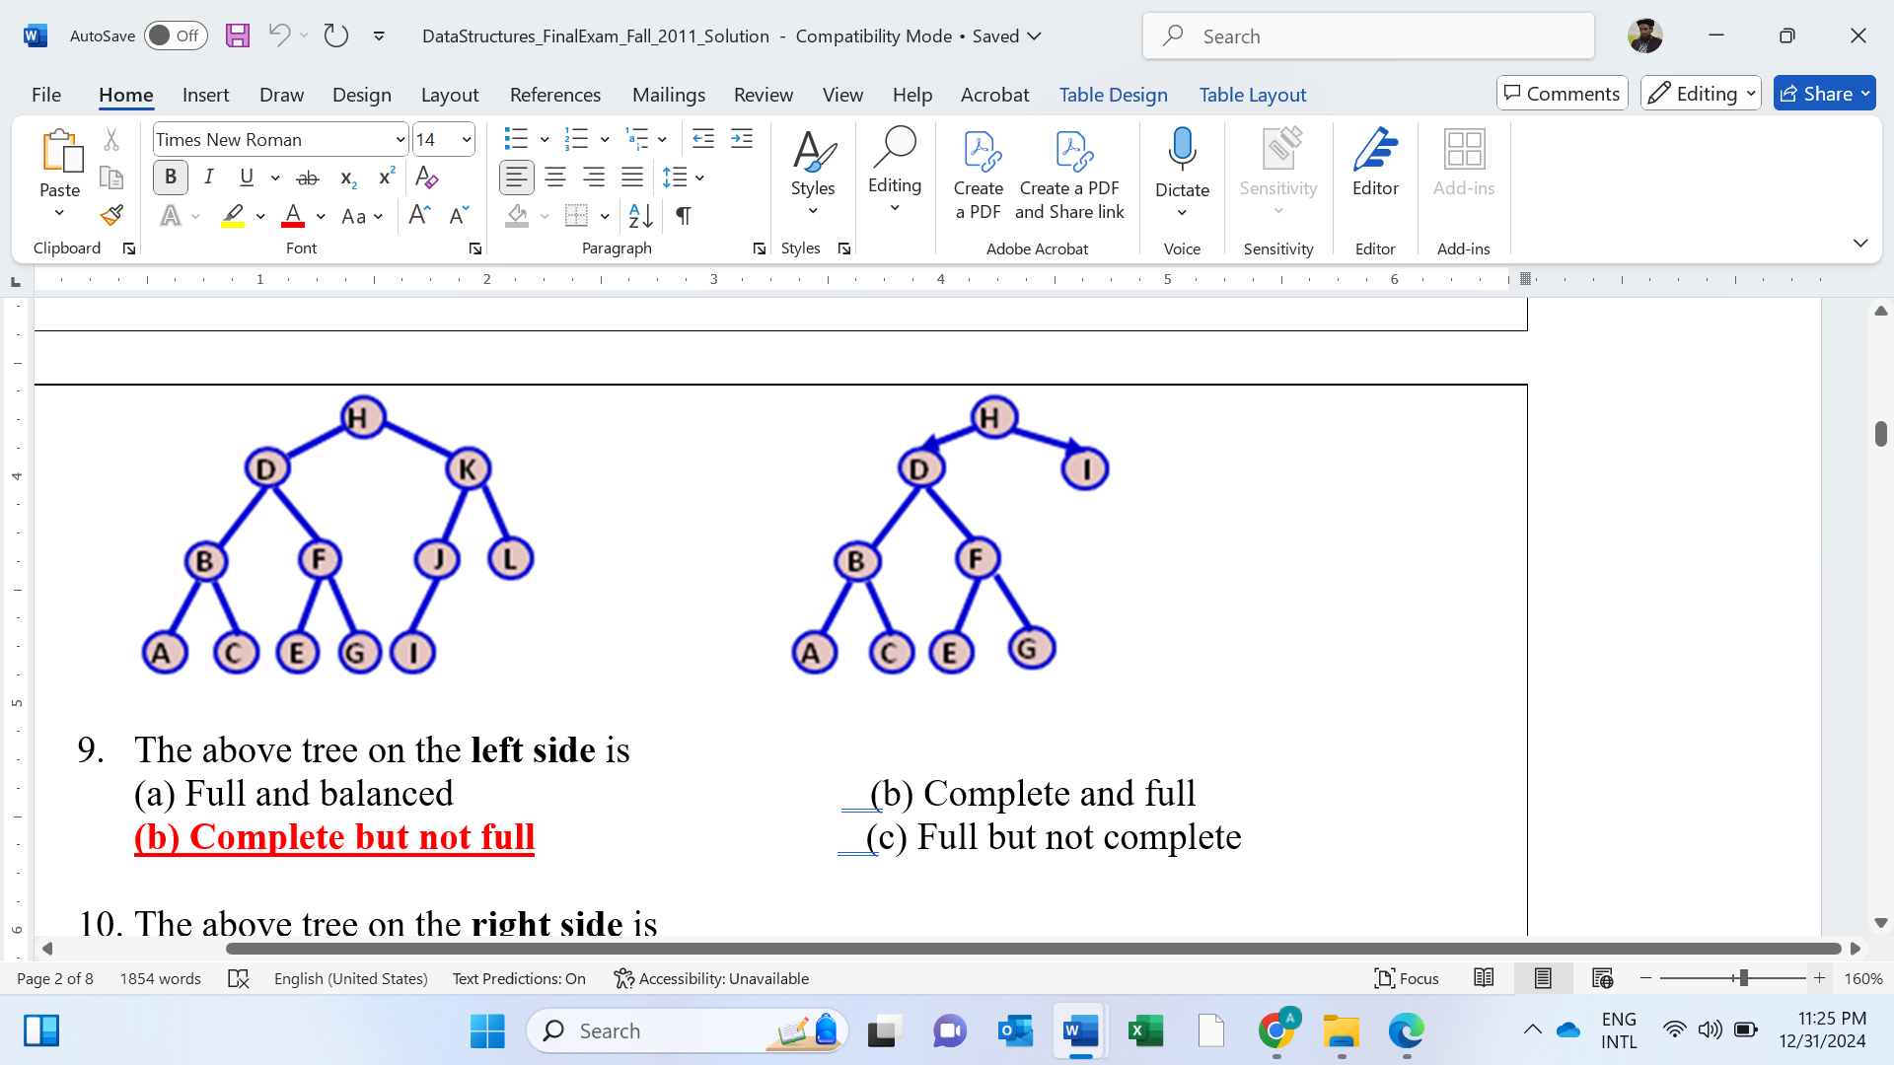

1. The above tree on the **left side** is

(a) Full and balanced (b) Complete and full

**(b) Complete but not full** (c) Full but not complete

1. The above tree on the **right side** is

(a) Full and balanced (b) Complete and full

(b) Complete but not full **(c) Full but not complete**

struct node{

int data;

node *next;

};

node *head;

void **Add**(int data) {

node * temp=head;

for(temp; temp->next!=NULL; temp=temp->next) { }

temp->next=new node;

temp=temp->next;

temp->data=data;

temp->next=NULL;

}

void **Display**() {

cout<<"\n";

for(node *temp=head; temp!=NULL; temp=temp->next){

cout<<" "<<temp->data;

}

}

Consider the **Nodes** portion of the reference code the next four MCQs

1. What will be the screen output of the following code

void **main()** {

head=new node; head->data=0; head->next=NULL;

Add(1);Add(3);Add(5);

**Display();**

}

(a) 1 3 4 5 **(b) 0 1 3 5**

(c) 0 1 3 4 5 (d) 0 1 3 4 5

1. What is the prefix equivalent of the string ***a* *-* [ *b* / (*c* - *d*)** *+* ***e* ] * *f* ?**

(a) **- / - + * *a* *b* *c* *d* *e* *f*** (b) **- *a * + /* *b* - *c* *d* *e*  *f***

(c) **- *\* a + /* *b* - *c* *d* *e*  *f*** (d) **- *\* a + /* - *b* *c* *d* *e*  *f***

unsigned int **hash**( char *key, unsigned int H_SIZE ) {

unsigned int hash_val = 0;

while (*key != '\0') {

hash_val = hash_val + *key;

key++;

}

unsigned int result = hash_val % H_SIZE;

}

1. What is the result of the following operation?, given the above function?

**hash**( “cde”, 99 )

(a) 100 (b) 99 **(c) 3** (d) 27

1. The resultant heap after the **deleting the minimum** value from the above **heap** is

1. The shortest path tree of the graph on the right side (a) is drawn on the right side (b)

|  |  |
| --- | --- |
| (a) | (b) |

1. What operation is performed on the tree on the left side **(a)** to transform into **(b)**?

|  |  |
| --- | --- |
| (a) | (b) |