**中级微观经济学2020年秋季学期期中考试**

Unless otherwise noted, all commodities mentioned in this exam are assumed to be income normal.

除特别说明外，该试卷中出现的商品都假设为正常品。

Total score: 90 points (满分为90分)

1. 单项选择题（选择正确或是最接近正确答案的选项， $25×2'$）
2. The Food Stamp is a social security program in the US that provides food coupons for poor people. The coupons can only be used to exchange for food in designated retail stores and cannot be sold for cash. Suppose a family has an income of $100 and receives $40 of food stamps each month. The family consumes only food (F) and clothes (C), the prices of which are both $1 per unit. Which of the following graphs represents the family’s budget constraint?

食品券计划是美国政府为穷人提供食物补贴的一项社会福利项目。该项目所发放的食品券仅能用于在指定商品兑换同等金额的食品，不能用于其他消费或兑换现金。假设一户家庭月收入为100美金，同时收到政府发放的40美金食品券。该家庭仅购买食物（F）和衣服（C）两种商品，且两种商品的价格都为1. 请问下面的哪个图形正确描绘了该家庭的预算约束线？

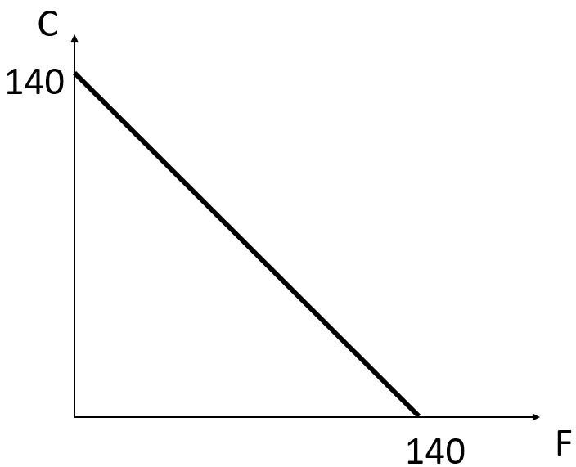 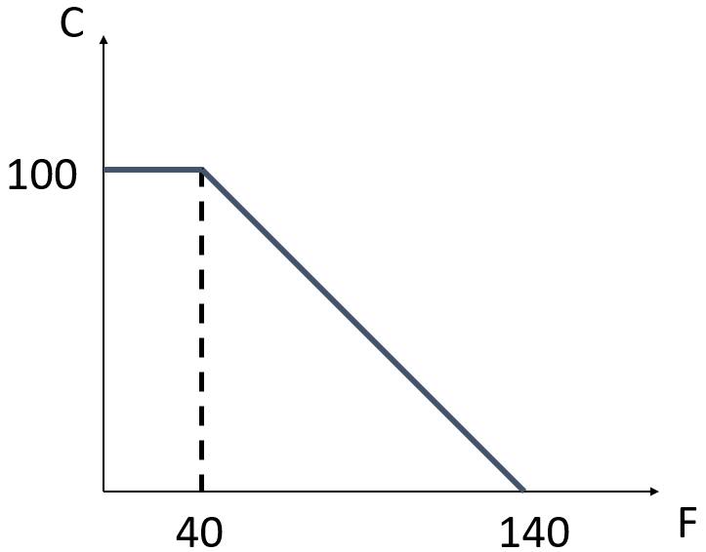

1. (B)

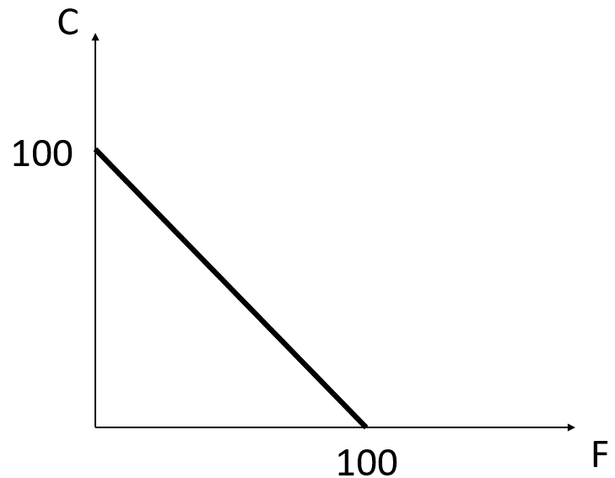 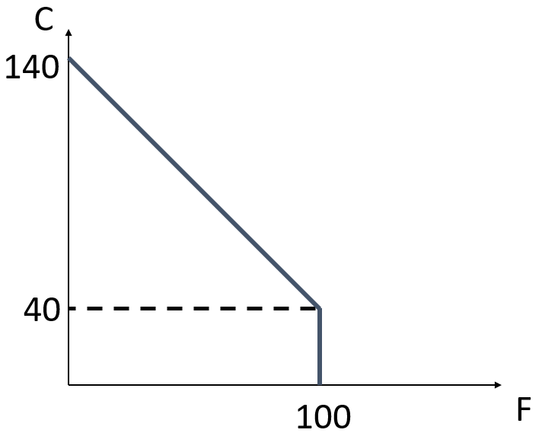

(C) (D)

1. Now let’s consider a different situation of the Food Stamp in question 1. Suppose the family still has an income of $100 and receives $40 of food stamps each month. However, the family realizes that there exists a black market where they can trade $1 of food stamp for $0.5 of cash. Again, the family consumes only food (F) and clothes (C), and the prices of them are both $1 per unit. Which of the following graphs represents the family’s budget constraint?

我们现在考察题1中食品券计划的另外一种情况。假设这户家庭月收入仍为100美金，同时收到政府发放的40美金食品券。然而除兑换同等价值的食物之外，该家庭发现面值1美金的食品券还可在黑市上兑换成0.5美元的现金。我们仍假设该家庭仅购买食物（F）和衣服（C）两种商品，且两种商品的价格都为1. 请问下面的哪个图形正确描绘了该家庭的预算约束线？

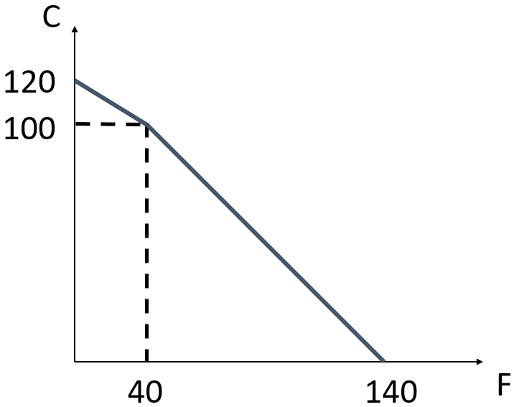 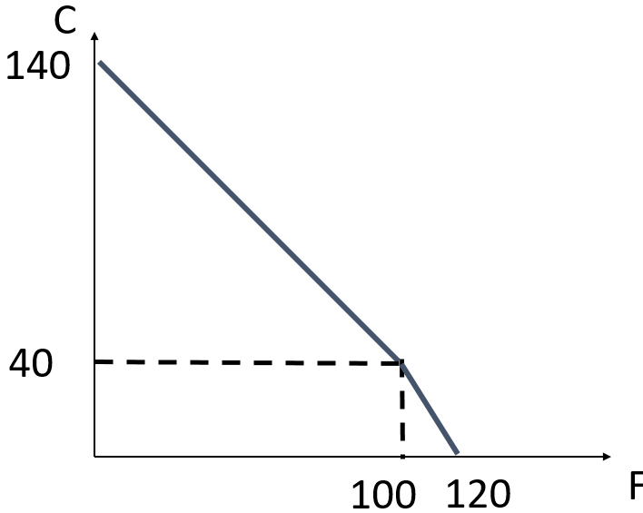

1. (B)

 

(C) (D)

1. John Snow is a fashionable guy. He consumes only two commodities, jackets (J) and sneakers (S). If two jackets are just as preferred as one pair of sneakers to John, which of the following is John’s optimal consumption strategy when $p_{J}:p_{S}=1:3$?____ Which one is John’s optimal strategy when $p_{J}:p_{S}=2:3$?____

琼恩雪诺十分时尚，他只购买两种商品：夹克衫(J)和运动鞋(S)。在他看来，两件夹克衫和一双运动鞋所受的偏好程度完全相同。如果夹克和运动鞋的价格之比 $p_{J}:p_{S}=1:3$，那么琼恩的最优购买策略为？____ 如果夹克和运动鞋的价格之比 $p_{J}:p_{S}=2:3$，那么琼恩的最优购买策略为？____

1. Only buying jackets; only buying sneakers (只买夹克；只买运动鞋)
2. Only buying jackets; only buying jackets (只买夹克；只买夹克)
3. Only buying sneakers; only buying sneakers (只买运动鞋；只买运动鞋)
4. Only buying sneakers; only buying jackets (只买运动鞋；只买夹克)
5. John Snow’s utility function is $U\left(x,y\right)=xy$.

Biden’s utility function is $U\left(x,y\right)=logx+logy$.

Trump’s utility function is $U\left(x,y\right)=log⁡(x+y)$

Obama’s utility function is $U\left(x,y\right)=-1/(xy+1)$

Clinton’s utility function is $U\left(x,y\right)=1000-xy$

Which of these persons have the same preferences as John Snow?

谁的偏好和琼恩雪诺的是一样的？

1. Biden and Clinton
2. Everyone except Trump (除Trump外的所有人)
3. Biden and Obama
4. All of them do (上述所有人)
5. John has Cobb-Douglas preferences over goods 1 and 2. Which of the following statements is **FALSE**?

假设琼恩拥有柯布-道格拉斯性质的偏好，下面哪个关于他的描述是**错误**的？

1. John’s Engel curve for good 1 is linear (商品1的恩格尔曲线是线性的)
2. John’s income offer curve is a ray from the origin (收入提供曲线是一条通过原点的射线)
3. John’s demand curve for good 1 is linear (商品1的需求曲线是线性的)
4. John’s optimal consumption bundle must include positive amounts of both goods if income is positive (当收入为正时，琼恩的最优商品组合一定同时包含数量为正的两种商品)
5. Joe Biden, the president-elect of the US, has a utility function given by $U\left(x,y\right)=x^{2}+16xy+64y^{2}$, where x and y are the quantities of the two goods that he consumes. Which of the following statements about his preferences is **TURE**?

刚刚当选美国总选的乔.拜登的效用函数可表述为 $U\left(x,y\right)=x^{2}+16xy+64y^{2}$，这里的x和y分别是他所消费的两种商品的数量。下面关于他偏好的表述哪一个是**正确**的？

1. Joe Biden’s preferences are non-convex (拜登的偏好是非凸的)
2. Joe Biden’s indifference curves are straight lines (拜登的无差异曲线是直线)
3. Joe Biden has a bliss point (拜登有一个餍足点)
4. Joe Biden’s indifferences curves are hyperbolas (拜登的无差异曲线是双曲线)
5. Mr. Xu’s can only afford two kinds of food during his graduate studies, instant noodles (N) and eggs (E). He had weird preferences and always consumed 1 bag of instant noodles with 2 eggs. Let N be the bags of instant noodles and E be the number of eggs he consumed. Which of the following utility functions could represent his preferences?

徐老师在读研的时候只吃得起两种食物：泡面（N）和鸡蛋（E）。他有一个非常奇怪的偏好，每煮1袋泡面一定要加2枚鸡蛋。我们用N代表泡面的袋数，E代表鸡蛋的个数。请问下面哪个效用函数能够正确描述徐老师的这一偏好？

$U\left(N,E\right)=min⁡\{N, 2E\}$

$U\left(N,E\right)=min⁡\{2N, E\}$

$U\left(N,E\right)=N+2E$

$U\left(N,E\right)=2N+E$

1. There are two types of food in the canteen, rice noodles (x) and stewed beef (y). Suppose John’s utility function is given by $U\left(x,y\right)=x^{0.7}y^{0.3}$ and his optimal consumption bundle is (0.7,0.3). The relative price $p_{x}/p_{y}$ is equal to ____

学校小白房出售米线(x)和炖牛肉(y)两种商品。已知琼恩的效用函数为 $U\left(x,y\right)=x^{0.7}y^{0.3}$，同时观察到他的最优消费组合是(0.7,0.3)。请问米线和炖牛肉的相对价格 $p_{x}/p_{y}$ 是多少？

1. 1
2. 7/3
3. 3/7
4. The information given is not enough to determine (信息不足，无法判断)
5. Which of the following changes **won’t** **shift** the demand curve of a commodity? ____

下列哪一选项的变动不会造成商品需求曲线的**移动**？

A. income changes (收入变动)

B. changes in the prices of the commodity’s substitutes (替代商品的价格变动)

C. own-price changes (自身价格的变动)

D. changes in preferences (偏好的变动)

1. The daily demand for gasoline in Haidian, Beijing is described by Q = 1000 – 4p, where Q are liters of gasoline sold and p is the price in *yuan*. The supply is Q = 100 + 2p. Suppose that the district government places a sales tax of 30 yuan on every liter of gasoline sold. What is the deadweight loss resulting from this tax? ____

海淀区的日均汽油需求函数为Q = 1000 – 4p，这里的Q为汽油需求的总升数，p是以元为单位的每升汽油的价格。市场供给函数为Q = 100 + 2p. 假设海淀区政府对每升汽油征收30元的销售税，那么该税收会造成多少无谓损失？____

1. 150 *yuan*
2. 400 *yuan*
3. 253.33 *yuan*
4. 600 *yuan*
5. John has an income of $800 in period 1 and an income of $500 in period 2. His utility function is Cobb-Douglas, given by $U\left(c_{1},c_{2}\right)=c_{1}^{0.8}c_{2}^{0.2}$, where $c_{1}$ is the dollars spent on consumption in period 1 and $c_{2}$ is the dollars spent on consumption in period 2. John can freely borrow or save in period 1 at an interest rate of 0.25. If he unexpectedly won a lottery which pays its prize in period 2 so that his income in period 2 would be $1,000 and his income in period 1 would remain $800, then his consumption in period 1 would ____

琼恩第一期收入800美元，第二期收入500美元。他的效用函数可表述为 $U\left(c_{1},c_{2}\right)=c_{1}^{0.8}c_{2}^{0.2}$，这里 $c_{1}$ 是第一期所消费的金额， $c_{2}$ 是第二期所消费的金额。此外，琼恩能以0.25的利率在第一期借款或储蓄。如果他意外中了彩票，使得第二期的收入上升到1000美元，第一期的收入保持800美元不变，那么和中彩票前相比，琼恩在第一期的消费金额将如何变化？____

1. Stay constant (保持不变)
2. Double (变为之前的两倍)
3. Increase by $400 (增加400美元)
4. Increase by $320 (增加320美元)
5. Mei is a rational agent and her initial endowment is given by $(ω_{1},ω_{2})$. When the prices of the two goods were $(p_{1},p_{2})$, Mei chose the consumption bundle $(x_{1}^{*},x_{2}^{*})$. If the prices of the two goods increase to $({2p}_{1},2p_{2})$ and her endowment remain the same, what would happen to the budget line? ___ What would be Mei’s new consumption bundle $(x_{1}^{'},x_{2}^{'})$?____

小梅是一个理性消费者，她的初始禀赋为 $(ω_{1},ω_{2})$. 当两种商品的价格分别为 $(p_{1},p_{2})$ 时，她选择的商品组合为 $(x_{1}^{*},x_{2}^{*})$。现假设禀赋保持不变，但两种商品的价格分别上升为 $({2p}_{1},2p_{2})$，那么她的预算约束线将会如何变化？____ 新的消费组合 $(x_{1}^{'},x_{2}^{'})$ 满足如下哪个条件？_____

1. The budget line will not change; $\left(x_{1}^{'},x_{2}^{'}\right)=(x_{1}^{*},x_{2}^{*})$ 预算线不变， $\left(x_{1}^{'},x_{2}^{'}\right)=(x_{1}^{*},x_{2}^{*})$
2. The budget line will not change; $\left(x_{1}^{'},x_{2}^{'}\right)=(x_{1}^{*}/2,x_{2}^{*}/2)$ 预算线不变， $\left(x_{1}^{'},x_{2}^{'}\right)=(x_{1}^{*}/2,x_{2}^{*}/2)$
3. The budget line pivots around the endowment point and becomes steeper; $\left(x_{1}^{'},x_{2}^{'}\right)=(x_{1}^{*},x_{2}^{*})$ 预算线围绕禀赋点旋转、变得更加陡峭， $\left(x_{1}^{'},x_{2}^{'}\right)=(x_{1}^{*},x_{2}^{*})$
4. The budget line shifts inward in a parallel manner; $\left(x_{1}^{'},x_{2}^{'}\right)=(x_{1}^{*}/2,x_{2}^{*}/2)$ 预算线向内平移， $\left(x_{1}^{'},x_{2}^{'}\right)=(x_{1}^{*}/2,x_{2}^{*}/2)$
5. Assume that there are only two consumers in a market, denoted by A and B. Their demand functions are given by $x_{A}=20-2P$ and $x_{B}=10-2P$. What is the market demand function? ____

假设市场中仅有两个消费者，A和B，他们的需求函数分别为 $x_{A}=20-2P$ 和 $x_{B}=10-2P$。下面哪个选项正确描述了市场的总需求函数？

$X\left(P\right)=30-4P$

$P=15-X$

$X\left(P\right)=\left\{\begin{aligned}0 if P>10 \\ 10-2P if 5<P≤10 \\ 30-4P if 0<P≤5\end{aligned}\right.$

$X\left(P\right)=\left\{\begin{aligned}0 if P>10 \\ 20-2P if 5<P≤10 \\ 30-4P if 0<P≤5\end{aligned}\right.$

1. A monopolist realized that, at its current quantity of supply, the market demand is own-price inelastic. That is, the size of the own-price elasticity is smaller than 1. In order to increase the revenue, the monopolist should ____ the quantity of supply and ____ the price.

一位垄断厂商发现，在当前的价格和供给数量下，市场需求价格是缺乏弹性的，即市场的需求价格弹性绝对值小于1. 如果这位厂商希望提高收益得话，他应该____供给数量、____价格。

1. decrease; lower (减少；降低)
2. decrease; raise (减少；提高)
3. increase; lower; (增加；降低)
4. increase; raise; (增加；提高)
5. John has a utility function that is given by $U\left(C,R\right)=32\sqrt{R}+C$, where R is the hours of leisure and C is the amount of dollars spent on consumption goods. He has $\overline{R}=16$ hours a day to divide between work and leisure. If John has a non-labor income of m=$40 and is paid a wage rate w= $8 per hour, how many hours will he choose to **work**?

琼恩的效用函数是 $U\left(C,R\right)=32\sqrt{R}+C$，其中R是用于闲暇的小时数，C是其它商品的消费金额。他每天有 $\overline{R}=16$ 小时可在闲暇和工作之间分配。如果琼恩有$40的非劳动收入，每小时的工资为$8，那么他每天的**工作**时间为？

1. 4 hours
2. 8 hours
3. 12 hours
4. 0 hours
5. John has a utility function $U\left(X,Y\right)=XY$, and an income of $4. If the prices of X and Y change from $(p_{x}=1,p_{y}=1)$ to $(p_{x}^{'}=2,p_{y}^{'}=1)$, the Compensating Variation and the Equivalent Variation will be ____?

琼恩的效用函数为 $U\left(X,Y\right)=XY$，收入为4美元。当商品价格从 $(p_{x}=1,p_{y}=1)$ 变化为 $(p_{x}^{'}=2,p_{y}^{'}=1)$ 时，该价格变动造成的CV (Compensating Variation) 和EV (Equivalent Variation)各是多少？

1. CV=4, EV=4
2. CV= $4\sqrt{2}-4$, EV= $4-2\sqrt{2}$
3. CV= $4\sqrt{2}-4$, EV=4
4. CV=4, EV= $4-2\sqrt{2}$
5. John consumes two **normal** goods $(x_{1},x_{2})$. He has an initial endowment given by $(ω_{1},ω_{2})$. Consider the case where the price of good 1 rises and the price of good 2 remains constant. If John is initially a net demander of good 1, what would happen to his consumption of good 1? ____ If John is initially a net supplier of good 1, what would happen to his consumption of good 1? ____

琼恩消费两种**正常**商品，它们的消费数量分别记为 $x_{1}$ 和 $x_{2}$. 他的初始禀赋组合记为 $(ω_{1},ω_{2})$. 假设商品1的价格上升而商品2的价格不变。如果琼恩一开始是商品1的净需求方，这一价格变化会如何影响他对商品1的消费量？____ 如果琼恩一开始是商品1的净供给方，这一价格又会如何影响他对商品1的消费量？

$x_{1}^{*}$____

1. increases; $x_{1}^{*}$ decreases
2. $x_{1}^{*}$ decreases; $x_{1}^{*}$ increases
3. $x_{1}^{*}$ decreases; we can’t tell
4. We can’t tell; $x_{1}^{*}$ decreases
5. John’s utility function for goods 1 and 2 is quasi-linear and is given by $U\left(x_{1},x_{2}\right)=\sqrt{x_{1}}+x_{2}$. The price of good 1 is $p_{1}=2$, and the price of good 2 is $p_{2}=4$. Which of the following graphs represents John’s **Engel Curve**?

琼恩的效用函数为拟线性，可表述为 $U\left(x_{1},x_{2}\right)=\sqrt{x_{1}}+x_{2}$。商品1的价格为 $p_{1}=2$，商品2的价格为 $p_{2}=4$。下面哪一选项正确描述了他的恩格尔曲线？

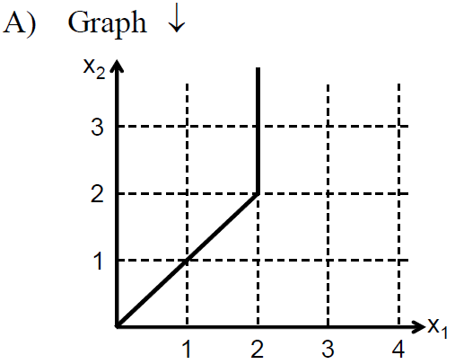 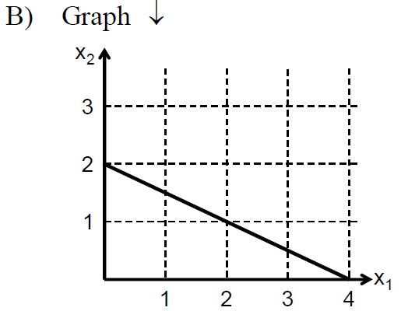

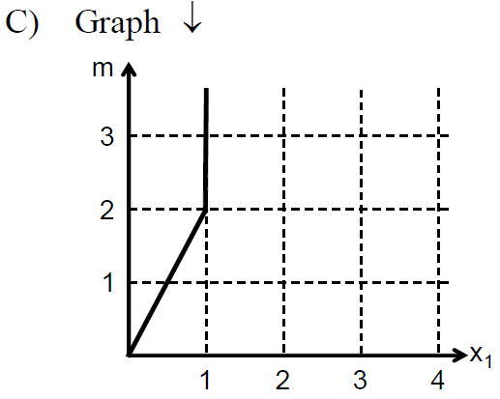 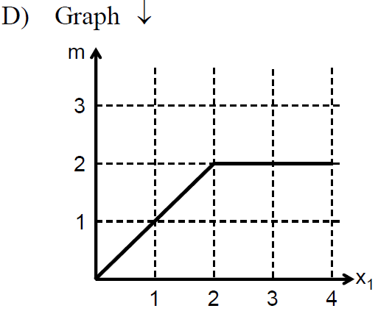

Answer: C

**Use the following information to answer question 19-20.**

**使用下列信息来回答19-20题。**

John’s utility function is $U\left(x_{1},x_{2}\right)=x_{1}x_{2}$. Every week he has 5 units of good 1 and 15 units of good 2 as endowment. He can buy or sell good 1 and good 2 at the prices $(p_{1}=1,p_{2}=1)$ in the market. He does not have any other income source. John regularly brings his endowment to market and trades to his optimal consumption bundle. One week, John brought his usual endowment to market only to learn that the price of good 1 had increased to $p_{1}^{'}=5$, while the price of good 2 remained at $p_{2}=1$.

琼恩的效用函数是 $U\left(x_{1},x_{2}\right)=x_{1}x_{2}$. 他每周都能得到5单位商品1和15单位商品2作为初始禀赋。他可以在市场上以 $(p_{1}=1,p_{2}=1)$ 的价格购买或出售商品，并没有其它的收入来源。琼恩每周都将禀赋商品组合交换成最优商品组合。有一周他发现商品1的价格上涨到 $p_{1}^{'}=5$，商品2的价格保持在 $p_{2}=1$ 没变。

1. Which of the following statements is correct about the substitution effect due to this price changes?

请问下面哪一个关于替代效应的陈述是正确的？

1. The substitution effect decreases the demand for good 1 by 1 unit (减少了1单位对于商品1的需求)
2. The substitution effect decreases the demand for good 1 by 3 units (减少了3单位对于商品1的需求)
3. The substitution effect increases the demand for good 2 by 10 units (增加了10单位对于商品2的需求)
4. The substitution effect increases the demand for good 2 by 20 units (增加了20单位对于商品2的需求)
5. Which of the following statements is correct about the endowment income effect due to this price change?

请问下面哪一个关于禀赋收入效应的陈述是正确的？

1. The endowment income effect increases the demand for good 1 by 2 units (增加了2单位对于商品1的需求)
2. The endowment income effect increases the demand for good 1 by 4 units (增加了4单位对于商品1的需求)
3. The endowment income effect increases the demand for good 1 by 10 units (增加了10单位对于商品1的需求)
4. The endowment income effect decreases the demand for good 2 by 10 units (减少了10单位对于商品2的需求)
5. Let ${(c}_{1},c_{2})$ be the amount of money that a consumer spends on consumption in periods 1 and 2, respectively. The consumer receives incomes denoted by ${(m}_{1},m_{2})$. The interest rate is r. Suppose the consumer was initially a saver. Which of the following statements is **FALSE** after the interest rate rises?

我们用 ${(c}_{1},c_{2})$ 来代表消费者在两个不同时期的消费金额，用 ${(m}_{1},m_{2})$ 来代表这一消费者在两个时期的收入，用r代表利率。如果该消费者在初始状态下是一个储蓄者，利率上升后，下面哪一项关于她的陈述是错误的？

1. The consumer may switch from a saver to a borrower (该消费者可能从一个储蓄者转变为一个借款者)
2. The consumer’s consumption in period 1, $c_{1}$, may increase (该消费者在第一期的消费金额可能增加)
3. The consumer’s consumption in period 1, $c_{1}$, may decrease (该消费者在第一期的消费金额可能减少)
4. The consumer’s welfare will increase (该消费者的福利将增加)
5. John consumes three commodities, $x_{1},x_{2},and x_{3}$. We have observed the following choices from him. When the prices $(p_{1},p_{2},p_{3})$ were $(1, 1, 2)$, the bundle $(x_{1},x_{2},x_{3})$ consumed by John was $(5, 19, 9)$; when the prices were $(1, 1, 1)$, the bundle consumed was $(12, 12, 12)$; when the prices were $(1, 2, 1)$, the bundle consumed was $(27, 11, 1)$. Which of the following statements is true about John’s behavior?

琼恩购买三种商品, $x_{1},x_{2},and x_{3}$. 通过观察得知他的消费记录如下：当价格 $(p_{1},p_{2},p_{3})$ 为 $(1, 1, 2)$ 时，琼恩购买的商品组合 $(x_{1},x_{2},x_{3})$ 为 $(5, 19, 9)$；当价格为 $(1, 1, 1)$ 时，他购买的商品组合为 $(12, 12, 12)$；当价格为 $(1, 2, 1)$ 时，他购买的商品组合为 $(27, 11, 1)$. 下列哪个选项是对琼恩消费行为的正确描述?

1. John’s behavior violates both WARP and SARP
2. John’s behavior does not violate WARP or SARP
3. John’s behavior violates WARP but does not violate SARP
4. John’s behavior violates SARP but does not violate WARP
5. Consider a market for coconuts. The government requires consumers to pay a quantity tax of $4 for each coconut they purchase and sellers to pay a quantity tax of $2 for each coconut they sell. The supply of coconuts is given by $S\left(p_{s}\right)=50p_{s}$, where $p_{s}$ is the real price received by suppliers. The demand for coconuts is given by $D\left(p_{d}\right)=1,500-100p_{d}$, where $p_{d}$ is the real price paid by buyers. How many coconuts will be traded in equilibrium?

我们来考查一个椰子市场。对于市场中所交易的每一单位椰子，政府要求消费者支付4美元的从量税，同时要求生产者支付2美元的从量税。椰子的市场供给函数为 $S\left(p_{s}\right)=50p_{s}$，这里的 $p_{s}$ 是扣税后生产者实际得到的椰子价格。椰子的市场需求函数为 $D\left(p_{d}\right)=1,500-100p_{d}$，这里的 $p_{d}$ 是付税后消费者实际支付的椰子价格。市场均衡时椰子的交易数量是多少个？

1. 300
2. 500
3. 700
4. 900
5. Let $p_{s}$ be the real price received by suppliers and $p_{d}$ be the real price paid by the buyers. Other things being equal, if the government increase the rate of the quantity tax imposed on traded goods, which of the following is **False**?

$p_{s}$ 是扣税后生产者实际得到的商品价格， $p_{d}$ 是付税后消费者实际支付的商品价格。其它条件不变，如果政府提高交易商品的从量税率，下面的哪一个说法是**错误**的？

1. $p_{d}$ increases ($p_{d}$ 上升)
2. $p_{s}$ decreases ($p_{s}$ 下降)
3. Deadweight loss increases (无谓损失增加)
4. The consumers’ tax incidence increases (消费者的税负分担比例上升)
5. Which of the following statements is **FALSE**? 下面的哪一表述是**错误**的？
6. Giffen goods must be income-inferior (吉芬商品一定是低档品)
7. Normal goods must be ordinary goods (正常商品一定是普通商品)
8. Income-inferior goods must be Giffen goods (低档品一定是吉芬商品)
9. Income-inferior goods may also be ordinary goods (低档品也可能是普通商品)
10. 简答计算题（共3题，40分）
11. Consider a case where utility is generated from two consumption goods, and U=U (x1, x2).

在本题中我们考虑从两种商品的消费中获得效用的情况，效用函数由U (x1, x2)表示。

1. State the relationship between the indifference curves and MRS. (1’) Use one sentence to explain the economic interpretation of MRS? (2’)

无差异曲线和MRS之间有什么关系？(1’) 用一句话解释MRS的经济学含义。(2’)

1. Derive MRS as a function of marginal utilities, MU1 and MU2. (3’)

推导MRS和边际效用MU1 、MU2之间的关系。(3’)

1. What is diminishing MRS? (1’) Explain its economic interpretation. (2’)

MRS递减的定义是什么？(1’) 如何理解MRS递减的经济学含义？(2’)

1. What is the definition of preference convexity? (2’) Use one sentence to explain its economic intuition? (1’)

凸偏好的定义什么？(2’) 用一句话解释凸偏好假设的经济含义。(1’)

1. A consumer receives an income of $m_{1}$ in period 1 and $m_{2}$ in period 2. There is only a single good, C, which has a price equal to one. The consumer’s utility function is defined over period 1 consumption, $c_{1}$, and period 2 consumption, $c_{2}$. It equals $U\left(c_{1},c_{2}\right)={1.1c}_{1}^{1/2}+c_{2}^{1/2}$. The consumer can freely borrow or save in period 1 at an interest rate, r.

消费者在第一期和第二期分别获得 $m_{1}$ 和 $m_{2}$ 数量的收入。他仅消费一种价格为1的商品，C。我们用c1和c2来分别表示该消费者在第一期和第二期的购买的商品数量。效用函数 $U\left(c_{1},c_{2}\right)={1.1c}_{1}^{1/2}+c_{2}^{1/2}$。该消费者可以r的利率在第一期借贷或储蓄。

1. Suppose $r=0.1$, $m_{1}=300$, and $m_{2}=110$. Write down the budget constraint equation. (2’) Draw the budget constraint in **solid line** on a graph where $c_{1}$ is measured on the horizontal axis and $c_{2}$ is measured on the vertical axis. Clearly indicate the slope and the endowment bundle. (2’)

假设 $r=0.1$, $m_{1}=300$, and $m_{2}=110$。请写出该消费者面临的预算约束方程。(2’) 在以 $c_{1}$ 为横轴、 $c_{2}$ 为纵轴的坐标图中用**实线**画出预算约束线，并清晰标示出斜率和初始禀赋点。(2’)

$$c_{1}+\frac{c_{2}}{1+r}=m_{1}+\frac{m_{2}}{1+r}$$

$$c_{1}+\frac{c_{2}}{1.1}=400$$

1. Suppose $r=0.1$, $m_{1}=300$, and $m_{2}=110$. Find the optimal consumption bundle for this consumer. (3’) Is this consumer a borrower or a saver? (1’)

假设 $r=0.1$, $m_{1}=300$, and $m_{2}=110$。该消费者在两期的最优消费量分别为多少？(3’) 该消费者是一个借款者还是一个储蓄者？(1’)

$$MRS=-\frac{\frac{1.1}{2\sqrt{c_{1}}}}{\frac{1}{2\sqrt{c_{2}}}}=-\frac{1.1\sqrt{c_{2}}}{\sqrt{c_{1}}}=-\left(1+r\right)=-1.1$$

$$c_{1}=c_{2}$$

$$c_{1}+\frac{c_{2}}{1.1}=c_{1}+\frac{c_{1}}{1.1}=\frac{21}{11}c_{1}=400$$

$$c_{1}=400*\frac{11}{21}=209.5=c_{2}$$

The consumer is a saver.

1. Other things being equal, suppose the interest rate goes up from 10% to 20%. Draw the new budget constraint in dashed line on the same graph that you have drawn for question 2(a). (2’)

假设其它条件不变，利率从10%上升到20%. 在你为2(a)所做的同一幅坐标图中，用**虚线**画出新的预算约束线。(2’)

1. Use a reveal preference argument and your results from 3(a)-3(c) to determine whether the consumer will be a saver or borrower in period 1 after the interest rate increases? (3’)

请基于显示偏好理论和2(a)-2(c)的结果来判断：当利率上升为20%后，该消费者在第1期是一个储蓄者还是借款者？(3’)

The consumer will remain a saver.

1. Use the rate of change version of the Slutsky equation to show how the consumer’s consumption in period 1, $c_{1}$, will change after a **decrease** in the interest rate. (4)

请基于变动率版本的斯勒茨基方程来判断利率**下降**后，该消费者在第1期的消费会怎样变化？

Slutsky equation (2’)

May increase or decrease / can’t determine (2’)

1. Our old friend, John Snow, has a utility function given by $U\left(x_{1},x_{2}\right)=min⁡\{2x_{1},x_{2}\}$, where $x_{1}$ and $x_{2}$ are the quantity of the two commodities consumed. His income is $40, and the prices are $\left(p_{1},p_{2}\right)=(2,1)$.

我们的老朋友，琼恩雪诺的效用函数为 $U\left(x_{1},x_{2}\right)=min⁡\{2x_{1},x_{2}\}$，这里的 $x_{1}$ 和 $x_{2}$ 是他所消费的两种商品的数量。琼恩的收入为40美金，两种商品的价格为 $\left(p_{1},p_{2}\right)=(2,1)$.

1. Calculate the utility-maximizing bundle for John. (3’)

请计算出使琼恩效用最大化的商品组合。(3’)

$$x_{2}=2x_{1}$$

$$p_{1}x_{1}+{p_{2}x}_{2}=m$$

$$x_{1}=\frac{m}{p_{1}+2p_{2}}, x_{2}=\frac{2m}{p_{1}+2p_{2}}$$

$$x_{1}=10, x_{2}=20$$

1. Suppose now the price of good 2 rises to $p_{2}^{'}=3$. What is the substitution effects of this change on the demand for good 1 and good 2? (4’)

从现在开始，商品2的价格上升为 $p_{2}^{'}=3$. 这一价格变化的替代效应会使得商品1和2的需求数量如何改变？(4’)

$$m'=80$$

$$x_{1}^{'}=10, x_{2}^{'}=20$$

Substitution effects are 0 for both.

1. Recall that the price of good 2 rises from $p_{2}=1$ to $p_{2}^{'}=3$. Calculate the compensating variation (CV) and equivalent variation (EV) of this change.

商品2的价格从1上升到3. 请计算这一价格变化对应的CV和EV各是多少？(4’)

Original bundle $(10,20)$, original utility = 20

An additional amount of income, CV, makes it just affordable under new prices.

$$x_{1}^{'}=\frac{40+CV}{8}, x_{2}^{'}=\frac{40+CV}{4}$$

$$u^{'}=\frac{40+CV}{4}=20$$

CV = $40

New bundle (5,10), new utility = 10

After paying an amount equal to EV:

$$x_{1}^{'}=\frac{40-EV}{4}, x_{2}^{'}=\frac{40-EV}{2}$$

$$u^{'}=\frac{40-EV}{2}=10$$

$$EV=\$20$$