Efficient B+ tree-based Data Storage in Object-based File System

Ohnmar Aung
University of Computer Studies, Yangon
ohnmaraung2008@gmail.com

Abstract
Being popular for managing data dynamically in today’s storage systems, fast data insertion, deletion and searching are also concerned with the system’s performance. Those criteria are heavily dependent on the way to handle the attributes of the algorithm used because it can determine how large as well as how much the system can hold data and throughput. B+ tree-based indexing algorithm is capable of scaling data logarithmically and so widely used in distributed file system. However, the level of the system’s scalability is solely associated with the order and height of the tree. The proposed system modifies the traditional B+ Tree in the form power of 2-based for data expansion and it is designed on object-based file system.

1. Introduction
A key requirement in distributed storage system includes high performance data storage and retrieval, data redundancy, resilience to disk failures and dynamic insertion of new storage space. RAID-based storage (Redundancy Arrays of Independence Disks) is now popular in distributed storage research area. Yet, limiting the object size to be placed( at least 64KB in Panasas and Lustre) lead to more scattering objects and complex index due to the fact that not all objects may come in the same size [2].
Capacity expansion requires the existing system to manage the extra disks for scaling as well. There must be enough system peripherals like CPU capacity as well as file system must scale to support the added data and meet the increased number of clients accessing those disks. To scale the system depends on how objects can be extended. The tools tailored to the system may promise to the desire level of performance.
The B+ tree is easy to implement for being balanced structure in which all path from root to the nodes are

same. Besides, the algorithm “B+ Tree” mostly used by the file system usually has been grown by splitting nodes (internal or leaf) in the tree and such expansion causes the tree level to be high. This results in frequent I/O operations to be taken much longer time throughout the whole process. Being raised more levels, system scales logarithmically and then storage’s useful capacity grows more slowly as it gets larger. Such natures are now being facing in those systems deploying tree-based approach for data storage, which becomes a major problem to be solved. This has resulted from increasing B+ Tree size associated with its order. Until now, there is no system based on B+ tree indexing structure with limited order and height for getting performance better. The more new resources are required to be added, the more complicated the workload for exercising equally or greater in proportion to the number of I/O events directed toward the contents of each targeted file to be found.
The proposed system stores files as objects in the form of B+ tree. In contrast with traditional tree, the order of the tree will grow based on power of 2-based expansion as the system needs. Contrary from those having unknown order and height approaches, the system can scale well over whenever resource demands and takes no longer than those found in nature from theoretical point of view. And it also can promises to the complexity not being higher than usual.
Popular file systems like NAS (Network Attached Storage) and SAN (Storage Area Network) has been encountered with bottlenecks like servers, I/O and even see difficulties during extending systems’ resources. The proposed system addresses the issue of scalability while simultaneously achieving high performance, balancing and availability through the use of OSD interface in which decoupled data and metadata, dynamic scalable distributed data management using B+ tree and achieving system’s throughput for fast data lookup and placement.
Section 2 describes about some related work in the current storage systems. The theoretical background used in the proposed system is explained in Section 3. The overview of the proposed system is described in Section 4. The discussion of the proposed system is concluded in Section 5.
2. Related Work
CRUSH [4] is based on four different bucket types, each with a different selecting algorithm to address data movement resulting from the addition or removal of devices and overall computational complexity. The algorithm distributes data objects among storage devices according to a per-device weight value, approximating a uniform probability distribution. The distribution is controlled by a hierarchical cluster map representing the available storage resources and composed of the logical elements from which it is built. Data is placed in the hierarchy by recursively selecting nested bucket items via pseudo-random hash-like function. In addition, the placement of replicas on storage devices in the hierarchy can also have a critical effect on data safety. Using the cluster map as a weighted hierarchical decision tree, the efficiency of CRUSH depends upon the depth of the storage hierarchy and on the types of buckets from which it is built. The system will get performance fluctuations with respect to the buckets specified.
One distributed network file system like Wofs[3] that splits a file into many small objects, stores these objects in remote file servers, and uses a special B+ tree to manage the metadata of these objects. Besides, it uses the object-range locking policy to avoid data incoherence and improve performance.
Gongye Zhou and his companions [5] proposed a B+ Tree Management Method of Object Attributes for Object-based Storage. That control storage attributes with two-level B+ tree structure: one for attributes index and another for object index.
None of the above systems consider limiting the order and height of B+ Tree .This becomes critical issue for system performance. The proposed system deeply takes into account “the order and height” of the tree for resource expansion and it also reduce unnecessary spaces whenever new ones are on demand. Besides, the system can promise the complexity due to frequent insertion and deletion not being higher than original B+ tree.
3. Background Theory
3.1 B+ Tree Data Storage

A B+ tree in certain aspects is a generalization of a binary search tree (BST). The main difference is that nodes of a B+ tree will point to many children nodes rather than being limited to only two found in simple B tree as shown in Figure 1. Having the tree branch in large amounts at each node, disk access time can be minimized for locating records that make the height of the multi-way search tree as small as possible. It is also a dynamic tree structure and thus, suitable for performing frequent nodes addition and deletion found in today’s large distributed storage system.
A simple B+ tree consists of one or more blocks of data, called nodes, linked together by pointers. Like many tree-based approach, it has three types of basic nodes: root, internal nodes and leaf. Internal nodes which are used as an index nodes that point to other nodes (child nodes) in the tree. Leaf nodes, also called data nodes maintain data page as well as pointer to neighboring nodes via doubly linked list. Data searching in the tree always starts at the root node and moves downwards until it reaches a leaf node. Both internal and leaf nodes contain key values that are used to guide the search for entries in the index. It is also a balanced tree due to the fact that every path from the root node to a leaf node has the same length. Major emphasis on B+ tree is to consider the order of the tree that makes how large it can be [6].
3.2 Basic I/O Operations in B+ Tree
For objects to be searching, insertion and deletion in B+ tree has particular features. Search in a B+ tree starts looking for its target in the root and advances through a path of internal nodes. B+ tree is always kept balanced by using node splitting or concatenating for the rebalancing needed due to operations of inserting new keys into the structure or deleting existing keys from it. The split and concatenate operations may propagate from the leaves up to the root.
New nodes can be created via insert operations based on some conditions like splitting of existing full node by self-balancing nature. The occurrences of node splitting due to increased resources are different from leaf node and those of parent node. Variations can be found in the followings: For a leaf node splitting, it takes two-step: firstly, it allocates new leaf and move half the bucket’s elements to
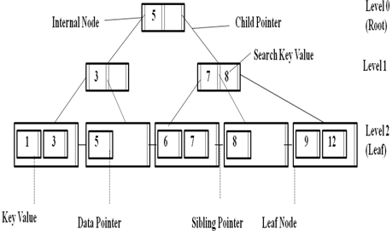
Figure 1: B+ Tree Data Structure

the new bucket. (The first node will contain the first half of the keys and the second node will contain the second half of the keys), and then finally, insert the new leaf’s smallest keys and address into the parent. As for a parent node to be separated, the process performs a little different. At the start, the search key values of P (parent node) and the new inserted key must still be distributed evenly among P and the new page introduced as a sibling of P. And, second and important case, the middle key is moved to the node above—notes that unlike splitting a leaf node where the middle key is copied and inserted into the parent, when it is split an internal node, the middle key is removed from the node being split and inserted into the parent node.
When a key is added to a full root, then the root splits into two and the middle key is promoted to become the new root. This is the only way for a B+ tree to increase in height—when split cascades the entire height of the tree from the leaf to the root. Whatever type of splitting, this can cause the tree level to be getting higher due to not having enough spaces. And also, complexity increase logarithmically in accordance with the tree depth. As a result, searching time can be much longer and this may not satisfy for large distributed storage system even for fulfilling a request [8].
4. Overview of the Proposed System
4.1 Object

Early storage systems based on block units which later overhead quickly mounts up since metadata server has to manage each individual blocks and also have limited intelligence. Again, storage trend moves data to be striped as files across multiple file servers. This requires that each
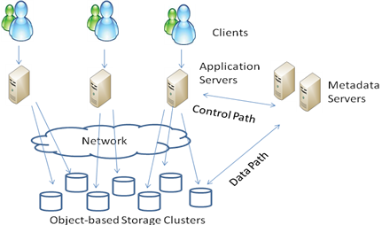
Figure 2: Architecture of the Object -based File System

of the file servers still act as both metadata and data storage for the files. A problem comes with metadata bottleneck resulting from scaling up the systems or if security is important.
Being found difficulties treating with both of files and blocks, a new approach is adopted in which files are broken into smaller chunks called objects which are identified by unique numbers rather than traditional path names. This simplifies and speeds accessing the objects. The proposed system is designed to store files as objects and allow the storage systems to scale performance and capacity in the same manner as compute clusters [1]. The architecture of the object-based file system is shown in figure 2.
4.2 Weight-based Allocation
Frequent data insertion and deletion can make the system different from the current state and it also requires the system to be load balance. Since B+ tree is self-balanced structure, which is suitable to weight-based object allocation for the proposed system. Accessing the object is only to use the object id which is calculated based on particular weights and locates where to place in the tree. All objects IDs in the proposed system are organized by a B+ tree. The object index is derived from the calculation of its weight. Therefore, a single attribute < object id> is supported as an index which points to the actual location of the object in the cluster. Since B+ tree consists of two types of nodes: internal nodes and leaf nodes. Internal points to other nodes in the tree whereas the leaf node points to actual data using data pointers. In addition, the leaf node also contains an additional pointer, called the sibling pointer, which is used to improve the efficiency of certain types of search [6].
Figure 3: (a) Object Allocation with Traditional B+ Tree,
(b) Object Allocation with Proposed B+ Tree

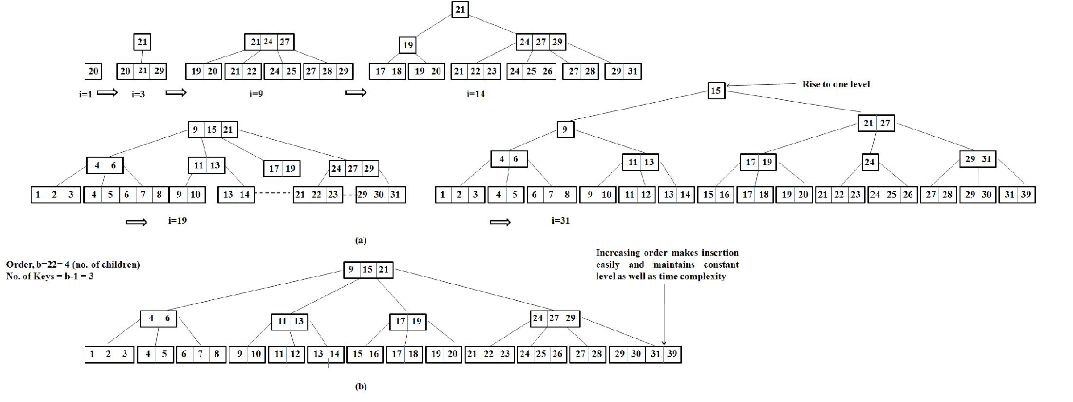

Figure 3: (a) Object Allocation with Traditional B+ Tree,
(b) Object Allocation with Proposed B+ Tree

The leaf node stores the actual address of the object and internal nodes points to the index of the child nodes which are allocated by their weight. The placement of the object with the proposed B+ tree is illustrated in the following section.
4.3 Scaling linearly with Power of 2-based Scheme
Scaling storage linearly seems somewhat counter-intuitive on the surface since it is so easy to simply purchase another set of disks to double the size of available storage [7]. Capacity expansion requires the existing system to mange those disks for scaling as well. There must be enough system peripherals like CPU capacity as well as file system must scale to support the added data and meet the increased number of clients accessing those disks.
The order, or branching factor b of a B+ tree measures the capacity of nodes (i.e. the number of children nodes) for internal nodes in the tree. The actual number of children for a node, referred to here as m, is constrained for internal nodes so that ┌ b/2 ┐ ≤ m ≤ b. The root is an exception: it is allowed to have as few as two children. For example, if the order of a B+ tree is 7, each internal node (except for the root) may have between 4 and 7. Leaf nodes have no children, but are constrained so that the number of keys must be at least └ b/2┘ and at most b − 1. In the situation where a B+ tree is nearly empty, it only contains one node, which is a leaf node [8].
Traditional B+ algorithm expands tree by making one level up. The performance of the algorithm depends upon the depth of the tree. The systems which used B+ tree can scale linearly based on the depth. Contrary from this, the proposed system is designed to scale by making fixed height and grows linearly depending upon the order of the tree. This can maintain the complexity at constant level.
4.4 Proposed B+ Tree
As for data insertion in the existing media, the traditional B+ tree can take at least two steps (levels) for initial and then, the tree gets longer and longer as the number of stored item increased. No one can tell how large the tree depth and can result in delaying access time.

Table 1. Proposed B+ Tree-based Data Insertion Algorithm
Insertion
Step 1: Perform a search to determine what bucket the new record should go into.

Step 2: If the bucket is not full, add the record.
Otherwise, split the bucket.
Allocate new leaf and move half the bucket’s elements to the new bucket.
Insert the new leaf’s smallest key and address into the parent.

Step 3: If the parent is full, check whether high is within range.
If high is ok, split it too.
Add the middle key to the parent node
Repeat until a parent is found that need not split.
If the root splits, create a new root which has one key and two pointers.
If high is not ok, promote the value of order. Go to Step 2.

In afford to reduce the load traffic resulting from large data traversing; the proposed system makes little changes to the original tree to be getting better performance. Since objects of the proposed system are arranged by their weight, it must be needed to know which object in the present system has the nearest value to the new object to place. Step 1 is taken new object into account for searching nearest neighborhood. The second step of the algorithm is not different from the original view. The bucket found in the previous step is checked whether it is full or not. If the condition is “ok” (not full), data is only placed. Otherwise, bucket separation is performed and new leaf’s smallest key is addressed into the parent node. After passing two steps, the next one is only considered for increasing order of the parent node which is a major contribution of the proposed system for achieving high data available and removing unnecessary network traffic for frequent data insertion and searching time. In those cases experienced in the former B+ Tree, parent nodes is also split again and creates new keys and cause the tree level high. This can be searching time further and further in parallel with the node number increased. The proposed B+ Tree simplifies it by only raising the tree order according to power of 2-based form. Having increased the

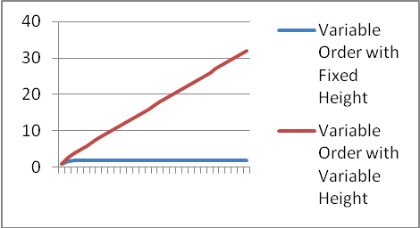
Figure 4: Complexities Comparison of Traditional B+ Tree and Proposed Approach

order by 2 power, much more parent nodes as well as child nodes can be handled and also the time complexity remains stable.
4.5 Resource Expansion with Proposed B+ Tree
Beginning from the base 2 of the order (b), there must be at most one search key value (b-1) and two child pointer (b<=n<=b) for each internal node as well as the root node. When new objects are requested to be stored, the tree requires expanding. However, node allocation starting from 2¹ is too short to be explained and thus, it will be more clear in the example with 2² of the order value.
Therefore, it raised the order by power of 2-based form and now, the order value becomes 2² (b=4) and the number of children grows up to 4 whereas 3 for search key value in each internal node.
Number of Objects
As shown in Figure 3(a), input sequences (i=1 to 31 times for example) comes 20, 29, 21... Etc at random and they are stored in the tree by ordering of their weights. When input count reaches to the certain value ( e.g i=3, 14 and 31) that exceeds the level or number of children restricted for each node to handle, the next data insertion will cause splitting the existing node and creates one level up by forming new root. Traditional B+ tree is kept self-balancing (all path from the root to the leaf is same) rising the depth of the tree. This last longer searching time and access time for both of next insertion and deletion data will suffer from it. Node may be between b/2 and at most b like in the usual B+ tree. As for high, there must be at most 2 for the whole tree and no level improvement is allowed. Only the value of the order can be promoted up to power of 2-based for resource expansion. The reason for this is the following: In ordinary B+ tree model, if b is threshold for each node to have, then adding new recordwhich exceeds the specified threshold makes node splitting in two conditions, either of parents or child node. Regular splitting of those two nodes is explained in Section 3.2. Instead of splitting parent node, increasing the order size can be the level of complexity constant and no high is raised. For input count i=31, depth of the tree becomes upper one level
4.6 Theoretical Complexities
Figure 4 shows the average time complexity for basic I/O operations like insertion, deletion and retrieving objects within a tree over ordinary variable depth versus the proposed fixed two level hierarchies. B+ tree performance is logarithmic with respect to the number of height. The vertical line represents the value of complexity whereas level, B+ tree scale as O(log_{b} n)- linearly with the hierarchy depth. When and where fixed level is defined, there is a slight performance advantage over normal range. The total time complexity of the tree takes O(log_{b} n) in general for b (order) of the tree with h (level) index. When increasing height, the depth becomes longer and it is taken time complexity more complicated.
The upper line that rose exponentially shows the results of value settings at variable order (increasing with power of 2-based form: b=2¹,2², 2³,…,2^{n}) with variable height (one level increases whenever there is node splitting occurred) and it is shown that the algorithm complexity becomes higher and higher as the level increases. Different from those, the lower line remained stable proves that variable order (based on power of 2) with fixed height (up most two level hierarchy) can maintain the complexity constant. Whatever the order value changes, the proposed system complexity remain steady by handling with fixed height.
5. Conclusion
Distributed storage systems present a variety ways of scalable challenges for data allocation. B+ Tree is suitable for dynamic data allocation except for having the issues of handling with the order and the height. The proposed system overcomes these barriers by limiting the order and height of the B+ tree for data expansion. And object allocation is weighted by their sizes and this can match with the nature of B+ tree. The proposed approach can perform better than traditional B+ tree for efficient data insertion and deletion. It is shown that the modified B+ tree data storage hierarchy can maintain total time complexity of the algorithm stable.
6. References
[1]. Harris, R. Parallel NFS: Finally, NFS Optimized for Clusters, 2007.
[2]. Parissis, G, Apostolopoulos, T, A distributed hash table-based approach for providing a file system neutral, robust and resilient storage infrastructure, 2009.
[3]. Wang, C.C and Hsu, Y. Wofs: A Distributed Network File System Supporting Fast Data Insertion and Truncation, 2010.
[4]. Weil, S.A, Brant, S.A, Miller, E. L, Long, D. D. E, and Maltzang, C. CRUSH : Controlled, Scalable, Decentralized Placement of Replicated Data, 2006.
[5]. Zhou, G., Yuan, L. and Chen, J. B+ Tree Management Method of Object Attributes for Object-Based Storage, 2007.
[6].http://www.mec.ac.in/resources/notes/notes/ds/bplus.htm
[7]. www.gluster.com
[8]. http://www.wikipedia.bplus.html

