Association rule learning:

* People who bought also bought something else
* People who did also did something else
* People who watch this also watch that etc

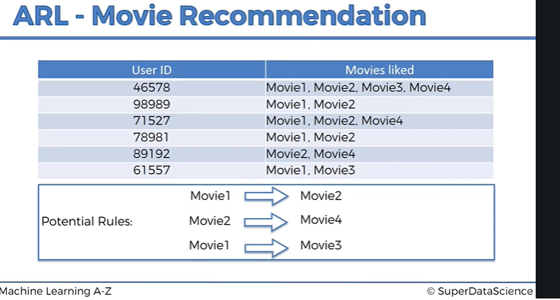

So this technique can be used to gather recommendation to users based on a strong rule.

Apriori technique:

Step 1

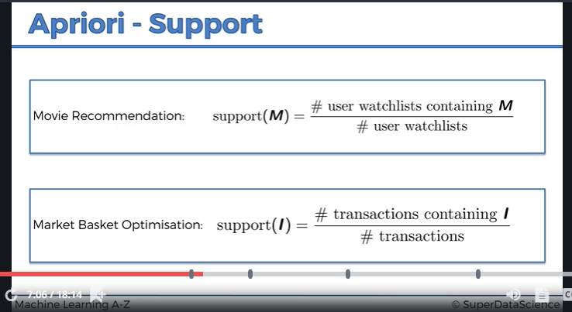

Step 2

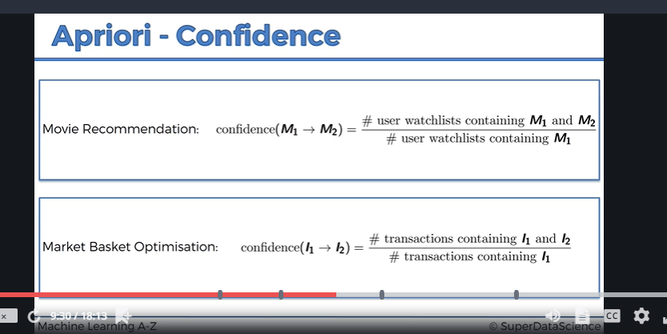

Step 3:

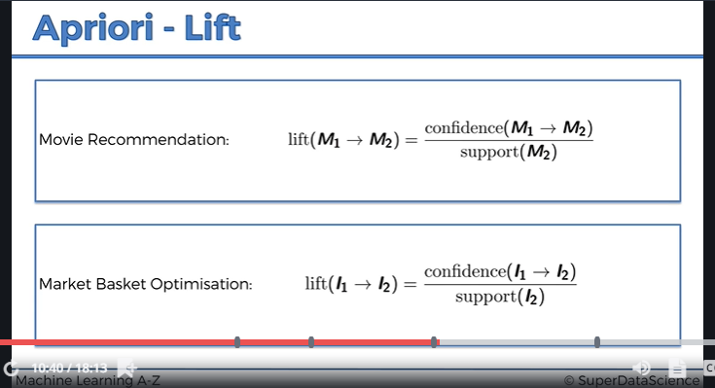

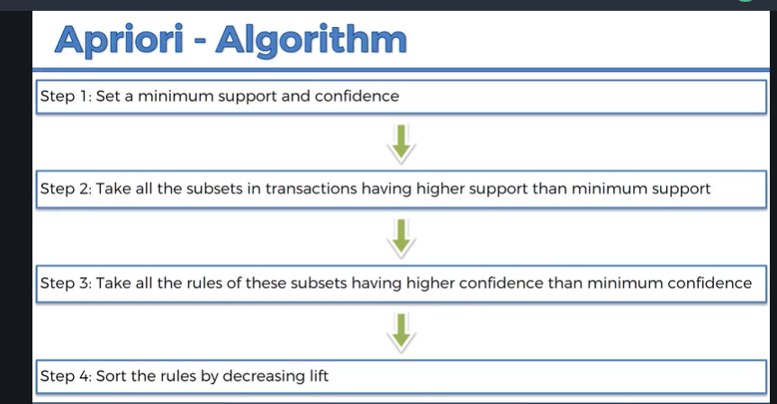

\*\* minimum support means you might not want to include support that is less than 20% so that you won’t have too large combination sample