Eclat

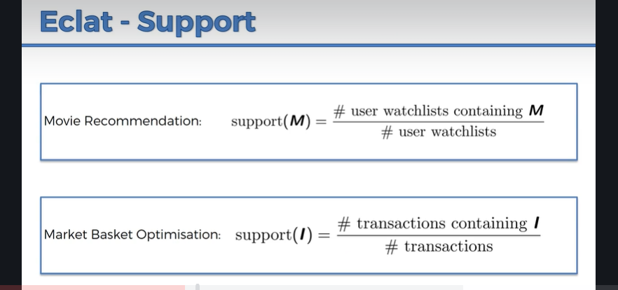

Basically, it is the same as Apriori, but it only looks at support, where M and I are set of items instead of just one item, eg how frequent this set of items shows in user watchlists

