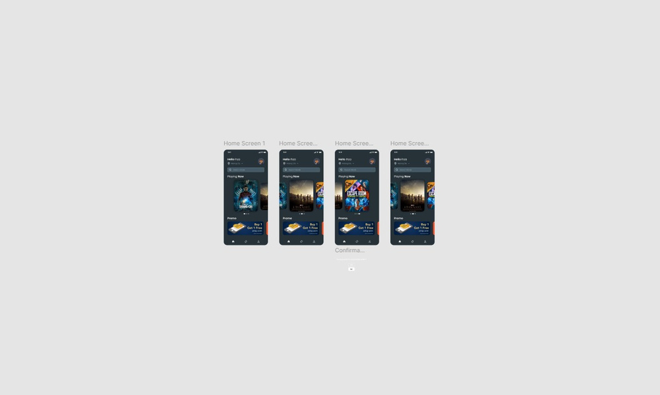

**before**

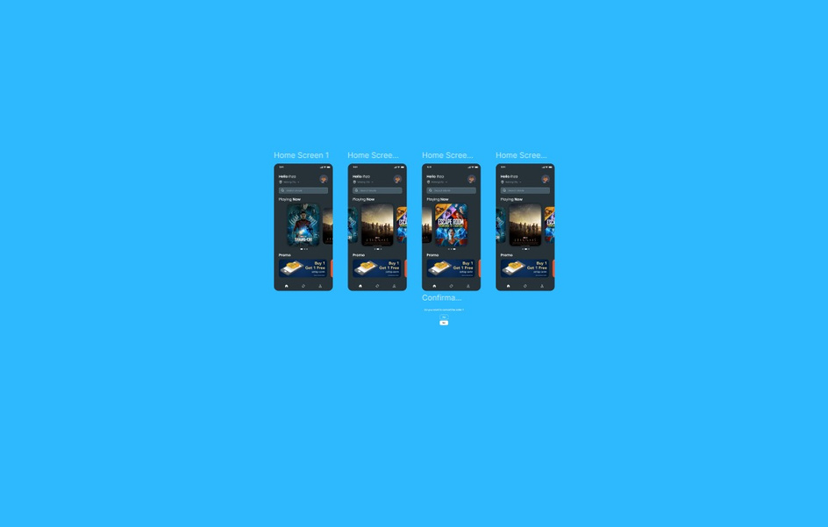

**after**

**background change**

**Aim:**   
To create an app that helps redesign the contact page of a design agency’s website, making it more user-friendly and intuitive for visitors to get in touch.

**Procedure:**

1. **Identify Key Features for the Contact Page:**
   * **Simple Contact Form:** Reduce the number of fields to essential information (Name, Email, Message, and a dropdown to select inquiry type like "Project Inquiry", "General Question", "Support").
   * **Interactive Map:** Add a location map (e.g., Google Maps) to show the agency's office location.
   * **Instant Communication:** Include chat or messaging options like a live chat feature or chatbots for immediate responses.
   * **Multiple Contact Methods:** Provide email, phone number, and social media links clearly, with icons.
   * **FAQ Section:** Provide quick links to common questions or answers before contacting the agency.
2. **Design UI/UX:**
   * **Minimalist Layout:** Use clear sections with a clean design. The form should be easy to find with prominent call-to-action buttons ("Send Message", "Start Chat").
   * **Responsive Design:** Ensure the layout is optimized for both desktop and mobile devices.
   * **Clear Visual Hierarchy:** Use headings and subheadings to distinguish different contact methods (e.g., "Get in Touch", "Location", "Social Media").
   * **Consistent Branding:** Use the agency’s branding colors, typography, and logos to maintain visual identity.
3. **Choose Development Tools:**
   * **For iOS:** Use Swift with UIKit or SwiftUI for modern, responsive design.
   * **For Android:** Use Kotlin and Material Design components for a streamlined experience.
   * **Backend Integration:** Connect the form with a backend service to handle submissions, such as Firebase or a server-side email handler.
4. **Develop the App:**
   * Build the contact page with form fields, integration with Google Maps for location, and live chat functionality.
   * Include a button that automatically opens the user’s email app to send an email, or integrate an API to send messages directly from the app.
5. **Testing:**
   * Test for bugs and ensure smooth navigation on both mobile and desktop views. Ensure form submissions are processed correctly.
   * Check chat functionality and responsiveness of the contact form.
6. **Launch:**
   * Deploy the redesigned contact page in the app after final testing.

**Result:**   
A user-friendly contact page within the app where visitors can quickly fill out a simplified form, access the agency’s location on a map, initiate live chats for real-time queries, and easily find alternative contact methods like email and social media links. The page is responsive, easy to navigate, and visually appealing, offering a streamlined communication experience.