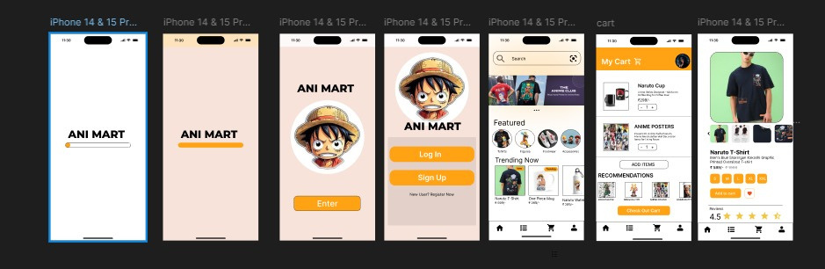

**animart**

1. **Analysis**

* **Goal**: Create an app for buying and selling animation art.
* **Users**:
  + Artists who sell their animations.
  + Buyers who collect animations.
* **Needs**: Easy browsing, smooth purchase process, and secure transactions.
* **Features**: User accounts, browsing, searching, purchase, and artist profiles.

2. **Ideation**

* **Home Screen**: Show featured animations and categories.
* **Navigation**: Simple menu for browsing, profile, and shopping cart.
* **Search**: Filters for animation style, price, and artist.
* **User Flow**: Sign up → Browse → View animation → Add to cart → Checkout.
* **Wireframes**: Sketch simple page layouts for each section.

3. **Modeling**

* **Prototype**: Create interactive mockups in tools like Figma or Adobe XD.
* **Test**: Run usability tests to improve the design based on user feedback.

Result

* **Final Design**: A clean, simple app with easy navigation, visually appealing animation displays, and a smooth buying process.