Appendix
Table of Contents
Appendix A.1 2
Appendix A.2 3
Appendix A.3 4
Appendix A.4 6
Appendix B.1 8
Appendix E.1 9

Appendix A.1
Interview with client to discuss the problem (before creation of solution)

- Interviewer (Me):
Hello Mr.XYZ, if you don’t mind, I would like to ask a few questions to you regarding your current circumstance. Why would you like to shift your records procedure to a technological approach?

- Interviewee (Mr.XYZ):
We had started our business here 3 years ago and had become quite popular with the community around us in the last couple of months. As we started to receive more customers, we started to find difficulties on tracking the inventory of our business. Oftentimes during popular times, writing the list of transactions on a book were taking long and we couldn’t keep track. Because of this, the staff and I came to an agreement to shift to a technological approach of utilising an application to make tracking inventory easier and faster.

- Interviewer (Me):
That makes sense, since to cope with increased customers, as a business, we also need to change our factors of production
Thank you Mr.XYZ, I will take this initial information, understand the required abilities for coding and come back to you.

- Interviewee (Mr.XYZ):
No problem, thank you for discussing with me.

Appendix A.2
Discussion with supervisor Ms.ABC about the problem
- Me:
Hello Ms.ABC, I approached my client Mr.XYZ a few days ago and I would like to ask if you could allow me to proceed to work on Mr.XYZ’s problem. My client is a small store owner who’s customer and sales are rapidly increasing. Due to this, he needs to upgrade to a technological method to keep track of the inventory of his store.

- Computer Science Teacher Ms.ABC:
Hello, of course you can work on Mr. XYZ’s problem as part of your assessment. Though, before I do grant permission, could you please let me know the technical skills and ideas for this inventory management product? It is important that you do have the sufficient knowledge to create the product.

- Me:
I will be utilising Java and the MySQL database to design the product for Mr. XYZ, where I will use Java NetBeans IDE to design the user interface and use the MYSQL database to keep updated information in a safe place. The main reason for using Java is because it has fast execution speeds and is portable.

- Computer Science Teacher Ms.ABC:
It seems to me you have a clear idea and method in which you will pursue and tackle the problem. You can proceed with the solution and let me know if you ever need help or advice as I am ready to help.

- Me:
Thank you Ms.ABC.

Appendix A.3
2nd Interview with client Mr.XYZ
- Interviewer (Me)
Hello Mr.XYZ, thank you for scheduling a time with me. If possible could you please state some general requirements you would like to see in the application?
- Interviewee (Mr.XYZ)
I would like to keep it online where all data is saved on the internet.
- Interviewer (Me)
Sir, do we need to have the application and the data connected to the internet? As the business is still a small scale with one store despite the rapid growth rate, we can keep the data internally. Moreover, keeping the data on the cloud could be a threat as there isn’t much security.
- Interviewee (Mr.XYZ)
That is a good point you bring up, I had initially though it would be good to have data backed up on the internet in case the hardware data gets affected. I guess we don’t need to keep it then if it could be a threat for us. Continuing with the idea of threat and security, if it is possible, I would like to know if there is any threat that is to happen or any mismanagement of the application.

- Interviewer (Me):
Yes Mr.XYZ, with the current situation, I believe it is best for us to keep it offline and within the computer. With the next point, we can certainly create an email functionality to alert the administrator if any login attempts are made consecutively. Moreover, we can try keep logs of the use of the application to observe any mismanagement. But, other than that Mr.XYZ, I would like to continue by asking what functionalities are you specifically looking for in the application?
- Interviewee (Mr.XYZ):
Thank you so much! That will help provide a more security and surveillance for the application.
The two specific components I would like to have in the application is a page to list the inflow of goods into the store and another page for being able to list the outflow of goods. Due to our growth and expansion in business, I believe we need separate accounts for staff since we have a decent number of rotating staff. So, a way to have multiple accounts would be appropriate for this application. Then moving onwards, I would also like to know the quantity of each good left and the details of each transaction as well. I think this would be the fundamental components required for the application to be effective and make it easy to monitor inventory. For increased security, I would like to have an alert system or something in similar to the idea as it would significantly affect our daily work if the data is altered.

- Interviewer (Me):
Thank you for the detailed specifications Mr.XYZ. If it is possible, could we discuss the other critical functions you would like in your application in another session? Using this information, I can create an application that is tailored to how you would like it.
- Interviewee (Mr.XYZ):
For sure. I will come up with some other functions which I would like to have till the next session we have.
- Interviewer (Me):
Thank you so much for your time Mr.XYZ!
- Interviewee (Mr.XYZ):
Thank you.

Appendix A.4
Discussing the main functionalities of the product
- Interviewer (Me)
Hello Mr.XYZ, were you able to come up with the additional functions you would like to have in the product?
- Interviewee (Mr.XYZ)
Yes, I was able to come up with some main ones. With the functions I stated in the previous session where:
- an account for each staff member
- a way to list inflow and outflow of goods
- display the quantity for each good
- details for each transaction
- alert system for any system breach
I would like to also add some similar to these where I would like to have: an editing function for each transaction in case they write an incorrect information, a low quantity alert system to alert the staff to restock those goods, a simple password change function for the staff, and finally a way to add, edit, and delete products, with a way to view the products.
- Interviewer (Me)
Thank you, sir, for taking your time. I believe we can implement all these functions into the product. To keep the data of the system secure, I will proceed and use a MySQL database to store all the information. It will be helpful to you sir as it is portable and can be transferred between devices easily without problem.
- Interviewee (Mr.XYZ)
That’s good to hear. If the method or place where the data is stored is secure, then it is fine with me. The focus for me is if the application and data is secure and safe. If it follows this point, then I do not mind it.
- Interviewer (Me)
Thank you Mr.XYZ. I will implement all of these criterions and provide you prototypes to look at in a bit.
- Interviewee (Mr.XYZ)
Thank you.

Appendix B.1
Showing prototypes of the product to the client (E-mail)
- Me:
Hello Mr.XYZ, hope you are having a good day! According to your choice, I have made the prototype for the product, please let me know how it looks!
Sincerely.
- Client (Mr.XYZ)
Hello, thank you for presenting the prototype. I really like the features that you have built into the tabs since it is really simplistic. However, it is difficult to read the words on the login, register and forgot password tabs. Is it possible if you could alter the colour and show it to me?
- Me:
For sure Mr.XYZ, is this a better combination?
Previous Design:
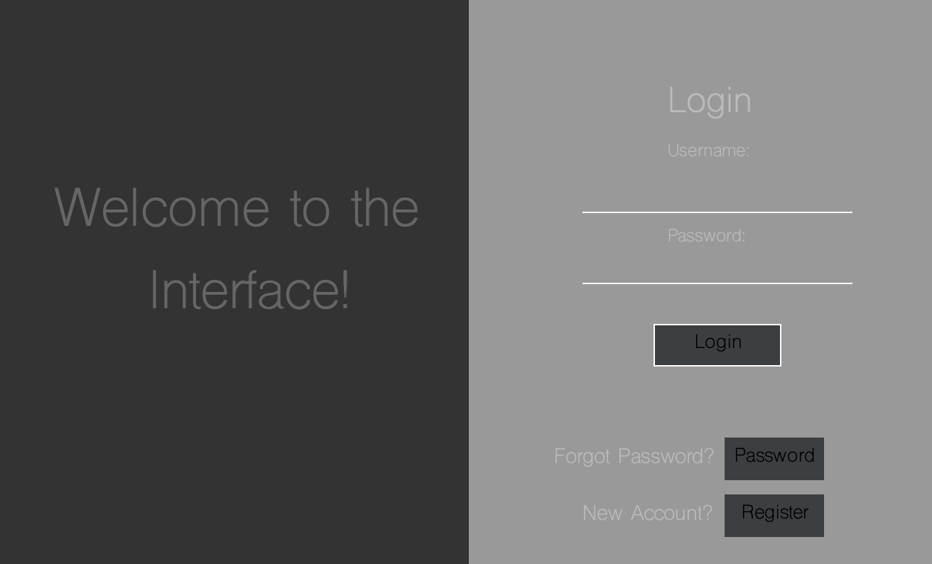
Updated Design:
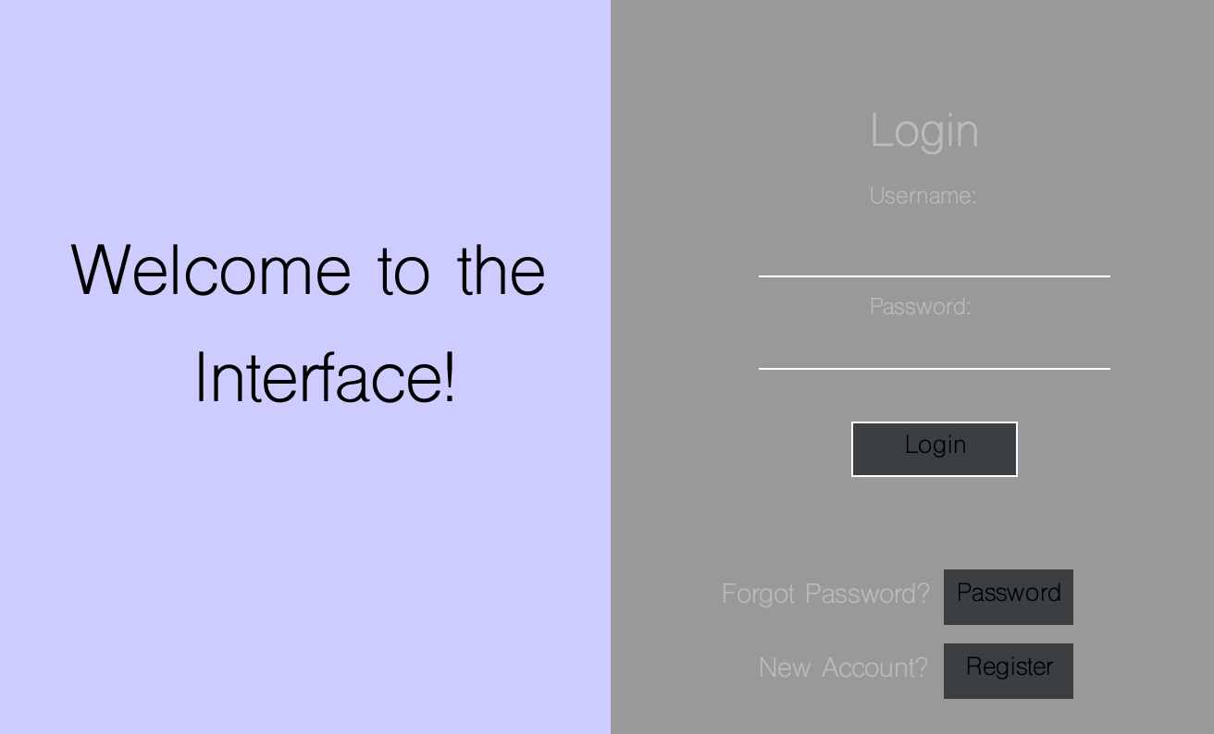
- Client (Mr.XYZ)
Yes, it is a much better combination. Please utilise this for the product for the three tabs.
- Me:
Will do Mr.XYZ, thank you so much for the feedback.

Appendix E.1
Client Feedback
- Me:
Hello Mr.XYZ, hope you are having a good day. I would like to discuss with you on your and your staff’s experiences with the “Streamliner” product. If you could, could you please tell me brief feedback based on the specifications. and any improvements that you would like to mention?
- Mr.XYZ
Hello. For sure I can help you with that. I will comment on the specifications in the order.
- For the first one, I would say the system is fast and can respond quickly to submission, making it quite effective.
- The list to add inflow and outflow of goods is simplistic and easy to use, hence easy when large transactions are made.
- It is good to see that all data is stored in a safe secure database to prevent any unknown access.
- Then, the product adding, editing and deleting method is efficient.
- I really like the table format and the search capability for the transaction list. It is really effective.
- The delete transaction method is simple and easy. I am happy that you added the extra feature of having a timestamp for the transaction so the staff can locate and edit much faster if needed.
- The alert system was fast and the log files were easy to understand what error happened.
- I feel the layout was effective for displaying the quantities of each good
- I also liked the idea that the low quantity items were in the home page and also highlighted in the product page. Good placement.
- Finally, the method to change the password was really easy and I also liked the logins were also timestamped. Really secure.
- Me:
Thank you so much sir. Could you also let me know the general outlook of the product?
- Mr.XYZ
Sure. I really liked the system. I feel like it will make our jobs become much easier and our work also more efficient. It is really fast, simple to understand and I think it will decrease the time for each customer order to be done, which means we can churn out more orders quickly in a day. I am pleased with Streamliner as it fulfils all the specifications that I wanted in the product. However, for the future, I would like to have some extra features such as a sales monitor which calculates the revenue & loss as well as a confirmation button because there might be accidental deletion or addition of products and transactions. This could cause some challenges to recover them. Otherwise, I am happy to have the system. Thank you so much for creating it.
- Me:
Thank you, sir, for the feedback. I really appreciated and enjoyed creating this product for you and I am happy to see it is in good use and efficient in solving the problem.

