**Task Explanation: Create a simple FreeStyle Job To Install Nginx on your server (tools:jenkins, ubuntu vm)**

**1.Installing nginx in ubuntu through jenkins**

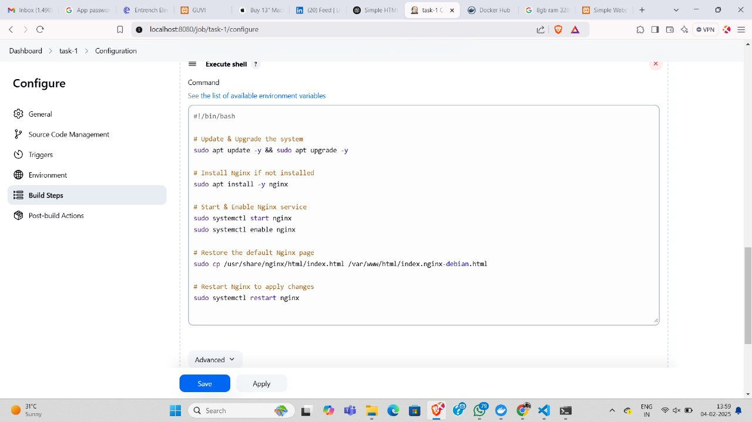

**2.Output in console**

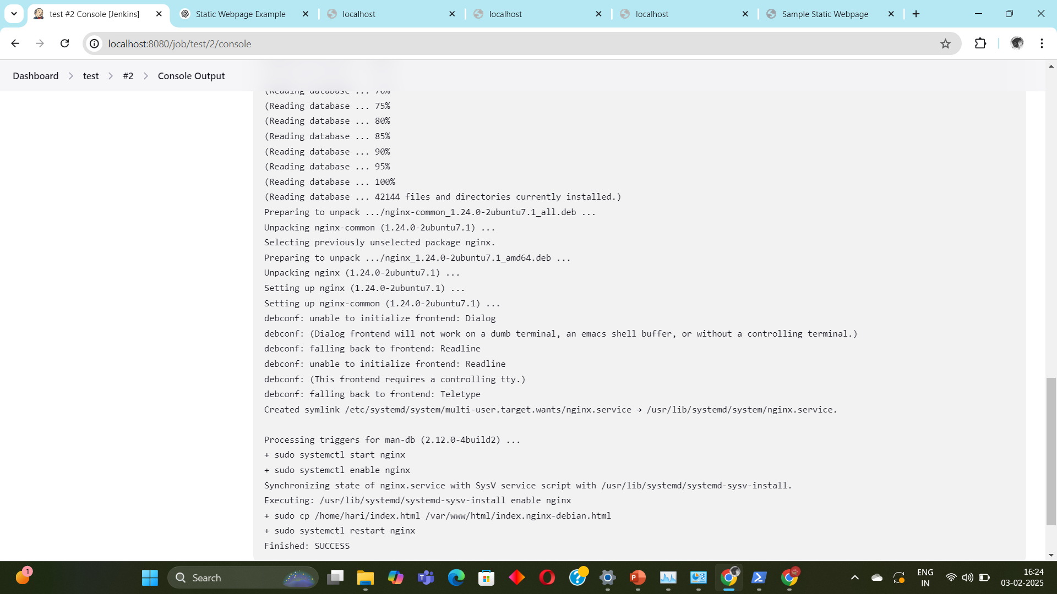

3.**Output in chrome**

