Alg. 7

* Need to find the relative frequency and word commonality
* Use functions
* Classes/ objected oriented programming not needed
* Ask user if they want to use ngram viewer or quit
  + 1 or 2
  + Try and except
* For all_words.csv
  + Each line is how often the word is used and how many books it came out of
  + Last value does not matter (skip)
* For total_count.csv
  + Each line is the year and how many times a word occurred in the literature
* Relative frequency formula
  + Amount of times word used in a year/the total words in the year
  + Times by 100 after
* Get user input
  + Ask for what word needs to be searched for
    - What word do you want to get the frequencies from:
  + Ask for starting year
    - Must be between 1505 and 2008
    - Must be an integer
      * Int(input
    - Must have range from only the start year to 2008 (ex. User inputs 1900 so it must be from 1900 – 2008 or from start-end date)
    - Try and except
  + Ask for ending year
    - Must be between 1505 and 2008
    - Must be an integer
      * Int(input
    - (ex. User inputs 1900 so it must be from 1900 – 2008, or from start- end date)
      * Try and except
* Display results in a table
* 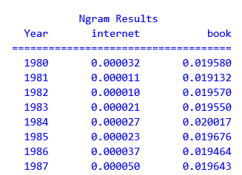Use Ngram Viewer
  + Table to show output of data to user
  + Three columns
    - Year
    - Word1 with frequencies
    - Word2 with frequencies
* Import csv module
* Open file
  + File=open(‘all_words.csv’)
  + Csv_file = csv.reader(file)
* Get list of strings for each line
  + For line in csv_file:
  + Print(line)
  + File.close()
* Possible functions to use from prior programs (maybe)
  + Relative frequency and word commonality

