Everything

**Important Dates**

1. SILab Workshop: Jan 31, 2025 4:00 PM
2. Presentation: Feb 22, 2025 12:00 PM

SILab Schedule

Monday to Thursday: 12 PM to 10 PM

Friday to Sunday: 12 PM to 6 PM

Safety Schedule

Mon: 5-6 PM Tues: 5-6 PM, 8-9 PM Wed: 8-9 PM

Thurs: 5-6 PM Sat: 1-2 PM Sun: 1-2 PM

**Main Components**

1. Redstone Torch
2. Platform
3. Redstone Dust
4. Redstone Lamp
5. Piston

**Materials**

1. Lorem ipsum

**Electronics**

1. Lorem ipsum

**To Do List**

1. Lorem ipsum

**Links**

<https://www.bu.edu/eng/academics/teaching-and-innovation/singh-imagineering-lab-silab/competitions/lutron-lighting-competition/>

Order: <https://www.amazon.com/> or <https://www.mcmaster.com/>

Questions

Torch

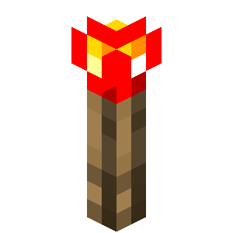

**Dimensions**: TBD

**Materials**: TBD

**Concept**: Red LED(s) on top; opening on bottom, once connected to the torch platform, complets all circuits, torch lights up

**Components**

1. LEDs, resistors, and wire
2. Snap connectors to complete circuit once torch is placed on the of the torch platform

**Materials**

1. 2/3 of the bottom is colored brown/potentially wood or acrylic
2. 1/3 of the top is red acrylic to shine LED through

Platform

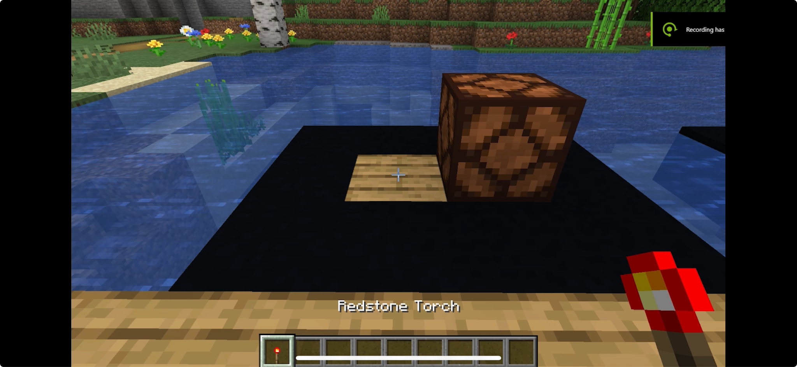

**Dimensions**: TBD

**Materials**: TBD

**Concept**: The center of the top face of the torch platform has an opening atop which you place the torch to complete the entire circuitry. The remaining space is used to complete the circuitry.

**Components**

1. Snap connectors to complete circuit once torch is inserted

**Materials**

1. Same material as the bottom of our torch?

Redstone Dust

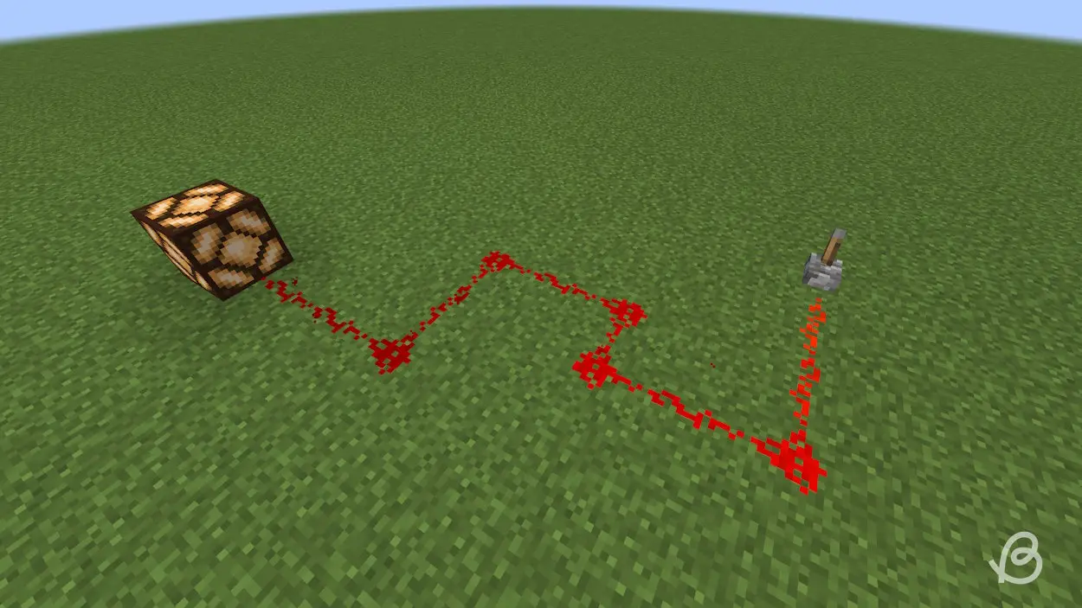

**Dimensions**: TBD

**Materials**: Bottom is red plastic (3D printed), top is red acrylic

**Concept**: The redstone dust works as a bridge between the torch platform and either the a) redstone lamp or the b) piston. It includes the wires from the torch platform and has a line of red leds that light up once the entire circuit is complete (torch is placed on the platform).

**Components**

1. LEDs spread throughout the platform
2. Wires to connect between the torch platform and the a) lamp or b) piston

**Materials**

1. Plastic
2. Acrylic

Lamp

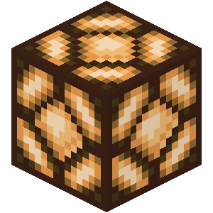

**Dimensions**: 5 “ by 5 “

**Materials**: TBD

**Concept**: Houses the battery, motor driver, largest lighting source

**Components**

1. TBD

**Materials**

1. TBD

Piston



**Dimensions**: 5“ by 5“, top extension box is ~¼ so ~1.25”, bottom box is ~¾ so 3.75”, the extension arm will be ~ x” so the top box can be raised up by ~ x”

**Materials**: TBD

**Concept**: If the torch is placed atop its platform, the piston shoots up and stays up so long as the torch is on the platform. The piston will also go up if the attached lever is moved up, and remains there till pulled down.

**Components**

1. Houses the servo, arduino, battery?, switch, wires

**Materials**

1. TBD

Lever

