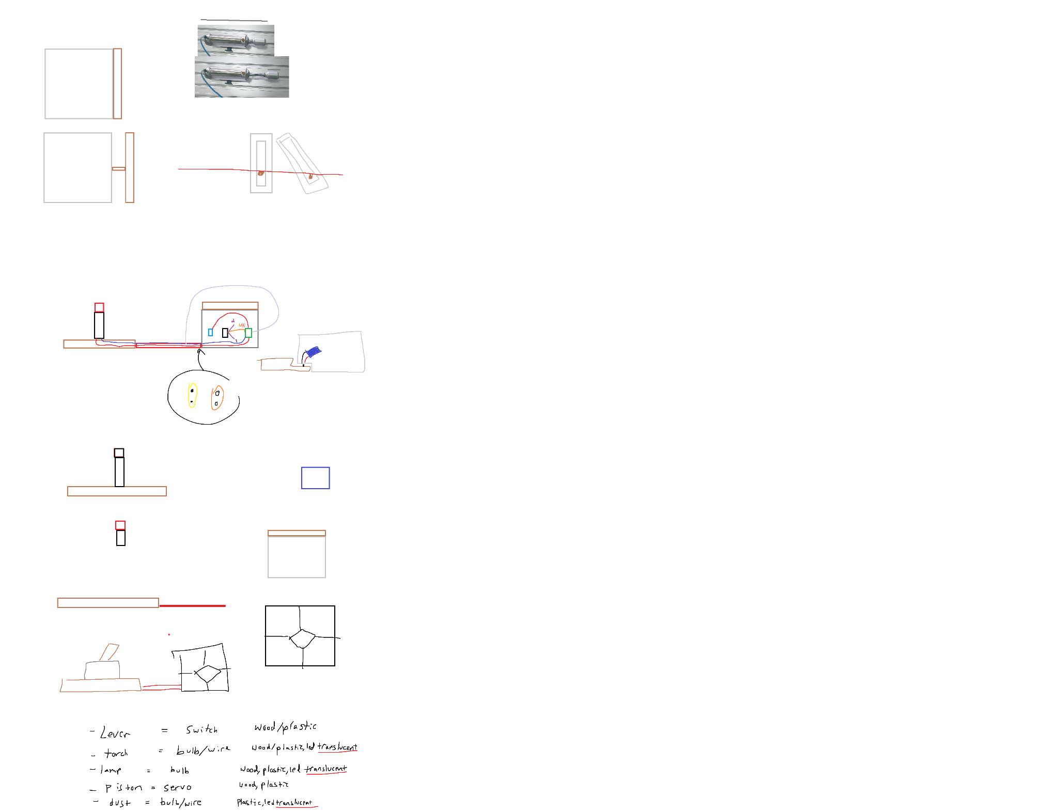







<https://www.tinkercad.com/things/8XH1GuTjRkR-spectacular-wluff-jaban>

| Oak Slab (wire channel) | Redstone Torch/Wire | Lever | Redstone dust/wire | Redstone Lamp/Bulb | Piston/Servo |
| --- | --- | --- | --- | --- | --- |
| Lasercut mdf | Acrylic transparent red? | Lasercut mdf | Acrylic transparent red paint | Acrylic transparent clear/beige/yellow | Lasercut mdf frame |
| Wires soldered | wires | plastic | Led bulbs spaced | Laser Cut mdf frame | servo |
| paint | Led bulb | connector | connector | battery | arduino |
| connector | Wood frame |  |  | Bright led bulb | battery |
|  | connecto |  |  | connector | connectors |
|  |  |  |  |  | 3d printed mechanism: rack and pinion or |
|  |  |  |  |  | Sturdy block with internal mechanism |

Oak Slab (wire channel)

Laser Cut mdf

Wires soldered

Redstone Torch/Wire

Redstone Lamp/Bulb

Piston/Servo

Redstone Dust/Wire