Web Site Slide Show ( WSSS )

WSSS is a Qt based program that will display a series of web pages for a specified duration. It is intended to be used on a main office screen for everone to see as they move around the office.
WSSS was developed by myself to show the weather and pilot status for our helicopter company. This alows the pilots to easly look up from their desks and keep informed as to what the weather is doing.
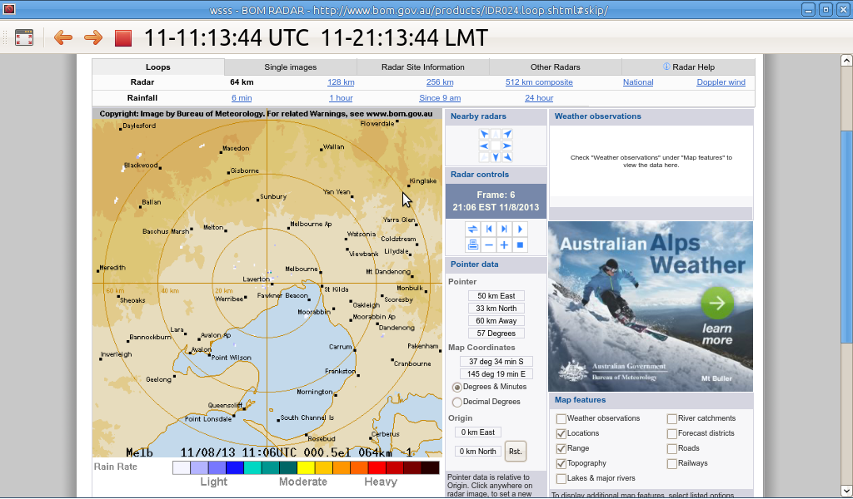
There is no defined limit to the number of sites to show. However, You may find that anything more than 8-10 tends to take too long to cycle round. It does depend on the content you wish to show.

The url is a standard http web address. If tou want to load from the local PCs drive the file:// type url works.

The timers in the code work in milliseconds so all values are givin in milliseconds.

ShowTime is the time in milliseconds to show thw page to the user
RefreshTime is the time in milliseconds to wait befor refershing the wep page. Thsi helps in reducing the amount of data the program consumes.

Each web page will tend to have its own optium size but may not visulay work on the sceern you are using. You are able to specifi a ZoomRatio to get the page to look right

The list of pages to show and the display properties are kept in a text file that uses the JSON format.
It is a very simple way of formating the data without having to get too clever.

If no file is specified in the command line of the program, the program will attempt to load a file called “settings.json” in the programs base directory. If it cant find that file, it will load a set of dummy sites.

Keyboard navigation

Right Arrow: Advance to next page
Left Arrow: Go back to previous page
Up and Down Arrow: Scroll the page up and down
P: Pause the the page
ESC or F11: Toggle between full and normal screen.
F2: Zoom in
F3: Zoom Out
F5: Reload the page

Mouse/touch navigation on toobar

Code

Based on QT 5.1.0
Uses WebKit Wdigets to show the web pages – same core code that chrome uses.
A number of timers used to determin the duration and refesh times of the pages

Repository

Git on VPS and Media02

