BPM DOCUMENTATION

Contents

0xDEADBEEF 2

Purpose of document 2

Requirements 2

POST/Power ON (Harrison James Marcks) 3

Blood Pressure Machine (Harrison James Marcks) 3

Human Interface (Huseyin Sert) 4

~~Screen (Huseyin Sert)~~ 4

~~Menu (Jesse Batt)~~ 5

Database (Jesse Batt) 5

Web Application (Dan Steer) 6

Networking (Dan Steer) 6

Acceptance Tests 8

POST/Power ON (Harrison James Marcks & Huseyin Sert) 8

Blood Pressure Monitor (Huseyin Sert) 10

~~Menu (Jesse Batt)~~ 11

Database (Jesse Batt) 12

Human Interface (Huseyin Sert) 13

~~Screen (Huseyin Sert)~~ 15

Web Application (Dan Steer) 17

Networking (Dan Steer) 19

Designs High-level 21

~~Screen (Huseyin Sert)~~ 21

~~Menu –Generic (Jesse Batt)~~ 22

Database (Jesse Batt) 23

POST / Power On (Harrison James Marcks) 24

BPM Activity (Harrison James Marcks) 25

Networking (Dan Steer) 26

Web Application (Dan Steer) 27

Designs Low-level 28

Post/Power ON (Huseyin Sert) 28

Database (Huseyin Sert) 29

Web Application (Huseyin Sert) 29

BPM Activity (Huseyin Sert) 30

Networking (Huseyin Sert) 31

# **0xDEADBEEF**

Members are as follows:

* Huseyin Sert (HS)
* Jesse Batt (JB)
* Harrison James Marcks (HJM)
* Dan Steer (DS)

# **Purpose of document**

This document aims to bring all **documentation** created for the BPM under one file.

This document was initially completed for B1 submission. The components that were completed for the B1 submission were as follows:

* Requirements
* Acceptance Tests
* High Level Design

The low level designs were not completed as we had not yet seen enough code or looked thoroughly through the hardware for the Blood Pressure Machine component.

Upon further revision, it was discovered that there were some errors in this document. Huseyin Sert was responsible for going through the entire document and correcting errors and making additions to the document.

Any text which has a line going through it ~~like this~~ was created in B1 submission which was discovered to be incorrect.

Requirements, acceptance tests and high level designs were contributed by all members. In the contents page it can be observed which part was completed by which member.

Low levels designs, on the other hand, were completed by Huseyin Sert.

# **Requirements**

|  |  |  |  |  |  |  |
| --- | --- | --- | --- | --- | --- | --- |
| ID | SUMMARY OF REQUIREMENT  (I WANT TO) | | RATIONALE  (SO THAT I CAN) | PRIORITY | SOURCE  (was not used in B1 submission) | CREATED |
| POST/Power ON (Harrison James Marcks) | | | | | | |
| P1 | Be able to test the memory | Verify the board will work correctly | | S |  | 04/10/2018 |
| ~~P2~~ | ~~Be able to test the screen~~ | ~~Verify the screen will display correctly~~ | | ~~S~~ |  | ~~04/10/2018~~ |
| P3 | Be able to test the CPU (Jump instructions) | Verify the board will work correctly | | S |  | 04/10/2018 |
| P4 | Be able to test the power | Verify the board will work correctly | | S |  | 04/10/2018 |
| P5 | Be able to test ROM | Verify the board will work correctly | | S |  | 04/10/2018 |
| P6 | Be able to perform POST/Power on the device | So the board can actually be used and boot up | | S |  | 04/10/2018 |
| P7 | Be able to check buttons | So that the buttons can be used | | S |  | 04/10/2018 |
| P8 | Check network interface | So that we can wired devices | | N |  | 04/10/2018 |
| ~~P9~~ | ~~Check blue tooth module~~ | ~~So that we can connect devices~~ | | ~~N~~ |  | ~~04/10/2018~~ |
| P10 | All tests run automatically on system start | Perform the tests automatically every time it is started | | C |  | 12/11/2018 |

|  |  |  |  |  |  |
| --- | --- | --- | --- | --- | --- |
| Blood Pressure Machine (Harrison James Marcks) | | | | | |
| B1 | Measure a user’s blood pressure | Take readings and make medical judgements | S |  | 15/10/2018 |
| ~~B2~~ | ~~Send BP readings to screen~~ | ~~View a user’s blood pressure~~ | ~~S~~ |  | ~~15/10/2018~~ |
| B3 | Read data from the readers | So that readings can be gathered | S |  | 17/10/2018 |
| B4 | Take average blood pressure | Have better results | C |  | 17/10/2018 |
| B5 | Filter out erroneous readings and data | Have more accurate results | S |  | 17/10/2018 |
| B6 | Measure blood pressure in real time | Read more relevant ratings | S |  | 17/10/2018 |

|  |  |  |  |  |  |
| --- | --- | --- | --- | --- | --- |
| Human Interface (Huseyin Sert) | | | | | |
| H1 | Perform a single button click | Interact with the device, select options | S |  | 25/11/2018 |
| H2 | Perform a double button click | Interact with the device, trigger secondary(subtasks) tasks | C |  | 25/11/2018 |
| H3 | Perform a long button click | Interact with the device, trigger secondary(subtasks) tasks | C |  | 25/11/2018 |
| H4 | Perform a multi-button click | Interact with the device, trigger secondary(subtasks) tasks |  |  | 25/11/2018 |
| ~~H5~~ | ~~Be able to use sliders~~ | ~~Interact with the device, navigate menu~~ | ~~C~~ |  | ~~25/11/2018~~ |
| ~~H6~~ | ~~View feedback on screen~~ | ~~Ensure that button clicks are registered~~ | ~~C~~ |  | ~~25/11/2018~~ |
| H7 | View feedback on LEDs | Ensure that button clicks are registered | C |  | 25/11/2018 |
| ~~H8~~ | ~~Enter user information~~ | ~~Have multiple user profiles~~ | ~~N~~ |  | ~~25/11/2018~~ |
| ~~H9~~ | ~~Change scale of BPM using slider~~ | ~~View more precise readings~~ | ~~C~~ |  | ~~25/11/2018~~ |
| ~~H10~~ | ~~Change the scale of the UI using the slider~~ | ~~I can enlarge the words on screen~~ | ~~N~~ |  | ~~25/11/2018~~ |

|  |  |  |  |  |  |
| --- | --- | --- | --- | --- | --- |
| ~~Screen (Huseyin Sert)~~ | | | | | |
| ~~S1~~ | ~~Display blood pressure reading~~ | ~~See blood pressure reading~~ | ~~S~~ |  | ~~25/11/2018~~ |
| ~~S2~~ | ~~Show other data being read from the device~~ | ~~The screen real estate is used effectively~~ | ~~N~~ |  | ~~25/11/2018~~ |
| ~~S3~~ | ~~Display blood pressure reading in real time~~ | ~~Ensure that the device is working properly, Tell patient what is going on with their readings~~ | ~~S~~ |  | ~~25/11/2018~~ |
| ~~S4~~ | ~~Display multiple blood pressure readings~~ | ~~Compare readings~~ | ~~N~~ |  | ~~25/11/2018~~ |
| ~~S5~~ | ~~Display Menu~~ | ~~Select different menu option, Perform different tasks~~ | ~~S~~ |  | ~~25/11/2018~~ |
| ~~S6~~ | ~~Display text and data in a clear and readable format~~ | ~~See text and data on the screen clearly~~ | ~~S~~ |  | ~~25/11/2018~~ |
| ~~S7~~ | ~~Display message on boot-up~~ | ~~Indicate that the screen will be working~~ | ~~S~~ |  | ~~25/11/2018~~ |

|  |  |  |  |  |  |
| --- | --- | --- | --- | --- | --- |
| ~~Menu (Jesse Batt)~~ | | | | | |
| ~~M1~~ | ~~Navigate a menu~~ | ~~Select different options~~ | ~~S~~ |  | ~~26/11/2018~~ |
| ~~M2~~ | ~~Select a menu option~~ | ~~My navigation has meaning~~ | ~~M~~ |  | ~~26/11/2018~~ |
| ~~M3~~ | ~~Return to Menu~~ | ~~I can select something else~~ | ~~M~~ |  | ~~26/11/2018~~ |
| ~~M4~~ | ~~Select the BPM Activity from the menu~~ | ~~I can take a reading~~ | ~~S~~ |  | ~~26/11/2018~~ |
| ~~M5~~ | ~~Select User Profiles from the menu~~ | ~~I can configure user profiles~~ | ~~N~~ |  | ~~26/11/2018~~ |
| ~~M6~~ | ~~Reboot the board~~ | ~~I can perform more controlled maintenance and fixing~~ | ~~S~~ |  | ~~26/11/2018~~ |
| ~~M7~~ | ~~Navigate to Options Menu~~ | ~~I can edit options~~ | ~~N~~ |  | ~~26/11/2018~~ |

|  |  |  |  |  |  |
| --- | --- | --- | --- | --- | --- |
| Database (Jesse Batt) | | | | | |
| DB1 | Load data from a database | Store a data for querying | S |  | 26/11/2018 |
| DB2 | Commit data to a database | Data can later be queried | S |  | 26/11/2018 |
| DB3 | Store user data in database | Multiple users can be stored | S |  | 26/11/2018 |
| DB4 | Load user data from the database | Different user data can be loaded | S |  | 26/11/2018 |
| DB5 | Keep track of previous readings | Keep a record of previous readings | S |  | 26/11/2018 |
| DB6 | Communicate with device and web app | So that the above can all operate | S |  |  |

|  |  |  |  |  |  |
| --- | --- | --- | --- | --- | --- |
| **Web Application (Dan Steer)** | | | | | |
| WA1 | Pages loads in reasonable time | To create a good user experience | S |  | 25/10/2018 |
| WA2 | Cross-browser compatible | The web app can be used on multiple platforms | S |  | 25/10/2018 |
| WA3 | Web application follows best practices | Ensure best web application performance | S |  | 25/10/2018 |
| WA4 | Sensitive information is not stored in source files | Good security practice | S |  | 25/10/2018 |
| WA5 | Responsive design is applied | Ensures good usability | C |  | 25/10/2018 |
| WA6 | Navigation is functional and intuitive | Ensures good usability | S |  | 25/10/2018 |
| WA7 | Prevent against SQL injection e.g. prepared statements | Good security practice | S |  | 25/10/2018 |
| WA8 | Connect to a Database | To load relevant data | M |  | 25/10/2018 |
| WA9 | Display blood pressure data | So user can access blood pressure information | M |  | 25/10/2018 |
| WA10 | Edit user information | To keep records accurate | M |  | 25/10/2018 |
| WA11 | Delete user information | Uphold data protection | M |  | 25/10/2018 |
| WA12 | Create a user profile | BPM can save results for specific user | M |  | 25/10/2018 |

|  |  |  |  |  |  |
| --- | --- | --- | --- | --- | --- |
| **Networking (Dan Steer)** | | | | | |
| NW1 | Connect to a network | To connect to the server | M |  | 25/10/2018 |
| NW2 | Disconnect from network | To disconnect from all networks | M |  | 25/10/2018 |
| NW3 | Enable Wi-Fi | To allow device to connect to a network (eg. the server) | M |  | 25/10/2018 |
| NW4 | Disable Wi-Fi | To disconnect from all networks | M |  | 25/10/2018 |
| NW5 | Disable Wi-Fi if not connected to network for prolonged period | Save power | C |  | 25/10/2018 |
| NW6 | Reconnect to last used network when Wi-Fi is enabled | Speed up connection to server | C |  | 25/10/2018 |
| NW7 | Forget a network | To remove networks no longer being used | S |  | 25/10/2018 |
| NW8 | Remember connection information for networks | The device can connect without entering a password | S |  | 25/10/2018 |
| NW9 | Enable/disable auto connect to networks | Increase usability | C |  | 25/10/2018 |

# **Acceptance Tests**

## **POST/Power ON (Harrison James Marcks & Huseyin Sert)**

**Test Name**: PP_T1  
**Requirements Tested**: P1  
**Outline**: Ensure that the system tests the memory  
**Pre-requisites**: System is turned off  
**Method**:

|  |  |  |
| --- | --- | --- |
| **STEP** | Action | Expected Observation |
| 1 | Turn on the system | The system will start to blink the LEDs |
| 2 | Wait | The system will eventually be started |

**~~Test Name~~**~~: PP_T2~~**~~Requirements Tested~~**~~: P2~~**~~Outline~~**~~: Ensure that the system tests the screen~~**~~Pre-requisites~~**~~: System is turned off~~**~~Method~~**~~:~~

|  |  |  |
| --- | --- | --- |
| **~~STEP~~** | ~~Action~~ | ~~Expected Observation~~ |
| ~~1~~ | ~~Turn on the system~~ | ~~The system will start to display characters on the screen~~ |
| ~~2~~ | ~~Wait~~ | ~~Eventually, it’ll move on to the next test~~ |

**Test Name**: PP_T3  
**Requirements Tested**: P3  
**Outline**: Ensure that the CPU instructions work correctly  
**Pre-requisites**: System is turned off  
**Method**:

|  |  |  |
| --- | --- | --- |
| **STEP** | Action | Expected Observation |
| 1 | Turn on the system | Diagnostic information will be notified on the LEDs relating to the jump instructions being tested |
| 2 | Wait | Eventually the system will move onto the next test |

**Test Name**: PP_T4  
**Requirements Tested**: P4  
**Outline**: Make sure the power is stable  
**Pre-requisites**: System is turned off  
**Method**:

|  |  |  |
| --- | --- | --- |
| **STEP** | Action | Expected Observation |
| 1 | Turn on the system | System shows it is starting |
| 2 | Wait | Information relating to the power supply is displayed |

**Test Name**: PP_T5  
**Requirements Tested**: P5  
**Outline**: Test the ROM to make sure everything is okay  
**Pre-requisites**: System is turned off  
**Method**:

|  |  |  |
| --- | --- | --- |
| **STEP** | Action | Expected Observation |
| 1 | Turn on the system | System shows it is starting |
| 2 | Wait | System shows ROM diagnostic information via blinking the LEDs |

**Test Name**: PP_T6  
**Requirements Tested**: P6  
**Outline**: The POST/Power On tests should be able to run  
**Pre-requisites**: System is turned off  
**Method**:

|  |  |  |
| --- | --- | --- |
| **STEP** | Action | Expected Observation |
| 1 | Turn the system on | The first test is run |
| 2 | Wait | Each subsequent test is run one after another |
| 3 | Wait | All tests have been run and the system is in a sane state OR some diagnostic information is being displayed |

**Test Name**: PP_T7  
**Requirements Tested**: P7  
**Outline**: Check to make sure the buttons can be read from  
**Pre-requisites**: System is turned off  
**Method**:

|  |  |  |
| --- | --- | --- |
| **STEP** | Action | Expected Observation |
| 1 | Turn on the system | The system shows it is starting |
| 2 | Ask for user input on both buttons | The system confirms each button press and carries on |

**Test Name**: PP_T8  
**Requirements Tested**: P8  
**Outline**: Check network interface  
**Pre-requisites**: System is turned off  
**Method**:

|  |  |  |
| --- | --- | --- |
| **STEP** | Action | Expected Observation |
| 1 | Turn the system on | System shows it is starting |
| 2 | Wait | The system performs a Hardware check to see if there is an Ethernet or Wi-Fi  Module |

**~~Test Name~~**~~: PP_T9~~**~~Requirements Tested~~**~~: P9~~  
**~~Outline~~**~~: Check blue-tooth module~~**~~Pre-requisites~~**~~: System is turned off~~**~~Method~~**~~:~~

|  |  |  |
| --- | --- | --- |
| **~~STEP~~** | ~~Action~~ | ~~Expected Observation~~ |
| ~~1~~ | ~~Turn on the system~~ | ~~System shows it is starting~~ |
| ~~2~~ | ~~Wait~~ | ~~The system performs a Hardware check to see if there is a blue-tooth module installed~~ |

**Test Name**: PP_T10  
**Requirements Tested**: P10, P1, P2, P3, P4, P5, P6, P7, P8, P9   
**Outline**: Perform all tests in sequence at system boot  
**Pre-requisites**: System is turned off  
**Method**:

|  |  |  |
| --- | --- | --- |
| **STEP** | Action | Expected Observation |
| 1 | Turn on the system. | The system shows it has begun booting using the LEDs |
| 2 | Wait | Eventually the LEDs begin to show POST diagnostic information via predefined (certain rhythm and order) way of LEDs blinking |
| 3 | Wait | More tests will be observed with more LED output |
| 4 | Wait | Eventually both the LEDs will flash 3 times quickly to inform that tests are completed |
| 5 | Wait | If tests fail, the red LED will remain on. |

## **Blood Pressure Monitor (Huseyin Sert)**

**Test Name**: B_T1  
**Requirements Tested**: B1, B2, B3, B6  
**Outline**: Ensure that the device can measure user’s blood pressure  
**Pre-requisites**: Make sure the device is turned on, healthy and sensors connected

**Method:**

|  |  |  |
| --- | --- | --- |
| **STEP** | Action | Expected Observation |
| 1. | Attach the sensors to a person | Sensors are properly attached to a person |
| 2. | Once the reading is completed, look at the blood pressure reading on the display | See a reasonable blood pressure reading |
| 3. | Repeat the above ***STEP***s again to check if readings are consistent | See same or very similar blood pressure readings |

**Test Name**: B_T2  
**Requirements Tested**: B4  
**Outline**: Ensure that the device can take the average blood pressure  
**Pre-requisites**: Make sure the device is turned on, healthy and sensors connected

**Method**:

|  |  |  |
| --- | --- | --- |
| **STEP** | Action | Expected Observation |
| 1. | Attach the sensors to a person | Sensors are properly attached to a person |
| 2. | Get three different readings from the machine in one sitting | End up with three very similar readings |
| 3. | Once the readings are completed, select the “average” option from the menu | Observe the “average” option returning the average result of the last three readings |

**Test Name**: B_T3

**Requirements Tested**: B1, B2, B3, B4, B5, B6

**Outline**: Ensure that the device can filter out erroneous readings and data

**Pre-requisites**: Make sure the device is turned on, healthy and sensors connected  
**Method:**

|  |  |  |
| --- | --- | --- |
| **STEP** | Action | Expected Observation |
| 1. | Attach the sensors to a person | Sensors are properly attached to a person |
| 2. | Get different readings from the machine | See the readings on the web application |
| 3. | If some readings are unusually high or low due to – person: not resting 3-5 minutes, talking, has fluctuating body temperature, smoking cigarette less than 30 mins prior to reading or other reasons, identify these readings and delete them. | See a realistic and accurate readings |

## **~~Menu (Jesse Batt)~~**

**~~Test Name~~**~~: MENU_T1~~**~~Requirements Tested~~**~~: M1, M2, M3, M4, M5, M6, S2, S5, H1, H5~~**~~Outline~~**~~: Ensure that the Menu can navigate between Sub-Menus and return to the Main Menu~~**~~Pre-requisites~~**~~: System turned on, display functional~~**~~Method~~**~~:~~

|  |  |  |
| --- | --- | --- |
| ~~STEP~~ | ~~Action~~ | ~~Expected Observation~~ |
| **~~1~~** | ~~Use device input such as buttons/sliders to cycle through possible menu options~~ | ~~Display shows cycling of possible menu options through a possible “hover over” state~~ |
| **~~2~~** | ~~Use button to select menu option, for example “Start BPM Reading” or “Settings”~~ | ~~Device correctly navigates to the chosen sub menu and the display reflects this~~ |
| **~~3~~** | ~~Use button to return to the main menu~~ | ~~Device returns correctly to the main menu and display reflects this~~ |

**~~Test Name~~**~~: MENU_T2~~**~~Requirements Tested~~**~~: M2, M3, M4, H5, BPM(All), S2, S5, DB1, DB5, H6~~**~~Outline~~**~~: Ensure the user can prompt the start of a BPM reading via Menu navigation on the device~~**~~Pre-requisites~~**~~: Device is on, Menu navigation working correctly, input connected~~**~~Method~~**~~:~~

|  |  |  |
| --- | --- | --- |
| ~~STEP~~ | ~~Action~~ | ~~Expected Observation~~ |
| **~~1~~** | ~~Use buttons to navigate to “Start Reading”~~ | ~~Device and display correctly reflect the selection~~ |
| **~~2~~** | ~~After the reading is complete, use buttons to navigate menu to view results of reading~~ | ~~Displays the correct reading on the screen~~ |
| **~~3~~** | ~~Select “View previous readings”, pull from database~~ | ~~Displays correctly~~ |
| **~~4~~** | ~~Return to menu using buttons~~ | ~~Display and device reach main menu~~ |

**~~Test Name~~**~~: MENU_T3~~**~~Requirements Tested~~**~~: M1, M2, M7, H1, S5, P6~~**~~Outline~~**~~: Ensure the board can be rebooted as prompted by the user~~**~~Pre-requisites~~**~~: Device is on, Menu navigation working correctly, I/O functional~~**~~Method~~**~~:~~

|  |  |  |
| --- | --- | --- |
| ~~STEP~~ | ~~Action~~ | ~~Expected Observation~~ |
| **~~1~~** | ~~Use buttons to cycle to reboot option~~ | ~~Display reflects this~~ |
| **~~2~~** | ~~Use button to select reboot option~~ | ~~Device shuts down safely, then reboots automatically, fully functional and ready to go~~ |

## **Database (Jesse Batt)**

**Test Name:** DB_T1

**Requirements Tested:** DB1, DB4, DB5, EU5, M1, M2

**Outline:** Data can be saved to the database as well as being displayed on the web app.

**Prerequisites:** The device is powered on, networking is enabled, and the web app server is running

**Method:**

|  |  |  |
| --- | --- | --- |
| **Step** | Action | Expected Observance |
| 1 | Take a test reading on the device | Reading is taken successfully, and SQL query is sent to the database |
| 2 | Load database backend to see if reading is saved | Reading saved |
| 3 | Load web app, view database | Database displays correctly on the web app |

**Test Name:** DB_T2

**Requirements Tested:** DB2, DB3, DB4, I7, M1, M2, M5, M8, H7

**Outline:** User data can be edited on the device then these changes will overwrite existing data for a user within the database

**Prerequisites:** The device is powered on, networking is enabled, and the web app server is running

**Method:**

|  |  |  |
| --- | --- | --- |
| **Step** | Action | Expected Observance |
| 1 | Navigate menu to find the user profile information. | The user information fields (age, gender etc.) should appear either blank or prefilled. |
| 2 | Edit the information. | Fields should be editable. |
| 3 | Save changes, which will send changes to the SQL database | Success pop up(?) |
| 4 | Open database via web app to view database | Updated values display correctly |

## **Human Interface (Huseyin Sert)**

**Test Name**: HI_T1  
**Requirements Tested**: H1. H2, H3, H4  
**Outline**: Ensure that a single button click is registered as only a click  
**Pre-requisites**: System is turned on, healthy, and ready to receive input  
**Method**:

|  |  |  |
| --- | --- | --- |
| **STEP** | Action | Expected Observation |
| 1 | Click the button for an option | No other type of button press is registered |

**Test Name**: HI_T2  
**Requirements Tested**: H1. H2, H3, H4  
**Outline**: Ensure that a double button click is registered as only a double click  
**Pre-requisites**: System is turned on, healthy, and ready to receive input  
**Method**:

|  |  |  |
| --- | --- | --- |
| **STEP** | Action | Expected Observation |
| 1 | Double click an option | No other type of button press is registered |

**Test Name**: HI_T3  
**Requirements Tested**: H1. H2, H3, H4  
**Outline**: Ensure that a single long press is registered as only a long a press  
**Pre-requisites**: System is turned on, healthy, and ready to receive input  
**Method**:

|  |  |  |
| --- | --- | --- |
| **STEP** | Action | Expected Observation |
| 1 | Hold button down to select an option | No other type of button press is registered |

**Test Name**: HI_T4  
**Requirements Tested**: H1. H2, H3, H4  
**Outline**: Ensure that pressing multiple buttons at once is registered as nothing else  
**Pre-requisites**: System is turned on, healthy, and ready to receive input  
**Method**:

|  |  |  |
| --- | --- | --- |
| **STEP** | Action | Expected Observation |
| 1 | Push multiple buttons | No other type of button press is registered |

**~~Test Name~~**~~: HI_T5~~**~~Requirements Tested~~**~~: H5~~**~~Outline~~**~~: Use the slider to change an option~~**~~Pre-requisites~~**~~: System is turned on, healthy, and ready to receive input~~**~~Method~~**~~:~~

|  |  |  |
| --- | --- | --- |
| **~~STEP~~** | ~~Action~~ | ~~Expected Observation~~ |
| ~~1~~ | ~~Adjust the slider such that an option is changed~~ | ~~The slider input is correctly handled~~ |

**~~Test Name~~**~~: HI_T6~~**~~Requirements Tested~~**~~: H6~~**~~Outline~~**~~: View feedback on the screen~~**~~Pre-requisites~~**~~: System is turned on, healthy, and ready to send output~~**~~Method~~**~~:~~

|  |  |  |
| --- | --- | --- |
| **~~STEP~~** | ~~Action~~ | ~~Expected Observation~~ |
| ~~1~~ | ~~Make changes to the system such that what is displayed to the user will change~~ | ~~Any changes or actions carried out by the user are communicated to them~~ |

**Test Name**: HI_T7  
**Requirements Tested**: H7  
**Outline**: View feedback on the LEDs  
**Pre-requisites**: System is turned on, healthy, and ready to send output  
**Method**:

|  |  |  |
| --- | --- | --- |
| **STEP** | Action | Expected Observation |
| 1 | Perform a button press | See LEDs response via quick blink, demonstrating that button click has been registered |

**~~Test Name~~**~~: HI_T8~~**~~Requirements Tested~~**~~: H8~~**~~Outline~~**~~: Enter information on a user~~**~~Pre-requisites~~**~~: System is turned on, healthy, and ready to receive input~~**~~Method~~**~~:~~

|  |  |  |
| --- | --- | --- |
| **~~STEP~~** | ~~Action~~ | ~~Expected Observation~~ |
| ~~1~~ | ~~Goto user profiles~~ |  |
| ~~2~~ | ~~Create or edit a new user~~ |  |
| ~~3~~ | ~~Enter user information using various combinations of the button presses~~ | ~~The data being entered can be entered by the user using the buttons~~ |

**~~Test Name~~**~~: HI_T9~~**~~Requirements Tested~~**~~: H9~~**~~Outline~~**~~: Use the slider to change the BPM scale~~**~~Pre-requisites~~**~~: System is turned on, healthy, and ready to receive input~~**~~Method~~**~~:~~

|  |  |  |
| --- | --- | --- |
| **~~STEP~~** | ~~Action~~ | ~~Expected Observation~~ |
| ~~1~~ | ~~Navigate to BPM screen option~~ |  |
| ~~2~~ | ~~Use the slider to zoom in/out~~ | ~~The readings are enlarged~~ |

**~~Test Name~~**~~: HI_T10~~**~~Requirements Tested~~**~~: H10~~**~~Outline~~**~~: Change the scale of the UI using the slider~~**~~Pre-requisites~~**~~: System is turned on, healthy, and ready to receive input~~**~~Method~~**~~:~~

|  |  |  |
| --- | --- | --- |
| **~~STEP~~** | ~~Action~~ | ~~Expected Observation~~ |
| ~~1~~ | ~~While on any screen use the slider to change the scale of the text and other things~~ | ~~The text is enlarged/shrunk~~ |

## **~~Screen (Huseyin Sert)~~**

**~~Test Name~~**~~: S_T1~~**~~Requirements Tested~~**~~: S1, S3~~**~~Outline~~**~~: Ensure that the screen displays the blood pressure reading~~**~~Pre-requisites~~**~~: Device is turned on, healthy and sensors are connected~~

**~~Method~~**~~:~~

|  |  |  |
| --- | --- | --- |
| **~~STEP~~** | ~~Action~~ | ~~Expected Observation~~ |
| ~~1.~~ | ~~Wait for machine to take the reading~~ | ~~Machine is taking a reading~~ |
| ~~2.~~ | ~~Once reading is complete, check the screen~~ | ~~See a blood pressure reading~~ |

**~~Test Name~~**~~: S_T2~~**~~Requirements Tested:~~** ~~S2~~**~~Outline~~**~~: Ensure that the screen displays all the available / useful data~~**~~Pre-requisites:~~** ~~Device is turned on and healthy~~

**~~Method:~~**

|  |  |  |
| --- | --- | --- |
| **~~STEP~~** | ~~Action~~ | ~~Expected Observation~~ |
| ~~1.~~ | ~~Connect all the sensors and peripherals that can be connected~~ | ~~All sensors and peripherals are fully connected~~ |
| ~~2.~~ | ~~Make sure that all the data is formatted perfectly on the screen so that every useful and available data can displayed on one screen~~ | ~~View all the available / useful data in one screen without any data missing or protruding out of the screen~~ |

**~~Test Name:~~** ~~S_T3~~**~~Requirements Tested:~~** ~~S1, S3~~**~~Outline:~~** ~~Ensure that the screen displays blood pressure reading in real time~~**~~Pre-requisites:~~** ~~Device is turned on, healthy and sensors are connected~~**~~Method:~~**

|  |  |  |
| --- | --- | --- |
| **~~STEP~~** | ~~Action~~ | ~~Expected Observation~~ |
| ~~1.~~ | ~~Attach sensors to a person~~ | ~~Sensors are connected to a person~~ |
| ~~2.~~ | ~~Wait for machine to take the reading~~ | ~~Machine is taking a reading~~ |
| ~~3.~~ | ~~Look at the screen~~ | ~~See the reading values change as the reading is still in progress~~ |

**~~Test Name~~**~~: S_T4~~**~~Requirements Tested~~**~~: S4~~**~~Outline~~**~~: Ensure that the screen can show multiple blood pressure readings at the same time~~**~~Pre-requisites~~**~~: Device is turned on and healthy~~**~~Method:~~**

|  |  |  |
| --- | --- | --- |
| **~~STEP~~** | ~~Action~~ | ~~Expected Observation~~ |
| ~~1.~~ | ~~Navigate to where the user profiles are on the menu~~ | ~~See a list of users~~ |
| ~~2.~~ | ~~Select a user from the list~~ | ~~See a list of previous readings on one screen~~ |

**~~Test Name~~**~~: S_T5~~**~~Requirements Tested~~**~~: S5~~**~~Outline~~**~~: Ensure that the screen can display a menu~~ **~~Pre-requisites~~**~~: Device is turned on and healthy~~

**~~Method~~**~~:~~

|  |  |  |
| --- | --- | --- |
| **~~STEP~~** | ~~Action~~ | ~~Expected Observation~~ |
| ~~1.~~ | ~~Look at the screen~~ | ~~See a list of options available to pick for different tasks~~ |

**~~Test Name~~**~~: S_T6~~**~~Requirements Tested~~**~~: S6~~**~~Outline~~**~~: Ensure that the screen can display text and data on the screen clearly with correct colour inversion~~ **~~Pre-requisites~~**~~: Device is turned on and healthy~~

**~~Method~~**~~:~~

|  |  |  |
| --- | --- | --- |
| **~~STEP~~** | ~~Action~~ | ~~Expected Observation~~ |
| ~~1.~~ | ~~Look at the screen~~ | ~~Be able to read text, options, menu and anything intended to be displayed on the screen without difficulty because a clear font is selected and correct colour inversion is being used~~ |

**~~Test Name~~**~~: S_T7~~**~~Requirements Tested~~**~~: S7~~**~~Outline~~**~~: Ensure that the screen can display a boot-up message~~ **~~Pre-requisites~~**~~: Device is healthy~~

**~~Method~~**~~:~~

|  |  |  |
| --- | --- | --- |
| **~~STEP~~** | ~~Action~~ | ~~Expected Observation~~ |
| ~~1.~~ | ~~Boot the device up~~ | ~~See a small message on the screen before the device is fully booted~~ |

## **Web Application (Dan Steer)**

**Test Name**: WA_T1  
**Requirements Tested**: WA1, WA3, WA5   
**Outline**: Run performance analysis on web application  
**Pre-requisites**: The PC is powered on and healthy, the PC is connected to the internet, Google Chrome is installed, the website is live, the active program Google Chrome  
**Method**:

|  |  |  |
| --- | --- | --- |
| **STEP** | Action | Expected Observation |
| 1 | Navigate to the index of the web application. | Google chrome is displaying the index of the web application |
| 2 | Enter the developer console by pressing F12, or right click, inspect element. Navigate to the *Audit* tab. | The developer console is open, and the active tab is *Audit* |
| 3 | Ensure all options are selected, apart from *Progressive Web App* and *SEO*. Select the *Desktop* device. | All relevant tabs are selected, the test is ready to begin. |
| 4 | Run Audit. | The audit is running. |
| 5 | Audit passes. | The web application is adequate (minimum score 45 for a given component) |
| 6 | Run the test again, this time select device *Mobile* | The audit is running. |
| 7 | Audit passes | The web application is adequate (minimum score 45 for a given component) |

**Test Name**: WA_T2  
**Requirements Tested**: WA2, WA6, WA8, WA9  
**Outline**: Web application is functional on multiple web browsers  
**Pre-requisites**:

The PC is powered on and healthy, the PC is connected to the internet, multiple web browsers are installed (Chrome, Firefox, Opera etc.), the website is live, a web browser is active  
**Method**:

|  |  |  |
| --- | --- | --- |
| **STEP** | Action | Expected Observation |
| 1 | Navigate to the index of the web application. | The index page of the website is being shown |
| 2 | Go to each page of the website | The current page is functional |
| 3 | Repeat steps 1-2 using multiple web browsers | The current page is functional |

**Test Name**: WA_T3  
**Requirements Tested**: WA6, WA8, WA10, WA11, WA12  
**Outline**: Test create, update and delete of a user account  
**Pre-requisites**:

The PC is powered on and healthy, the PC is connected to the internet, a web browser is installed, the website is live, a web browser is active  
**Method**:

|  |  |  |
| --- | --- | --- |
| **STEP** | Action | Expected Observation |
| 1 | Navigate to the index of the user section of the web application | The user profiles section of the website is being showed in the web browser |
| 2 | Create a new user | A new user has been created successfully. The user is visible. |
| 3 | Edit the information about the user that has just been created | Changes have been made to the user account just created, and the information has been saved successfully. |
| 4 | Delete the user that has just been created | The all information about the user has been successfully deleted. |

**Test Name**: WA_T4  
**Requirements Tested**: WA3, WA4, WA7  
**Outline**: Check source files don’t leak sensitive information  
**Pre-requisites**:

The PC is powered on and healthy, source files are available to access, the root of the web application directory is active (either in terminal or GUI), a text editor is installed  
**Method**:

|  |  |  |
| --- | --- | --- |
| **STEP** | Action | Expected Observation |
| 1 | Open each source file (e.g. .html, .css, .js, .php etc.) | The source file contains no database connection information (e.g. password, user, DB etc.).  If database queries are used, prepared statements are in place to prevent SQL based attacks. |

# 

## **Networking (Dan Steer)**

**Test Name**: NW_T1  
**Requirements Tested**: NW1, NW3  
**Outline**: Connect to a new network  
**Pre-requisites**:

Device is powered on and healthy and Wi-Fi is disabled  
**Method**:

|  |  |  |
| --- | --- | --- |
| **STEP** | Action | Expected Observation |
| 1 | ~~Navigate menu to find the Wi-Fi options~~ | ~~A list of options relating to Wi-Fi is listed~~ |
| 2 | Turn on Wi-Fi | The device will search for available networks, and list them when the search is complete. |
| 3 | Choose a network and attempt to connect | The device will try and connect to the selected network. A prompt to enter the password may appear. |
| 4 | Enter network password if required | Connection is successful |

**Test Name**: NW_T2  
**Requirements Tested**: NW2, NW7  
**Outline**: Forget a network  
**Pre-requisites**:

Device is powered on and healthy, Wi-Fi is enabled and connected to a network  
**Method**:

|  |  |  |
| --- | --- | --- |
| **STEP** | Action | Expected Observation |
| 1 | ~~Navigate menu to find the Wi-Fi options~~ | ~~A list of options relating to Wi-Fi is listed~~ |
| 2 | Disconnect from the active network | The device should now be disconnected from the network it was connected to |
| 3 | Select option to forget the network it was connected to | A prompt may appear to confirm choice. A list of available network will be listed |
| 4 | Try and connect to the network that has just been ‘forgotten’ | The prompt to enter a password may appear. This proves the device no longer remembers the network |

**Test Name**: NW_T3  
**Requirements Tested**: NW1, NW2, NW3, NW4, NW5, NW9  
**Outline**: Wi-Fi automatically turns off when inactive for defined period   
**Pre-requisites**:

Device is powered on and healthy, Wi-Fi is enabled and connected to a network, auto-connect to networks is enabled in the Wi-Fi options.  
**Method**:

|  |  |  |
| --- | --- | --- |
| **STEP** | Action | Expected Observation |
| 1 | ~~Navigate menu to find the Wi-Fi options~~ | ~~A list of options relating to Wi-Fi is listed~~ |
| 2 | Disconnect from the active network | The device should now be disconnected from the network it was connected to |
| 3 | Disable ‘auto-connect’ to networks | The option has been disabled. |
| 4 | Disable Wi-Fi | Wi-Fi should be turned off |
| 5 | Enabled Wi-Fi | A list of available networks should be listed |
| 6 | Wait for defined period | After period, Wi-Fi should automatically be disabled |

**Test Name**: NW_T4  
**Requirements Tested**: NW1, NW3, NW6, NW8  
**Outline**: Device remembers previously connected networks   
**Pre-requisites**:

Device is powered on and healthy, Wi-Fi is disabled, auto-connect to networks is enabled in the Wi-Fi options.  
**Method**:

|  |  |  |
| --- | --- | --- |
| **STEP** | Action | Expected Observation |
| 1 | ~~Navigate menu to find the Wi-Fi options~~ | ~~A list of options relating to Wi-Fi is listed~~ |
| 2 | Enabled Wi-Fi | A list of available networks should be listed  If a previously connected network is available, the device will automatically connect to it |

# **Designs High-level**

## **~~Screen (Huseyin Sert)~~**

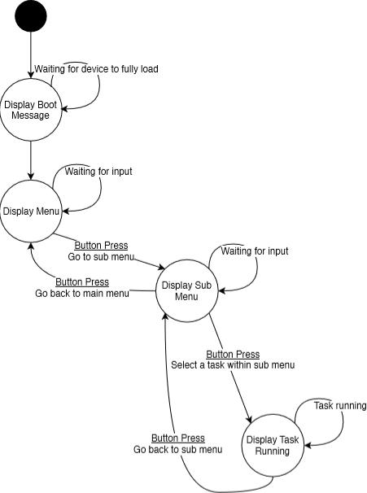

## **~~Menu –Generic (Jesse Batt)~~**

~~~~

## **Database (Jesse Batt)**



## **POST / Power On (Harrison James Marcks)**



## **BPM Activity (Harrison James Marcks)**



## **Networking (Dan Steer)**



## **Web Application (Dan Steer)**



# **Designs Low-level**

## **Post/Power ON (Huseyin Sert)**

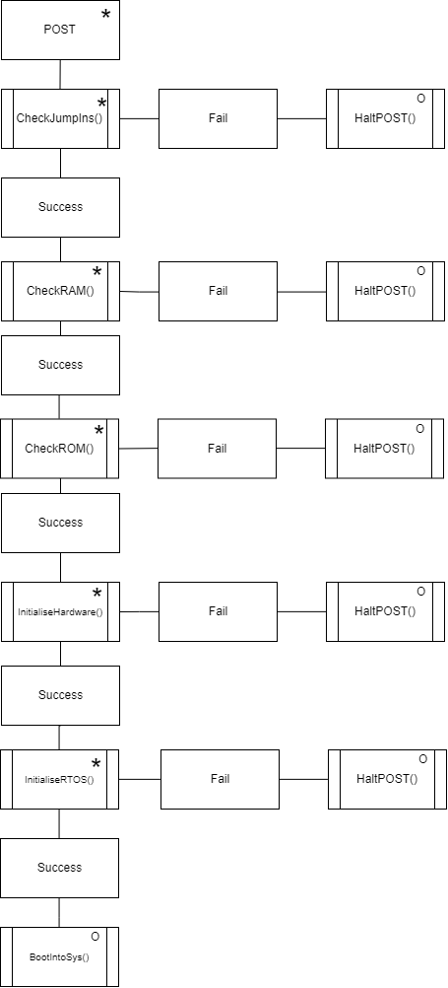

## **Database (Huseyin Sert)**

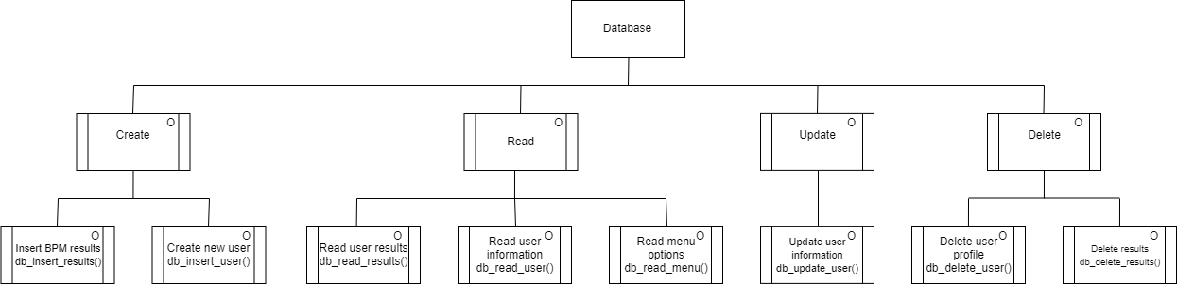

## **Web Application (Huseyin Sert)**

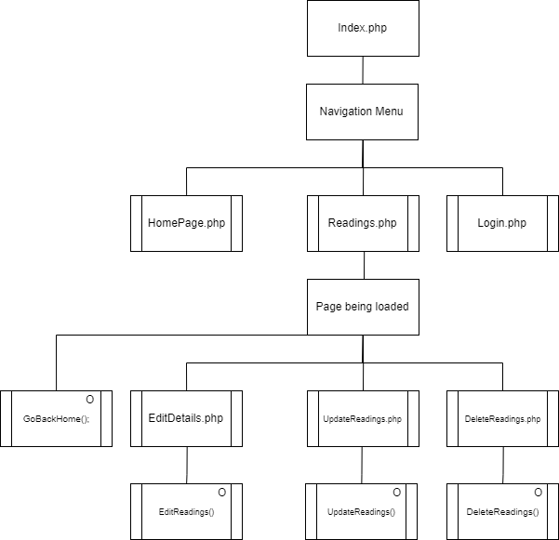

## **BPM Activity (Huseyin Sert)**

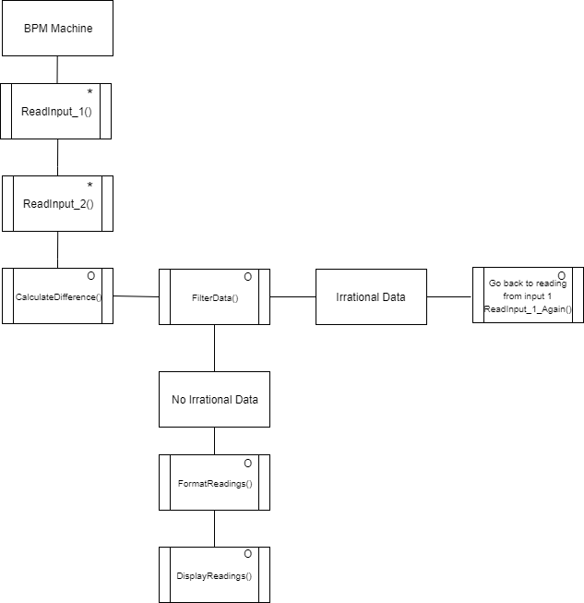

## **Networking (Huseyin Sert)**

