ECG DOCUMENTATION

Contents

**0xDEADBEEF** 2

**Purpose of document** 2

**Requirements** 2

POST/Power on 3

Ease Of Use 3

Interfacing Between Devices 4

Menu 4

Data Handling 5

Database 5

Human Interface 5

Screen 6

ECG 6

**Acceptance Tests** 8

**POST/Power On** 8

**Ease of Use (Huseyin Sert)** 10

**Interfacing Between Devices (Dan Steer)** 12

**Menu** 14

**Data Handling** 15

**Database (Dan Steer)** 16

**Human Interface** 16

**Screen (Huseyin Sert)** 18

**ECG** 19

**Designs** 21

**Initial High Level (Huseyin Sert)** 21

**Interfacing between Devices** 22

Low Level (Dan Steer) 22

High Level (Huseyin Sert) 22

**Database** 23

Low Level (Dan Steer) 23

High Level (Dan Steer) 23

**Screen** 24

Low Level (Huseyin Sert) 24

High Level (Huseyin Sert) 25

# **0xDEADBEEF**

Members are as follows:

* Huseyin Sert (HS)
* Jesse Batt (JB)
* Harrison James Marcks (HJM)
* Dan Steer (DS)

# **Purpose of document**

This document aims to bring all documentation created for the ECG under one file.

The **requirements** for ECG component of the assignment were made collectively by **all** **members** of the 0xDEADBEEF.

However, **acceptance** **tests**, high level and low level designs were **created** **individually**. These documentations will be identified with the creator’s initials to make it easier to see the individual contribution of each member.

On the contents page you can see a name next to each component. This mean that component is accomplished by that name. There is also the **WhoDidWhat_Documentation_Review_ECG.doc** document which gives more concise and easy to follow version of individual progress along with all the reviews made by users to each other’s work.

Ideas to discuss:

-Cross out requirements and or acceptance test that are not feasible

-Apparently Martin told Larry’s group to do this and Laurence was fine with it

-Names on individual components created on **this** document?

-Is this a good idea?

-Laurence wanted design documents to be in PDF format…

-Might need to chase him up on that or confirm with other people

-There were way more stuff I took notes off but my laptop is dead and it is 4:11am.

-I need to sleep

# **Requirements**

Key: POST/Power on = P, **Ease Of Use = E,** Interfacing Between Devices = I, **Menu = M,** Data Handling, **Database = DB,** Human Interface = H, **ECG = EL,** Screen = S

**Key:** S = Show Stopper, **C = Critical,** M = Major, **N= Normal**, T = Trivial

|  |  |  |  |  |  |  |
| --- | --- | --- | --- | --- | --- | --- |
| ID | SUMMARY OF REQUIREMENT  (I WANT TO) | | RATIONALE  (SO THAT I CAN) | PRIORITY | SOURCE | CREATED |
| POST/Power on | | | | | | |
| P1 | Be able to test the memory | Verify the board will work correctly | | S |  | 04/10/2018 |
| P2 | Be able to test the screen | Verify the screen will display correctly | | S |  | 04/10/2018 |
| P3 | Be able to test the CPU (Jump instructions) | Verify the board will work correctly | | S |  | 04/10/2018 |
| P4 | Be able to test the power | Verify the board will work correctly | | S |  | 04/10/2018 |
| P5 | Be able to test ROM | Verify the board will work correctly | | S |  | 04/10/2018 |
| P6 | Be able to perform POST/Power on the device | So the board can actually be used and boot up | | S |  | 04/10/2018 |
| P7 | Be able to check buttons | So that the buttons can be used | | S |  | 04/10/2018 |
| P8 | Check network interface | So that we can wired devices | | N |  | 04/10/2018 |
| P9 | Check bluetooth module | So that we can connect devices | | N |  | 04/10/2018 |
| P10 | All tests run automatically on system start | Perform the tests automatically every time it is started | | C |  | 12/11/2018 |

|  |  |  |  |  |  |
| --- | --- | --- | --- | --- | --- |
| Ease Of Use | | | | | |
| EU1 | Be able to use the device within 2 minutes | So that the user can get a reading as soon as possible | C |  | 04/10/2018 |
| EU2 | Not charge it very often | Not have to worry too often | B |  | 04/10/2018 |
| EU3 | Power it via USB | A special cable is not needed | S |  | 04/10/2018 |
| EU4 | Be able to take it with me | Take a reading whenever | T |  | 04/10/2018 |
| EU5 | Be able to view results on a screen | Give the readings meaning in the moment | S |  | 04/10/2018 |
| EU6 | Be able to adjust screen brightness | Have a more comfortable viewing experience | N |  | 04/10/2018 |
| EU7 | Be able to adjust the text size | I can read the words incase they’re too small | N |  | 04/10/2018 |
| EU8 | Be able to improve accessibility for visually impaired | More people have access to the device | T |  | 04/10/2018 |
| EU9 | Be able to charge device when its ON | Not depend on the limited charge capacity of the device |  |  |  |
| EU10 | Be able to charge device when its OFF | Make sure its ready to use when I need it |  |  |  |

|  |  |  |  |  |  |
| --- | --- | --- | --- | --- | --- |
| Interfacing Between Devices | | | | | |
| I1 | Be able to interface with a computer via USB | I can download past results | S |  | 04/10/2018 |
| I2 | Be able to interface with a computer via blue tooth | I can download past results if I don’t have a cable | N |  | 04/10/2018 |
| I3 | Be able to interface with the board via wifi | I can gather results without a cable | N |  | 04/10/2018 |
| I4 | Be able to interface with the board via ethernet | I can gather results remotely | N |  | 04/10/2018 |
| I5 | Be able to receive results via text | I can immediately alert a Dr. or family member | N |  | 04/10/2018 |
| I6 | Be able to interface with a remote database | I can save results to something else | M |  | 04/10/2018 |
| I7 | Be able to interface a local database | I can save results from previous tests | N |  | 04/10/2018 |
|  |  |  |  |  |  |

|  |  |  |  |  |  |
| --- | --- | --- | --- | --- | --- |
| Menu | | | | | |
| M1 | Navigate a menu | Select different options | S |  | 04/10/2018 |
| M2 | Select a menu option | My navigation has meaning | M |  | 04/10/2018 |
| M3 | Return to Menu | I can select something else | M |  | 04/10/2018 |
| M4 | Select the ECG from the menu | I can take a reading | S |  | 04/10/2018 |
| M5 | Select User options from the menu | I can configure user profiles | N |  | 04/10/2018 |
| M6 | Select Historical ECG readings | I can view old readings | T |  | 04/10/2018 |
| M7 | Reboot the board | I can perform more controlled maintenance and fixing | S |  | 04/10/2018 |
| M8 | Have an Options option | I can edit options | N |  | 04/10/2018 |
|  |  |  |  |  |  |

|  |  |  |  |  |  |
| --- | --- | --- | --- | --- | --- |
| Data Handling | | | | | |
| D1 | Record readings to a file | I can export the file | N |  | 04/10/2018 |
| D2 | Record readings to a human readable format | I can view the readings | C |  | 04/10/2018 |
| D3 | Be able to store data | I can store data for later | N |  | 04/10/2018 |

|  |  |  |  |  |  |
| --- | --- | --- | --- | --- | --- |
| Database | | | | | |
| DB1 | Load data from a database | Store a data for querying | N |  | 04/10/2018 |
| DB2 | Commit data to a database | Data can later be queried | N |  | 04/10/2018 |
| DB3 | Store user data in database | Multiple users can be stored | N |  | 04/10/2018 |
| DB4 | Load user data from the database | Different user data can be loaded | N |  | 04/10/2018 |
| DB5 | Keep track of previous readings | Keep a record of previous readings | N |  | 04/10/2018 |

|  |  |  |  |  |  |
| --- | --- | --- | --- | --- | --- |
| Human Interface | | | | | |
| H1 | Perform a button press | I can interact with the device | S |  | 04/10/2018 |
| H2 | Perform a button double click | I can interact with the device | C |  | 04/10/2018 |
| H3 | Perform a long button press | I can interact with the device | C |  | 04/10/2018 |
| H4 | Perform a multi-button press | I can interact with the device | C |  | 04/10/2018 |
| H5 | Use the slider | I can interact with the device | C |  | 04/10/2018 |
| H6 | View feedback on the screen | I can interact with the device | C |  | 04/10/2018 |
| H7 | Enter user information | I can have multiple profiles | N |  | 04/10/2018 |
| H8 | Change scale of ECG using slider | I can view more precise readings | C |  | 17/10/2018 |
| H9 | Change the scale of the UI using the slider | I can enlarge the words on screen | N |  | 17/10/2018 |

|  |  |  |  |  |  |
| --- | --- | --- | --- | --- | --- |
| Screen | | | | | |
| S1 | Display heart rate | See the heart rate immediately | S |  | 04/10/2018 |
| S2 | Show all available data on the screen | The screen real estate is used effectively | N |  | 04/10/2018 |
| S3 | Display heart rate in real time | See readings are relevant | S |  | 04/10/2018 |
| S4 | Display multiple ECG readings | Compare previous readings | N |  | 04/10/2018 |
| S5 | Display a menu | Select different menu options | S |  | 04/10/2018 |
|  |  |  |  |  |  |

|  |  |  |  |  |  |
| --- | --- | --- | --- | --- | --- |
| ECG | | | | | |
| EL1 | Measure a user’s heart rate | Measure a user’s heart rate | S |  | 04/10/2018 |
| EL2 | Send ECG readings to screen | View a user’s heart rate | S |  | 04/10/2018 |
| EL3 | Read data from all the electrodes | So that readings can be gathered | S |  | 04/10/2018 |
| EL4 | Adjust sensitivity based on age | Readings can be more precise based on the type of user | N |  | 04/10/2018 |
| EL5 | Filter out interference | The readings aren’t skewed | S |  | 04/10/2018 |
| EL6 | Measure heart rate in real time | Viewable readings are relevant | S |  | 04/10/2018 |

# **Acceptance Tests**

## **POST/Power On**

**Test Name**: PP_T1  
**Requirements Tested**: P1  
**Outline**: Ensure that the system tests the memory  
**Pre-requisites**: System is turned off  
**Method**:

|  |  |  |
| --- | --- | --- |
| **STEP** | Action | Expected Observation |
| 1 | Turn on the system | The system will start to display information to the screen |
| 2 | Wait | The system will eventually be started |

**Test Name**: PP_T2  
**Requirements Tested**: P2  
**Outline**: Ensure that the system tests the screen  
**Pre-requisites**: System is turned off  
**Method**:

|  |  |  |
| --- | --- | --- |
| **STEP** | Action | Expected Observation |
| 1 | Turn on the system | The system will start to display characters on the screen |
| 2 | Wait | Eventually, it’ll move on to the next test |

**Test Name**: PP_T3  
**Requirements Tested**: P3  
**Outline**: Ensure that the CPU instructions work correctly  
**Pre-requisites**: System is turned off  
**Method**:

|  |  |  |
| --- | --- | --- |
| **STEP** | Action | Expected Observation |
| 1 | Turn on the system | Diagnostic information will be displayed on the screen relating to the jump instructions being tested |
| 2 | Wait | Eventually the system will move onto the next test |

**Test Name**: PP_T4  
**Requirements Tested**: P4  
**Outline**: Make sure the power is stable  
**Pre-requisites**: System is turned off  
**Method**:

|  |  |  |
| --- | --- | --- |
| **STEP** | Action | Expected Observation |
| 1 | Turn on the system | System shows it is starting |
| 2 | Wait | Information relating to the power supply is displayed |

**Test Name**: PP_T5  
**Requirements Tested**: P5  
**Outline**: Test the ROM to make sure everything is okay  
**Pre-requisites**: System is turned off  
**Method**:

|  |  |  |
| --- | --- | --- |
| **STEP** | Action | Expected Observation |
| 1 | Turn on the system | System shows it is starting |
| 2 | Wait | System shows ROM diagnostic information on the screen |

**Test Name**: PP_T6  
**Requirements Tested**: P6  
**Outline**: The POST/Power On tests should be able to run  
**Pre-requisites**: System is turned off  
**Method**:

|  |  |  |
| --- | --- | --- |
| **STEP** | Action | Expected Observation |
| 1 | Turn the system on | The first test is run |
| 2 | Wait | Each subsequent test is run one after another |
| 3 | Wait | All tests have been run and the system is in a sane state OR some diagnostic information is being displayed |

**Test Name**: PP_T7  
**Requirements Tested**: P7  
**Outline**: Check to make sure the buttons can be read from  
**Pre-requisites**: System is turned off  
**Method**:

|  |  |  |
| --- | --- | --- |
| **STEP** | Action | Expected Observation |
| 1 | Turn on the system | The system shows it is starting |
| 2 | Ask for user input on both buttons | The system confirms each button press and carries on |

**Test Name**: PP_T8  
**Requirements Tested**: P8  
**Outline**: Check network interface  
**Pre-requisites**: System is turned off  
**Method**:

|  |  |  |
| --- | --- | --- |
| **STEP** | Action | Expected Observation |
| 1 | Turn the system on | System shows it is starting |
| 2 | Wait | The system performs a Hardware check to see if there is an Ethernet or Wi-Fi  Module |

**Test Name**: PP_T9  
**Requirements Tested**: P9  
**Outline**: Check blue-tooth module  
**Pre-requisites**: System is turned off  
**Method**:

|  |  |  |
| --- | --- | --- |
| **STEP** | Action | Expected Observation |
| 1 | Turn on the system | System shows it is starting |
| 2 | Wait | The system performs a Hardware check to see if there is a blue-tooth module installed |

**Test Name**: PP_T10  
**Requirements Tested**: P10, P1, P2, P3, P4, P5, P6, P7, P8, P9  
**Outline**: Perform all tests in sequence at system boot  
**Pre-requisites**: System is turned off  
**Method**:

|  |  |  |
| --- | --- | --- |
| **STEP** | Action | Expected Observation |
| 1 | Turn on the system. | The system shows it has begun booting using the LEDs |
| 2 | Wait | Eventually the screen will begin to show POST diagnostic information |
| 3 | Wait | More tests will appear on the screen and completed one after another |
| 4 | Wait | Eventually a splash screen will be displayed, and the user will be informed of any tests that may have failed. |

## **Ease of Use (Huseyin Sert)**

**Test Name**: EU_T1  
**Requirements Tested**: EU1

**Outline**: Ensure that the device boots up under 2 minutes

**Pre-requisites**: Make sure the device is turned off and healthy

**Method:**

|  |  |  |
| --- | --- | --- |
| *STEP* | *Action* | *Expected Observation* |
| 1. | Power on the device | Observe booting process |
| 2. | Run a timer to record the time it took boot up | Device fully booted |

**Test Name**: EU_T2  
**Requirements Tested**: EU2, EU3, EU4  
**Outline**: Ensure that the device does not need to be charged very often  
**Pre-requisites**: Device is fully charged

**Method**:

|  |  |  |
| --- | --- | --- |
| **STEP** | Action | Expected Observation |
| 1. | Connect the device to a power source and make sure the battery is charging | Battery should be charging |
| 2. | Stop charging the battery at 100% | Battery percentage should be 100% |
| 3. | Run a timer until the device turns off itself and then take the reading from the timer | Device should be turned off and you should have a reading that tells you how long the device can run on battery |

**Test Name**: EU_T3

**Requirements Tested**: EU3, EU9, EU10

**Outline**: Ensure that the device can be powered by USB

**Pre-requisites**: Device can be turned off or turned on

**Method:**

|  |  |  |
| --- | --- | --- |
| **STEP** | Action | Expected Observation |
| 1. | Connect the device to power source via a USB connection | Device is connected to the power source |
| 2. | Ensure that the battery is being charged | LEDs on the device should indicate that the power is being transmitted from the power source to the device |
| 3. | Check the battery percentage | Battery percentage should be going up |

**Test Name**: EU_T4

**Requirements Tested**: EU5, S1, S2, S3, S4

**Outline**: Ensure that the results can be viewed on the screen

**Pre-requisites**: Device is turned on and healthy

**Method**:

|  |  |  |
| --- | --- | --- |
| **STEP** | Action | Expected Observation |
| 1. | Navigate to where the results are being displayed | You are on the expected menu section |
| 2. | Check the screen | Results are being displayed |

**Test Name:** EU_T5  
**Requirements Tested**: EU6, EU8  
**Outline:** Ensure that users can adjust the screen brightness  
**Pre-requisites**: Device is turned on and healthy

**Method**:

|  |  |  |
| --- | --- | --- |
| **STEP** | Action | Expected Observation |
| 1. | Navigate to where the screen brightness settings are | See the brightness setting options |
| 2. | Select the brightness options and click on the button to **decrease** the brightness | Screen brightness is dimming down |
| 3. | Select the brightness options and click on the button to **increase** the brightness | Screen brightness is increasing |

**Test Name**: EU_T6  
**Requirements Tested**: EU7, EU8  
**Outline**: Ensure that text size is adjustable  
**Pre-requisites**: Device is turned on and healthy  
**Method**:

|  |  |  |
| --- | --- | --- |
| **STEP** | Action | Expected Observation |
| 1. | Navigate to where the screen font settings are | See the font settings options |
| 2. | Select the font options and click on the button to **decrease** the size of font | Font size is decreasing |
| 3. | Select the font options and click on the button to **increase** the size of font | Font size is increasing |

## **Interfacing Between Devices (Dan Steer)**

**Test Name:** IBD_T1

**Requirements Tested:** I1, D3, DB5

**Outline:**  A PC can read files from the ECG

**Prerequisites:** The PC and ECG are powered and healthy, the ECG is connected to the PC via USB.

**Method:**

|  |  |  |
| --- | --- | --- |
| **Step** | Action | Expected Observance |
| 1 | View USB devices on the PC. | The PC should list the ECG as a device. |
| 2 | Mount the ECG to the OS. | The ECG should successfully mount to the OS. |
| 3 | Navigate to the ESG and list files. | The ECG should successfully mount to the OS. |

**Test Name:** IBD_T2

**Requirements Tested:** I2, P9, M1, D3, DB5, S5

**Outline:** The ECG can send files via Bluetooth to a PC.

**Prerequisites:** The PC and ECG are powered on and healthy, Bluetooth is turned on and discoverable on the PC and ECG.

**Method:**

|  |  |  |
| --- | --- | --- |
| **Step** | Action | Expected Observance |
| 1 | Search for Bluetooth devices on the PC. | The PC can find the ECG as a Bluetooth device. |
| 2 | Connect the ECG on via the PC. | The ECG should receive a prompt to connect to the PC.  The ECG should accept the request, and the PC should show a healthy connection status to the ECG. |
| 3 | On the ECG, navigate the menu to find files. Use the buttons to send via Bluetooth. | The PC should get a notification of an incoming file from the ECG. |

**Test Name:** IBD_T3

**Requirements Tested:** I3, I4, P8, D3, DB5,

**Outline:** View files on the ECG from a PC.

**Prerequisites:** The PC and ECG are powered on and healthy, is connected to the network via Wi-Fi or Ethernet, the ECG and PC are on the same network, ECG credentials are known.

**Method:**

|  |  |  |
| --- | --- | --- |
| **Step** | Action | Expected Observance |
| 1 | List connected device on the router. | The ECG should be visible and should have an IP address. |
| 2 | Using the PC, SSH into the ECG using its IP. | SSH connection should be successful. |
| 3 | Using the correct terminal commands; navigate to the folder containing ECG save files, and list. | A list of files in the current directory should be listed. |

**Test Name:** IBD_T4

**Requirements Tested:** I6, P8, M1, D3, S4, S5

**Outline:** Send data from ECG to a server.

**Prerequisites:** The ECG is powered on and healthy, is connected to a network via Ethernet or Wi-Fi and the PC is connected to the network via Ethernet or Wi-Fi, The server is connected to the same network as the ECG.

**Method:**

|  |  |  |
| --- | --- | --- |
| **Step** | Action | Expected Observance |
| 1 | Check ECG has a successful connection with the server. | ECG is connected to the server. |
| 2 | Navigate menu to find the list of records on the ECG and select the option to upload a singular file to the server. | A prompt should appear on ESG to confirm server upload. |
| 3 | Confirm upload from prompt. | An uploading prompt appears.  An upload complete prompt proceeds. |
| 4 | Check the file has successfully been uploaded to server. | An uploading prompt appears.  An upload complete prompt proceeds. |

**Test Name:** IBD_T5

**Requirements Tested:** I7, E5, M1, D3, DB5, S5

**Outline:** View previous results from database.

**Prerequisites:** The ECG is powered on and healthy, results have already been saved to the local database.

**Method:**

|  |  |  |
| --- | --- | --- |
| **Step** | Action | Expected Observance |
| 1 | Navigate menu to results page. | Results are shown in chronological order (latest first) |

**Test Name:** IBD_T6

**Requirements Tested:** I5, E5, M1, D1, D3, H7, S3, S5, E1, E3, E6

**Outline:** Results are sent via SMS to client.

**Prerequisites:** The ECG is powered on and healthy.

**Method:**

|  |  |  |
| --- | --- | --- |
| **Step** | Action | Expected Observance |
| 1 | Navigate menu and select record new readings. | Recording screen is shown. |
| 2 | After the results have been recorded, select option to send results via SMS. | A prompt should appear to enter a phone number. |
| 3 | Confirm phone number and press send. | The results are received in plain text to the specified phone number. |

## **Menu**

**Test Name**: MENU_T1  
**Requirements Tested**: M1, M2, M3, M4, M5, M6, S2, S5, H1, H5  
**Outline**: Ensure that the Menu can navigate between Sub-Menus and return to the Main Menu  
**Pre-requisites**: System turned on, display functional   
**Method**:

|  |  |  |
| --- | --- | --- |
| STEP | Action | Expected Observation |
| **1** | Use device input such as buttons/sliders to cycle through possible menu options | Display shows cycling of possible menu options through a possible “hover over” state |
| **2** | Use button to select menu option, for example “Start ECG Reading” or “Settings” | Device correctly navigates to the chosen sub menu and the display reflects this |
| **3** | Use button to return to the main menu | Device returns correctly to the main menu and display reflects this |

**Test Name**: MENU_T2  
**Requirements Tested**: M2, M3, M4, H5, ECG(All), S2, S5, DB1, DB5, H6  
**Outline**: Ensure the user can prompt the start of an ECG reading via Menu navigation on the device  
**Pre-requisites**: Device is on, Menu navigation working correctly, ECG sensors connected  
**Method**:

|  |  |  |
| --- | --- | --- |
| STEP | Action | Expected Observation |
| **1** | Use buttons to navigate to “Start Reading” | Device and display correctly reflect the selection |
| **2** | After the reading is complete, use buttons to navigate menu to view results of reading | Displays the correct reading on the screen |
| **3** | Select “View previous readings”, pull from database | Displays correctly |
| **4** | Return to menu using buttons | Display and device reach main menu |

**Test Name**: MENU_T3  
**Requirements Tested**: M1, M2, M7, H1, S5, P6  
**Outline**: Ensure the board can be rebooted as prompted by the user  
**Pre-requisites**: Device is on, Menu navigation working correctly, I/O functional  
**Method**:

|  |  |  |
| --- | --- | --- |
| STEP | Action | Expected Observation |
| **1** | Use buttons to cycle to reboot option | Display reflects this |
| **2** | Use button to select reboot option | Device shuts down safely, then reboots automatically, fully functional and ready to go |

## **Data Handling**

**Test Name**: DH_T1  
**Requirements Tested**: D3  
**Outline**: Ensure that the device can store ECG readings on the device/database  
**Pre-requisites**: Device is on and functional, sensors connected and working correctly  
**Method**:

|  |  |  |
| --- | --- | --- |
| STEP | Action | Expected Observation |
| **1** | Begin an ECG reading on the device | Device starts reading, following the reading, option for saving data results appears |
| **2** | Select option to save data to device | successfully saves |
| **3** | Load results data from device | Data loads and displays on the screen |

**Test Name**: DH_T2  
**Requirements Tested**: D1, D2  
**Outline**: Ensure that the data can be saved as a file that can be readable by a computer  
**Pre-requisites**: Device is on, reading has taken place **Method**:

|  |  |  |
| --- | --- | --- |
| STEP | Action | Expected Observation |
| **1** | Following ECG reading, select “save as file” | ding |
| **2** | Connect ECG to PC | PC can detect and view data results file |
| **3** | Open file in a text editor | Data file is human readable and formatted |

## **Database (Dan Steer)**

**Test Name:** DB_T1

**Requirements Tested:** DB1, DB4, DB5, EU5, M1, M2

**Outline:** Data is being loaded from the database.

**Prerequisites:** The ESG is powered and healthy.

**Method:**

|  |  |  |
| --- | --- | --- |
| **Step** | Action | Expected Observance |
| 1 | Navigate menu to find the list of past readings. | A list of previous readings should be listed. |

**Test Name:** DB_T2

**Requirements Tested:** DB2, DB3, DB4, I7, M1, M2, M5, M8, H7

**Outline:** Edit user data.

**Prerequisites:** The ESG is powered and healthy.

**Method:**

|  |  |  |
| --- | --- | --- |
| **Step** | Action | Expected Observance |
| 1 | Navigate menu to find the user profile information. | The user information fields (age, gender etc.) should appear either blank or prefilled. |
| 2 | Edit the information. | Fields should be editable. |
| 3 | Save changes. | * A save success prompt should appear. * Information fields should appear again, but with the alterations. |

## **Human Interface**

**Test Name**: HI_T1  
**Requirements Tested**: H1. H2, H3, H4  
**Outline**: Ensure that a single button click is registered as only a click  
**Pre-requisites**: System is turned on, healthy, and ready to receive input  
**Method**:

|  |  |  |
| --- | --- | --- |
| **STEP** | Action | Expected Observation |
| 1 | Click the button for an option | No other type of button press is registered |

**Test Name**: HI_T2  
**Requirements Tested**: H1. H2, H3, H4  
**Outline**: Ensure that a double button click is registered as only a double click  
**Pre-requisites**: System is turned on, healthy, and ready to receive input  
**Method**:

|  |  |  |
| --- | --- | --- |
| **STEP** | Action | Expected Observation |
| 1 | Double click an option | No other type of button press is registered |

**Test Name**: HI_T3  
**Requirements Tested**: H1. H2, H3, H4  
**Outline**: Ensure that a single long press is registered as only a long a press  
**Pre-requisites**: System is turned on, healthy, and ready to receive input  
**Method**:

|  |  |  |
| --- | --- | --- |
| **STEP** | Action | Expected Observation |
| 1 | Hold button down to select an option | No other type of button press is registered |

**Test Name**: HI_T4  
**Requirements Tested**: H1. H2, H3, H4  
**Outline**: Ensure that pressing multiple buttons at once is registered as nothing else  
**Pre-requisites**: System is turned on, healthy, and ready to receive input  
**Method**:

|  |  |  |
| --- | --- | --- |
| **STEP** | Action | Expected Observation |
| 1 | Push multiple buttons | No other type of button press is registered |

**Test Name**: HI_T5  
**Requirements Tested**: H5  
**Outline**: Use the slider to change an option  
**Pre-requisites**: System is turned on, healthy, and ready to receive input  
**Method**:

|  |  |  |
| --- | --- | --- |
| **STEP** | Action | Expected Observation |
| 1 | Adjust the slider such that an option is changed | The slider input is correctly handled |

**Test Name**: HI_T6  
**Requirements Tested**: H6  
**Outline**: View feedback on the screen  
**Pre-requisites**: System is turned on, healthy, and ready to send output  
**Method**:

|  |  |  |
| --- | --- | --- |
| **STEP** | Action | Expected Observation |
| 1 | Make changes to the system such that what is displayed to the user will change | Any changes or actions carried out by the user are communicated to them |

**Test Name**: HI_T7  
**Requirements Tested**: H7  
**Outline**: Enter information on a user  
**Pre-requisites**: System is turned on, healthy, and ready to receive input  
**Method**:

|  |  |  |
| --- | --- | --- |
| **STEP** | Action | Expected Observation |
| 1 | Goto user profiles |  |
| 2 | Create or edit a new user |  |
| 3 | Enter user information using various combinations of the button presses | The data being entered can be entered by the user using the buttons |

**Test Name**: HI_T8  
**Requirements Tested**: H8  
**Outline**: Use the slider to change the ECG scale  
**Pre-requisites**: System is turned on, healthy, and ready to receive input  
**Method**:

|  |  |  |
| --- | --- | --- |
| **STEP** | Action | Expected Observation |
| 1 | Navigate to ECG screen |  |
| 2 | Use the slider to zoom in/out | The readings are enlarged |

**Test Name**: HI_T9  
**Requirements Tested**: H9  
**Outline**: Change the scale of the UI using the slider  
**Pre-requisites**: System is turned on, healthy, and ready to receive input  
**Method**:

|  |  |  |
| --- | --- | --- |
| **STEP** | Action | Expected Observation |
| 1 | While on any screen use the slider to change the scale of the text and other things | The text is enlarged/shrank |

## **Screen (Huseyin Sert)**

**Test Name**: S_T1  
**Requirements Tested**: S1, S3, E1, E6  
**Outline**: Ensure that the screen displays the heart rate  
**Pre-requisites**: Device is turned on and healthy

**Method**:

|  |  |  |
| --- | --- | --- |
| **STEP** | Action | Expected Observation |
| 1. | Connect the sensors | Sensors are connected |
| 2. | Look at the screen | See the heart rate |
| 3. | Take off the sensors | See the heart rate value either disappear or display 0 |

**Test Name**: S_T2  
**Requirements Tested:** S2, DB1, DB4  
**Outline**: Ensure that the screen displays all the available / useful data  
**Pre-requisites:** Device is turned on and healthy

**Method:**

|  |  |  |
| --- | --- | --- |
| **STEP** | Action | Expected Observation |
| 1. | Connect all the sensors and peripherals that can be connected | All sensors and peripherals are fully connected |
| 2. | Make sure that all the data is formatted perfectly on the screen so that every useful and available data can displayed on one screen | View all the available / useful data in one screen without any data missing or protruding out of the screen |

**Test Name:** S_T3  
**Requirements Tested:** S1, S3, E1, E6  
**Outline:** Ensure that the screen displays heart rate in real time  
**Pre-requisites:** Device is turned on, healthy and sensors are connected  
**Method:**

|  |  |  |
| --- | --- | --- |
| **STEP** | Action | Expected Observation |
| 1. | Attach sensors to a person | Sensors are connected to a person |
| 2. | Look at the heart rate reading on the screen | See the heart rate reading on the screen that should be changing according to persons physical activity |
| 3. | Attach the sensors to a different person | Sensors are connected to another person |
| 4. | Look at the heart rate reading on the screen | See that the heart rate reading on the screen is potentially different and still changing which proves that the readings are done in real time |

**Test Name**: S_T4  
**Requirements Tested**: S4, DB1, DB3, DB4, DB5  
**Outline**: Ensure that the screen can show multiple ECG readings at once  
**Pre-requisites**: Device is turned on and healthy  
**Method:**

|  |  |  |
| --- | --- | --- |
| **STEP** | Action | Expected Observation |
| 1. | Navigate to where the user profiles are on the menu | See a list of users |
| 2. | Select a user from the list | See a list of previous readings on one screen |

**Test Name**: S_T5  
**Requirements Tested**: S5, P2, H6, M1, M2, M3, M4, M5, M6  
**Outline**: Ensure that the screen can display a menu **Pre-requisites**: Device is turned on and healthy

**Method**:

|  |  |  |
| --- | --- | --- |
| **STEP** | Action | Expected Observation |
| 1. | Look at the screen | See a list of options available to pick for different tasks |

## **ECG**

**Test Name**: EL_T1  
**Requirements Tested**: EL1, EL2, EL3, EL5, EL6  
**Outline**: Take the measurements for a user’s heart rate  
**Pre-requisites**: System is on, healthy, ready to receive electrode input, ready to display heart rate  
**Method**:

|  |  |  |
| --- | --- | --- |
| **STEP** | Action | Expected Observation |
| 1 | Navigate to ECG reading screen |  |
| 2 | Attach electrodes to user |  |
| 3 | View Screen | The user’s heart rate is displayed with very little erroneous or odd readings and is shown to be operating in real time |

**Test Name**: EL_T2  
**Requirements Tested**: EL1, EL2, EL3, EL4, EL5, EL6  
**Outline**: The sensitivity of the device needs to be changed based on a user’s age  
**Pre-requisites**: System is on, healthy, ready to receive electrode input, ready to display heart rate  
**Method**:

|  |  |  |
| --- | --- | --- |
| **STEP** | Action | Expected Observation |
| 1 | Navigate to ECG Screen |  |
| 2 | Attach electrodes to user |  |
| 3 | View Screen and record readings |  |
| 4 | Attach electrodes to a different, older user |  |
| 5 | Adjust sensitivity | The readings on the screen should show similar/as clean results as compared to the first readings |

# **Designs**

## **Initial High Level (Huseyin Sert)**

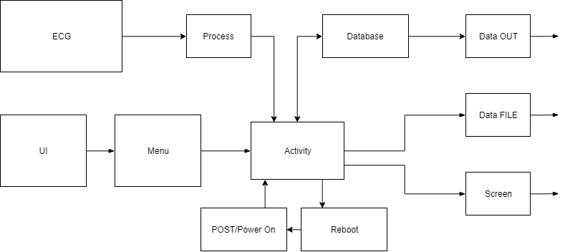

## **Interfacing between Devices**

### Low Level (Dan Steer)

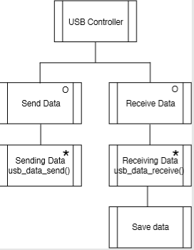

### High Level (Huseyin Sert)

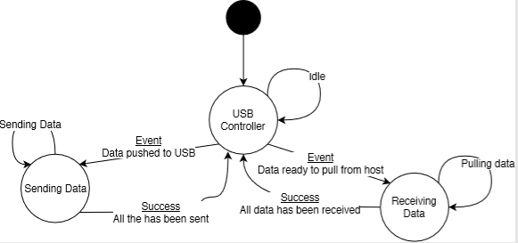

## **Database**

### Low Level (Dan Steer)

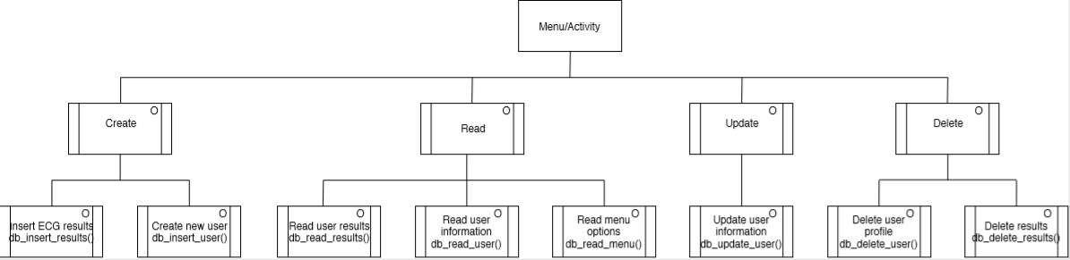

### High Level (Dan Steer)

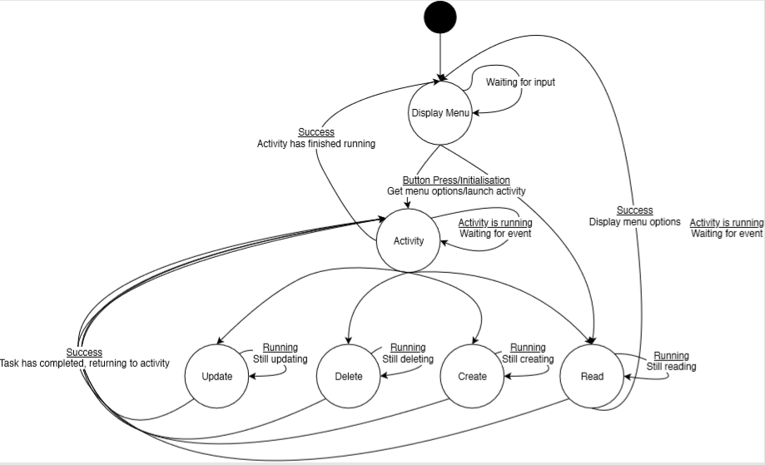

## **Screen**

### Low Level (Huseyin Sert)

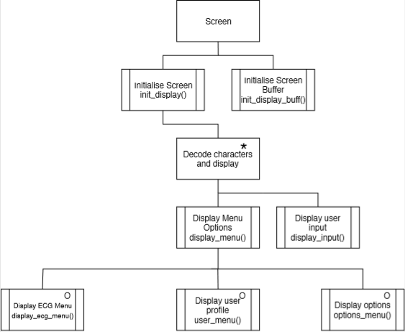

### High Level (Huseyin Sert)

