Harrison Leece Mech 211 True Position Tolerance Homework

1) The best position tolerance zone shape to maximize the available tolerance for a round hole is c) cylindrical.

2) The tolerance zone is unchanged by produced feature size when the b) RFS modifier is applicable.

3) A tolerance specification on a hole has an MMC modifier. For every .002” departure of the hole diameter from MMC size, the tolerance zone increases b) .002’’.

4) A dowel pin pressed into one part and passing through a clearance hole in another part is an example of a(n) b) Floating fastener application.

5) If a hole is .001” out of the acceptable tolerance zone and the tolerance is specified at MMC, it might be possible to make the hole acceptable by c) increasing the hole diameter.

True False

6) A floating fastener condition exists when a bolt passes through a clearance hole in one part and threads into a hole in the second part.

b) false

Fill in the blank

7) Basic dimensions must be used to define the true positions for features that have position tolerances applied.

8) A position tolerance zone for a hole is centered on the center position of the hole.

9) A floating fastener condition exists when a bolt passes through clearance holes in two parts.

Short Answer

10) Create a feature control frame to control position within a diameter of .026” at MMC relative to datum A primary, B secondary, and C tertiary.

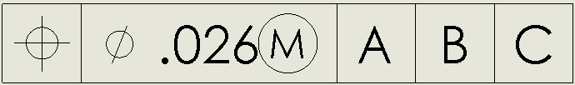

11) Create a feature control frame to control position within a diameter of .018” at RFS relative to datum B primary, E secondary, and F tertiary

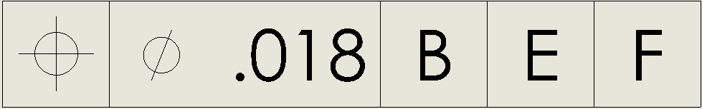

Application

12) Tolerance = .002 + .018 = .020

13) Tolerance =(.384-.380) + .036 = .040

14) Tolerance = .281-.250 = .031

15) Top plate tolerance: (.188-.164)\*[1/3] = .008

Bottom plate tolerance: (.188-.164)\*[2/3] = .016

16) Top plate tolerance: (.220-.190)\*[1/3] = .010

Bottom plate tolerance: (.220-.190)\*[2/3] = .020

17) Clearance Holes MMC = .250+.016 = .266

18) Clearance Hole MMC = .312+.018\*[1/3] = .318