* Active Noise Control :

Active Noise Control is a very effective electronic method to reduce the effect of the noise in an environment. It is basically generation of anti-noise, equal in magnitude and opposite in phase with the noise. The anti-noise and the noise are destructively interfered to remove the effects of noise from the path of the noise.

Active Noise Cancellation or active noise control involves the electro-acoustic generation of a sound field to cancel an unwanted existing sound filed. Active Noise Control is the more often used term.

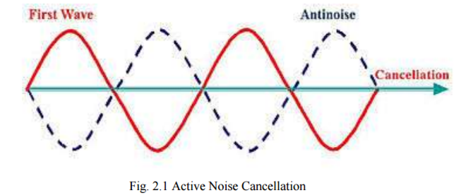

A very basic single channel active noise control system consists of:

* A reference microphone sensor- to sample the disturbance to be cancelled.
* An electronic control system to process the input signal and then generate the control signal. This is basically an adaptive filter.
* A loudspeaker driven by the control signal to generate the anti-noise.
* An error microphone to provide feedback to the controller so that it can adjust itself to minimize the resulting sound output.
* Two major types of active noise control system will be considered here:
* Adaptive filtering - the coefficients are updated adaptively to reduce the error output,
* Waveform synthesis- a type of feed-forward control that is suited only to periodic noise.