Battleground

Group 11

Sohail, Hanif and Harrison, Ubadinobi-Ebili

Project Overview

The purpose of the application is to design a turn-based, multiplayer, strategy, fighting game. The game shall begin by showing the user(s) the title screen, which consists of the title of the game and the rules. The rules are as follows: the user(s) can choose to have a player vs player match, or a player vs computer match; the user(s) are allowed to only choose one character for each round, the match consists of the user(s) attempting to reduce the others character’s health until it reaches 0, the user(s) can reduce their opponent’s character’s health by choosing one of four attacks visible to them during their turn, each attack will do a varying amount of damage based on the user(s)’s character’s stats and the opponent’s character’s stats, as well as the type of move used; after the user(s) has chosen a type of move to use, the characters will deal damage to each other in order of their speed stat; once either character has reduced their opponent’s health to 0, they are declared the winner.

Once the user(s) choose(s) to proceed past the title screen they will be taken to the main menu; the main menu allows the user(s) to choose if the game will consist of a player vs player match, or a player vs computer match. The main menu will also allow the user(s) to choose their nickname(s), as well as which characters will be participating in the game. There will be two toggles, the first to control if the game will be player vs player, or player vs computer; the second toggle will allow the user(s) to switch between which player is currently picking a character. There will also be a random choice which will pick a character at random for the currently selected player.

Once the user(s) choose(s) to proceed past the main menu they will be taken to the gameplay screen. The game screen is the screen where the actual gameplay will take place. On the game screen the user(s) will be able to see the characters they have chosen, their character’s current health, and their character’s moves. After the user(s) have chosen a move, the game will reduce each player’s character’s health accordingly, change the character’s picture to match the move they are performing, and determine if a winner has been found.

The development environment that will be used to design the game will be Visual Studio. Supporting software to help the design of the project will include Visual Paradigm, to create the wireframe and UML outline; and Git, to support version control. The game shall be a Universal Windows Platform app (UWP). The business logic of the program shall be written in C#. The user interface shall be written using XAML.

**User Interface (Wireframe)**

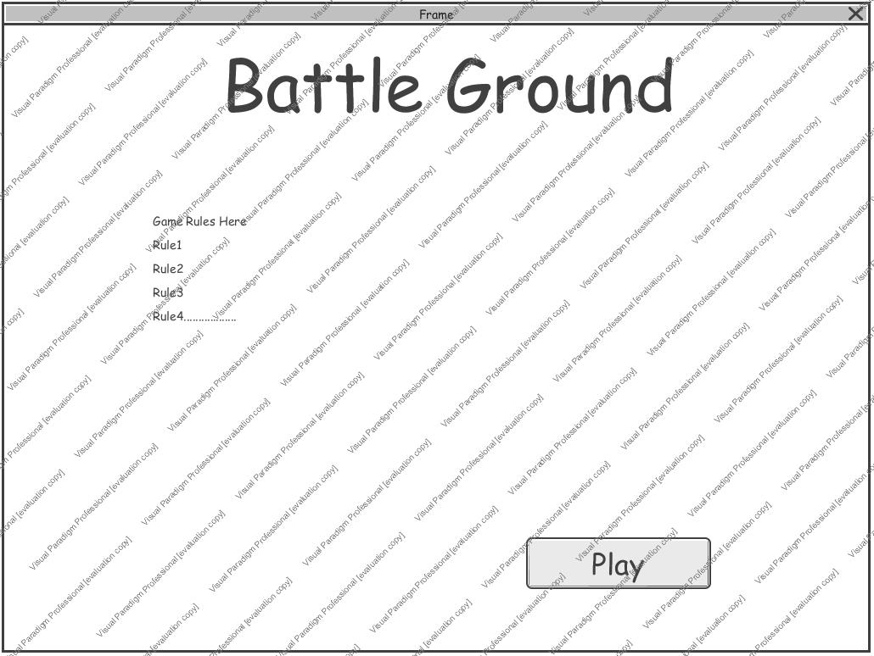

This Battle Ground welcome page will be displayed which contains rules of the game and then navigates to the character selection page below.

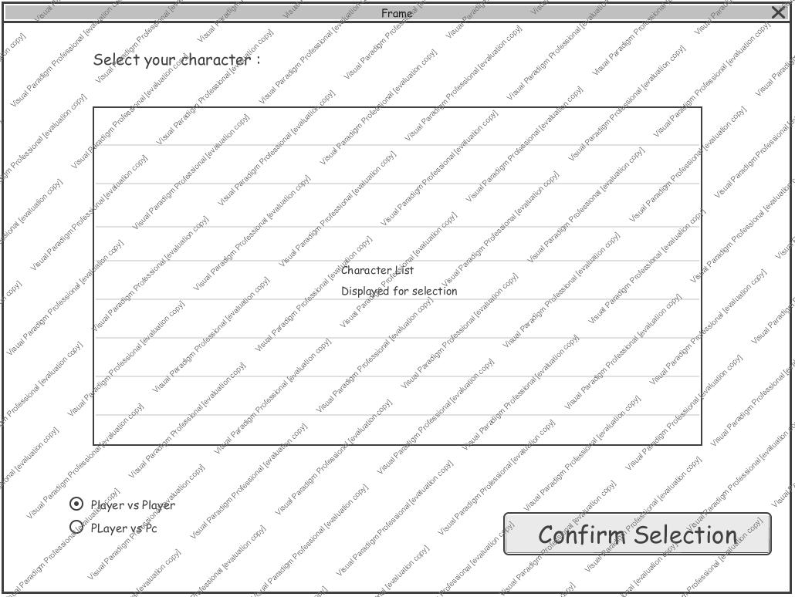

This page will display the available list of characters in the game, and also provide the user(s) with the option of playing 1v1 or against pc. A toggle button will be implemented instead of a radio button. After a character is selected, a game round will then begin as shown below.

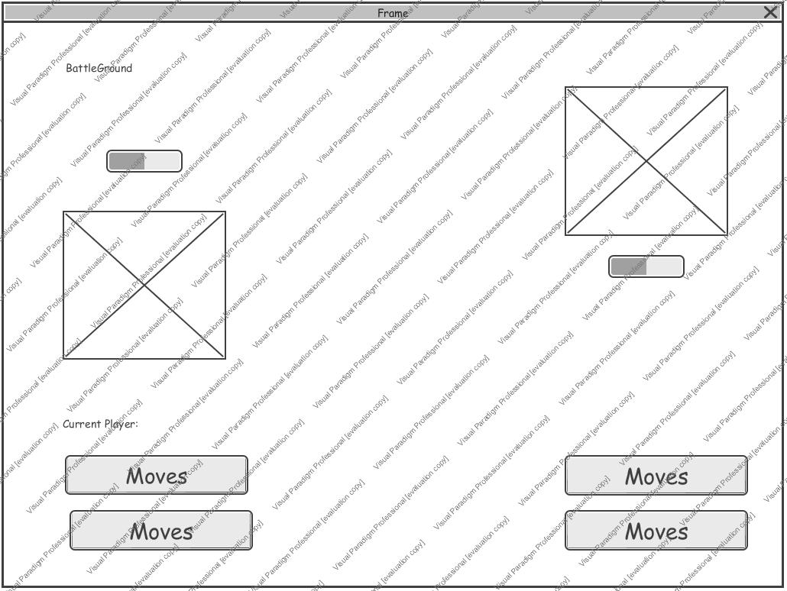

This frame will display the gameplay screen until a winner emerges, here the user(s) will select moves and attack in a sequential manner.

When a winner emerges the winner frame window is displayed which will have an image of the winning character and also several options for the user to select.

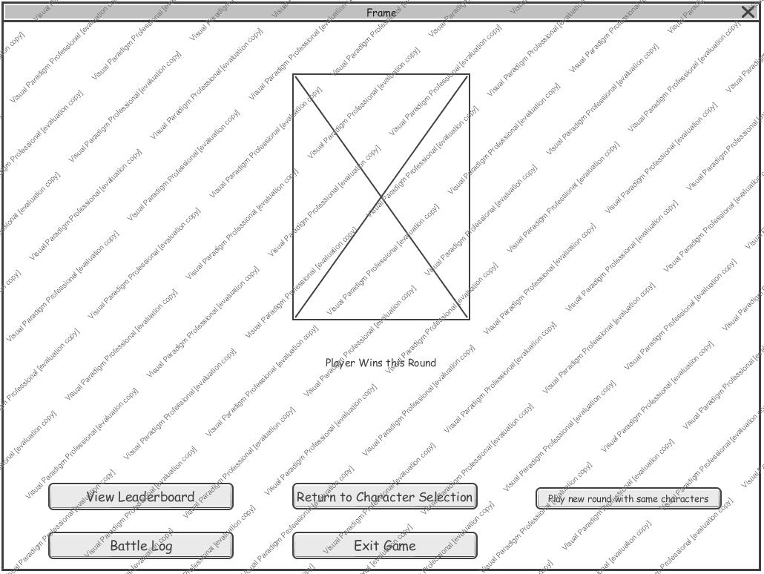

UML Diagram

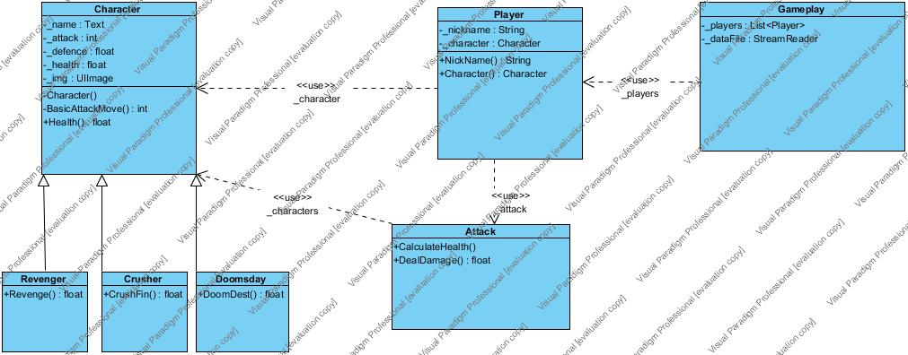

Sequence Diagram

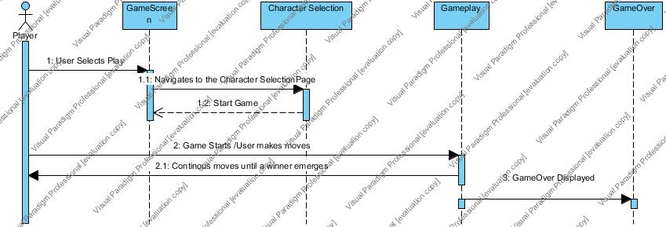

Data Design

The Battle Log - The game shall store data that summarizes the game as a whole. Information included in the data log includes: the type of match being played (player vs player, or player vs computer), the nickname chosen by each player, which character each player has chosen, which move each player chose, the effect each move had on each character’s health, and the winner of the match. The user(s) can view this log at the end of the game if they so choose. This log is reset at the start of each game.

Leaderboard – Records the number of wins that each character has. Persists even after the game is closed.

Work Assignments

Sohail Hanif:

· Character classes (C#)

· Attack class (C#)

· Game screen logic (C#)

· Game screen (XAML)

· Battle log (Data file)

Harrison, Ubadinobi-Ebili

· Player class (C#)

· Main menu logic (C#)

· Title page (XAML)

· Main menu (XAML)

· Leaderboard (Data file)